DS-K1T501SF customized firmware build211112 configuration guide
- Customization Background
Customization firmware version
DZP20211028031_501_H2_EN_GM_V1.1.0_build211112
Customization firmware functions
- Enable K1T501SF to call 2nd generation indoor units (DS-KH6320, DS-KH8350, DS-KH8520) with protocol 2.0 firmware version (V2.1.10 and later)

- After the indoor unit is bound to Hik-Connect, push the call to the mobile phone and implement the video intercom function.

- When the visitor presses the call button to call 4200 or indoor unit or Hik-Connect, after the door is opened remotely, a prompt is added on the local end of the device: The green light for remote door opening flashes and the English voice prompt “Door is open”.

- Support configuration: When fingerprint or card verification fails, it will automatically call the indoor unit.

- Support other access control function of baseline K1T501SF.

Please restore the device to factory settings after customization firmware upgrade is complete

- Configuration Step

Set up DS-K1T501SF
- Modify the K1T501SF device name

Modify the device name to 11-digit data, the format is as follows (* phase *** building ** unit * floor **** room number).
The floor number is fixed to 1, the main door station and the slave door station should share same phase, building, and unit name. The room number should be the number of indoor unit. For example: indoor unit 101, (1 as floor number, 01 as room number) , then the room number we enter here should be 0001)
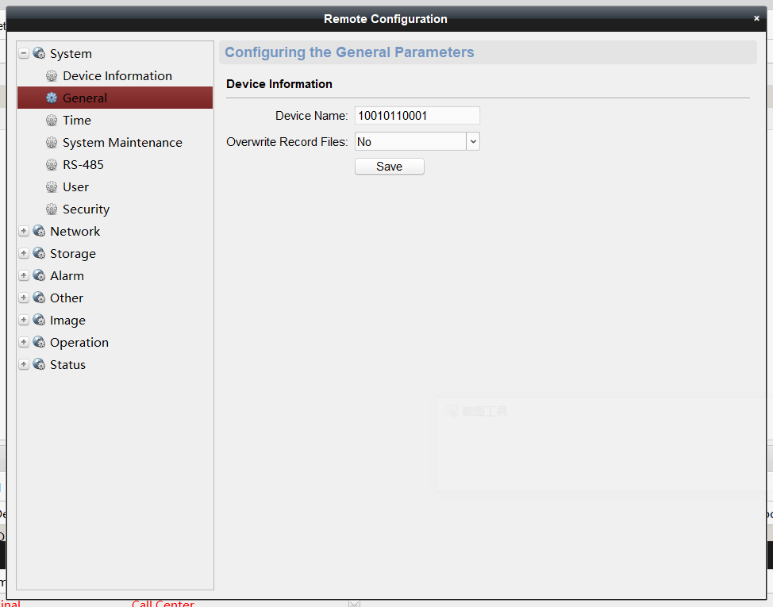

- Configure automatic call configuration (optional)

Function: Automatically call the indoor unit if authentication fails, it is off by default.

This function can be opened and closed by configuring the opening and closing of the closed door lock (requires saving and apply parameters to take effect)
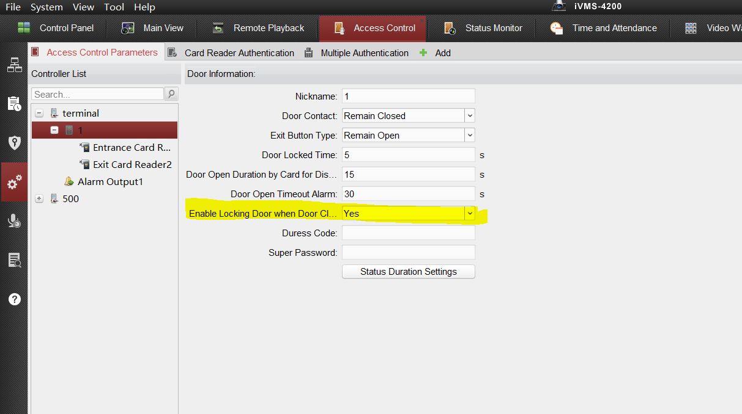

Configure the second-generation indoor unit
Set network linkage between indoor station and the terminal.
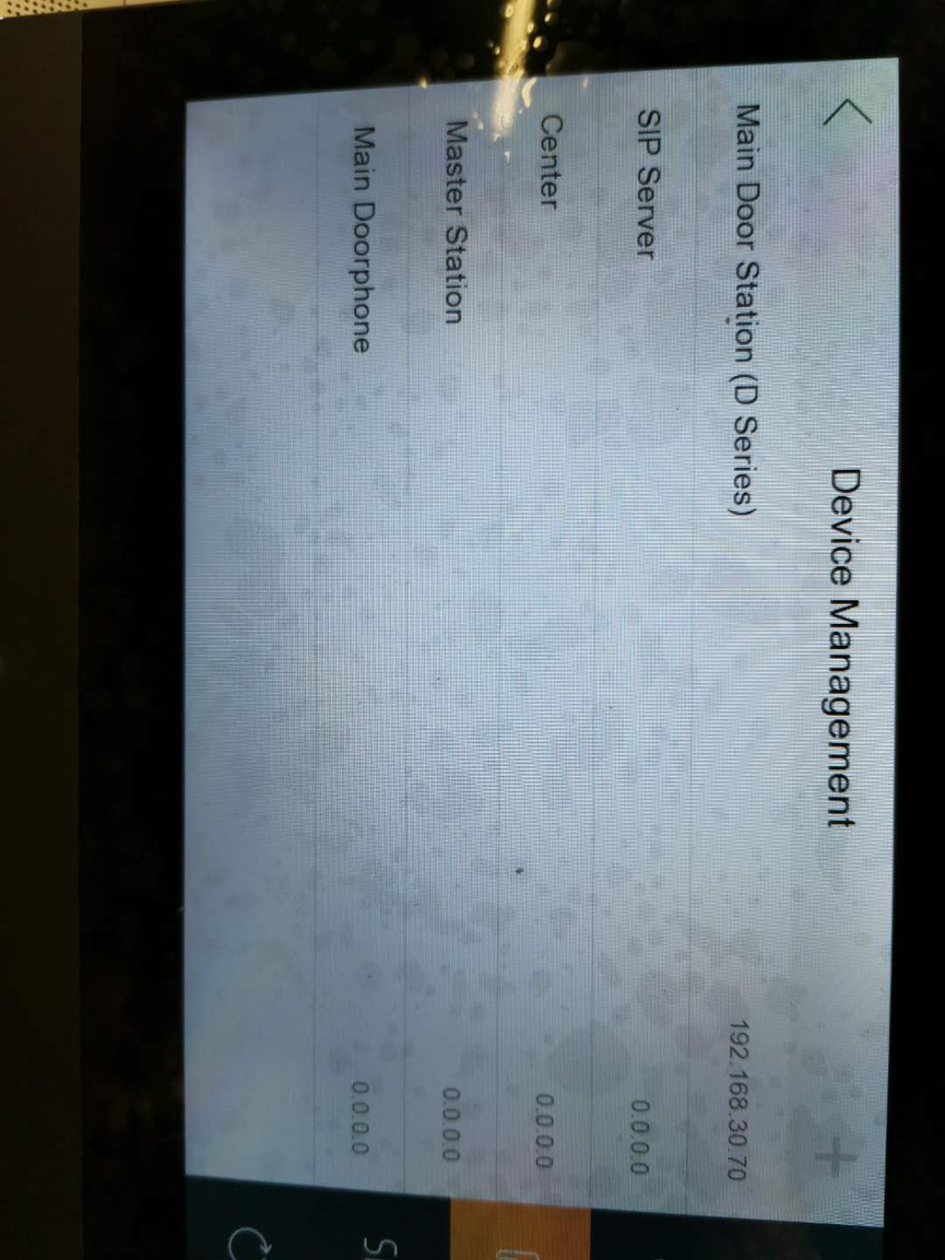

Both the indoor unit and Hik-Connect can receive calls after pressing the button of terminal.
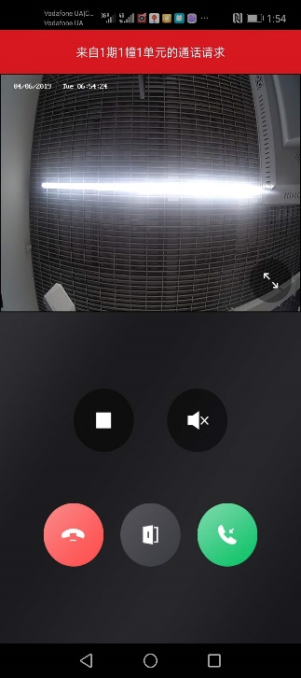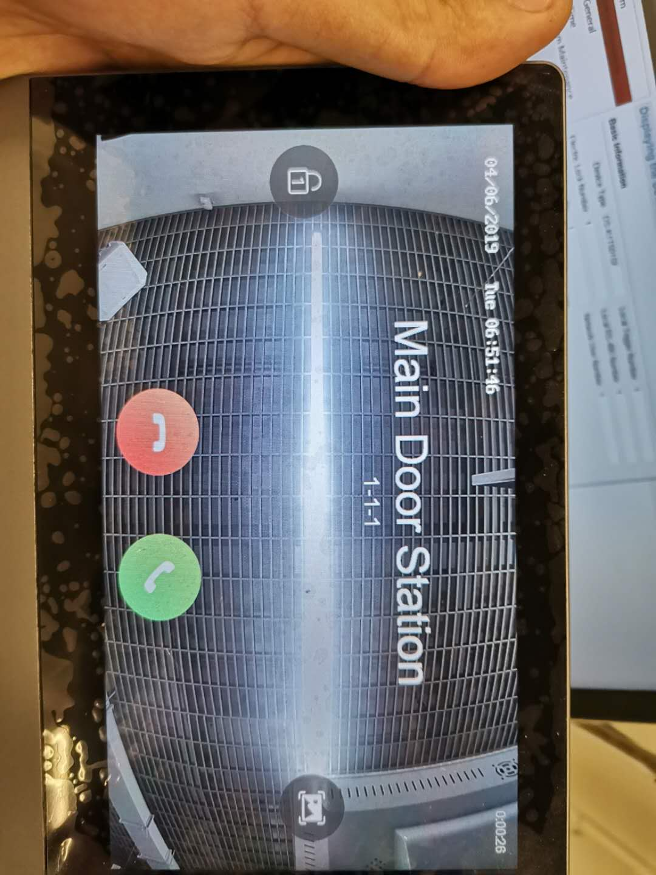

Set door station extension:
Go to network-advanced setting

Enter “0” in alarm station port number, then this terminal will be the master door station.
If the number is set as “1-99”, this terminal will be slave door station.
The maximum extension number is 8.

If the terminal is slave one, enter IP address of main one in “alarm station IP adress”
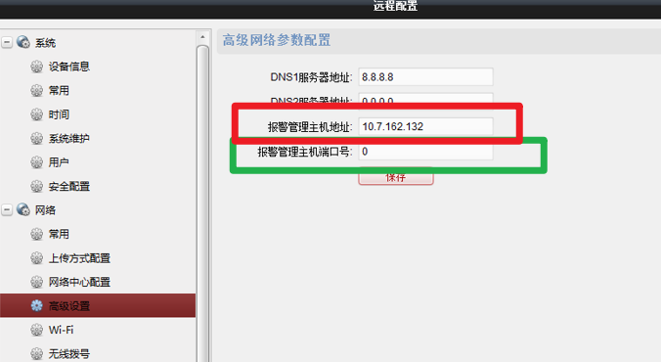

6. Call master station configuration:
Tool: SDK demo
Open the configuration interface as shown in the figure: The name of group number 32 is configured as the IP address of the management machine, and then saved. 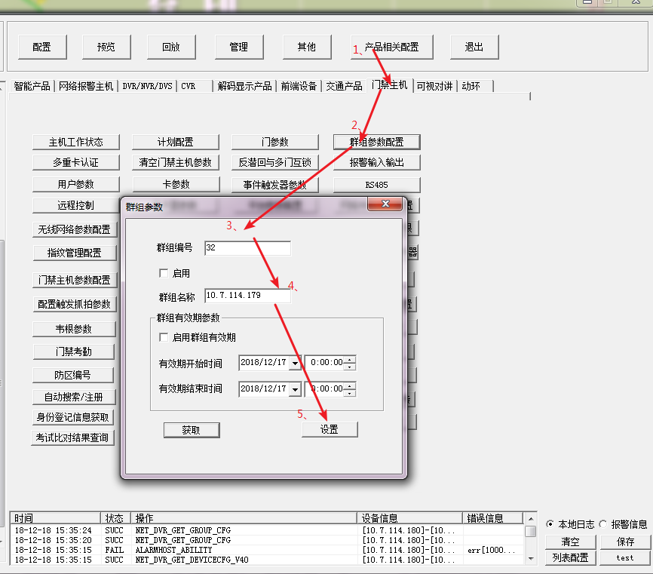

7. Other default configuration instructions
The maximum talk time is 120 seconds, and the door station will hang up automatically after 120 seconds.

Note:
1. If the call fails (for example, the device prompt "The room number cannot be empty, please enter the room number" or "Callinge failed"), check whether the device is online. If all are online, temporarily change the room number of the indoor station to Other numbers (***floor**room), change back after a few seconds
2. Note that the main stream resolution of DS-K1T501 video parameters is 720P, if other resolution, indoor station does not support preview.
3. Call logic: press the doorbell button to call the indoor unit, and the phone button to call 4200.

