Display Module Release Note
(2019-06-04)
Device Model: | Firmware Version | Display sub unit device firmware: V1.0.0_190520  Door station main unit device firmware: V2.0.6_190522  Door station sub unit device firmware: V1.0.0_190522
 | iVMS-4200 Version | V2.6.5.22 build20190425
Note: Improve keyboard module user experience and add the address book function

New function:
- The display module supports to show boot animation
- The display module supports standby interface
- Prompt to active the device when device is not activated
- After the activation, the display module is in the standby state, and when the motion detection occurs, automatically enter the main interface or the address book interface.
- Display module support personnel import and display function
- On the client side, the personnel will be divided into Normal Person and Visitor Person;
- Normal Person must bind the room number, the default room number is 1, and it will automatically display it in the address book; Visitor Person cannot display the room number in the address book;
- When the keyboard module is not connected, the display module starts to directly enter the address book interface; when the keyboard module is connected, the display module will show the main interface, and presses the up and down keys to enter the address book interface;
- The display module supports button prompt tone
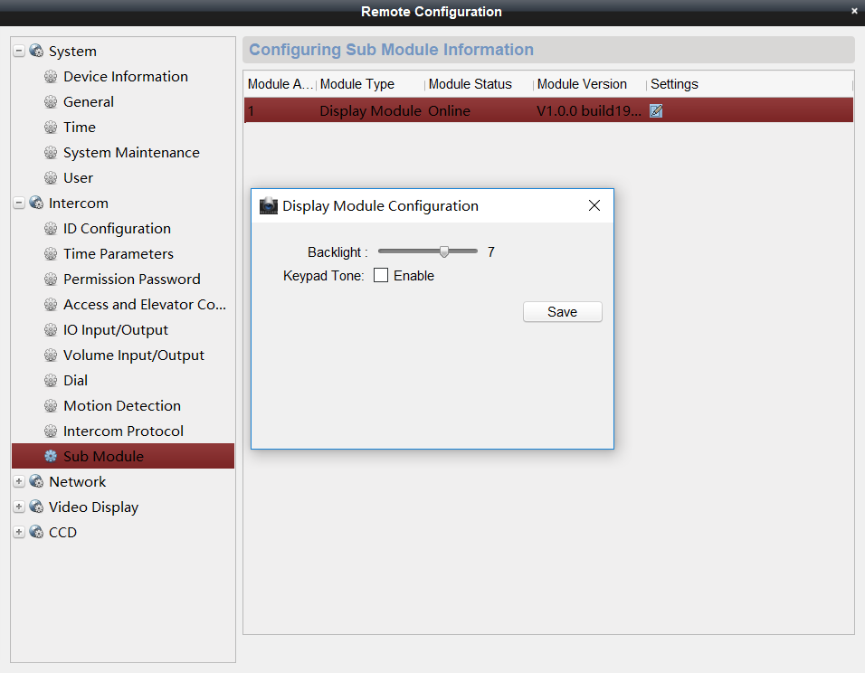
- Calling the resident through the display module
- The visitor can select the name displayed in the address book, then press OK to enter the confirmation interface, and then press OK again to call the indoor station which corresponding to the room number;
(Long press the up and down keys to speed up the page flipping speed of the address book)
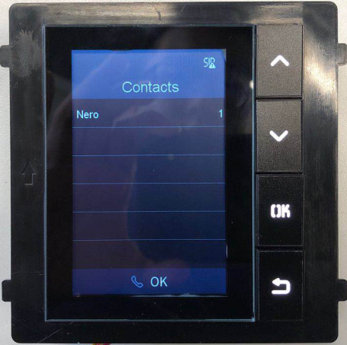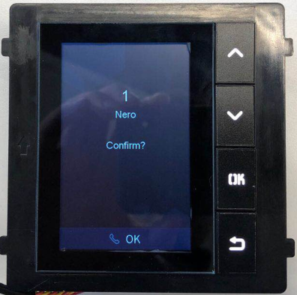
- When the keyboard module inputs a number, the display module will display the number synchronously.
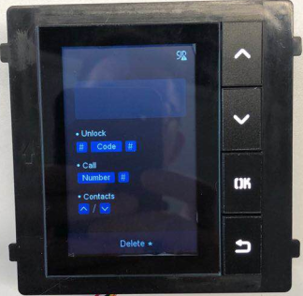
- Support for entering the password through the keyboard module to open the door, the operation process will be displayed on the display module.
- When the keyboard module is connected, you can enter “#password#” to unlock the door;
- When the keyboard module enters the password, the public password, or the duress password to open the door, the display module will update in real time and prompt the door is opened, the password is wrong, etc.
- The display module supports multi-language display, and switch with the main module
- The display module, keyboard module, nametag module, indicator module and card module can be upgraded through the iVMS-4200.
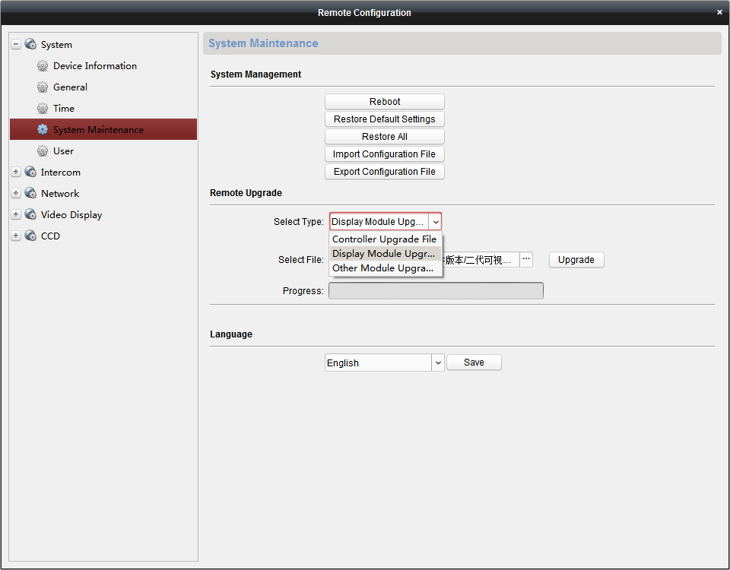
Modified Features:
- Multi-language increase to 19 countries: English, French, Portuguese (Brazil), Spanish, Russian, German, Italian, Polish, Arabic, Turkish, Vietnamese, Hungarian, Dutch, Romanian, Czech , Bulgarian, Greek, Croatian, Serbian
- The number of personnel issued can support up to 500

Note:
- The maximum number of sub-modules is as follows:
Max nametag modules: 8;
Max keyboard modules: 1;
Max indicator modules: 1;
Max card modules: 5;
Max display modules: 1
The maximum number of any combination of modules is 8, but if it include the display module, the maximum is 5.
- It is recommended to upgrade the firmware of other sub-modules before upgrading the firmware of the display module.

Customer Impact and Recommended Action
This new firmware upgrade is to improve product performance, and will take effect automatically after upgrading from previous versions. We’d like to inform you the above changes. Also, we are sorry for any possible inconvenience of use-habit changes caused by this action.
For questions or concerns, please contact our local technical support team.
Note:
- Hikvision has all rights to alter, modify and cancel this notice.
- Hikvision doesn’t give any guarantee for old models’ stock.
- Hikvision is not liable for any typing or printing errors.
- For special model’s change details, please contact our local technical support team.

Hikvision Digital Technology CO., Ltd.
No. 555 Qianmo Road, Binjiang District, Hangzhou 310052, China
Tel: +86-571-8807-5998
FAX: +86-571-8993-5635
Email: support@hikvision.com

