

DS-72xx Series Embedded Net DVR
USER’S MANUAL

Hikvision ® Network Digital Video Recorder User Guide

Copyright © 2010, Hikvision, Ltd. All rights reserved.

This document may not be copied in whole or in part or otherwise reproduced without prior written consent from Hikvision except where specifically permitted under Europe and international copyright law.

The information in this document is subject to change without notice. Hikvision assumes no responsibility or liability for any errors or inaccuracies that may appear in this book.

This manual is written for DVR firmware version 1.2.2.
TABLE OF CONTENTS
CHAPTER1 Introduction 5
Preventive and Cautionary Tips 6
DVR Specifications 6
Connecting Your DVR 8
Operating Your DVR 9
Using the Front Panel Controls 9
Using the IR Remote Control 11
Using a USB Mouse 12
Using the Soft Keyboard 12
Rear Panel Diagram 14
CHAPTER2 Getting Started 16
Starting and Shutting Down Your DVR 17
Rebooting and Locking Your DVR 18
Setting Date & Time 18
Checking the Status of Your DVR 20
CHAPTER3 Live Feed 21
Watching a Live Feed 22
Understanding Live Feed Icons 22
Operating the Live Feed 23
Using the Display Menu 25
Configuring Live Feed Displays 27
Setting Camera Order 28
CHAPTER4 Record Settings 29
Configuring Settings for Recording 30
Configuring Recording Settings 30
Configuring a Quick Recording Schedule 31
Configuring an Advanced Recording Schedule 32
CHAPTER5 Playback 34
Playing Back a Recording 35
Understanding the Playback Interface 35
Searching for Recorded Files 35
Playing Back Recorded Files 36
CHAPTER6 Backup 38
Backing Up Video Clips 39
Selecting Video Clips 39
Backing Up Video Clips 40
Backing Up Recorded Files 41
CHAPTER7 System Configuration 42
Configuring Network Settings 43
Managing User Accounts 44
Adding a New User 44
Deleting a User 45
Editing a User 45
Configuring PTZ Cameras 46
Configuring Basic PTZ Settings 46
Customizing PTZ Presets, Patterns and Patrols 47
Configuring Alarms and Exceptions 49
Setting Up Motion Detection 49
Configuring Alarm Inputs 50
Configuring Exceptions 51
Configuring E-mail Settings 52
CHAPTER8 Camera Management 53
Configuring Cameras 54
To setup privacy zones 54
Configuring Video Tampering Detection 55
Configuring Video Loss Detection 56
Configuring OSD Settings 57
CHAPTER9 Disk Management 58
Managing Disks 59
Checking Disk Status 59
Formatting Disk 59
Enabling Disk Overwrite 60
Managing Files 61
Searching for Recorded Files 61
Locking and Unlocking Recorded Files 61
CHAPTER10 DVR Management 63
Managing System 64
Upgrading the System Firmware 64
Restoring Default Settings 64
Exporting & Importing Configuration 65
Viewing System Logs 67
Locking and Unlocking System Menus 68

CHAPTER1 Introduction

Preventive and Cautionary Tips
Before connecting and operating your DVR, please be advised of the following tips:
• Ensure unit is installed in a well-ventilated, dust-free environment.
• Unit is designed for indoor use only.
• Keep all liquids away from the DVR.
• Ensure environmental conditions meet factory specifications.
• Ensure unit is properly secured to a rack or shelf. Major shocks or jolts to the unit as a result of dropping it may cause damage to the sensitive electronics within the unit.
• Use the DVR in conjunction with an Uninterruptible Power Supply (UPS).
• Power down the unit before connecting and disconnecting accessories and peripherals.

DVR Specifications
• Compression:
• Video encoding parameters of each channel can be set separately, including resolution, frame rate, bit rate, image quality.
• Each channel supports normal and event compression parameters.
• Supports both composite stream and video only stream. Audio and video streams are strictly synchronized.
• Supports Hikvision watermark.
• Supports dual stream. Sub stream up to CIF resolution.
• Local Functions (Monitoring):
• Supports 1/4/9/16 screen live view, channel sequence is adjustable.
• VGA output support 1280x1024 and 1024x768.
• For DS-7208HFI-ST and DS-7216HFI-ST, HDMI port is optional.
• Support live view group switch, manual switch and automatic cycle, the interval of automatic cycle can be adjusted.
• Supports shielding of an assigned live view channel.
• Supports various PTZ protocols, PTZ preset, patrol and pattern.
• Support local multi-user management. The administrator can set every guest user’s access right. Users can log off and switch.
• Supports mouse, front panel, IR control
• Local Functions (HDD Management):
• Supports up to 2 SATA HDD, each HDD can support max 2TB capacity.
• Supports S.M.A.R.T. technology.
• Supports HDD hibernation function.
• Supports Windows compatible file system format and technology of pre-allocating hard disk space to avoid HDD fragments.
• Recording and Playback:
• Supports continuous and event recording types
• Supports 8 recording time periods with separate recording types.
• Supports pre/post-recording time for alarm and motion detection.
• Supports pause, play fast, play slow, skip forward, and skip backward when playback, locating in progress bar by dragging the mouse.
•Supports up to 16 channels playback.
• Backup:
• Supports USB storage device, SATA CD/DVD backup.
• Supports backup device maintenance and management.
• Alarm & Exception:
• Unified management of DVR alarm input/output.
• Supports motion detection, network disconnect detection, video output standard mismatch detection.
• Supports auto recovery from exceptions.
• For DS-7200-xx/SN series, alarm module and front panel button are optional.
• Network:
• Supports 10/100M adaptive network interface.
• Supports TCP/IP protocols, DHCP, DNS, DDNS, NTP, and SADP, etc.
• Supports unicast and multicast, support TCP and UDP for unicast
• Supports remote search, playback and download video files.
• Supports remote configuration and import and export of DVR settings.
• Supports remote acquisition of device status, system log and alarm status.
• Supports remote format of hard disk, upgrade, reboot.
• Supports event alarm and exceptions upload to remote management host.
• Support user management. Administrator can create and manage remote users and set their privilege.
• Supports remote instantaneous JPEG capture.
• Supports remote PTZ control.
• Supports voice talk and broadcast.
• Includes built-in WEB Server.
• Development:
• SDK for Windows and Linux environment is available.
• Demo software source codes are available.
• Development support and training of application system are available.

Connecting Your DVR
You may follow the diagram below (Figure 2) in connecting your DVR to its peripherals.

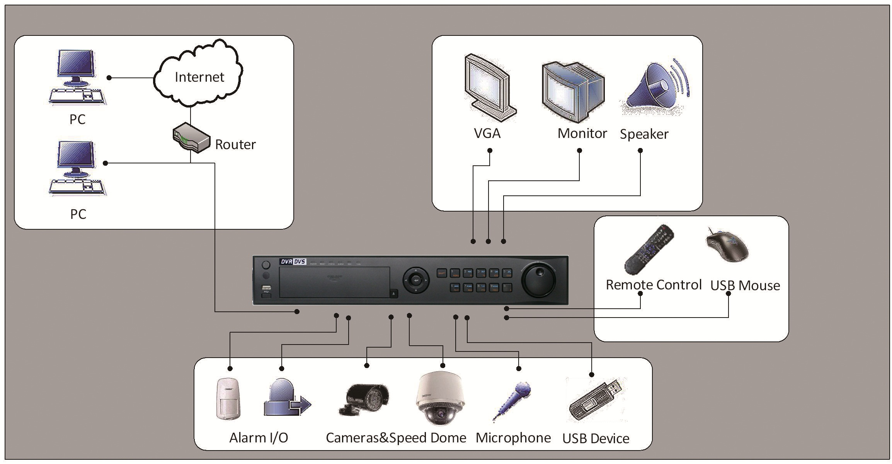
Fig 2: DVR Connection Diagram

Operating Your DVR
There are numerous ways to navigate and operate your DVR. You may use the Front Panel Controls, the included IR (Infra-Red) Remote, a Mouse and the Soft-Keyboard.
Using the Front Panel Controls
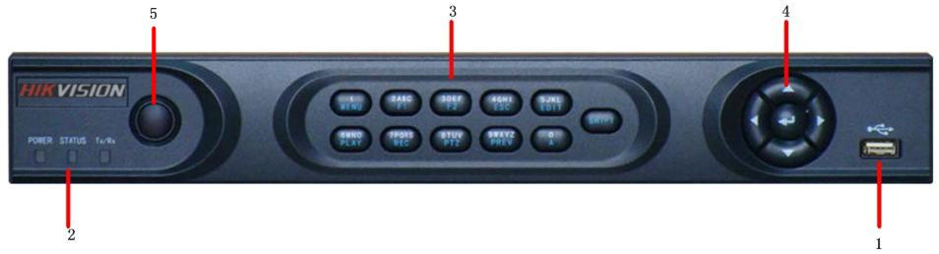
Figure 1: DS-7200HVI-ST/SN, DS-7204HFI-ST/SN and DS-7208HFI-ST/SN
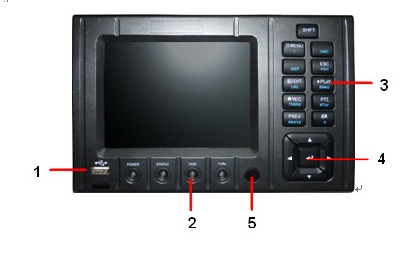
Figure 2: DS7204HVI-ST/L
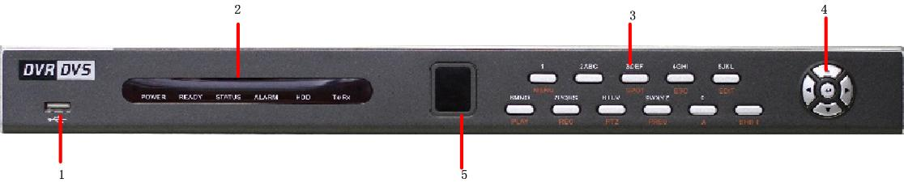
Figure 3: DS-7208HVI-ST(/SE) series and DS-7216HFI-ST(/SE/SN)
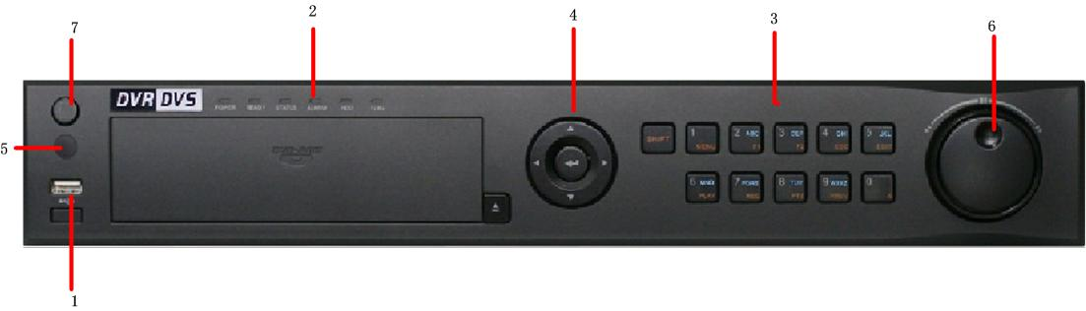
Figure 4: DS-7216HVI-ST(/SE)

Notes: For DS-7204HVI-ST/M and DS-7204HVI-ST/E, there is not button in front panel.
The controls on the front panel include:
- USB Ports: Universal Serial Bus (USB) ports for additional devices such as USB mouse and USB Hard Disk Drive (HDD).
- Status Indicators: Status indicators for different features of the DVR.
• Alarm: Alarm indicator turns red when a sensor alarm is detected.
• Ready: Ready indicator turns green when DVR is functioning properly.
• Status: Status indicator turns green when DVR is controlled by an IR remote.
• HDD: HDD indicator blinks red when data is being read from or written to HDD.
• Tx/Rx: Tx/Rx indictor blinks blue when network connection is functioning properly.
- Control Buttons:
• MENU: (1) Enter numeral “1”; (2) Access the main menu interface.
• 2/ABC/F1: (1) Enter numeral “2”; (2) Enter letters “ABC”; (3) [Zoom-] in PTZ control mode
• 3/DEF/F2: (1) Enter numeral “3”; (2) Enter letters “DEF”; (3) [Zoom+] in PTZ control mode
• 4GHI/ESC: (1) Enter numeral “4”; (2) Enter letters “GHI”; (3) Exit and back to the previous menu.
• 5JKL/EDIT: (1) Enter numeral “5”; (2) Enter letters “JKL”; (3) Delete characters before cursor; (4)Select the checkbox and ON/OFF switch; (4) [Iris+] in PTZ control mode
• 6MNO/PLAY: (1) Enter numeral “6”; (2) Enter letters “MNO”; (3) Playback, for direct access to playback interface.
• 7PQRS/REC: (1) Enter numeral “7”; (2) Enter letters “PQRS”; (3) Manual record, for direct access to manual record interface; manually enable/disable record.
• 8TQV/PTZ: (1) Enter numeral “8”; (2) Enter letters “TQV”; (3) Access PTZ control interface;
(4) [Iris-] in PTZ control mode.
• 9WXYZ/PREV: (1) Enter numeral “9”; (2) Enter letters “WXYZ”; (3) Multi-camera display in preview; (4) [Focus-] in PTZ control mode
• 0/A: (1) Enter numeral “0”; (2) switch between input methods (upper and lowercase alphabet, symbols and numeric input); (3) [Focus+] in PTZ control mode
• SHIFT: The SHIFT button is used for switch button action between numeric button and control button.
- DIRECTION/ENTER Buttons:
• DIRECTION Buttons: The DIRECTION buttons are used to navigate between different fields and items in menus. In Playback mode, the Up and Down button is used to speed up and slow down recorded video. In Preview mode, these buttons can be used to cycle through channels.
• ENTER Button: The ENTER button is used to confirm selection in any of the menu modes. It can also be used to tick checkbox fields. In Playback mode, it can be used to play or pause the video.
- IR Receiver: Operation by IR remote control
- JOG SHUTTLE Control: The JOG SHUTTLE control can be used to move the active selection in a menu. In the Playback mode, the inner ring can be used to speed up/slow down the video. In Preview mode, it can be used to cycle through different channels.
- POWER Button: The POWER button is used for power on or power off the DVR.

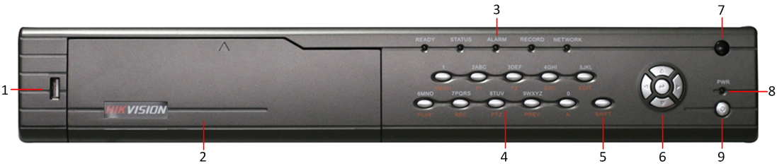
Figure 5. DS-7200HVI-ST/RW, DS-7200HFI-ST/RW Front Panel

- USB Interface: Connects USB mouse or USB flash memory devices.
- DVD-ROM: Space for DVD-ROM.
- Status Indicators:
- READY: the indicator lights in green when the device is running normally.
- STATUS: the indicator lights when the compound key switches to numeric/letter input mode.
- ALARM: the indicator lights in red when there is sensor alarm occurring.
- RECORD: the indicator lights in green when the unit is under recording.
- NETWORK: the indictor flickers in green when network connection is functioning normally.
- Compound Buttons:
- 1 MENU: (1) Enter numeral “1”; (2) Access the main menu interface.
- 2ABC/F1: (1) Enter numeral “2”; (2) Enter letters “ABC”; (3) The F1 button when used in a list field will select all items on the list. In PTZ Control mode, it will turn on/off PTZ light.
- 3DEF/F2: (1) Enter numeral “3”; (2) Enter letters “DEF”; (3) The F2 button is used to cycle through tab pages. It will also bring up the Channel & OSD Position settings.
- 4GHI/ESC: (1) Enter numeral “4”; (2) Enter letters “GHI”; (3) Exit and back to the previous menu.
- 5JKL/EDIT: (1) Enter numeral “5”; (2) Enter letters “JKL”; (3) Delete characters before cursor;
(4)Select the checkbox and ON/OFF switch; (5) Start/stop record clipping in playback.
- 6MNO/PLAY: (1) Enter numeral “6”; (2) Enter letters “MNO”;
(3) Playback, for direct access to playback interface
- 7PQRS/REC: (1) Enter numeral “7”; (2) Enter letters “PQRS”; (3) Manual record, for direct access to manual record interface; manually enable/disable record
- 8TUV/PTZ: (1) Enter numeral “8”; (2) Enter letters “TUV”; (3) Access PTZ control interface.
- 9WXYZ/PREV: (1) Enter numeral “9”; (2) Enter letters “WXYZ”; (3) Multi-camera display in live view.
- 0/A: (1) Enter numeral “0”; (2) switch between input methods (upper and lowercase alphabet, symbols and numeric input).
- SHIFT: Switch of compound keys between the numeric/letter input and functional control.
- Control Buttons:
- Directional buttons: In menu mode, the direction buttons are used to navigate between different fields and items and select setting parameters. In playback mode, the Up and Down buttons are used to speed up and slow down record play, and the Left and Right buttons are used to select the recording 30s forwards or backwards. In live view mode, these buttons can be used to cycle through channels.
- Enter: The Enter button is used to confirm selection in menu mode; or used to select checkbox fields and ON/OFF switch. In playback mode, it can be used to play or pause the video. In single-frame play mode, pressing the Enter button will advance the video by a single frame. And in auto sequence live view mode, the buttons can be used to pause / resume auto sequence.
- IR Receiver: Operation by IR remote control.
- PWR: the indicator lights in green when DVR is powered up.
- Power On/Off: press and hold the button to turn off the device.

Note: It is important to note that you must click the EDIT button on either the remote or front panel on a text field before you’re able to edit its content. After you’re done entering text, you must hit the ENTER button to be able to move on to the next field.

Using the IR Remote Control

Your DVR may also be controlled with the included IR remote control, shown in Figure 4. Batteries (2x AAA) must be installed before operating.

Figure 4. IR Remote Control

The keys on the remote control closely resemble the ones found on the front panel. Referring to Figure 4, they include:
1. POWER Button: Same as POWER button on front panel.
2. DEV Button: Enables/Disables Remote Control.
3. Alphanumeric Buttons: Same as Alphanumeric buttons on front panel.
4. EDIT Button: Same as EDIT button on front panel.
5. A Button: Same as A button on front panel.
6. REC Button: Same as REC button on front panel.
7. PLAY Button: Same as PLAY button on front panel.
8. INFO Button: Reversed.
9. VOIP Button: Reversed.
10. MENU Button: Same as MENU button on front panel.
11. PREV Button: Same as PREV button on front panel.
12. DIRECTION/ENTER Buttons: Same as DIRECTION/ENTER buttons on front panel.
13. PTZ Button: Same as PTZ button on front panel.
14. ESC Button: Same as ESC button on front panel.
15. RESERVED: Reserved.
16. F1 Button: Same as F1 button on front panel.
17. PTZ CONTROL Buttons: Buttons to adjust the iris, focus and zoom of a PTZ camera.
18. F2 Button: Same as F2 button on front panel.

Aim the remote control at the IR receiver located at the front of the unit to test operation. If there is no response:
1. Using the front control panel or the mouse, go into Main Menu > System Con-figuration> Display configuration.
2. Check and remember DVR device No. The default ID# is 255. This ID# is valid for all IR controls.
3. Press the DEV button on the remote.
4. Enter the DVR ID# from step 2.
5. Press the ENTER button on the remote.

If the Status indicator on the front panel turns blue, the remote control is operating properly. If the Status indicator does not turn blue and there is still no response from the remote, please check the following:
1. Batteries are installed correctly and the polarities of the batteries are not reversed.
2. Batteries are fresh and not out of charge.
3. IR receiver is not obstructed.

Using a USB Mouse

A regular 3-button (Left/Right/Scroll-wheel) USB mouse can also be used with this DVR. To use a USB mouse:
1. Plug USB mouse into one of the USB ports on the front panel of the DVR.
2. The mouse should automatically be detected. If in a rare case that the mouse is not detected, please refer to the recommended device list from your provider.

The buttons on the mouse corresponds to:
1. Left Button:
• Single-Click: Select a component of a menu, such as a button or an input field. This is similar to pressing the ENTER button on the remote/front panel controls.
• Double-Click: Switch between single screen and multi-screen mode in Preview/Playback mode.
• Click and Drag: Clicking and dragging the Left mouse button can be used to control the pan/tilt of a PTZ camera as well as to vary the amount of dig-ital zoom. It can also be used to setup the alarm areas.

2. Right Button:
• Single-Click: Shows pop-up menu.

3. Scroll-Wheel:
• Scroll Up: In Preview mode, scrolling up will switch to the previous screen. In Menu mode, it will move the selection to the previous item.
• Scroll Down: In Preview mode, scrolling down will switch to the next screen. In Menu mode, it will move the selection to the next item.

Using the Soft Keyboard

When a mouse is used to perform task on the DVR, clicking on a text input field will bring up the Soft Keyboard, shown in Figure 5.

Figure 5. Soft Keyboard

The buttons on the soft keyboard represents:

Switch to Lowercase: Switch to lowercase input
Switch to Uppercase: Switch to uppercase input
Symbols: Switch to symbols input.
Backspace: Delete the character in front of the cursor.
Enter: Confirm selection.
ESC: Exit out of Soft Keyboard.

Rear Panel Diagram
DS-7204HVI-ST, DS-7204HFI-ST Rear Panel:
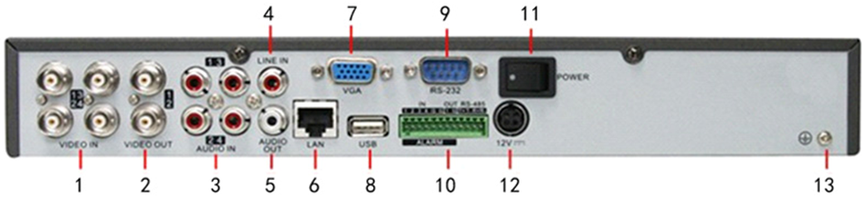
DS-7204HVI-ST/RW and DS-7204HFI-ST/RW Rear Panel:

DS-7204HVI-ST/L Rear Panel:
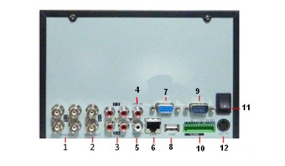

No. | Item | Description
1 | VIDEO IN | BNC connectors for analog video input
2 | VIDEO OUT | BNC connector for video output.
3 | AUDIO IN | RCA connectors for analog audio input
4 | LINE IN | RCA connector for audio input
5 | AUDIO OUT | RCA connector for audio output
6 | LAN | Connector for LAN (Local Area Network)
7 | VGA | DB15 connector for VGA output. Display local video output and menu
8 | USB | Connector for USB devices
9 | RS-232 Interface | DB9 connector for RS232 devices.
10 | ALARM IN | Connector for alarm input
10 | ALARM OUT | Connector for alarm output
10 | RS-485 Interface | Connector for RS-485 devices. T+, T- pin connects to PTZ
11 | POWER | Switch for turn on/off the device
12 | 12V | 12VDC power supply
13 | GND | Ground(needs to be connected when DVR starts up)

Notes:
DS-7204HVI-ST/M and DS-7204HVI-ST/E have almost the same rear panel of DS-7204HVI-ST, except that:
- DS-7204HVI-ST/M doesn’t have RS-232 port.
- DS-7204HVI-ST/E doesn’t have RS-232 port, alarm input or output ports and RS-485 ports.

DS-7204HVI-ST/SE, DS-7204HFI-ST/SE Rear Panel:
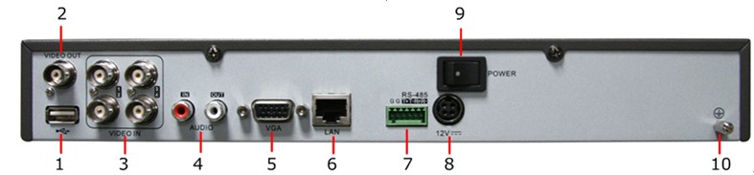
No. | Item | Description
1 | USB | Connector for USB devices
2 | VIDEO OUT | BNC connector for video output.
3 | VIDEO IN | BNC connectors for analog video input
4 | AUDIO IN/OUT | RCA connectors for analog audio input/output
5 | VGA | DB15 connector for VGA output. Display local video output and menu
6 | LAN | Connector for LAN (Local Area Network)
7 | RS-485 Interface | Connector for RS-485 devices. T+, T- pin connects to PTZ
8 | 12V | 12VDC power supply
9 | POWER | Switch for turn on/off the device
10 | GND | Ground(needs to be connected when DVR starts up)

DS-7208HVI-ST Rear Panel:
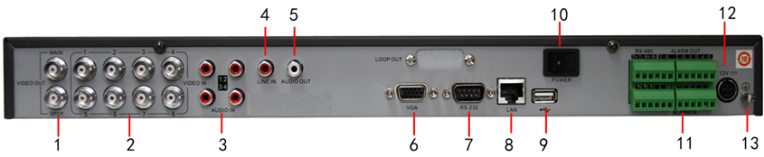
DS-7208HVI-ST/RW Rear Panel:
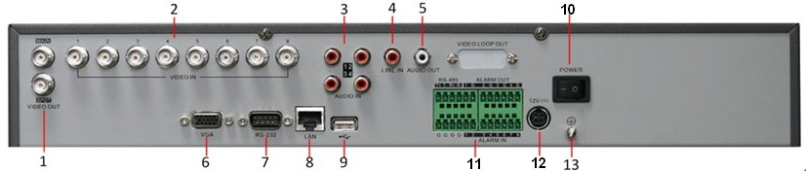
DS-7208HFI-ST/RW Rear Panel:
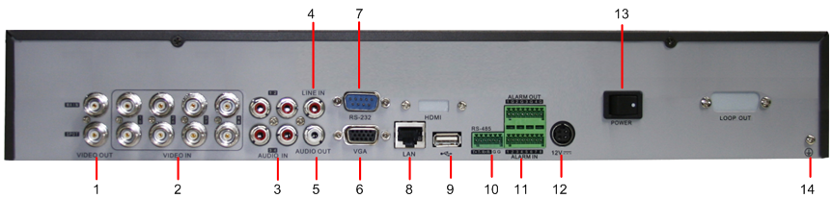

No. | Item | Description
1 | MAIN VIDEO OUT | BNC connectors for main video out
1 | SPOT VIDEO OUT | BNC connectors for spot video out
2 | VIDEO IN | BNC connectors for analog video input
3 | AUDIO IN | RCA connectors for analog audio input
4 | LINE IN | RCA connector for audio input
5 | AUDIO OUT | RCA connector for audio output
6 | VGA | DB15 connector for VGA output. Display local video output and menu
7 | RS-232 Interface | DB9 connector for RS-232 devices.
8 | LAN | Connector for LAN (Local Area Network)
9 | USB | Connector for USB devices
10 | POWER | Switch for turn on/off the device
11 | ALARM IN | Connector for alarm input
11 | ALARM OUT | Connector for alarm output
11 | RS-485 Interface | Connector for RS-485 devices. T+, T- pin connects to PTZ
12 | 12V | 12VDC power supply
13 | GND | Ground(needs to be connected when DVR starts up)

DS-7208HVI-ST/SE Rear Panel:
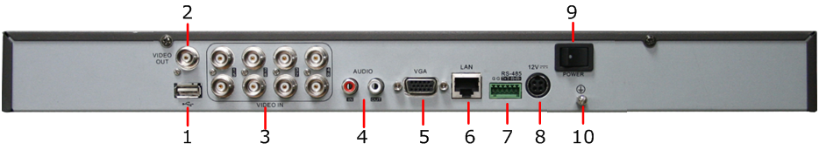
No. | Item | Description
1 | USB | Connector for USB devices
2 | VIDEO OUT | BNC connectors for main video out
3 | VIDEO IN | BNC connectors for analog video input
4 | AUDIO IN | RCA connectors for analog audio input
4 | AUDIO OUT | RCA connector for audio output
5 | VGA | DB15 connector for VGA output. Display local video output and menu
6 | LAN | Connector for LAN (Local Area Network)
7 | RS-485 Interface | Connector for RS-485 devices. T+, T- pin connects to PTZ
8 | POWER | Switch for turn on/off the device
9 | 12V | 12VDC power supply
10 | GND | Ground(needs to be connected when DVR starts up)

DS-7216HVI-ST (/RW) Rear Panel:
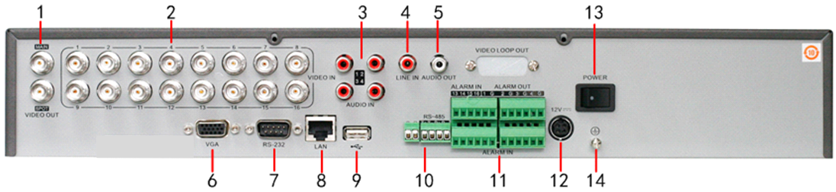
DS-7208HFI-ST Rear Panel:
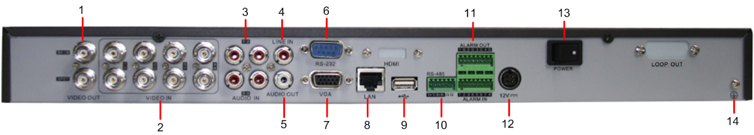
DS-7216HFI-ST Rear Panel:
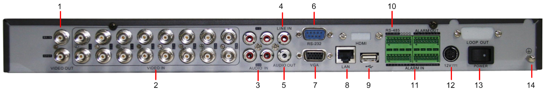
DS-7216HFI-ST/RW Rear Panel:
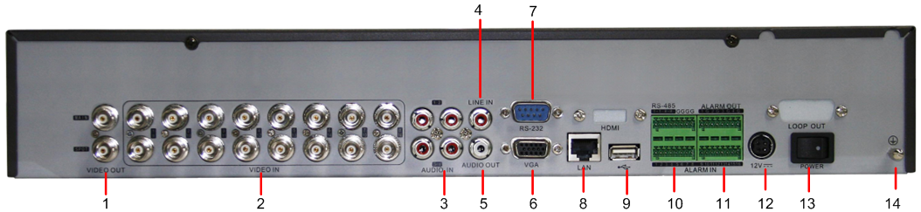

No. | Item | Description
1 | MAIN VIDEO OUT | BNC connectors for main video out
1 | SPOT VIDEO OUT | BNC connectors for spot video out
2 | VIDEO IN | BNC connectors for analog video input
3 | AUDIO IN | RCA connectors for analog audio input
4 | LINE IN | RCA connector for audio input
5 | AUDIO OUT | RCA connector for audio output
6 | VGA | DB15 connector for VGA output. Display local video output and menu
7 | RS-232 Interface | DB9 connector for RS-232 devices.
8 | LAN | Connector for LAN (Local Area Network)
9 | USB | Connector for USB devices
10 | RS-485 Interface | Connector for RS-485 devices. T+, T- pin connects to PTZ
11 | ALARM IN | Connector for alarm input
11 | ALARM OUT | Connector for alarm output
12 | 12V | 12VDC power supply
13 | POWER | Switch for turn on/off the device
14 | GND | Ground(needs to be connected when DVR starts up)

DS-7216HVI-ST/SE Rear Panel:
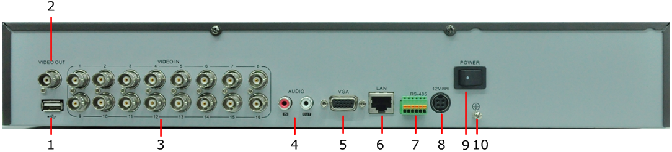
DS-7208HFI-ST/SE Rear Panel:
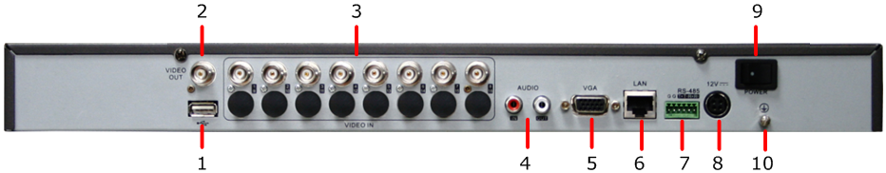
DS-7216HFI-ST/SE Rear Panel:
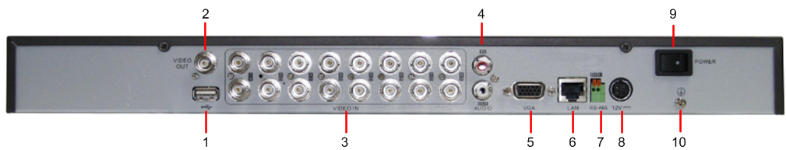
No. | Item | Description
1 | USB | Connector for USB devices
2 | VIDEO OUT | BNC connectors for main video out
3 | VIDEO IN | BNC connectors for analog video input
4 | AUDIO IN | RCA connectors for analog audio input
4 | AUDIO OUT | RCA connector for audio output
5 | VGA | DB15 connector for VGA output. Display local video output and menu
6 | LAN | Connector for LAN (Local Area Network)
7 | RS-485 Interface | Connector for RS-485 devices. T+, T- pin connects to PTZ
8 | POWER | Switch for turn on/off the device
9 | 12V | 12VDC power supply
10 | GND | Ground(needs to be connected when DVR starts up)

DS-7204HVI-ST/SN and DS-7204HFI-ST/SN Rear Panel:
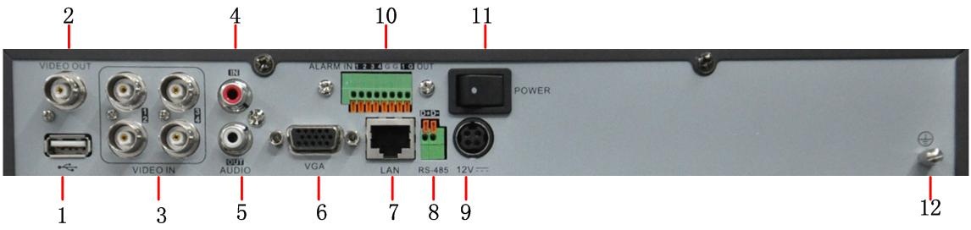
DS-7208HVI-ST/SN Rear Panel:
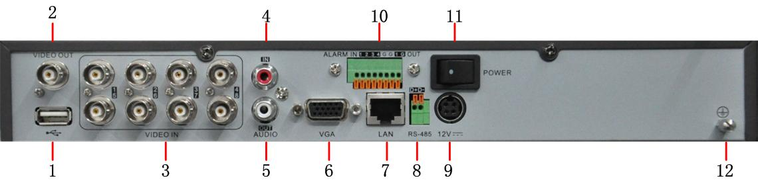
DS-7208HFI-ST/SN Rear Panel:

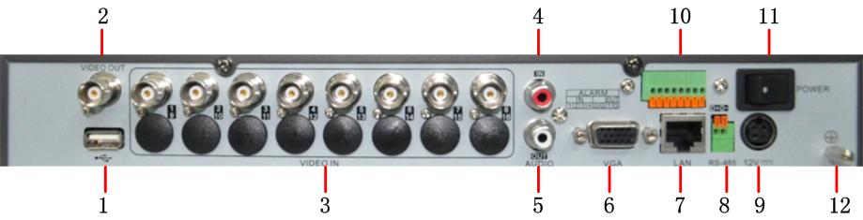
DS-7216HVI-ST/SN Rear Panel:

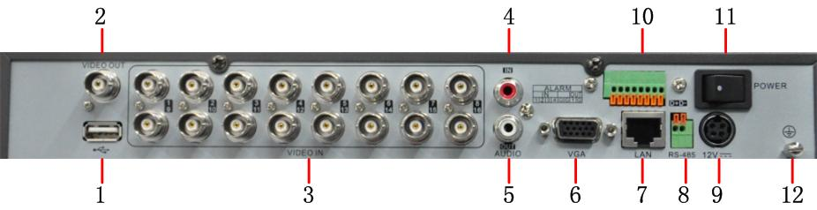
DS-7216HFI-ST/SN Rear Panel:

No. | Item | Description
1 | USB | Connector for USB devices
2 | VIDEO OUT | BNC connectors for main video out
3 | VIDEO IN | BNC connectors for analog video input
4 | AUDIO IN | RCA connectors for analog audio input
5 | AUDIO OUT | RCA connector for audio output
6 | VGA | DB15 connector for VGA output. Display local video output and menu
7 | LAN | Connector for LAN (Local Area Network)
8 | RS-485 Interface | Connector for RS-485 devices. T+, T- pin connects to PTZ
9 | POWER | Switch for turn on/off the device
10 | Alarm | 4 alarm input, 1 alarm output
11 | 12V | 12VDC power supply
12 | GND | Ground(needs to be connected when DVR starts up)

CHAPTER2 Getting Started

Starting and Shutting Down Your DVR

Proper startup and shutdown procedures are crucial to expanding the life of your DVR.

To startup your DVR:
1. Ensure the power supply is plugged into an electrical outlet. It is HIGHLY recommended that an Uninterruptible Power Supply (UPS) be used in conjunction with the unit. The Power indicator LED on the front panel should turn red, indicating the unit is receiving power.
2. Connect the DVR to a VGA or BNC monitor. When both connected, only the VGA monitor display the menu.
3. Press the POWER switch on the back rear panel. The Power indicator LED should turn blue. The unit will begin to start.
4. After startup, the Power indicator LED will remain blue. A splash screen will be shown (Figure 7).

Figure 7. Startup Splash Screen

There are two proper ways to shutdown the DVR.
Option 1: Standard Shutdown
- Enter the Shutdown menu shown in Figure 8 by going to Main Menu > Maintenance > Shutdown.

Figure 8. Shutdown Menu

- Select the Shutdown button.
- Click the Yes button.

• OPTION 2: Manual Shutdown
1. Press and hold the POWER button for 3 seconds.
2. Enter the administrator’s username and password in the dialog box for authentication.
3. Click the Yes button.

Note: Do not press the POWER button again when the system is shutting down.

Rebooting and Locking Your DVR

While in the Shutdown menu (Figure 8), you may also reboot or lock your DVR. Locking your DVR will return you to the Live Feed mode, which will require the correct administrator password to exit out of it. The Reboot button will reboot your DVR.

To reboot or lock your DVR:
1. Enter the Shutdown menu by going to Main Menu > Maintenance > Shutdown.
2. Select the Lock button to lock the DVR or the Reboot button to reboot the DVR.

Setting Date & Time

It is extremely important to setup the system date and time to accurately timestamp recordings and events.
To setup date and time:
- Enter the System Configuration menu by going to Main Menu > System Configuration, as shown in Figure 9.
Figure 9. System Configuration Menu

- Click the Time/Date button to enter the Time/Date menu (Figure 10).

Figure 10. Time / Date Menu

3. The current system time and date as well as the time zone will be displayed. Using the directional buttons on the front panel/remote or the mouse, select the correct date, time and time zone.
4. To enable Daylight Savings Time, click and check the Enable DST checkbox.
5. To acquire the time and date over an NTP (Network Time Protocol) Server, check the Synchronize via NTP server checkbox. You may enter your own NTP server or select from one of the default locations from the list of servers, as shown in Figure 11.

Figure 11. Time / Date Menu

6. Click the Save button to save settings and click the Exit button to exit out of the menu. Clicking the Exit button without clicking the Save button will exit the menu without saving.

Checking the Status of Your DVR
The current status of your DVR can be checked at anytime by going to the Status menu. The status menu, shown in Figure 12 can be accessed by going to Main Menu > Status.

Figure 12. Status Menu

The items that are found on the Status menu include:

• Device Information: The model number of the DVR, serial No., the current firmware version installed on DVR, etc.
• Chan Status: Cameras working status in DVR such as motion, tampering, video loss and video exception.
• Record Status: Recording status of the cameras, including: stream type, frame rate, bit rate, resolution, record type, etc.
• Alarm Status: The status of external alarm in/out on DVR
• Network Status: Network status such as IP address, gateway, DNS server, client port, etc.
• HD Status: Hard disk status on DVR.

CHAPTER3 Live Feed

Watching a Live Feed
The Live Feed mode is automatically started after the DVR boots up. It is also at the very top of the menu hierarchy, thus hitting the ESC button multiple times (depending on which menu you’re on) will bring you to the Live Feed mode.

Understanding Live Feed Icons
There are multiple icons on each display in Live Feed mode to indicate different camera status and settings. These icons include:
Event Icon: Indicates video loss or tampering, motion detection and /or sensor alarm.
Record Icon: Indicates the current channel is recording. There cording may have been started manually, from a schedule, and/or triggered from motion or alarm.
Picture Settings Icon: Adjust picture settings for selected display.
PTZ Control Icon: Enter PTZ control mode for the selected display.
Preset Icon: Recall PTZ preset.
Patrol Icon: Recall PTZ patrol.
Tour Icon: Recall PTZ tour.
Zoom In/Zoom Out: Zoom in/out with PTZ.
Full Screen/Exit Full Screen Icon: Enter into/exit out of full screen mode for selected display.
Audio On/Audio Off Icon: Enable/disable audio for selected display.
Close Icon: Exit out of current setting and return to previous mode.

Figure 13. Live Feed Icons

Operating the Live Feed
In Live Feed mode, you may adjust the settings for individual cameras by left-clicking on the desired display with the mouse.. The selected display will be surrounded with a green border, as shown in Figure 14 .
Figure 14. Live Feed Mode

The settings you may adjust with each display includes:
• Picture Settings: Settings for the brightness, contrast, saturation and hue of selected display. To adjust the picture settings of a display:
1. Select display.
2. Click the Picture Settings icon. This will bring up the Picture Settings menu, as shown in .Figure 15.

Figure 15. Picture Settings Menu

3. Increase/decrease amount for brightness, contrast, saturation and hue. The affect will be displayed immediately on the screen.
4. Click the Close icon to save the settings and return to the Live Feed mode.

• PTZ Control: If the selected camera is a PTZ camera, you may control it directly from the display. To control a PTZ camera:
1. Select display that corresponds to a PTZ camera.
2. Click the PTZ Control icon. This will bring up additional PTZ control buttons, as shown in Figure 16.
Figure 16. PTZ Control Mode

3. Control the PTZ using PTZ control buttons. Pan and tilt PTZ by clicking on the directional buttons. Zoom in and out using the Zoom In/Out buttons and recall presets, patrols and patterns by clicking the number next to the corresponding icons.
4. Click the Close icon to return to Live Feed mode.

Note: PTZ parameters for the camera must be set correctly before the PTZ can be controlled.

Note: A maximum of five presets, patrols and patterns can be displayed on this interface. More presets, patrols and patterns can be recalled in the PTZ Configuration menu.

• Audio: Enable/disable audio for selected display. To enable or disable audio:
1. Select display to enable/disable audio.
2. Enable audio by clicking the Enable Audio icon and disable audio by clicking the Disable Audio icon. An error message similar to the one shown in Figure 17 will pop up if the Enable Audio option is not selected in the Display Configuration menu for the specified channel.

Figure 17. Enable Audio Error Window

• Digital Zoom Mode: Enable digital zoom on the selected channel. Once enabled, the regular feed will be shown in the lower right corner while the zoomed in view will be shown on the full screen. The zoomed in region may be changed by moving the red rectangle in the regular feed window.
• Full Screen Mode: Enable full screen mode for selected display. To enable full screen mode:
1. Select display to enable full screen on.
2. Click the Full Screen icon.
3. Click the Exit Full Screen icon to return to normal display mode.

Using the Display Menu
The Display Menu can be accessed by right-clicking the mouse on any of the display in Live Feed mode. The Display menu, shown in Figure 18 allows you to quickly change into different display modes and to start/stop auto-switching of the display modes.

Figure 18. Live Feed Display Menu

2x2 Mode: Click to switch to four channel display mode. 3x3 Mode: Click to switch to nine channel display mode.
4x4 Mode: Click to switch to sixteen channel display mode.
Main Menu: Click to go to DVR Main Menu. If Lock Main Menu is selected in the Lock Menus menu, you must enter the current Admin Password to exit out of the Live Feed.
Start/Stop Auto-Switch: Click to start/stop auto-switch. Auto-switch will cycle through selected cameras. Switching of camera can be on an individual or multiple camera basis.
Next Set of Display: next set of display. In 2x2 mode, this will Click to view the show the next four display. In 3x3 mode, this will show the next nine display.

Note: In order to use auto-switching of channels, the dwell time must be configured in the Display Configuration menu.

Note: After 20 seconds of inactivity, the DVR will automatically exit out of the Display menu and go back into the Live Feed mode.

Note: The Lock Main Menu setting is selected by default, meaning the Admin password must be enter to exit out of the Live Feed into the Main Menu. To change this option and remove the lock to the Main Menu, visit the Lock Menus menu (See Locking and Unlocking System Menus on Page 68).

Configuring Live Feed Displays

Live Feed displays can be customized to your own needs. These settings can be accessed by entering the Display Configuration menu, shown in Figure 19.

Figure 19. Display Configuration Menu

To customize display settings:
1. Enter the Display Configuration menu by going to Main Menu > System Configuration > Display Configuration.
2. Select the Video Output to configure. You may configure the VGA, Main VOUT or Auxiliary VOUT.
3. The settings available to configure for each video output includes:
• Screen Configuration: Screen configuration of each video output. You may select between a 1x1, 2x2, 3x3 or 4x4 configuration (only 1x1 option is available if select Auxiliary).
• Sequencing Dwell Time: The time in seconds to dwell between switching of channels when Start Sequence is selected in Live Feed. Selecting Disable Switching will disable switching in Live Feed.
• Enable Audio: Enables/disables audio output for the selected video output.
•Main CVBS Scaling: Enable/Disable main CVBS scaling.
• Language: You can select OSD language
• Output Format: Designates the video output standard.
• Device Name/No.: Designates the device name and number of the current unit.
• VGA Resolution: There are two options: 1280x1024, 1024x768.
• Mouse Pointer Speed: Pointer speed of the mouse, the higher the amount, the faster the mouse would move.
•Menu Output Mode: Choose the monitor to display the menu, VGA/HDMI, CVBS or auto detective.

Setting Camera Order
Setting the camera order allows you to logically position cameras for more efficient monitoring of your own individual location.

Figure 20. Camera Order Setting

To set the camera order:
1. Enter the Display Configuration menu, shown in Figure 19 by going to Main Menu > System Configuration > Display Configuration.
2. Select the Video Output to configure camera order for.
3. Select the Screen Configuration you would like to use in Live Feed. The preview of the screen configuration on the right will change depending on the option selected.
4. Each display in the preview of the screen configuration will have a selection box containing a list of the different cameras that are available on the DVR. Pressing the up and down button of each selection box, select the camera you would like to show in the particular display. Selecting ‘X’ will disable the display.
5. Click the Previous and Next button to go to the next set of displays for the selected screen configuration. For example, in 2x2 screen configuration mode, pressing the Next button will bring up the next set of 4 displays.
6. Click the save button to save settings.
7. Repeat steps 2-6 to adjust the camera order for other video outputs.
8. Click the Exit button to exit out of the menu.

Note: You must click the Save button after adjusting the order of one video output before you are able to move on to adjust another one.

CHAPTER4 Record Settings

Configuring Settings for Recording
There are multiple ways to setup your DVR for recording. They include setting up a recording schedule, triggering a recording by motion detection and/or a sensor alarm, and manually starting the recording.

Configuring Recording Settings
Before setting your DVR up for recording, certain settings should be configured first. These settings can be found in the Recording Configuration menu, shown in Figure 21.

Figure 21. Recording Configuration Menu

The first set of settings to configure in this menu is the recording quality settings. To configure the recording quality settings:
1. Enter the Recording Quality Settings menu by going to Main Menu > Recording Configuration > Recording Quality Settings. The Recording Quality Settings menu is shown in Figure 22.

Figure 22. Recording Quality Settings Menu

2. Select the camera to configure in the camera drop down menu on the upper left of the menu. If all cameras are to be configured with the same settings, select All Cameras from the list.
3. Select the Encoding Parameters mode to configure. Either Continuous or On Event can be selected.
4. Select the recording camera resolution in the Resolution drop down menu. The options for the camera recording resolution include 4CIF, and CIF
5. Select the recording Frame Rate to use for the designated camera. A rate of 30 all the way down to 1 of a frame can be selected.
6. Set the picture quality using the Picture Quality slider. Increasing the picture quality will also increase the bit rate of the video feed. The resolution and frame rate of the feed will be adjusted automatically.
7. Select the Input Mode. There are two options: Standard and Gentle. If Gentle is slected, the contrast is lower.
8. Select the Pre-record time. The pre-record time is the time in seconds to also record before a recording is triggered. Setting the pre-record time to MAX will allow the DVR to use up to the maximum available buffer space for recording.
9. Select the Post-record time. The post-record time is the time in seconds to also record after a recording has ended.
10. Enter the erase video after time. The Erase Video After time denotes the amount of days that files will be deleted after its initial recording. Setting the time to 0 will allow the DVR to only delete and overwrite files when the HDD is full.
11. Repeat steps 3-9 for other Encoding Parameters mode.
12. Select the Save button to save the recording quality settings and select Exit to return to the previous menu. Selecting the Exit button without clicking Save will quit out of the menu without saving settings.

Configuring a Quick Recording Schedule
A quick recording schedule allows you to set one time period per day for recording. To setup a quick recording schedule:
1. Enter the Quick Schedule Configuration menu, shown in Figure 23 by going to Main Menu > Recording Configuration > Quick Schedule Configuration.

Figure 23. Quick Schedule Configuration Menu

2. Select the camera to configure from the camera drop down menu. If all the cameras are to be configured with the same settings, select All Cameras from the list.
3. Check the Enable checkbox to enable the recording schedule. If the checkbox is unchecked, the recording schedule will be disabled.
4. Check the 24/7 checkbox if you would like to record continuously or on event for 24 hours a day, 7 days a week. If you wish to schedule different frames for Monday through Sunday, leave the 24/7 checkbox unchecked and skip to step 6.
5. Select Recording Type for 24/7 recording and move on to step 8. Recording type includes Continuous for continuous recording or On Event for recording when an event is triggered (i.e. from detected motion).
6. Select the start and stop time for each day of the week. The start and stop time are listed using a 24 hr cycle (i.e. 18:00 is equivalent to 6:00pm).
7. Select Recording Type for each day of the week. Recording type includes Continuous for continuous recording or On Event for recording when an event is triggered (i.e. from detected motion) for the selected time period.
8. Select the Save button to save the schedule settings and select Exit to return to the previous menu. Selecting the Exit button without clicking Save will quit out of the menu without saving settings.

Note: On Event recordings are recordings that are triggered from motion detection and/or from an external alarm.
Note: If an event occurs during Continuous recording, the frame rate will automatically switch to that set for Event recording.

Configuring an Advanced Recording Schedule

An advanced recording schedule allows you to schedule multiple time periods per day for recording as oppose to a single time period of a quick recording schedule. Setting up an advanced recording schedule will allow you to further conserve disk space by recording only during the time periods you would like to record at.

To setup an advanced recording schedule:
1. Enter the Advanced Schedule Configuration menu, shown in Figure 24 by going to Main Menu > Recording Configuration > Advanced Schedule Configuration.

Figure 24. Advanced Schedule Configuration Menu

2. Select the camera to configure from the camera drop down menu. If all the cameras are to be configured with the same settings, select All Cameras from the list.
3. Check the Enable checkbox to enable the recording schedule. If the checkbox is unchecked, the recording schedule will be disabled.
4. Select a day between Monday to Sunday to configure schedule for.
5. Setup time periods for schedule. If the 24HR checkbox is checked, recording will occur over the entire day. To setup multiple time periods, uncheck 24HRand enter the Start and Stop Time for the selected day. The start and stop time are listed using a 24 hr cycle (i.e. 18:00 is equivalent to 6:00pm).
6. Select recording type under Type for selected day of the week. Recording type includes Continuous for continuous recording or On Event for recording when an event is triggered (i.e. from detected motion) for the selected time period.
7. If there are scheduling errors detected, such as overlapping time periods, error messages such as those shown in Figure 25 will appear.

Figure 25. Advanced Schedule Configuration Error Messages

8. Check the Enable Audio checkbox if you would like to enable audio recording along with the video. Audio can only be recorded if an audio source (such as a microphone) is connected to the DVR.
9. Select the Add button to add time frame to schedule. The newly added time frame will appear in the schedule on the left, with the schedule parameters shown on the right. Continuous recordings are shown in blue on the schedule while event recordings are shown in yellow. An example of this can be seen in Figure 26.
Figure 26. Advanced Schedule Configuration Example

10. Repeat steps 4-10 to setup additional time periods for the selected day.
11. Select the Save button to save the schedule settings and select Exit to return to the previous menu. Selecting the Exit button without clicking Save will quit out of the menu without saving settings.

Note: Creating a schedule in the Quick Schedule Configuration menu will also create a schedule in Advanced Schedule Configuration. The quick schedule will show up as a time period in the Advanced Schedule Configuration.

CHAPTER5 Playback

Playing Back a Recording

Previously recorded files can be played back using the Playback Interface. You must first search for recordings to play them back.

Understanding the Playback Interface

It’s important to understand how to use the Playback Interface to efficiently navigate through recorded files. To access the Playback Interface, shown in Figure 27, go to Main Menu > Playback.

Figure 27. Playback Interface Menu

Some of the main features of the Playback Interface includes:
• Channel Selector: Select the channel to search for recordings on.
• Calendar: Select the date to search for recordings on.
• Timeline: Select the time to search for recordings on.
• Preview: Shows a preview of the selected recording.
• Playback Controls: Controls for playback of the selected recording.
• Clip Backup Tools: Tools to backup clips from a recording.
• Clip playback controls: control for playback of marked clip.

Searching for Recorded Files
The Playback Interface allows for easy searching of recorded files. To search for recorded files using the Playback Interface:
1. Enter the Playback menu, shown in Figure 27 by going to Main Menu > Playback.
2. Select the channel to search for recordings on.
3. Select the date to search for recordings on using the calendar. The system date is shown at the top of the calendar. You may change the month and year of the calendar by clicking the left and right arrows next to the month and year. Dates with recordings in the selected month and channel are displayed in light blue, while dates without recordings are dark gray. The active selected date is displayed in light gray, as shown in Figure 28.
Figure 28. Playback Menu Example

4. Click on the desired date that is highlighted in light blue to search for recordings. If recordings exist, the timeline will be filled with blue bars to designate recorded files. The playback marker, indicated by a green vertical line will automatically jump to the beginning of the earliest recordings for the selected date. The marker can be moved to any other location by clicking on the desired position on the blue bars.
5. Select the Play button in the Playback Controls to start playback of the recording.

Playing Back Recorded Files
After finding the recordings, you would like to playback, you may use the Playback Controls to navigate through the recording. The controls found under Playback Controls include:
Play Button: Button to playback recording.
Pause Button: Button to pause recording.
Decrease Speed Button: Button to decrease play speed.
Increase Speed Button: Button to increase play speed.
Hide Toolbar: Button to hide toolbar in playback mode.
Enter/Exit Full-Screen Mode: Buttons to enter into and exit out of full-screen mode.
Enable / Disable Audio: Buttons to enable and disable audio in playback mode.
Zoom In: 4x zoom in when playback.

Figure 29. Playback Control Buttons

To playback recorded files:
1. Search and select recording to playback in the Playback Interface.
2. Click the Play button to begin playback of selected recording and the Pause button to pause playback.
3. You may slow down or speed up the playback speed by clicking the Decrease Speed/Increase Speed button.
4. Click the Full-Screen button to enter full-screen playback mode, shown in Figure 30.

Figure 30. Full-Screen Playback Mode

5. In full-screen mode, you may hide the toolbars by clicking the Hide Toolbar button. Clicking the Exit Full-Screen button will return you to the original playback mode.
6. Click the Enable/Disable Audio button to turn on and off audio during playback.
7. Click the Digital Zoom button to enable digital zoom. Once enabled, the regular recorded feed will be shown in the lower right corner while the zoomed in view will be shown on the full screen. The zoomed in region may be changed by moving the red rectangle in the regular recorded feed window.
8. Click the Exit button to return to the previous menu.

CHAPTER6 Backup

Backing Up Video Clips

Video clips can be backed up to various devices, such as USB flash drives, USB HDDs or a DVD writer.

Selecting Video Clips
Video clips can be selected for backup in the Playback Interface using the controls found in the Mark Clip For Backup panel, shown in Figure 31.
Start Clip Play Clip Stop Clip Save Clip Clear Clip
Figure 31. Mark Clip For Backup Controls

The controls found in the Mark Clip For Backup panel includes:
• Start Clip Button: Mark the starting point for the video clip.
• Stop Clip Button: Mark the ending point for the video clip.
• Play Clip Button: Play the selected video clip.
• Save Clip Button: Save the selected video clip to the HDD.
• Clear Clip Button: Clear the selected video clip.

To select video clips in the Playback Interface:
1. Enter the Playback Interface, shown in Figure 32 by going to Main Menu > Playback.

Figure 32. Playback Menu

2. Search for the recorded files that you would like to select video clips from. Video clips can only be selected in single playback mode.
3. Select the starting position of the video clip by clicking the desired location on the blue recordings bar.
4. Click the Start Clip button.
5. Select the ending position of the video clip.
6. Click the stop Clip button.
7. The selected video clip time range will be shown at the bottom of the Playback Interface, as seen in Figure 33.
Figure 33. Video Clip Time Range

8. You may play the video clip using the Play Clip button or use the arrow keys shown next to the clip time range to progress through the video one second, minute or hour at a time.
9. Click the Save Clip button to save clip to the DVR. Clip must be first saved to the DVR before it can be backed up to an external USB storage device or to a DVD writer. Clicking the Clear Clip button will remove the video clip.
10. Repeat steps 2-7 to select additional clips. If you would like to backup video clips at this point, click the Backup button.

Note: The Play Clip, Save Clip and Clear Clip buttons are not available unless a completed video clip is selected. A completed video clip has a start and end point marked by using the Start Clip and End Clip button.
Note: The Start Clip button is not available when there is still a video clip that has not been saved or cleared.

Backing Up Video Clips
After video clips have been selected in the Playback Interface, you may back them up to an external USB storage device or DVD writer by going to the Backup menu.

To backup video clips:
1. Enter the Clips Backup menu, shown in Figure 34 by first going to Main Menu > Playback. In the Playback menu, click the Clips Backup button.

Figure 34. Clips Backup Menu

2. If video clips were successfully saved to the HDD using the Playback Interface, they will be listed under the Backup Clips heading on the left hand side of the menu. The camera number as well as the time range would be listed.
3. Select the video clips you would like to backup by checking the checkbox next to the desired clips. You may also click the Play icon to play and review the clip. Video clips can be deleted by selecting it and clicking the Remove button or by clicking the Remove All button to delete all clips.
4. Connect at least one USB storage device to the DVR. If the device is compatible with the DVR, it will automatically be detected. Select the backup device from the Backup Device drop down menu.
5. The Clips Selected, Required Space and Available Space will be displayed on the Clips Backup menu. If the USB storage device has not been properly initialized and formatted, you may click on the Format button to do so. It is important to note that formatting will delete ALL data from the storage device.
6. If the available space on the storage device is adequate, select the Backup button to begin backup of the selected clips.
7. After clips have been backed up, you may click the Playback button to return to the Playback Interface or the Done button to return to the previous menu.

Note: Formatting a storage device will permanently delete all the files on that device. There is also NO WARNING MESSAGE after clicking the Format button to format the storage device. Please proceed with caution and backup all critical data from the storage device before formatting.

Backing Up Recorded Files
Not only can video clips be backed up, full recorded files can also be backed up to a storage medium.

To back up recorded files:
1. Search for recorded files using the File Management menu.
2. Select the files you would like to backup by checking the box next to the file. You may also check the All File box to backup all files. The total required space will be shown next to Total Size.
3. Click the Files Backup button, this will take you to the Files Backup menu, as shown in Figure 35.

Figure 35. Files Backup Menu

4. In the Files Backup menu, connect a USB storage device and click the Refresh button. If the device is detected, a list of its file contents as well as the available free space will be shown.
5. You may delete files on the USB storage device to free up additional storage space by clicking the Delete button on the selected file. You may also format the device by clicking the Format button. Formatting will remove ALL files from the device.
6. When there is sufficient storage space for backup, click the Backup button. A backup progress bar will be shown.
7. Click the OK button once backup has completed.
8. Click the Exit button to return to the File Management menu.

CHAPTER7 System Configuration

Configuring Network Settings

Network settings must be configured before you’re able to use your DVR over the network.
To configure network settings:
1. Enter the Network Configuration menu, shown in Figure 36 by going to Main Menu > System Configuration > Network Configuration.

Figure 36. Network Settings Menu

2. The current network settings are displayed on the right side of the menu.
3. If you have a DHCP server running and would like your DVR to automatically obtain an IP address and other network settings from that server, check the DHCP checkbox.
4. If you would like to configure your own settings, enter the settings for:
• IP Address: IP address you would like to use for your DVR.
• Subnet Mask: Subnet Mask of network.
• Default Gateway: IP address of your Gateway. Typically the IP address of your router.
• DNS Server: The preferred and alternate Domain Name System (DNS). Server to be used with your DVR.
5. To enable Dynamic DNS (DDNS), check the DDNS checkbox. Dynamic DNS allows you to create a hostname and associate it to your IP address, making access to your DVR over the internet easier. To configure DDNS:
1. Enable DDNS by checking the DDNS checkbox.
2. Select a DDNS provider from the DDNS Provider selection box.
3. Enter settings for Server Address, DVR Domain Name, User Name, and Password.
6. If a central monitoring station that is compatible with your DVR is available, you may enter its settings under Central Station IP and Central Station Port.
7. Enter the Client Port and HTTP Port to be use with your DVR. The client port designates the port to be use with the client software while the HTTP port refers to the one to be use with the built-in Web Server.
8. To enable extended remote connection, check the extended remote connection checkbox, the total amount of remote connections can be up to 50 by means of sub stream for 7216HVI-ST.
9. After all settings have been configured; you may test the connection by clicking the Test Connection button. A confirmation message, similar to the one shown in Figure 37 will pop up if the network is working properly.

Figure 37. Test Connection Confirmation

10. Select the Save button to save the network settings and select Exit to return to the previous menu. Selecting the Exit button without clicking Save will quit out of the menu without saving settings.

Managing User Accounts
By default, your DVR comes with two user accounts, the Administrator account and guest account. The Administrator user name is admin and the password is 12345. The default password for Administrator should be changed right away for security reasons. The Administrator has the authority to add, delete or configure parameters for many of the system functions..

Adding a New User

You may add up to 31 new users to your DVR. To add new users:
1. Enter the User Settings menu, shown in Figure 38 by going to Main Menu > System Configuration > User Settings.

Figure 38. User Settings Menu

2. Under Users List, click on guest or select this entry to add a new user.
3. Once a new entry has been selected, the fields under Users will become editable. Enter the information for Name, Password and Verify.
4. In the Remote Permissions panel select the functions that you would like to give the user access to remotely. You may also check the All checkbox to give full control to the selected remote user. These functions include:
• Log Search: View logs that are saved on the DVR.
• Serial Port Control: Configure settings for RS232 and RS485 ports.
• Two-Way Audio: Ability to use two-way radio between the remote client and the DVR.
• Advanced Control: Manage hard disk drives (initializing and setting properties for HDDs). Ability to remote update system firmware and stop ping of the relay output.
• Live View: Access the Live Feed.
• PTZ Control: Control PTZ cameras.
• Configuration: Configure parameters, restore parameters to factory defaults and import settings to as well as export settings from DVR.
• Video Output Control: Configure settings for video output.
• Alarm Control: Alert or control the relay output of the DVR. Alarm and exception settings must be configured properly to upload to host.
• Shutdown/Reboot: Shutdown or reboot the DVR.
• Playback: Playback recordings remotely.
• All: Full permission to use all functions.
5. Click the Save button to save user settings and click Done to return to the previous menu.

Note: If you forget the password to your DVR, please contact your supplier.
Note: The guest permissions can be set in the Lock Menus menu (See Locking and Unlocking System Menus on pages 68).

Deleting a User

To delete a user from the DVR:
1. Enter the User Settings menu, shown in Figure 38 by going to Main Menu > System Configuration > User Settings.
2. Select a user to delete in the Users List panel.
3. Click the Remove button to delete user.
4. Click the OK button to confirm deletion of user.
5. Click the Done button to exit menu.
Note: The admin and guest in the users list cannot be deleted.

Editing a User

To edit a user:
1. Enter the User Settings menu, shown in Figure 38 by going to Main Menu > System Configuration > User Settings
2. Select a user to edit in the Users List panel.
3. Edit user information in the Users and Remote Permissions panel.
4. Click the Done button to exit menu.

Configuring PTZ Cameras

Configuring Basic PTZ Settings
Settings for a PTZ camera must be configured before it can be used. Before proceeding verify that the PTZ and RS-485 of the DVR are connected properly.

To configure PTZ settings:
1. Enter the PTZ Configuration menu, shown in Figure 42 by going to Main Menu > System Configuration > PTZ Configuration.

Figure 39. PTZ Configuration Menu

2. Select the Serial Settings tab.
3. Select the camera to configure in the camera drop down menu on the upper left of the menu. If all cameras are to be configured with the same settings, select All Cameras from the list.
4. Configure PTZ settings, including those of Baud Rate, Data Bit, Stop Bit, Parity, Flow Ctrl, Protocol and Address according to the parameters of the PTZ camera(s).
5. Click the Save button to save current settings.

To test and verify PTZ settings:
1. Enter the PTZ Configuration menu, shown in Figure 42, by going to Main Menu > System Configuration > PTZ Configuration.
2. Select the On Camera Settings tab. This will open up the On Camera Settings menu, shown in Figure 40.

Figure 40. PTZ Configuration Menu > On Camera Settings Menu

3. Select the camera to test in the camera drop down menu.
4. Using the Directional buttons and other PTZ control buttons (Zoom In/Out, Focus In/Out, Iris In/Out), test the functionality of the PTZ camera. If PTZ camera and protocol supports it, you may also click the Auto-Scan button to test its function. PTZ controls buttons are shown in Figure 41.
Figure 41. PTZ Controls Button

5. If PTZ camera is not working properly, make sure PTZ is connected and configured with the correct settings under the Serial Settings tab.
6. Click Done to exit and return to the previous menu.

Customizing PTZ Presets, Patterns and Patrols

Your DVR allows you to customize presets, patterns and patrols for a connected PTZ camera. A PTZ camera must first be configured before PTZ presets, patterns and patrols can be customized.

To customize PTZ presets:
1. Enter the PTZ Configuration menu, shown in Figure 42 by going to Main Menu > System Configuration > PTZ Configuration.
2. Select the On Camera Settings tab.
3. Select [Save Presets] and move the camera to the desired position using the PTZ control buttons.
4. Click on a preset number in the upper left corner of the screen. The current position of the PTZ camera will be set for the selected preset number.
5. To test the newly configured preset, first move the PTZ camera to a different position. Select [Recall Presets] and click on the preset number. The camera should move to the location that was set for the selected preset number.
6. Click the Done button to exit out of the PTZ Configuration menu.

Note: Only the first 23 presets are shown in the table. To save or recall more presets, click on the “...” button. Clicking the “...” button will bring up a selection list for presets up to 200.

To customize PTZ patterns:
1. Enter the PTZ Configuration menu, shown in Figure 42 by going to Main Menu > System Configuration > PTZ Configuration.
2. Select the On Camera Settings tab.
3. Select a Pattern Number to set from the drop down list.
4. Click the Record button to begin recording the movement of the PTZ.
5. Move the PTZ to the desired locations using the PTZ control buttons.
6. Click the Save button to save pattern.
7. To test out your new pattern, click the Play button. The PTZ should move as it did during the recording process. You may click the Stop button at any time to end the pattern. Clicking the Play button again will start playing the PTZ pat-tern again at the initial position.
8. Click the Done button to exit out of the PTZ Configuration menu.

To customize PTZ patrols:
1. Enter the PTZ Configuration menu, shown in Figure 42 by going to Main Menu > System Configuration > PTZ Configuration.
2. Select the On Camera Settings tab.
3. Select a Patrol Number to set from the drop down list.
4. Select a Preset Number that is next to the Patrol Number from the dropdown list that you would like to add to the patrol.
5. Click the Add button. The Preset Number will be added to the patrol list.
6. Repeat steps 4-5 until you have included all the presets you would like to have on the patrol.
7. Click the Up and Down button at the bottom of the list to change the order of the presets in the patrol.
8. To test out your new preset, click the Play button. The PTZ should move through the list of added presets.
9. Click the Done button to exit out of the PTZ Configuration menu.

Configuring Alarms and Exceptions

Setting Up Motion Detection
Set up properly, using motion detected recording will increase the number of days your DVR is able to record. It will only record relevant events rather than everything, which will also make searching for events easier.

To set up motion detection:
1. Enter the Motion Detection Settings menu, shown in Figure 42 by going to Main Menu > Recording Configuration > Motion Detection Settings.

Figure 42. Motion Detection Settings Menu

2. Select the camera to configure in the camera drop down menu on the upper left of the menu. If all cameras are to be configured with the same settings, select All Cameras from the list.
3. Check the Enable Motion Detection checkbox to enable motion detection for the selected camera. Uncheck the checkbox to disable motion detection.
4. Set the motion detection sensitivity by adjusting the green Sensitivity bar. The more lime green rectangles selected in the bar, the higher the sensitivity will be to motion.
5. Set the motion detection region in the preview screen on the right side of the menu by left-clicking with the mouse on an open area. A red grid will be shown, designating that the selected area is part of the motion detection region. Dragging or left-clicking on areas that overlap the current selected motion detection area will include them into the region. You may also click the Full Screen button to include the whole area into the motion detection region. Left-clicking on any part of the grid will remove that section from the motion detection region.
6. If you’re not satisfied with the selected region, you may click the Clear button to reset the motion detection area.
7. Select the Actions to take if motion is detected in the designated regions. More than one action can be selected. The action available includes:
• Sound Audio Warning: DVR will sound an audio warning if motion is detected in the designated regions of the camera.
• Pop-up Image on Monitor: DVR will show an image of what caused the motion on the monitor.
• Notify Surveillance Center: DVR will notify surveillance center when motion is detected.
• Send Email: DVR will send an email out to the designated recipients when motion is detected.
• Trigger Alarm Output: DVR will trigger alarm output when motion is detected. Selecting this option will enable the Alarm Output list, where the output to trigger can be selected.
8. Select the Save button to save the motion detection settings and select Exit to return to the previous menu. Selecting the Exit button without clicking Save will quit out of the menu without saving settings.

Configuring Alarm Inputs
Recordings can also be triggered from an external sensor alarm device. To setup recording triggers from alarm inputs:
1. Enter the Trigger Settings menu, shown in Figure 43 by going to Main Menu > Recording Configuration > Trigger Settings.

Figure 43. Trigger Settings Menu

2. Select the Recording Triggers tab.
3. Select the camera to configure in the camera drop down menu on the upper left of the menu. If all cameras are to be configured with the same settings, select All Cameras from the list.
4. Check the Enable Trigger Events checkbox to enable trigger events for the selected camera. Uncheck the checkbox to disable trigger events.
5. Select the trigger inputs that you would like to associate with the selected camera.
6. Select the Save button to save the trigger settings and select Exit to return to the previous menu. Selecting the Exit button without clicking Save will quit out of the menu without saving settings.

Certain actions can also be performed if an alarm input is triggered. To setup trigger actions:
1. Enter the Trigger Settings menu, shown in Figure 43 by going to Main Menu > Recording Configuration > Trigger Settings.
2. Select the menu Trigger Actions tab; this will take you to the Trigger Actions submenu, shown in Figure 44.

Figure 44. Trigger Actions Sub-Menu.

3. Select the alarm input to configure in the Alarm Input No. drop down menu on the upper left of the menu. If all alarm inputs are to be configured with the same settings, select All from the list.
4. Select the Trigger Action for the external alarm input device. Normal Open or Normal Close can be selected.
5. Select the PTZ Actions (only if a PTZ camera is configured on the DVR) to run when the alarm input is triggered. Only one PTZ action can be selected per alarm input.
6. Select the Actions to run when the alarm input is triggered. Multiple actions can be selected per alarm input. The action available includes:
• Sound Audio Warning: DVR will sound an audio warning if alarm is triggered.
• Pop-up Image on Monitor: DVR will show the corresponding channel that is associated with the trigger input.
• Notify Surveillance Center: DVR will notify surveillance center when alarm is triggered.
• Send Email: DVR will send an email out to the designated recipients when alarm is triggered.
• Trigger Alarm Output: DVR will trigger alarm output when input is triggered. Selecting this option will enable the Alarm Output list, where the output to trigger can be selected.
7. Select the Save button to save the trigger settings and select Exit to return to the previous menu. Selecting the Exit button without clicking Save will quit out of the menu without saving settings.

Configuring Exceptions
Actions can also be triggered when the DVR detects certain exceptions. To setup exception configuration:

1. Enter the Exception Configuration menu, shown in Figure 45 by going to Main Menu > System Configuration > Exception Configuration.

Figure 45. Exception Configuration Menu

2. Select the Exception Type to configure. The exception type includes:
• HDD Full: If selected, trigger action when HDD is full.
• HDD Error: If selected, trigger action when errors on the HDD are detected.
• Network Failure: If selected, trigger action when a network failure is detected.
• IP Conflict: If selected, trigger action if an IP conflict is detected.
• Illegal Login: If selected, trigger action when illegal logins are detected.
• Video Output Standard Mismatch: If selected, trigger action when video output standard does not match.
3. Select the Actions to take when the exception is detected. More than one action can be selected. The actions available includes:
• Sound Audio Warning: DVR will sound an audio warning if exception is detected.
• Notify Surveillance Center: DVR will notify surveillance center if exception is detected.
• Send Email: DVR will send an email out to the designated recipients if exception is detected.
• Trigger Alarm Output: DVR will trigger alarm output if exception is detected. Selecting this option will enable the Alarm Output list, where the output to trigger can be selected.
4. Select the Save button to save the exception settings and select Exit to return to the previous menu. Selecting the Exit button without clicking Save will quit out of the menu without saving settings.

Configuring E-mail Settings
If you would like to have the DVR send out e-mails when certain events are detected or exceptions have been triggered, you must first setup the e-mail settings.

To setup e-mail settings:
1. Enter the Email Configuration menu, shown in Figure 46 by going to Main Menu > System Configuration > Email Configuration.

Figure 46. Email Configuration Menu

Under Server Information, enter all pertinent email information, including:
• Server Authentication: Enable if email server requires authentication. Enabling Server Authenticating will enable the User Name and Password fields.
• User Name: User name to use for server authentication.
• Password: Password to use for server authentication.
• SMTP Server: Address for SMTP server.
• SMTP Port: Port for SMTP server.
• From Email Address: The From address to use when an e-mail is sent out from the DVR.
• Attach JPEG: Enabling will attach a small JPEG segment (duration can be set next to the Attach JPEG checkbox) to the out-going e-mail.
• SSL: Enable Secure Sockets Layer (SSL) for out-going e-mail.

3. Enter To E-mail Address and click the Add button. The e-mail address will be added to the Recipients List.
4. You may now test the e-mail settings by clicking the Test button or remove an e-mail address off the Recipients List by selecting the recipient and clicking Remove.
5. Select the Save button to save the e-mail settings and select Exit to return to the previous menu. Selecting the Exit button without clicking Save will quit out of the menu without saving settings.

CHAPTER8 Camera Management

Configuring Cameras

To setup privacy zones
1. Enter the Privacy Zones menu, shown in Figure 47 by going to Main Menu > Camera Setup > Privacy Zones.

Figure 47. Privacy Zones

Privacy Zones Menu
2. Select the camera to setup privacy zones in using the camera drop down menu on the upper left of the menu. If all cameras are to be configured with the same settings, select All Cameras from the list.
3. Click Enable Privacy Zones.
4. Up to four privacy zones can be used per camera and are shown using four different colors, yellow, green, blue and pink. Using the mouse, click and drag out rectangular boxes defining the desired zones.
5. You may clear a privacy zone at any time by clicking on the corresponding Clear Zone button or Clear All button to clear all zones.
6. Select the Save button to save the privacy zones settings and select Exit to return to the previous menu. Selecting the Exit button without clicking Save will quit out of the menu without saving settings.

Configuring Video Tampering Detection

Video tampering detection can be used to recognize if an area of a camera is purposely covered and to respond accordingly.

To configure video tampering detection:
1. Enter the Video Tampering Detection menu, shown in Figure 48 by going to Main Menu > Camera Setup > Video Tampering Detection.

Figure 48. Video Tampering Detection Menu

2. Select the camera to setup video tampering detection in using the camera drop down menu on the upper left of the menu. If all cameras are to be configured with the same settings, select All Cameras from the list.
3. Click Enable Video Tampering Detection.
4. Adjust the Sensitivity for video tampering detection.
5. The tampering detection is the full screen in default.
6. Select Actions to take if video tampering is detected. More than one action can be selected per channel. These actions include:
• Sound Audio Warning: DVR will sound an audio warning if tampering is detected.
• Pop-up Image on Monitor: DVR will show the corresponding channel that is associated with the tampered channel.
• Notify Surveillance Center: DVR will notify surveillance center when tampering is detected.
• Send Email: DVR will send an email out to the designated recipients when tampering is detected.
• Trigger Alarm Output: DVR will trigger alarm output when tampering is detected. Selecting this option will enable the Alarm Output list, where the output to trigger can be selected.
7. Select the Save button to save the settings and select Exit to return to the previous menu. Selecting the Exit button without clicking Save will quit out of the menu without saving settings.

Configuring Video Loss Detection
Video loss detection can be enabled on any of the channels on your DVR to detect the loss of video.

To configure video loss detection:
1. Enter the Video Loss Detection menu, shown in Figure 49 by going to Main Menu > Camera Setup > Video Loss Detection.

Figure 49. Video Loss Detection Menu

2. Select the camera to setup video loss detection in using the camera drop down menu on the upper left of the menu. If all cameras are to be configured with the same settings, select All Cameras from the list.
3. Click Enable Video Loss Detection.
4. Select Actions to take if video loss is detected. More than one action can be selected per channel. These actions include:
• Sound Audio Warning: DVR will sound an audio warning if video loss is detected.
• Pop-up Image on Monitor: DVR will show the corresponding channel that is associated with the video loss channel.
• Notify Surveillance Center: DVR will notify surveillance center when video loss is detected.
• Send Email: DVR will send an email out to the designated recipients when video loss is detected.
• Trigger Alarm Output: DVR will trigger alarm output when video loss is detected. Selecting this option will enable the Alarm Output list, where the output to trigger can be selected.
5. Select the Save button to save the privacy zones settings and select Exit to return to the previous menu. Selecting the Exit button without clicking Save will quit out of the menu without saving settings.

Configuring OSD Settings
On Screen Display (OSD) settings can be configured in the OSD Configuration menu. The OSD is shown in each display in Live Feed and Playback mode.

To configure OSD settings:
1. Enter the OSD Configuration menu, shown in Figure 50 by going to Main Menu > Cameras Setup > OSD Configuration.

Figure 50. OSD Configuration Menu

2. Select the camera to setup OSD configuration in using the camera drop down menu on the upper left of the menu. If all cameras are to be configured with the same settings, select All Cameras from the list.
3. Configure OSD settings, including:
• Camera Name: Name of selected camera.
• Display Camera Name: Enable to display camera name in OSD.
• Display Date: Enable to display date in OSD.
• Display Week: Enable to display week in OSD.
• Date Format: Format of date.
• Time Format: Format of time.
• OSD Display: Display style for OSD.
4. Using the mouse, click and drag OSD elements on preview screen to desired location.
5. Select the Save button to save OSD settings and select Exit to return to the previous menu. Selecting the Exit button without clicking Save will quit out of the menu without saving settings.

CHAPTER9 Disk Management

Managing Disks

Checking Disk Status
The status of all installed hard disk drives (HDD) can be checked under the Disk Management menu.

To check the status of installed disks:
1. Enter the Disk Management menu, shown in Figure 51 by going to Main Menu > System Configuration > Disk Management.

Figure 51. Disk Management Menu

2. There are four different panels found in the Disk Management menu. They include:
• Disk Utilization: Displays the maximum space available of all disks combined.
• Available Disks: Displays a list of all installed disks and their respective space and status.
• Status: Displays the available disk space of all disks combined.

3. Click the Done button to exit out of Disk Management.

Formatting Disk
A newly installed hard disk drive (HDD) must be first formatted before it can be used with your DVR. Formatting the disk will erase all data on it.

To format a new disk:
1. Enter the Disk Management menu, shown in Figure 51 by going to Main Menu > System Configuration > Disk Management.
2. Select a disk to format. A disk that has not been formatted will show Error Detected as its status. If the disk is one that is newly installed, the status of drive will show up as Non-Active and the Reformat button will change to the Add button.
3. Click the Reformat button.
4. A confirmation message, similar to the one shown in Figure 52 will appear on the screen. Click the Yes button to continue formatting process.

Figure 52. Disk Format Confirmation

5. A format progress bar (Figure 53) will be shown on the menu. After the disk has been formatted, the status of the disk will change to Active.

Figure 53. Disk Format Progress Bar

6. Click the Done button to exit out of Disk Management.

Enabling Disk Overwrite
Enabling disk overwrite will allow the DVR to overwrite the installed disks once the disks are full.

To enable disk overwrite:
1. Enter the Disk Management menu, shown in Figure 54 by going to Main Menu > System Configuration > Disk Management.
2. Check the Overwrite checkbox.
3. Click the Save button.
4. Click the Done button to exit out of Disk Management.

Managing Files

Searching for Recorded Files
Previously recorded files can be searched by criteria in the File Management menu.

To search for recorded files:
1. Enter the File Management menu, shown in Figure 54 by going to Main Menu > System Configuration > File Management.

Figure 54. File Management Menu

2. Select the cameras that you would like to include in the search. Analog cameras are listed on the first row, preceded with the letter A.
3. Select the Start Time.
4. Select the End Time.
5. Select the Video Type. Video type includes Continuous and On Event recordings.
6. Select the File Type. File type includes Locked and Unlocked files.
7. Click the Search button or if you would like to search for only locked files, Search All Locked Files button.
8. A list of results with your search criteria will be shown at the bottom of the menu (Figure 55).

Figure 55. File Search Results

9. You may now play the selected file by clicking the Play button that is next to the file.
10. Click the Done button to exit out of the File Management menu.

Locking and Unlocking Recorded Files

To Lock and unlock recorder files:

1. Search for recorded files using the File Management menu.
2. Select the file you would like to lock/unlock.
3. Click the Lock icon for the selected file.
4. Click the Done button to exit out of the File Management menu.

Note: Locked files will never be overwritten until they are unlocked.

CHAPTER10 DVR Management

Managing System

Upgrading the System Firmware
The system firmware for your DVR can be updated from a USB storage device.

To update the system firmware:
1. Enter the Firmware Upgrade menu, shown in Figure 56 by going to Main Menu > Maintenance > Firmware Upgrade.

Figure 56. Firmware Upgrade Menu

2. Connect the USB storage device to a USB port on the DVR.
3. Click the Refresh button. The contents of the USB storage device will be shown on the screen.
4. Select the firmware file. The firmware file is named digicap.dav.
5. Click the Upgrade button to upgrade the DVR. The DVR will automatically reboot after the upgrade is completed. If you do not wish to upgrade at this point, click the Cancel button.

Restoring Default Settings

To restore factory default settings to your DVR:
1. Enter the Factory Default menu, shown in Figure 57 by going to Main Menu > Maintenance > Factory Default.

Figure 57. Factory Default Menu

2. Select the OK button to restore factory defaults or select the Cancel button to return to the previous menu.

Note: Network information such as IP address, subnet mask and gateway will not be restored.

Exporting & Importing Configuration
Configuration information from your DVR can be exported to a USB storage device and imported into another DVR. This will allow you to efficiently setup the same configuration on numerous DVRs.

To export DVR configuration:
1. Enter the Export/Import Configuration menu, shown in Figure 58 by going to Main Menu > Maintenance > Export/Import Configuration.
Figure 58. Import/Export Configuration Menu

2. Connect the USB storage device to a USB port on the DVR.
3. Click the Refresh button. The contents of the USB storage device will be shown on the screen.
4. Click the New Folder button to create a new folder or the Delete button to delete a file/folder.
5. Select the location where you would like the configuration to be stored on the USB storage device.
6. Click Export to export a configuration file to USB storage device. The configuration file will be named devCfg.bin.
7. Click the Exit button to exit out of the Export/Import Configuration menu.

To import DVR configuration:

1. Enter the Export/Import Configuration menu, shown in Figure 61 by going to Main Menu > Maintenance > Export/Import Configuration.
2. Connect the USB storage device to a USB port on the DVR.
3. Click the Refresh button. The contents of the USB storage device will be shown on the screen.
4. Select the configuration file. The configuration file is named devCfg.bin.
5. Click the Import button.
6. Click the Exit button to exit out of the Export/Import Configuration menu.

Viewing System Logs
Many events of your DVR are logged into the system logs.

To access the system logs and search for these events:
1. Enter the System Logs menu, shown in Figure 59 by going to Main Menu > Maintenance > System Logs.

Figure 59. System Logs Menu

2. Select the date from the Calendar to search for system logs in. The current system date is displayed in the upper left corner of the menu.
3. Select the log type using the Search Type drop down list. Four log types are available: Alarm, Exception, Operation, and Information.
4. Click the Search button. The search results will be disabled in a list on the right side of the menu (Figure 60). If there are more than 2000 entries, click the Prev Page or Next Page button to display more entries

Figure 60. System Log Search Results

5. Select an entry to view more detail information about the entry.
6. If applicable, you may also view the associated video to the selected log entry by clicking the Play button.
7. Log files can also be exported onto a USB storage device. To export a log file, connect a USB storage device to the DVR, select the log files to export and click the Export button.
8. Click the Done button to exit out of menu.

Locking and Unlocking System Menus
System menus on your DVR can be locked to prevent unauthorized local access.

To lock and unlock system menus:
- Enter the Lock Menus menu, shown in Figure 61 by going to Main Menu > Maintenance > Lock Menus.
- User is admin by default. Main menu can be lock/unlock by clicking the icon beside it.
- Once a system menu is locked, access to that menu will only be granted after the correct Admin password is entered.

Figure 61. Lock Menus Menu

- Select the guest using the User drop down list, shown in Figure 62.
- Select the menus you would like to lock/unlock by selecting the Lock icon beside the menu’s name in the list on the right. You may also choose to lock and unlock all settings or just recording settings by clicking on the corresponding buttons (Unlock All Settings, Lock All Settings, Lock All Recording Settings).
- Click the Done button to save setting and to return to the previous menu.

Figure 62. Guest Lock Menu

