

Network Camera
Installation Manual
V3.0.3

Hangzhou Hikvision Digital Technology Co., Ltd.
http://www.hikvision.com
Thank you for purchasing our product. If there are any questions, or requests, please do not hesitate to contact the dealer. This manual applies to
Box camera Ⅰ: DS-2CD852MF-E, DS-2CD862MF-E
Box camera Ⅱ: DS-2CD886BF-E, DS-2CD886MF-E, DS-2CD877BF, DS-2CD876BF, DS-2CD876MF
Box camera Ⅲ: DS-2CD883F-E(W), DS-2CD854F-E(W), DS-2CD853F-E(W), DS-2CD864FWD-E(W), DS-2CD863PF(NF)-E(W), DS-2CD893PF(NF)-E (W), DS-2CD893PFWD(NFWD)-E(W), DS-2CD833F-E(W)
Dome camera Ⅰ: DS-2CD752MF-E
Dome camera Ⅱ: DS-2CD752MF-FB(H),DS-2CD752MF-IFB(H), DS-2CD762MF-FB(H), DS-2CD762MF-IFB(H)
Dome camera Ⅲ: DS-2CD783F-E(I), DS-2CD754F-E(I), DS-2CD764FWD-E(I), DS-2CD754FWD-E(I), DS-2CD753F-E(I), DS-2CD763PF(NF)-E(I), DS-2CD793PF(NF)-E(I), DS-2CD793PFWD(NFWD)-E(I), DS-2CD733F-E(I)
Bullet Camera: DS-2CD8264F-E(I), DS-2CD8264F-ES(I),DS-2CD8254F-E(I), DS-2CD8254F-ES(I), DS-2CD8253F-E(I), DS-2CD8253F-ES(I)，DS-2CD8233F-E(I), DS-2CD8233F-ES(I)
Cube Camera: DS-2CD8153F-E(W)(I), DS-2CD8133F-E(W)(I)
Mini Dome Camera: DS-2CD7164-E,DS-2CD7153-E, DS-2CD7133-E

This manual may contain several technical incorrect places or printing errors, and the content is subject to change without notice. The updates will be added to the new version of this manual. We will readily improve or update the products or procedures described in the manual.
DISCLAIMER STATEMENT
“Underwriters Laboratories Inc. (“UL”) has not tested the performance or reliability of the security or signaling aspects of this product. UL has only tested for fire, shock or casualty hazards as outlined in UL’s Standard(s) for Safety, UL60950-1. UL Certification does not cover the performance or reliability of the security or signaling aspects of this product. UL MAKES NO REPRESENTATIONS, WARRANTIES OR CERTIFICATIONS WHATSOEVER REGARDING THE PERFORMANCE OR RELIABILITY OF ANY SECURITY OR SIGNALING RELATED FUNCTIONS OF THIS PRODUCT.”

Safety Instruction
These instructions are intended to ensure that the user can use the product correctly to avoid danger or property loss.
The precaution measure is divided into ‘Warnings’ and ‘Cautions’:
Warnings: Serious injury or death may be caused if any of these warnings are neglected.
Cautions: Injury or equipment damage may be caused if any of these cautions are neglected.
 | 
Warnings Follow these safeguards to prevent serious injury or death. | Cautions Follow these precautions to prevent potential injury or material damage.
Warnings:
- In the use of the product, you must strictly comply with the electrical safety regulations of the nation and region.
- Source with DC 12V or AC24V according to the IEC60950-1 standard. Please refer to technical specifications for more details.
- Do not connect several devices to one power adapter as an adapter overload may cause over-heating and can be a fire hazard.If use the POE as the power supply, please make sure that the POE Switch have the sufficient power.
- Please make sure that the plug is firmly inserted into the power socket.
- When the product is installed on a wall or ceiling, the device should be firmly fixed.
- If smoke, odor, or noise rise from the device, turn off the power at once and unplug the power cable, then contact the service center.
- If the product does not work properly, please contact your dealer or the nearest service center. Never attempt to disassemble the camera yourself. (We shall not assume any responsibility for problems caused by unauthorized repair or maintenance.)
Notice:
- Make sure the power supply voltage is correct before using the camera.
- Do not drop the camera or subject it to physical shock.
- Do not touch sensor modules with fingers. If cleaning is necessary, use a clean cloth with a bit of ethanol and wipe it gently. If the camera will not be used for an extended period of time, put on the lens cap to protect the sensor from dirt.
- Do not aim the camera at the sun or extra bright places. A blooming or smear may occur otherwise (which is not a malfunction however), and affecting the endurance of sensor at the same time.
- The sensor may be burned out by a laser beam, so when any laser equipment is being used, make sure that the surface of the sensor will not be exposed to the laser beam.
- Do not place the camera in extremely hot or cold temperatures (the operating temperature should be between -10°C ~ +60°C, dusty or damp locations, and do not expose it to high electromagnetic radiation.
- To avoid heat accumulation, good ventilation is required for a proper operating environment.
- While shipping, the camera should be packed in its original packing, or packing of the same texture.
- Regular part replacement: a few parts (e.g. electrolytic capacitor) of the equipment should be replaced regularly according to their average life time. The average time varies because of differences between operating environment and usage history, so regular checking is recommended for all users. Please contact with your dealer for more details.
Table of Contents
Chapter 1 Introduction 1
1.1 Network camera Functions and Features 1
1.2 Applications 1
Chapter 2 Physical Description 3
2.1 Box Camera Physical Description 3
2.1.1 Box Camera Ⅰ 3
2.1.2 Box Camera Ⅱ 5
2.1.3 Box Camera Ⅲ 7
2.2 Dome Camera Physical Description 9
2.2.1 Dome Camera Ⅰ 9
2.2.2 Dome Camera Ⅱ 10
2.2.3 Dome Camera Ⅲ 11
2.3 Bullet Camera Physical Description 12
2.4 Cube Camera Physical Description 13
2.5 Mini Dome Camera Physical Description 15
Chapter 3 Installation 16
3.1 Box Camera Installation 16
3.2 Dome Camera Installation 18
3.2.1 Dome Camera Ⅰ 18
3.2.2 Dome Camera Ⅱ 20
3.2.3 Dome Camera Ⅲ 21
3.3 Bullet Camera Installation 23
3.4 Cube Camera Installation 26
3.5 Mini Dome Camera Installation 28

Chapter 1 Introduction
Network camera is a kind of embedded digital surveillance product that combines the features of both traditional analog camera and net DVS (Digital Video Server). Due to the embedded Linux operation system and the latest Davinci hardware platform of TI, the system operates with high scheduling efficiency. Furthermore, the firmware is burned in the flash, which makes the product small, reliable and highly stable.

1.1 Network camera Functions and Features
Functions:
- Advanced compression with high compression ratio.
- Heartbeat Function: The server can acquire real time operating performance of the network camera through the heartbeat function.
- Two way audio.
- Alarm Function: Motion detection, Video tampering, Network disconnect , IP address conflict, Storage exception.
- Support reset button, dual stream, mobile phone surveillance.
- User Management: Support multilevel right management. The administrator can create up to 15 separate users with different right levels, which highly improves the system security.
- Build-in WEB browser and support IE browsing.
- Software Development Kit (SDK) is available.
Compression Functions:
- Support 1 channel video signal and standard H.264 encoding compression, which supports both variable bit rate and variable frame rate; besides, you can self-define both the video quality and its compressed bit rate.
Remote Control:
- The product offers a 10M/100M self-adaptive Ethernet interface.
- Support TCP/IP, HTTP, DHCP, DNS, DDNS, RTP/RTSP, PPPoE, SMTP, NTP protocols.
- Set the parameters, browse real time videos or check the camera performance through software or IE, and store the compressed bit rate through network.
- Support remote upgrades and maintenance.

1.2 Applications
This camera is ideal for remote control network applications. E.g.:
- Network surveillance for bank counters, supermarkets and factories.
- Remote surveillance for nursing homes, kindergartens and schools.
- AI janitors.
- AI building/district management systems.
- Self-service systems of power plants.
- Pipelining and warehouse monitoring.
- Surveillance for airdrome, railway station, bus stop etc.

Chapter 2 Physical Description
The network cameras can be classified to eight types according to the physical structure: Box camera Ⅰ, Box camera Ⅱ, Box camera Ⅲ, Dome camera Ⅰ,Dome camera Ⅱ, Bullet Camera, Cube Camera, Mini Dome Camera.

2.1 Box Camera Physical Description

2.1.1 Box Camera Ⅰ
Camera description:
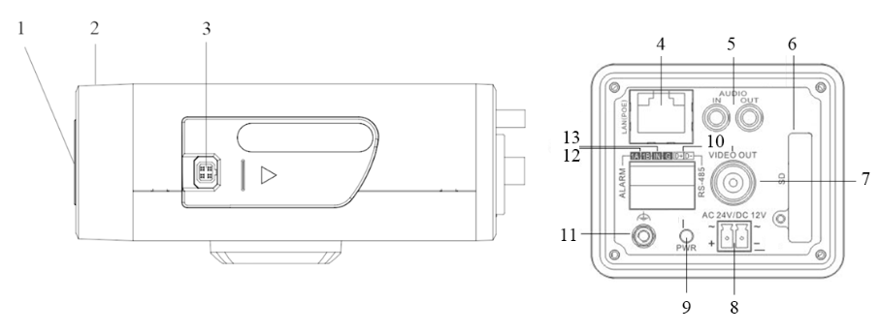
Figure 2.1.1

Serial NO. | Description
1 | CS Lens mount
2 | Back Focus Ring
3 | Auto iris interface
4 | 10M/100M self-adaptive Ethernet interface
5 | AUDIO IN: Audio input interface  AUDIO OUT: Audio output interface
6 | SD: SD card slot
7 | VIDEO OUT: Video output interface
8 | Power supply
9 | PWR: Power LED indicator
10 | D+, D-: RS-485 interface
11 | Ground
12 | 1A, 1B: Alarm output interface
Serial NO. | Description
13 | IN, G: Alarm input interface

Back Focus Adjustment:
When it still fails to realize precise focusing after having confirmed the correct lens interface, the back focus adjustment may be required.
Operate the following steps:
Tighten the lens firstly and then loosen the fixed back focus ring; rotate the lens slowly until the video image turns to be clear, and finally tighten and lock the back focus ring.

Note:
The type of auto-iris interface is square four-hole type, and the definition of each pin as shown:
 | Video | DC
1 | Power | Damp-
2 | NC | Damp+
3 | Video | Drive+
4 | GND | Drive-
Auto iris interface with video driving uses three pins: Power, Video and GND; Auto iris interface with DC driving uses four pins: Damp+, Damp-, Drive+ and Drive-.

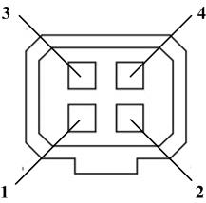

Camera connection:
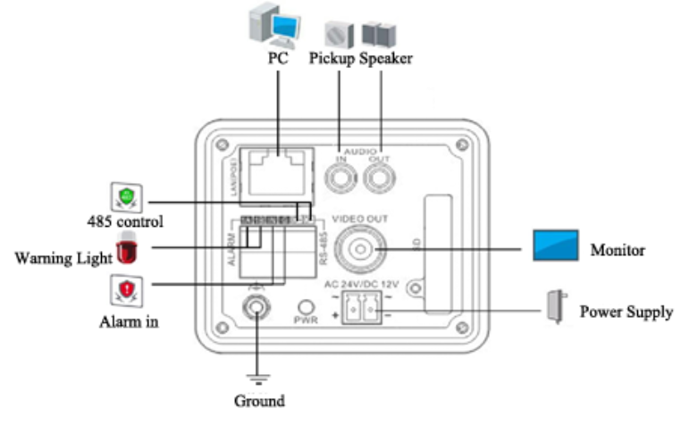
Figure 2.1.2

2.1.2 Box Camera Ⅱ
Camera description:
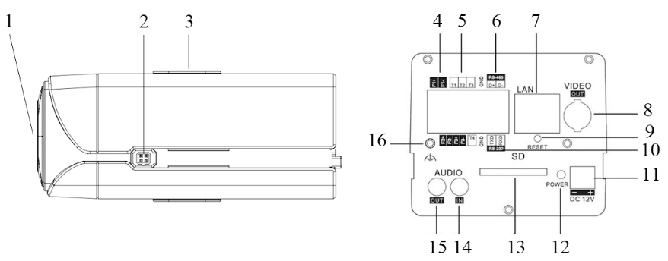
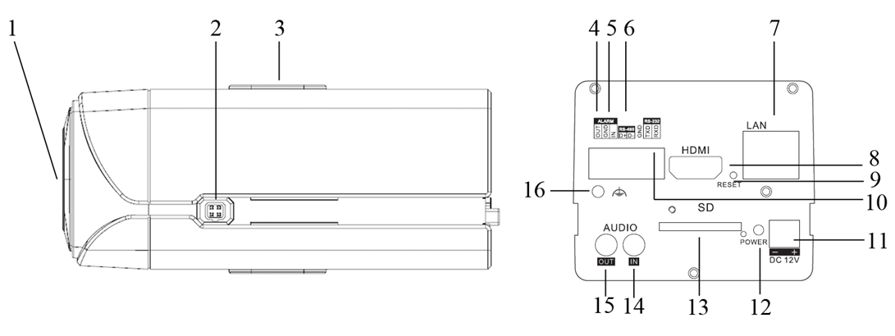
Figure 2.1.3

Serial NO. | Description
1 | CS Lens mount
2 | Auto iris interface
3 | Bracket mounting holes
4 | F1+ F1-, F2+ F2- ,F3+ F3-: Alarm output interface
5 | T1,T2,T3, T4,GND: Alarm input interface
6 | D+, D-: RS-485 interface
7 | 10M/100M self-adaptive Ethernet interface
8 | VIDEO OUT: Video output interface
9 | RESET: Reset the camera
10 | TXD, RXD, GND: RS-232 interface
11 | Power supply
12 | PWR: Power LED indicator
13 | SD: SD card slot
14 | AUDIO IN: Audio input interface
Serial NO. | Description
15 | AUDIO OUT: Audio output interface
16 | Ground

Back Focus Adjustment:
When it still fails to realize precise focusing after having confirmed the correct lens interface, the back focus adjustment may be required.
Operate the following steps:
Tighten the lens firstly and then loosen the fixed back focus ring; rotate the lens slowly until the video image turns to be clear, and finally tighten and lock the back focus ring.

Note:
The type of auto-iris interface is square four-hole type, and the definition of each pin as shown:
 | Video | DC
1 | Power | Damp-
2 | NC | Damp+
3 | Video | Drive+
4 | GND | Drive-
Auto iris interface with video driving uses three pins: Power, Video and GND; Auto iris interface with DC driving uses four pins: Damp+, Damp-, Drive+ and Drive-.

Camera connection:
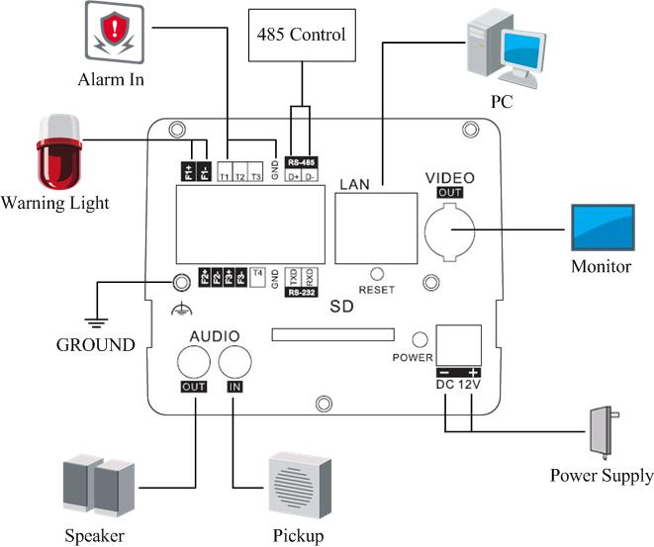
Figure 2.1.4

2.1.3 Box Camera Ⅲ
Camera description:
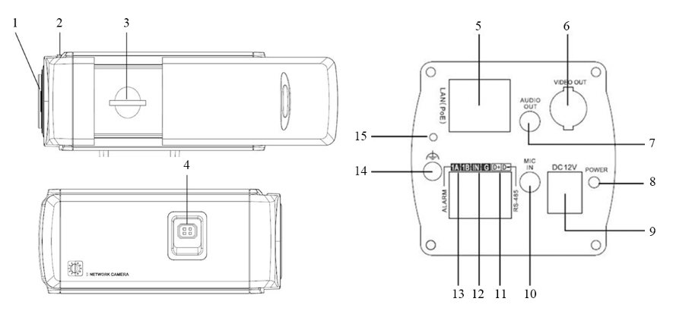
Figure 2.1.5

Serial NO. | Description
1 | Lens mount
2 | Back Focus Ring
3 | SD: SD card slot
4 | Auto iris interface
5 | 10M/100M self-adaptive Ethernet interface
6 | VIDEO OUT: Video output interface
7 | AUDIO OUT: Audio output interface
8 | PWR: Power LED indicator
9 | Power supply
10 | MIC IN: Audio input interface
11 | D+, D-: RS-485 interface
12 | IN, G: Alarm input interface
13 | 1A, 1B: Alarm output interface
14 | Ground
15 | RESET: Reset the camera

Back Focus Adjustment:
When it still fails to realize precise focusing after having confirmed the correct lens interface, the back focus adjustment may be required.
Operate the following steps:
Tighten the lens firstly and then loosen the fixed back focus ring; rotate the lens slowly until the video image turns to be clear, and finally tighten and lock the back focus ring.

Note:
The type of auto-iris interface is square four-hole type, and the definition of each pin as shown:
 | Video | DC
1 | Power | Damp-
2 | NC | Damp+
3 | Video | Drive+
4 | GND | Drive-
Auto iris interface with video driving uses three pins: Power, Video and GND; Auto iris interface with DC driving uses four pins: Damp+, Damp-, Drive+ and Drive-.

Camera connection:
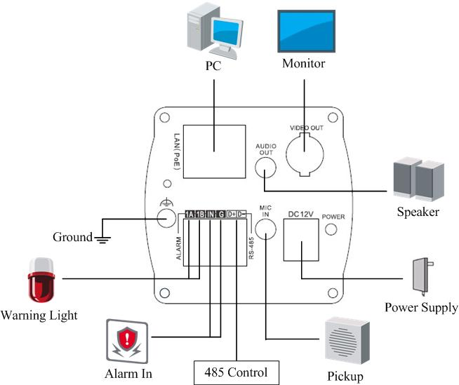
Figure 2.1.6

2.2 Dome Camera Physical Description

2.2.1 Dome Camera Ⅰ
Camera description:
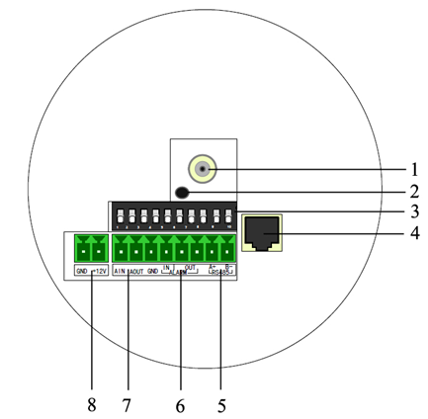
Figure 2.2.1

Serial NO. | Description
1 | Video output interface
2 | PWR: Power LED indicator
3 | Dial switch
4 | 10M/100M self-adaptive Ethernet interface
5 | D+, D-: RS-485 interface
6 | Alarm IN: Alarm input interface  Alarm OUT: Alarm output interface
7 | AIN: Audio input interface  AOUT: Audio output interface
8 | Power supply
Address& protocols dial switch. The defining for dial switch: 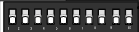, from 1 to 5 dial switch functions are shown as following:
Switch Function | ON | OFF
1 | SHARP | SOFT
2 | AES | AI
3 | BLC | OFF
4 | FL | ON
5 | NAGC | SAGC
Camera connection:
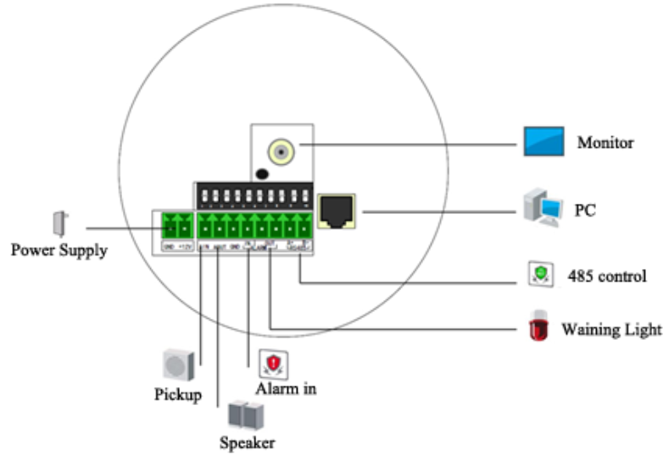
Figure 2.2.2

2.2.2 Dome Camera Ⅱ
Camera description:
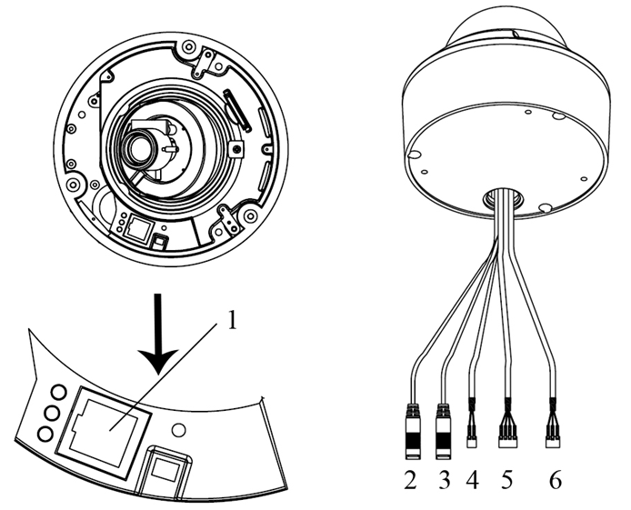
Figure 2.2.3

Serial NO. | Description
1 | 10M/100M self-adaptive Ethernet interface
2 | AUDIO IN: Audio input interface
3 | AUDIO OUT: Audio output interface
4 | D+, D-: RS-485 interface
5 | ALARM  IN, G: Alarm input interface  1A, 1B: Alarm output interface
6 | Power supply
Camera connection:
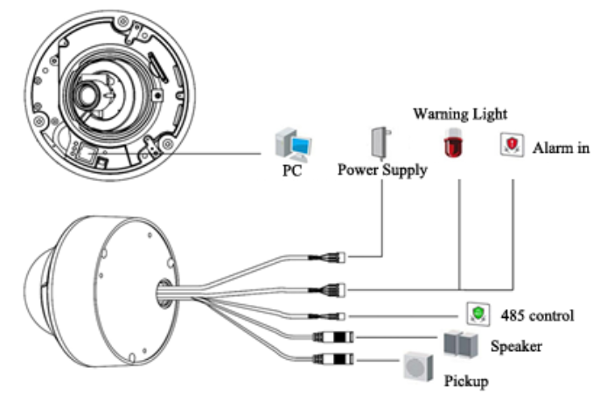
Figure 2.2.4

2.2.3 Dome Camera Ⅲ
Camera description:
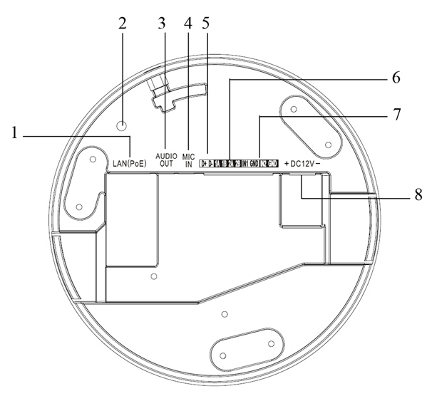
Figure 2.2.5
Serial NO. | Description
1 | 10M/100M self-adaptive Ethernet interface
2 | INITIAL SET: Reset the camera
3 | AUDIO OUT: Audio output interface
4 | MIC IN: Audio input interface
5 | D+, D-: RS-485 interface
6 | 1A, 1B, 2A, 2B: Alarm output interface
7 | IN1, GND, IN2, GND: Alarm input interface
8 | Power supply
Camera connection:
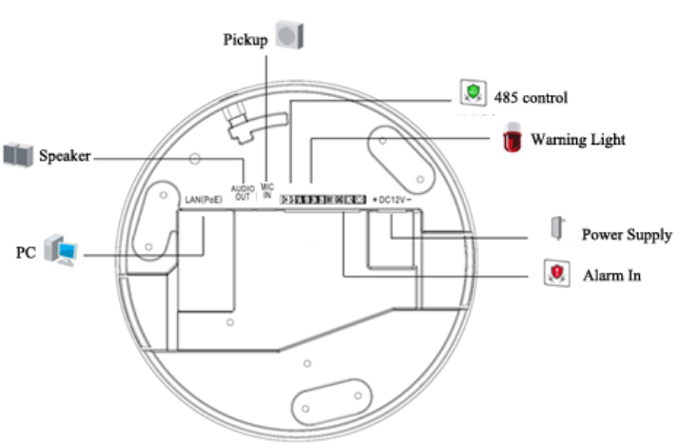
Figure 2.2.6

2.3 Bullet Camera Physical Description
Camera description:
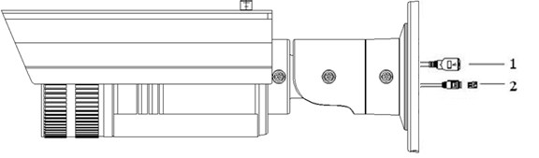
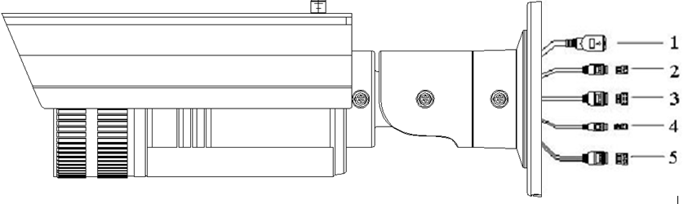
Figure 2.3.1

Serial NO. | Description
1 | 10M/100M self-adaptive Ethernet interface
2 | Power supply
3 | IN, G: Alarm input interface  1A, 1B: Alarm output interface
4 | D+, D-: RS-485 interface
5 | AUDIO IN, G: Audio input interface  AUDIO OUT, G: Audio output interface

Camera connection:
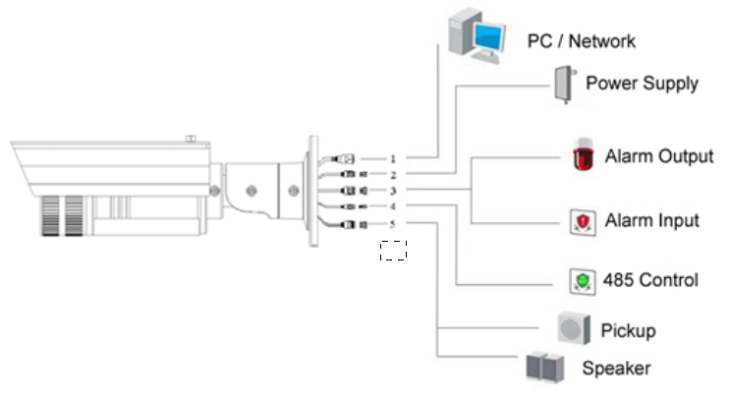
Figure 2.3.2

2.4 Cube Camera Physical Description
Camera description:
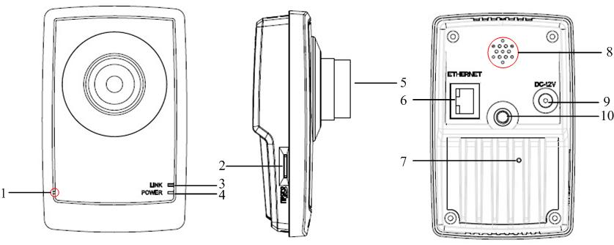
Figure 2.4.1

Serial NO. | Description
1 | Microphone hole
2 | Micro SD card solt
3 | LINK: Network status LED indicator.  When the network is connected, the LED flickers in green.
4 | Power LED indicator, It turns solid red when power is applied to the unit
5 | Lens
6 | ETHERNET: 10M / 100M self-adaptive Ethernet interface
7 | RESET: Reset all parameters to factory default settings
8 | Speaker hole
9 | Power supply
10 | Bracket mounting holes, used to fix the camera to the bracket
Note:
When the camera is power up, press the ‘RESET’ button for about 10 seconds, then all parameters, including user name, password, IP address, port number, etc., will be reset to the factory default settings.

Camera connection:
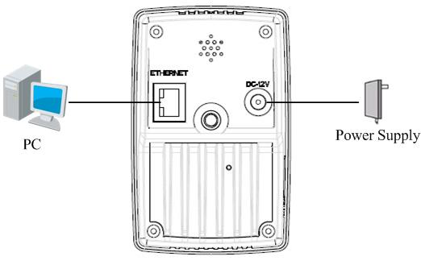
Figure 2.4.2

2.5 Mini Dome Camera Physical Description
Camera description:
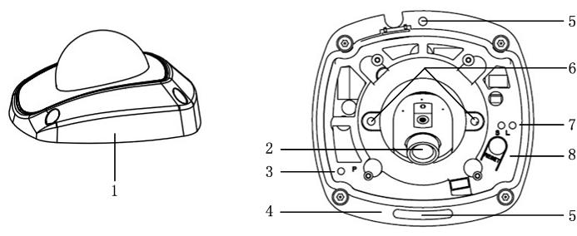
Figure 2.5.1
Serial NO. | Description
1 | Back box
2 | Lens
3 | P: Power LED indicator, It turns solid red when power is applied to the unit.
4 | Bottom board
5 | Bottom board set screw hole
6 | Lens set screw
7 | S & L: Network status LED indicator.  When the network is connected, the “S” LED turns solid orange, while the “L” LED flickers in green.
8 | RESET: Reset all parameters to factory default settings.
Note:
When the camera is power up, press the ‘RESET’ button for about 10 seconds, then all parameters, including user name, password, IP address, port number, etc., will be reset to the factory default settings.

Camera connection:
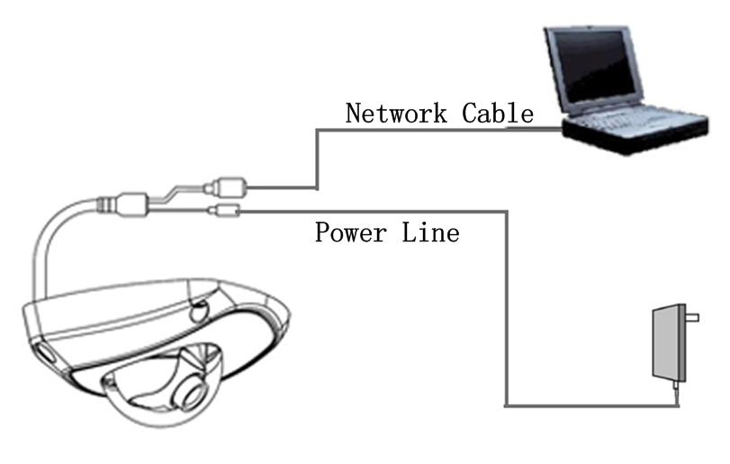
Figure 2.5.2

Chapter 3 Installation
Note:
- Please check if all the items on the package list have been included with your camera.
- Read the following contents carefully before the installation.
- Make sure that all the related equipment is power-off during the installation.
- Check the power supply to prevent any damage caused by mismatching problems.
- Do not place the camera in extremely hot or damp environment. To avoid heat accumulation, good ventilation is required for a proper operating environment.
- If the product does not operate properly, please contact your dealer or the nearest service center. Never attempt to disassemble the camera yourself. Users are responsible for any problem caused by modification or repairing without authorization.

3.1 Box Camera Installation
Box camera Ⅰ, Ⅱ, Ⅲ can be fixed in both wall and ceiling, customers can choose different ways to install the camera according to their specific needs. The following section introduces the ceiling mounting, and the wall mounting follows the same way:

Step 1: Fix the mounting bracket to the ceiling.
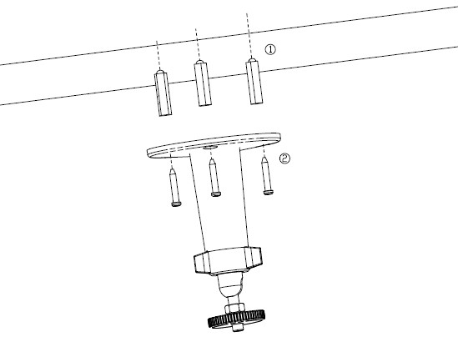
Figure 3.1.1 Fix camera mounting bracket
Note:
If it is wall, you need to fix the expand bolt (note: the mounting hole of the expand bolt should align with the bracket) before fixing the bracket, as step ① in Figure 3.1.1. If the wall surface is wooden, the step ① in Figure 3.1.1 can be ignored and you can use the self-tapping screw to fix the bracket directly. Please note that the wall on which the camera is fixed should be able to bear at least three times the weight of the bracket and the camera.

Step 2: Screw the camera’s mounting hole to the mounting bracket, and then adjust the camera to the desired monitoring location and finally tighten the knob on bracket to secure the camera to the ceiling.
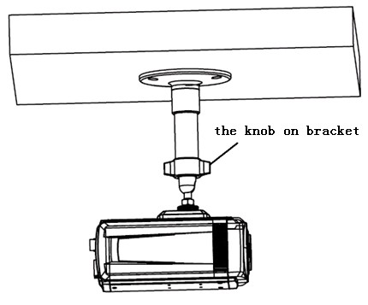
Figure 3.1.2 Fix the Camera

Step 3: Mount the camera lens: connect the VIDEO OUT interface of the camera to the debugging monitor, and adjust lens focus until you have obtained the clearest video images on the monitor, and then lock the lens. If required, loosen the knob on the mounting bracket and adjust the camera lens to the desired monitoring scene, and finally tighten the knob on bracket.
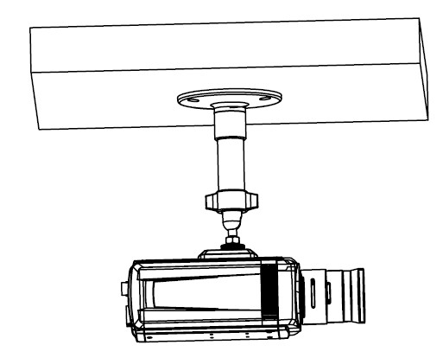
Figure 3.1.3 Mount and adjust Lens

3.2 Dome Camera Installation

3.2.1 Dome Camera Ⅰ
Dome camera can be installed including hold mounting, ceiling mounting, cylinder mounting and other styles. Customers can choose different ways to install the camera according to their specific needs. Please do as the following specific steps to install the dome (take ceiling mounting as example).
Step 1: when the wall is wood, use the self-tapping screws to fix the ceiling plate to the wall surface.
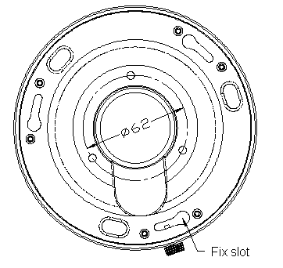
Figure 3.2.1 Fix in ceiling
Step 2: Insert the three columns of Dome camera into the three fix slots of the ceiling plate. Pay attention to the direction of insertion. Let the ceiling plate “I” logo and the Dome camera “I” logo in the same direction. Meanwhile, rotate the dome camera 15 degrees counterclockwise until the dome camera can’t be rotated further.
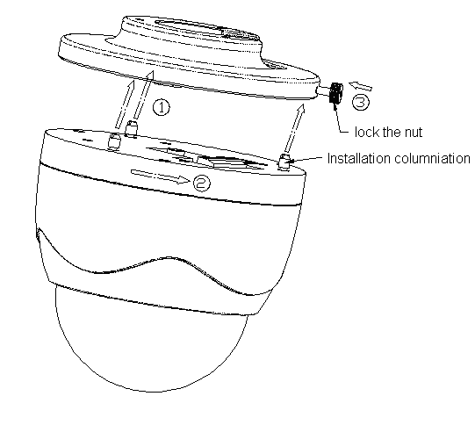
Figure 3.2.2 Dome camera fixing
Step 3: Make sure the “I” signs on the dome camera and the locking screw on the ceiling plate is alignment. Then screw down the locking screw on the ceiling plate.
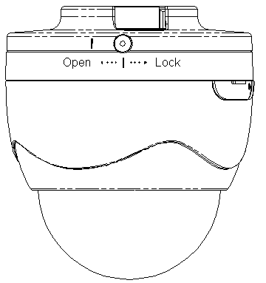
Figure 3.2.3 Dome camera fixed

3.2.2 Dome Camera Ⅱ
The ceiling mounting is a suitable installation way for this camera. Please stick to the following steps:
Step 1: First, loosen the screw with a hexagonal screw driver (attached with the camera), and take down the transparent cover shown as below:
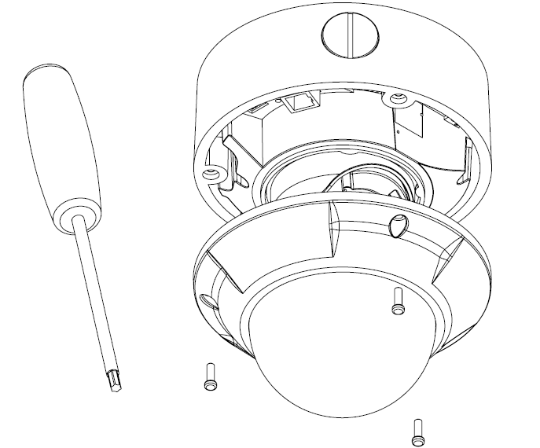
Figure 3.2.4 Unload the Cover
Step 2: Use the screws to fix the dome camera on the ceiling.
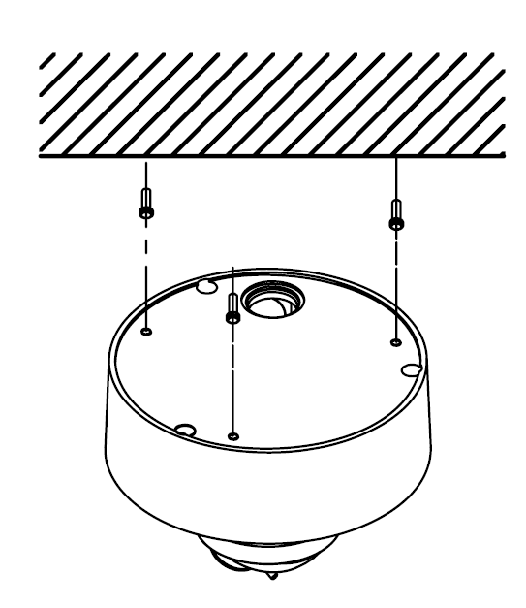
Figure 3.2.5 Install the Camera
Step 3: Adjust the camera’s view angle while watching the video on the adjustment monitor. Loosen the fixed screws, and adjust the camera horizontally and vertically. Adjust the lens focus to get optimal video effect.
Step 4: Tighten the screw after adjusting camera’s view angle, and cover the transparent casing.
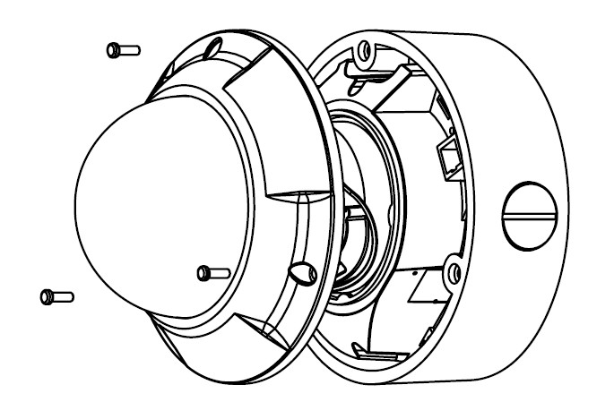
Figure 3.2.6 Install the Cover

3.2.3 Dome Camera Ⅲ
The ceiling mount is a suitable installation method for this camera. Please stick to the following steps:
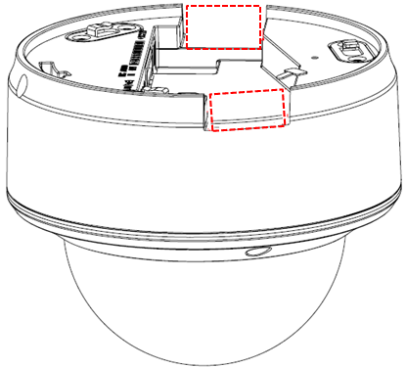
Note:
If required, user can apply the pliers to remove the clip (refer to the part marked in dotted line) on the side of the back box and then feed cables through the opening to secure on the ceiling.
Figure 3.2.7
Step 1: Use the screws to fix the bottom plate on the ceiling, and rotate dome camera counterclockwise to attach it to the bottom plate, and finally use the lock screw to secure the dome camera.

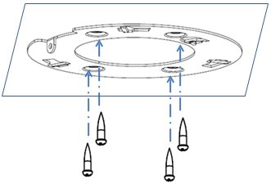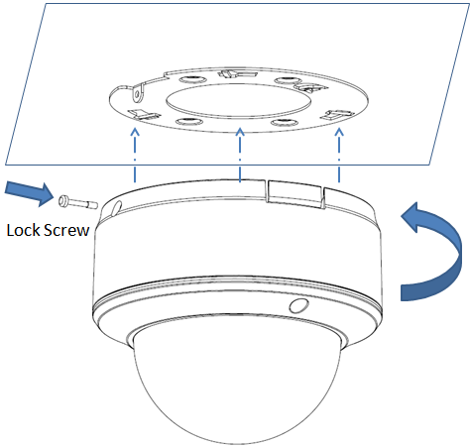
Figure 3.2.8
Step 2: Loosen the set screws with a hexagonal screw driver (attached with the camera), and take down the dome cover.
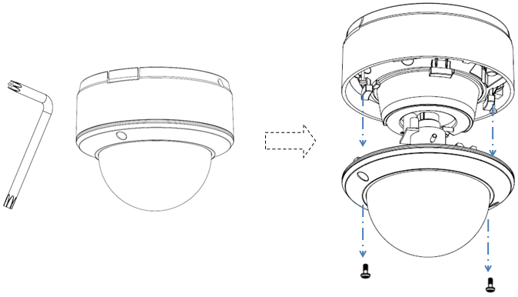
Figure 3.2.9
Step 3: While viewing the video on the monitor, adjust the camera’s view angle for your need.
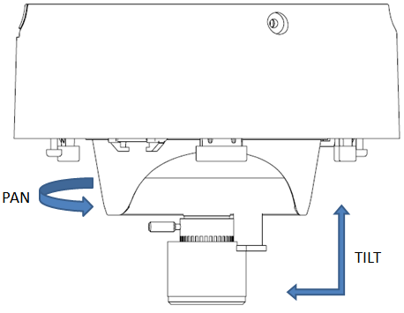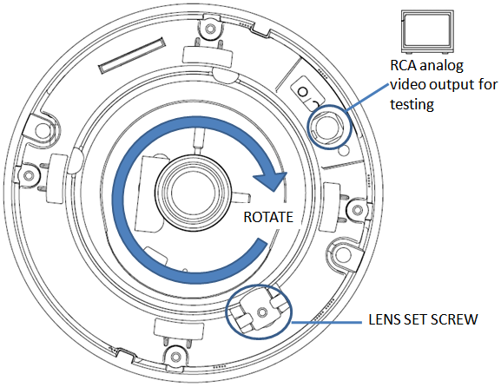
Figure 3.2.10
Step 4: Install the dome cover and tighten the screws.
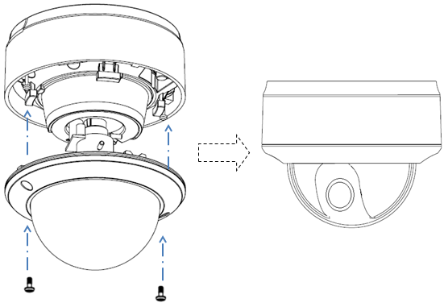
Figure 3.2.11

3.3 Bullet Camera Installation
Bullet camera can be fixed in both wall and ceiling, customers can choose different ways to install the camera according to their specific needs. The following section introduces the wall mounting, and the ceiling mounting follows the same way:

Step 1: Fix the camera wire hidden box to the wall.
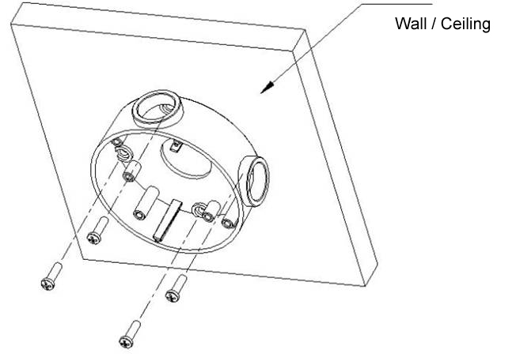
Fig 3.3.1 Fix camera wire hidden box
Note:
If it is cement wall, you need to fix the expand bolt (note: the mounting hole of the expand bolt should align with the wire hidden box) before fixing wire hidden box as shown in Figure 3.3.1. If the wall surface is wooden, you can use the self-tapping screw to fix the wire hidden box directly. Please note that the wall on which the camera is fixed should be able to bear at least three times the weight of the bracket and the camera.

Step 2: Use screws to fix the mounting bracket with camera main body to wire hidden box as shown in Figure 3.3.2.
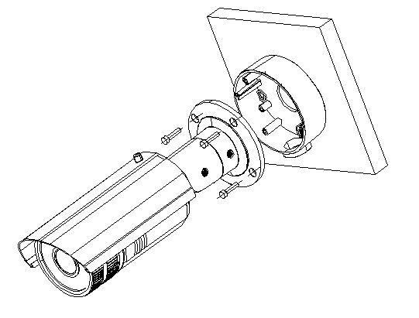
Fig 3.3.2 Fix the camera

Step 3: Adjust the camera to the desired monitoring location and finally tighten the nuts on bracket to fix the camera.
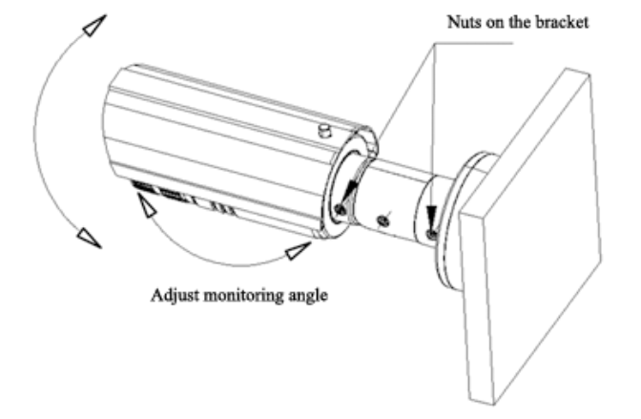
Fig 3.3.3 Adjust monitoring location
Step 4: Twist-off front cover from the camera, then adjust the lens as shown in Figure 3.3.4 and Figure 3.3.5.
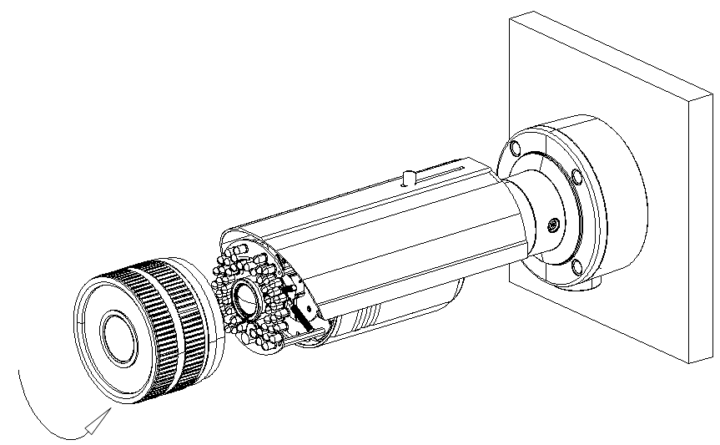
Figure 3.3.4
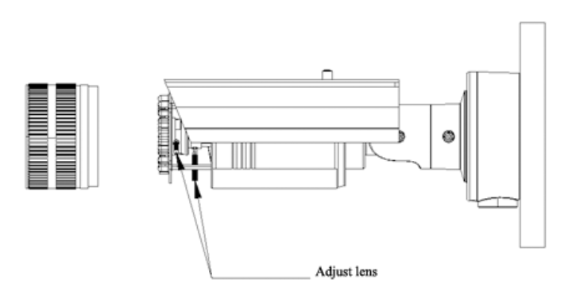
Figure 3.3.5 Adjust lens
Step 5: The last step, fix the lens and front cover as shown in Figure 3.3.6.
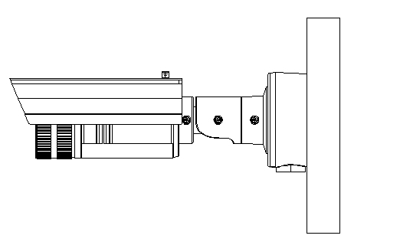
Fig 3.3.6

3.4 Cube Camera Installation
Cube camera can be fixed in both wall and ceiling, customers can choose different ways to install the camera according to their specific needs. The following section introduces the ceiling mounting, and the wall mounting follows the same way:

Step 1: Fix the camera mounting bracket to the ceiling.
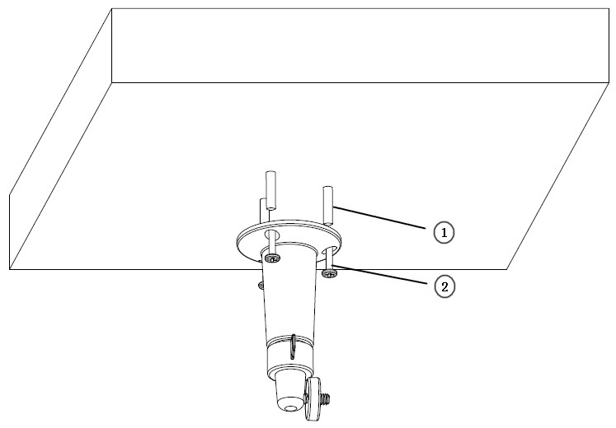
Figure 3.4.1 Fix camera mounting bracket
Note:
If it is cement wall, you need to fix the expand bolt (note: the mounting hole of the expand bolt should align with the bracket) before fixing the bracket as step ① in Figure 3.4.1. If the wall surface is wooden, the step ① in Figure 3.4.1 can be ignored and you can use the self-tapping screw to fix the bracket directly. Please note that the wall on which the camera is fixed should be able to bear at least three times the weight of the bracket and the camera.

Step 2: Screw the mounting hole to the mounting bracket, and then adjust the camera to the desired monitoring location and finally tighten the knob on bracket to secure the camera to the ceiling.
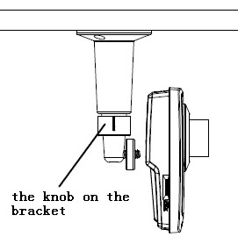
Figure 3.4.2 Fix the Camera

Step 3: Viewing the video on the computer, if the scene is not the place that you want to monitor, loosen the knob on the mounting bracket and adjust the camera lens to the desired monitoring scene, and finally tighten the knob on bracket.
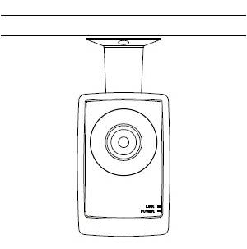
Figure 3.4.3 Done

3.5 Mini Dome Camera Installation
The ceiling mount is a suitable installation method for this camera. Please stick to the following steps:
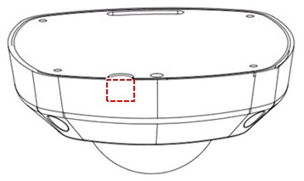
Note:
If required, user can apply the pliers to remove the clip (refer to the part marked in dotted line) on the side of the back box and then feed cables through the opening to secure on the ceiling.
Figure 3.5.1
Step 1: Loosen the set screws with a hexagonal screw driver (attached with the camera), and take down the back box shown as below:
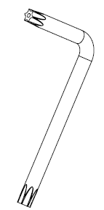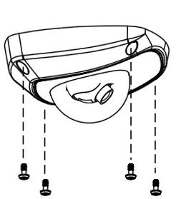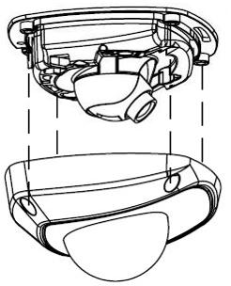
Figure 3.5.2 Remove the back box
Step 2: Use the screws to fix the bottom board on the ceiling.
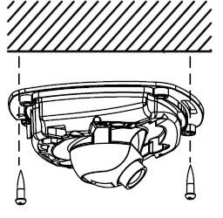
Figure 3.5.3 Fix the bottom board
Step 3: While viewing the video on the computer, adjust the camera’s view angle for your need.
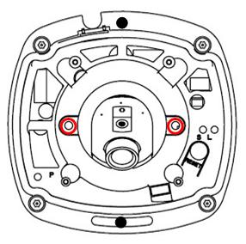
Loosen the lens set screws.
Figure 3.5.4

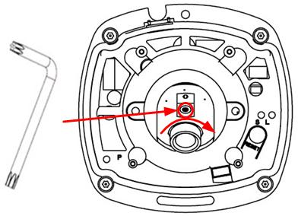
Insert the hexagonal
screw driver into the hole
marked in the picture ,
and then adjust horizontally
and vertically the camera’s pan
and tilt by turning the
hexagonal screw driver.
Figure 3.5.5

Tighten the lens set screws.
Figure 3.5.6
Note:
- As the lens of camera has already been factory adjusted to the best imaging effect, thus it only needs to adjust the pan and tilt view angle.
- If the image is not clear without the back box, please don’t worry, the back box will affect the imaging effect, so when you test the imaging effect of lens, the back box must be installed to the camera

Step 4: Install the back box, and tighten the set screws.
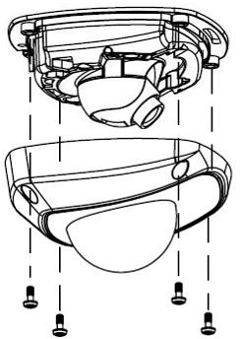
Figure 3.5.7 Install the back box
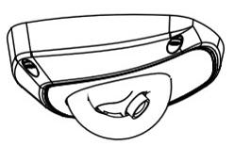
Figure 3.5.8 Done

First Choice for Security Professionals

