

Network Camera
Quick Guide
V3.0.3

Hikvision Digital Technology Co., Ltd.
http://www.hikvision.com
Thank you for purchasing our product. If there are any questions, or requests, please do not hesitate to contact the dealer. This manual applies to
Box camera Ⅰ: DS-2CD852MF-E, DS-2CD862MF-E
Box camera Ⅱ: DS-2CD886BF-E, DS-2CD886MF-E, DS-2CD877BF, DS-2CD876BF, DS-2CD876MF
Box camera Ⅲ: DS-2CD883F-E(W), DS-2CD854F-E(W), DS-2CD853F-E(W), DS-2CD864FWD-E(W), DS-2CD863PF(NF)-E(W), DS-2CD893PF(NF)-E (W), DS-2CD893PFWD(NFWD)-E(W), DS-2CD833F-E(W)
Dome camera Ⅰ: DS-2CD752MF-E
Dome camera Ⅱ: DS-2CD752MF-FB(H),DS-2CD752MF-IFB(H), DS-2CD762MF-FB(H), DS-2CD762MF-IFB(H)
Dome camera Ⅲ: DS-2CD783F-E(I), DS-2CD754F-E(I), DS-2CD764FWD-E(I), DS-2CD754FWD-E(I), DS-2CD753F-E(I), DS-2CD763PF(NF)-E(I), DS-2CD793PF(NF)-E(I), DS-2CD793PFWD(NFWD)-E(I), DS-2CD733F-E(I)
Bullet Camera: DS-2CD8264F-E(I), DS-2CD8264F-ES(I),DS-2CD8254F-E(I), DS-2CD8254F-ES(I), DS-2CD8253F-E(I), DS-2CD8253F-ES(I)，DS-2CD8233F-E(I), DS-2CD8233F-ES(I)
Cube Camera: DS-2CD8153F-E(W)(I), DS-2CD8133F-E(W)(I)
Mini Dome Camera: DS-2CD7164-E,DS-2CD7153-E, DS-2CD7133-E

This manual may contain several technical incorrect places or printing errors, and the content is subject to change without notice. The updates will be added to the new version of this manual. We will readily improve or update the products or procedures described in the manual.
DISCLAIMER STATEMENT
“Underwriters Laboratories Inc. (“UL”) has not tested the performance or reliability of the security or signaling aspects of this product. UL has only tested for fire, shock or casualty hazards as outlined in UL’s Standard(s) for Safety, UL60950-1. UL Certification does not cover the performance or reliability of the security or signaling aspects of this product. UL MAKES NO REPRESENTATIONS, WARRANTIES OR CERTIFICATIONS WHATSOEVER REGARDING THE PERFORMANCE OR RELIABILITY OF ANY SECURITY OR SIGNALING RELATED FUNCTIONS OF THIS PRODUCT.”

Table of Contents
Chapter 1 Interface Description 1
1.1 Box Camera Interface Description 1
1.1.1 Box Camera Ⅰ 1
1.1.2 Box Camera Ⅱ 2
1.1.3 Box Camera Ⅲ 3
1.2 Dome Camera Interface Description 4
1.2.1 Dome Camera Ⅰ 4
1.2.2 Dome Camera Ⅱ 5
1.2.3 Dome Camera Ⅲ 6
1.3 Bullet Camera Interface Description 6
1.4 Cube Camera Interface Description 7
1.5 Mini Dome Camera Interface Description 8
Chapter 2 Search and Modify IP 9
Chapter 3 Preview via WEB browser 11

Chapter 1 Interface Description

1.1 Box Camera Interface Description

1.1.1 Box Camera Ⅰ
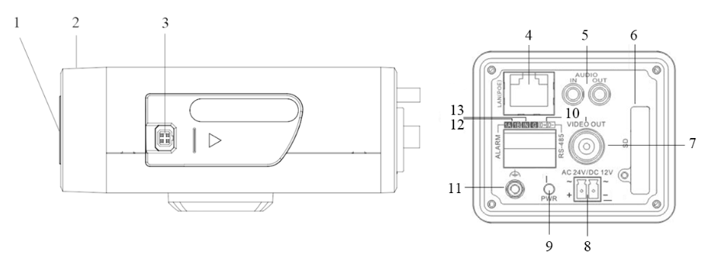
Figure 1.1.1

Serial NO. | Description
1 | CS Lens mount
2 | Back Focus Ring
3 | Auto iris interface
4 | 10M/100M self-adaptive Ethernet interface
5 | AUDIO IN: Audio input interface  AUDIO OUT: Audio output interface
6 | SD: SD card slot
7 | VIDEO OUT: Video output interface
8 | Power supply
9 | PWR: Power LED indicator
10 | D+, D-: RS-485 interface
11 | Ground
12 | 1A, 1B: Alarm output interface
13 | IN, G: Alarm input interface

1.1.2 Box Camera Ⅱ
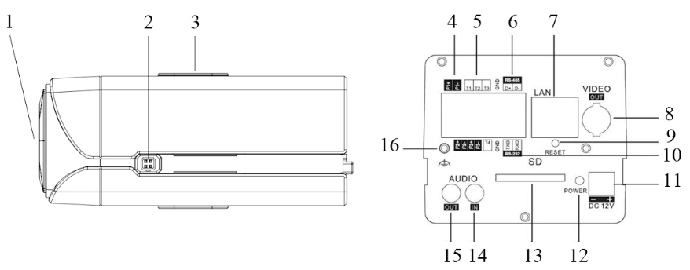
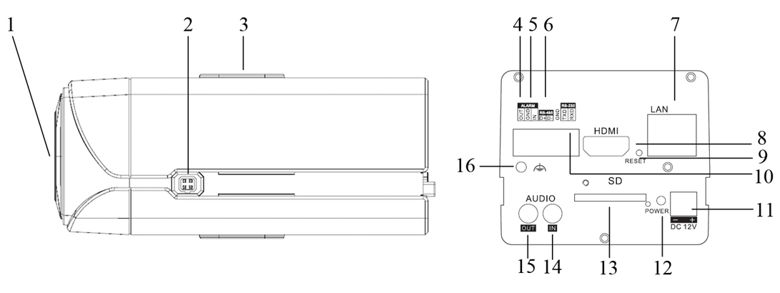
Figure 1.1.2

Serial NO. | Description
1 | CS Lens mount
2 | Auto iris interface
3 | Bracket mounting holes
4 | F1+ F1-, F2+ F2- ,F3+ F3-: Alarm output interface
5 | T1,T2,T3, T4,GND: Alarm input interface
6 | D+, D-: RS-485 interface
7 | 10M/100M self-adaptive Ethernet interface
8 | VIDEO OUT: Video output interface
9 | RESET: Reset the camera
10 | TXD, RXD, GND: RS-232 interface
11 | Power supply
12 | PWR: Power LED indicator
13 | SD: SD card slot
14 | AUDIO IN: Audio input interface
15 | AUDIO OUT: Audio output interface
16 | Ground

1.1.3 Box Camera Ⅲ
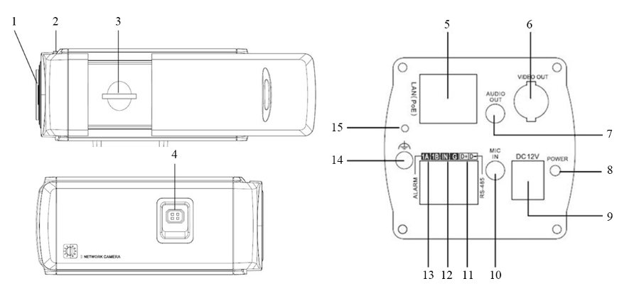
Figure 1.1.3

Serial NO. | Description
1 | Lens mount
2 | Back Focus Ring
3 | SD: SD card slot
4 | Auto iris interface
5 | 10M/100M self-adaptive Ethernet interface
6 | VIDEO OUT: Video output interface
7 | AUDIO OUT: Audio output interface
8 | PWR: Power LED indicator
9 | Power supply
10 | MIC IN: Audio input interface
11 | D+, D-: RS-485 interface
12 | IN, G: Alarm input interface
13 | 1A, 1B: Alarm output interface
14 | Ground
15 | RESET: Reset the camera

1.2 Dome Camera Interface Description

1.2.1 Dome Camera Ⅰ
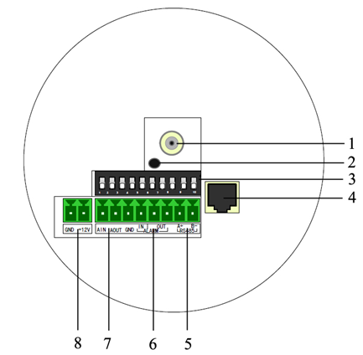
Figure 1.2.1

Serial NO. | Description
1 | Video output interface
2 | PWR: Power LED indicator
3 | Dial switch
4 | 10M/100M self-adaptive Ethernet interface
5 | D+, D-: RS-485 interface
6 | Alarm IN: Alarm input interface  Alarm OUT: Alarm output interface
7 | AIN: Audio input interface  AOUT: Audio output interface
8 | Power supply

1.2.2 Dome Camera Ⅱ
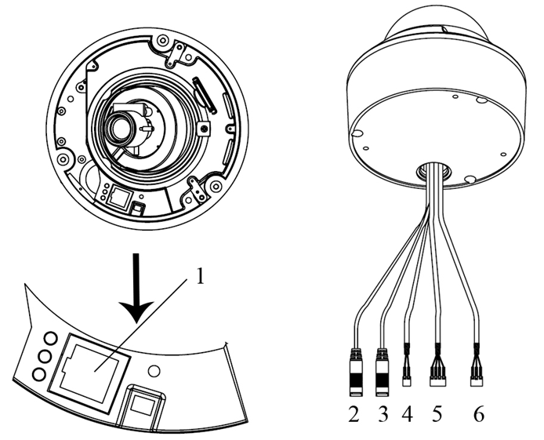
Figure 1.2.2

Serial NO. | Description
1 | 10M/100M self-adaptive Ethernet interface
2 | AUDIO IN: Audio input interface
3 | AUDIO OUT: Audio output interface
4 | D+, D-: RS-485 interface
5 | ALARM  IN, G: Alarm input interface  1A, 1B: Alarm output interface
6 | Power supply

1.2.3 Dome Camera Ⅲ
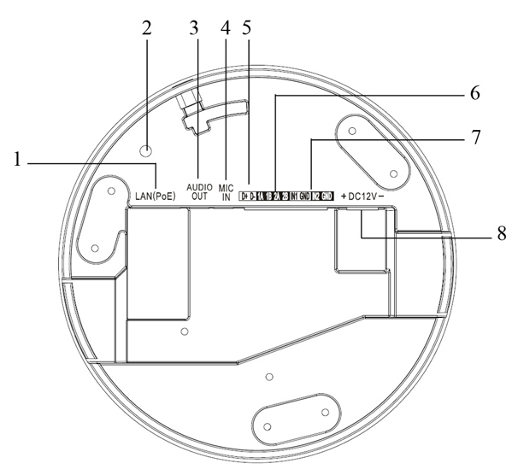
Figure 1.2.3
Serial NO. | Description
1 | 10M/100M self-adaptive Ethernet interface
2 | INITIAL SET: Reset the camera
3 | AUDIO OUT: Audio output interface
4 | MIC IN: Audio input interface
5 | D+, D-: RS-485 interface
6 | 1A, 1B, 2A, 2B: Alarm output interface
7 | IN1, GND, IN2, GND: Alarm input interface
8 | Power supply

1.3 Bullet Camera Interface Description
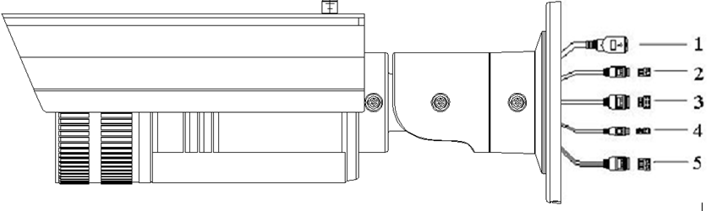
Figure 1.3.1

Serial NO. | Description
1 | 10M/100M self-adaptive Ethernet interface
2 | Power supply
3 | IN, G: Alarm input interface  1A, 1B: Alarm output interface
4 | D+, D-: RS-485 interface
5 | AUDIO IN, G: Audio input interface  AUDIO OUT, G: Audio output interface

1.4 Cube Camera Interface Description
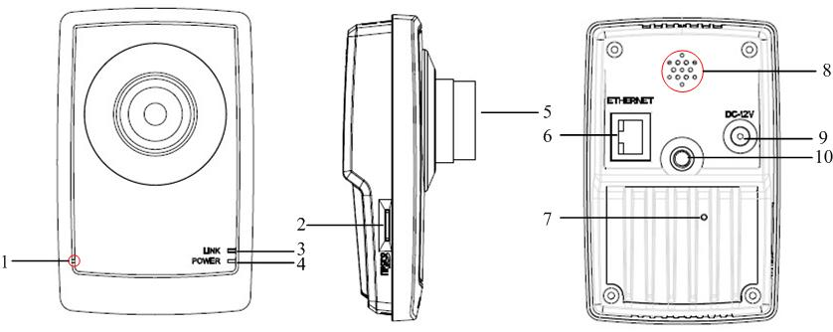
Figure 1.4.1

Serial NO. | Description
1 | Microphone hole
2 | Micro SD card solt
3 | LINK: Network status LED indicator.  When the network is connected, the LED flickers in green.
4 | Power LED indicator, It turns solid red when power is applied to the unit
5 | Lens
6 | ETHERNET: 10M / 100M self-adaptive Ethernet interface
7 | RESET: Reset all parameters to factory default settings
8 | Speaker hole
9 | Power supply
10 | Bracket mounting holes, used to fix the camera to the bracket

1.5 Mini Dome Camera Interface Description
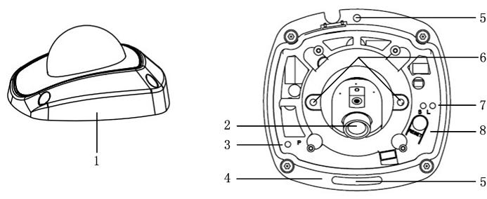
Figure 1.5.1
Serial NO. | Description
1 | Back box
2 | Lens
3 | P: Power LED indicator, It turns solid red when power is applied to the unit.
4 | Bottom board
5 | Bottom board set screw hole
6 | Lens set screw
7 | S & L: Network status LED indicator.  When the network is connected, the “S” LED turns solid orange, while the “L” LED flickers in green.
8 | RESET: Reset all parameters to factory default settings.

Chapter 2 Search and Modify IP
SADP (Search Active Devices Protocol) software can automatically search the IP address of network cameras in the same local area network (LAN) with connection diagram as following:
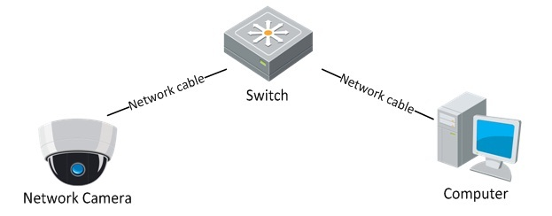
Figure 2.1
The operation of searching and modifying IP address is described as following:

1. Install the SADP software, and then run the “sadpdlg.exe”.
Figure 2.2

2. Search IP address.
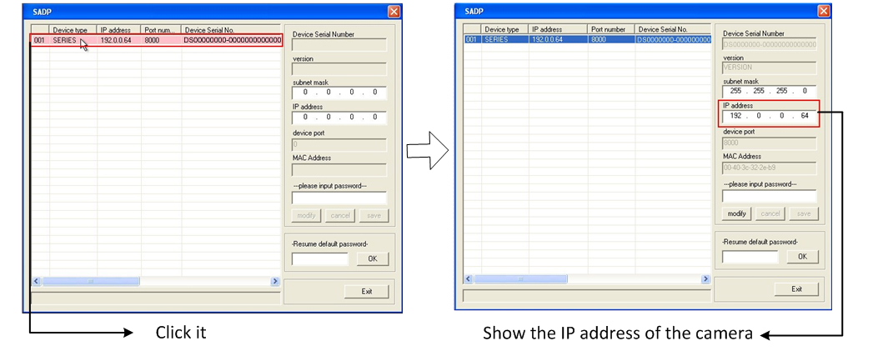
Figure 2.3

3. Modify IP address.
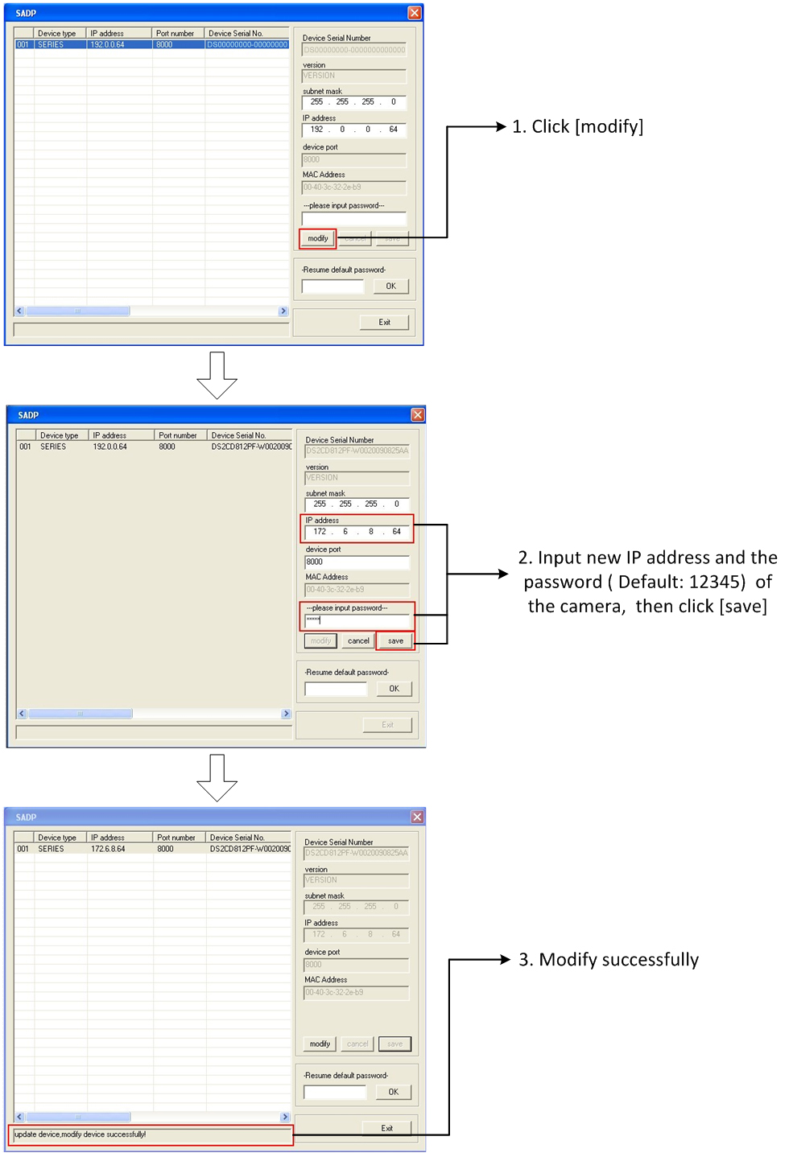
Figure 2.4

Chapter 3 Preview via WEB browser
Note: The default IP of network cameras is ‘192.0.0.64’ with ‘admin’ as the administrator, ‘12345’ as the password, and ‘8000’ as the default port.

For monitoring camera images, a computer running the Microsoft Windows Operating System and Internet Explorer (Version 6.0 or later) are required. In this manual, we take Windows XP and IE 6.0 for example.
This chapter describes how to view the video from the camera via web browser, and operate as following:
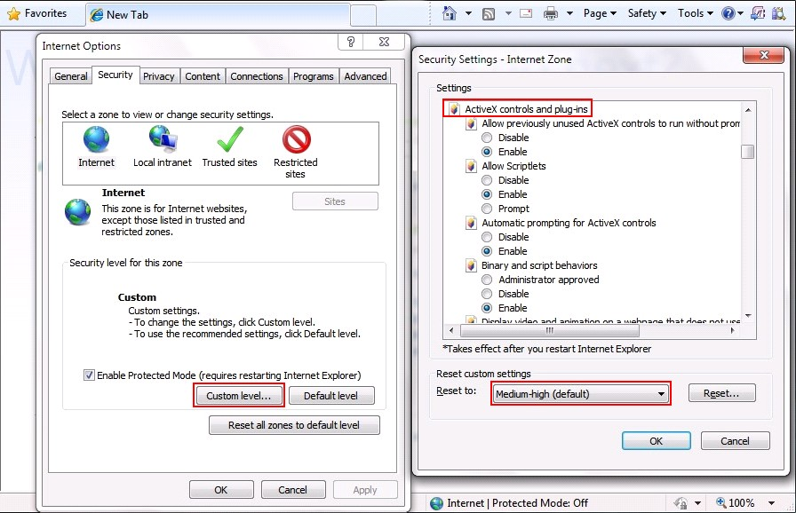
Figure 3.1
1. Open the IE browser, set the security level to [Medium] in [Tools/InternetOptions/Security/Custom Level…]
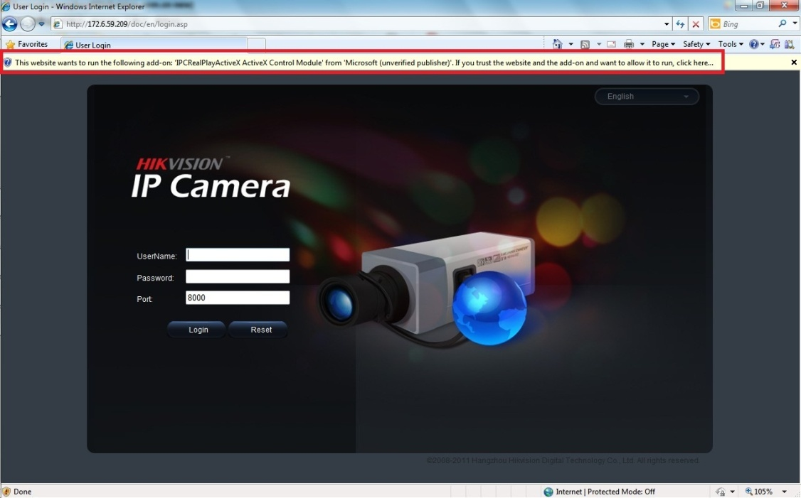
Figure 3.2
2. Input the IP address of the camera and press [Enter], and
then click the dialog box that pops up.

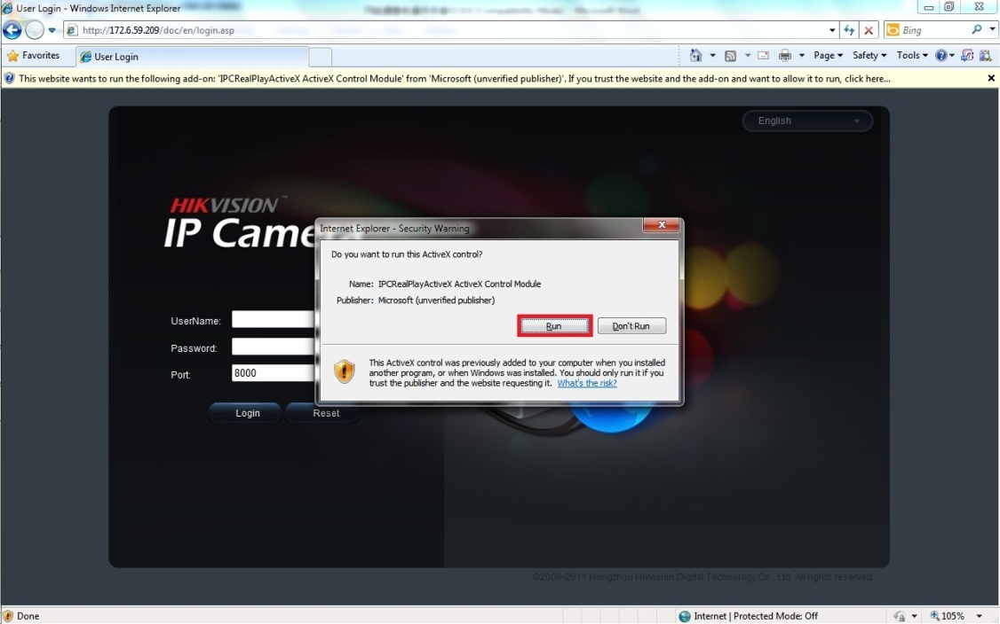
Figure 3.3
3. Click [Run] to install the ActiveX control.

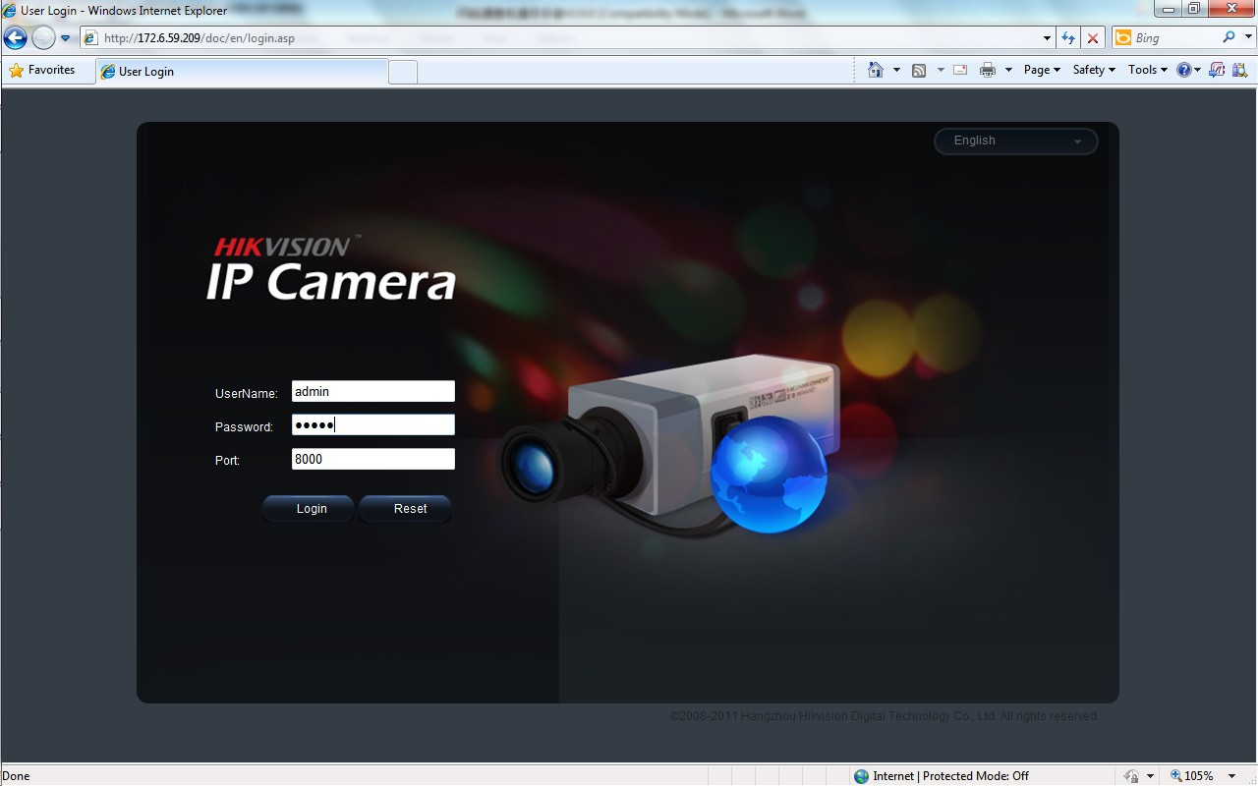
Figure 3.4

4. Input “Username” (Default: admin), “Password” (Default: 12345)
and “Port” (Default: 8000) of the camera, then click [Login]

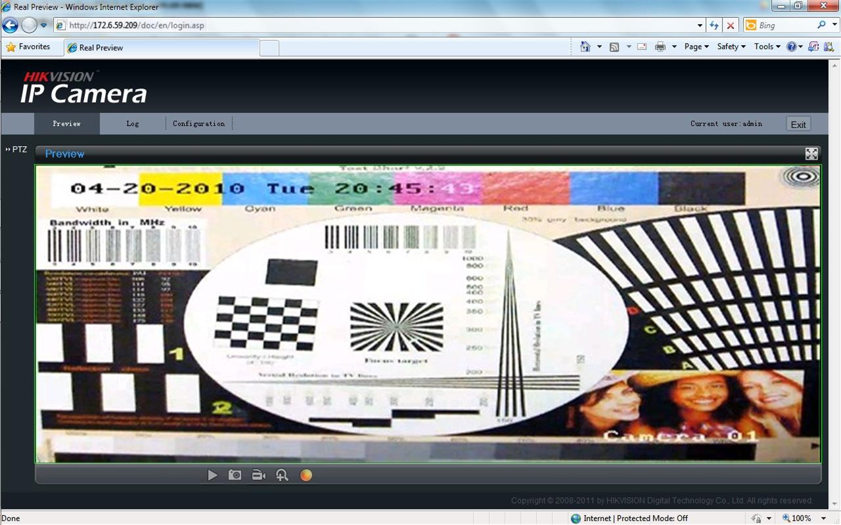
Figure 3.5
5. View the image

Note: For detailed instructions of further configuration, please refer to the user manual of network camera.

First Choice for Security Professionals

