

Network Camera

User Manual

V3.0.3

Hikvision Digital Technology Co., Ltd.
http://www.hikvision.com
Thank you for purchasing our product. If there are any questions, or requests, please do not hesitate to contact the dealer.
This manual applies to Network Camera.
This manual may contain several technical incorrect places or printing errors, and the content is subject to change without notice. The updates will be added to the new version of this manual. We will readily improve or update the products or procedures described in the manual.

DISCLAIMER STATEMENT
“Underwriters Laboratories Inc. (“UL”) has not tested the performance or reliability of the security or signaling aspects of this product. UL has only tested for fire, shock or casualty hazards as outlined in UL’s Standard(s) for Safety, UL60950-1. UL Certification does not cover the performance or reliability of the security or signaling aspects of this product. UL MAKES NO REPRESENTATIONS, WARRANTIES OR CERTIFICATIONS WHATSOEVER REGARDING THE PERFORMANCE OR RELIABILITY OF ANY SECURITY OR SIGNALING RELATED FUNCTIONS OF THIS PRODUCT.”

Regulatory Information

FCC Information
FCC compliance: This equipment has been tested and found to comply with the limits for a digital device, pursuant to part 15 of the FCC Rules. These limits are designed to provide reasonable protection against harmful interference when the equipment is operated in a commercial environment. This equipment generates, uses, and can radiate radio frequency energy and, if not installed and used in accordance with the instruction manual, may cause harmful interference to radio communications. Operation of this equipment in a residential area is likely to cause harmful interference in which case the user will be required to correct the interference at his own expense.

FCC Conditions
This device complies with part 15 of the FCC Rules. Operation is subject to the following two conditions:
1. This device may not cause harmful interference.
2. This device must accept any interference received, including interference that may cause undesired operation.

EU Conformity Statement


This product and - if applicable - the supplied accessories too are marked with "CE" and comply therefore with the applicable harmonized European standards listed under the Low Voltage Directive 2006/95/EC, the EMC Directive 2004/108/EC.


2002/96/EC (WEEE directive): Products marked with this symbol cannot be disposed of as unsorted municipal waste in the European Union. For proper recycling, return this product to your local supplier upon the purchase of equivalent new equipment, or dispose of it at designated collection points. For more information see: www.recyclethis.info.

2006/66/EC (battery directive): This product contains a battery that cannot be disposed of as unsorted municipal waste in the European Union. See the product documentation for specific battery information. The battery is marked with this symbol, which may include lettering to indicate cadmium (Cd), lead (Pb), or mercury (Hg). For proper recycling, return the battery to your supplier or to a designated collection point. For more information see: www.recyclethis.info.

Safety Warnings and Cautions

Please pay attention to the following warnings and cautions:
Hazardous Voltage may be present: Special measures and precautions must be taken when using this device. Some potentials (voltages) on the device may present a hazard to the user. This device should only be used by employees from our company with knowledge and training in working with these types of devices that contain live circuits.
Power Supply Hazardous Voltage: AC mains voltages are present within the power supply assembly. This device must be connected to a UL approved, completely enclosed power supply, of the proper rated voltage and current. No user serviceable parts inside the power supply.
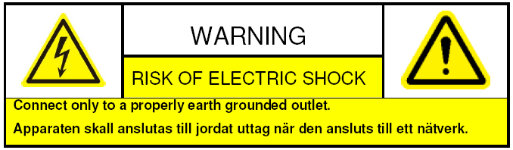
System Grounding (Earthing): To avoid shock, ensure that all AC wiring is not exposed and that the earth grounding is maintained. Ensure that any equipment to which this device will be attached is also connected to properly wired grounded receptacles and are approved medical devices.

Power Connect and Disconnect:The AC power supply cord is the main disconnect device to mains (AC power).The socket outlet shall be installed near the equipment and shall be readily accessible.
Installation and Maintenance:Do not connect/disconnect any cables to or perform installation/maintenance on this device during an electrical storm.

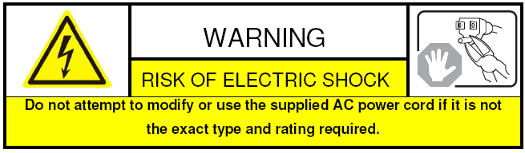
Power Cord Requirements: The connector that plugs into the wall outlet must be a grounding-type male plug designed for use in your region. It must have certification marks showing certification by an agency in your region. The connector that plugs into the AC receptacle on the power supply must be an IEC 320, sheet C13, female connector. See the following website for more information http://kropla.com/electric2.htm.

Lithium Battery:This device contains a Lithium Battery. There is a risk of explosion if the battery is replaced by an incorrect type. Dispose of used batteries according to the vendor’s instructions and in accordance with local environmental regulations.
Perchlorate Material: Special handling may apply. See www.dtsc.ca.gov/hazardouswaste/perchlorate. This notice is required by California Code of Regulations, Title 22, Division 4.5, Chapter 33: Best Management Practices for Perchlorate Materials. This device includes a battery which contains perchlorate material.

Taiwan battery recycling:

Please recycle batteries.

Thermal and Mechanical Injury:Some components such as heat sinks, power regulators, and processors may be hot; care should be taken to avoid contact with these components.

Electro Magnetic Interference:This equipment has not been tested for compliance with emissions limits of FCC and similar international regulations. This device is not, and may not be, offered for sale or lease, or sold, or leased until authorization from the United States FCC or its equivalent in other countries has been obtained. Use of this equipment in a residential location is prohibited. This equipment generates, uses and can radiate radio frequency energy which may result in harmful interference to radio communications. If this equipment does cause harmful interference to radio or television reception, which can be determined by turning the equipment on and off, the user is required to take measures to eliminate the interference or discontinue the use of this equipment.

Lead Content:
Please recycle this device in a responsible manner. Refer to local environmental regulations for proper recycling; do not dispose of device in unsorted municipal waste.

Safety Instruction
These instructions are intended to ensure that the user can use the product correctly to avoid danger or property loss.
The precaution measure is divided into ‘Warnings’ and ‘Cautions’:
Warnings: Serious injury or death may be caused if any of these warnings are neglected.
Cautions: Injury or equipment damage may be caused if any of these cautions are neglected.
 | 
Warnings Follow these safeguards to prevent serious injury or death. | Cautions Follow these precautions to prevent potential injury or material damage.
Warnings:
- In the use of the product, you must strictly comply with the electrical safety regulations of the nation and region.
- Source with DC 12V or AC 24V (Whether supporting AC 24V lies on the specific camera model) according to the IEC60950-1 standard. Please refer to technical specifications for more details.
- Do not connect several devices to one power adapter as an adapter overload may cause over-heating and can be a fire hazard. If use the POE as the power supply, please make sure that the POE Switch have the sufficient power .(Whether supporting PoE power supply lies on the specific camera model)
- Please make sure that the plug is firmly inserted into the power socket.
- When the product is installed on a wall or ceiling, the device should be firmly fixed.
- If smoke, odor, or noise rise from the device, turn off the power at once and unplug the power cable, then contact the service center.
- If the product does not work properly, please contact your dealer or the nearest service center. Never attempt to disassemble the camera yourself. (We shall not assume any responsibility for problems caused by unauthorized repair or maintenance.)
Cautions:
- Make sure the power supply voltage is correct before using the camera.
- Do not drop the camera or subject it to physical shock.
- Do not touch sensor modules with fingers. If cleaning is necessary, use a clean cloth with a bit of ethanol and wipe it gently. If the camera will not be used for an extended period of time, put on the lens cap to protect the sensor from dirt.
- Do not aim the camera at the sun or extra bright places. A blooming or smear may occur otherwise (which is not a malfunction however), and affecting the endurance of sensor at the same time.
- The sensor may be burned out by a laser beam, so when any laser equipment is being used, make sure that the surface of the sensor will not be exposed to the laser beam.
- Do not place the camera in extremely hot or cold temperatures (the operating temperature should be between -10°C~+60°C, dusty or damp locations, and do not expose it to high electromagnetic radiation.
- To avoid heat accumulation, good ventilation is required for a proper operating environment.
- While shipping, the camera should be packed in its original packing, or packing of the same texture.
- Regular part replacement: a few parts (e.g. electrolytic capacitor) of the equipment should be replaced regularly according to their average life time. The average time varies because of differences between operating environment and usage history, so regular checking is recommended for all users. Please contact with your dealer for more details.
- Improper use or replacement of the battery may result in hazard of explosion. Replace with the same or equivalent type only. Dispose of used batteries according to the instructions provided by the battery manufacturer.

Table of Contents

Chapter 1 Network Camera Connection 8
1.1 Cable Network 8
1.2 Wireless Network 8
1.3 Network Connection 9
Chapter 2 Network Access 10
2.1 Access over IE Browser 10
2.1.1 Live View 10
2.1.2 Parameters Configuration 12
2.1.3 Wireless Parameters Configuration 27
2.2 Access over Client Software 28
2.2.1 Live View 29
2.2.2 Camera Parameters Configuration 29
2.2.3 Wireless Parameter Configuration 33
Chapter 3 Access over Internet 34
3.1 Access network camera with static IP 34
3.2 Access network camera with dynamic IP 35
Appendix 1 SADP Introduction 39
Appendix 2 Port Map 41
Appendix 3 Pin Definition 43

Chapter 1 Network Camera Connection

1.1 Cable Network
Two methods can be used to connect between network camera and PC, shown as below:
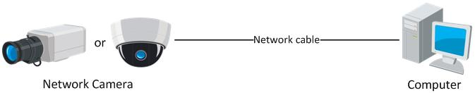

Figure 1.1.1 Cross Line Connection
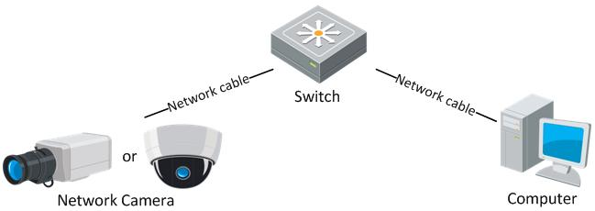

Figure 1.1.2 Direct Line Connection

1.2 Wireless Network
Note: This section is only for wireless network camera with mark '-W' in the model number.
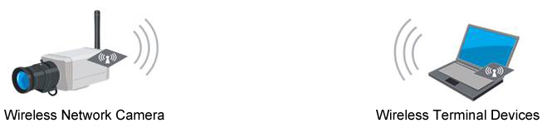

Figure 1.2.1Point-to-point Communication Through Wireless Network
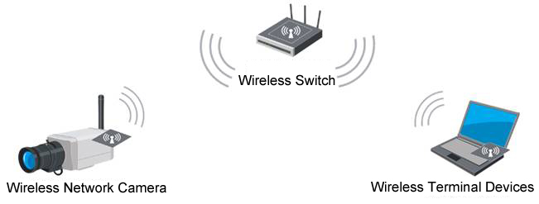

Figure 1.2.2 Communication Via Wireless Switching Equipment

1.3 Network Connection
Before visiting network camera over network, user should acquire its IP address first. SADP is a software tool which can automatically detect network device in the LAN and give the device’s information like IP address, mask, port number, device serial number, software version, etc., as shown in Figure 1.3.1.
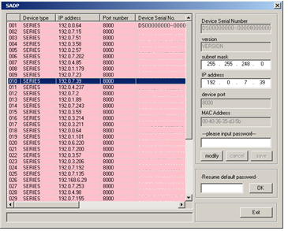

Figure 1.3.1
Select the device, and set its IP address and mask at the same network segment with the PC.
For the detailed introduction of SADP, please refer to Appendix 1.
Note:The network camera is set with the factory default IP address of “192.0.0.64”, the port of “8000”, the super user name of “admin” and the password of “12345”.

Chapter 2 Network Access
After hardware installation, user can view live video and configure parameters for the network camera, including IP address, subnet mask and port number, etc. The following two methods can be used to access the camera:
- View live video and configure parameters over IE browser.
- View live video and configure parameters over client software.

2.1 Access over IE Browser
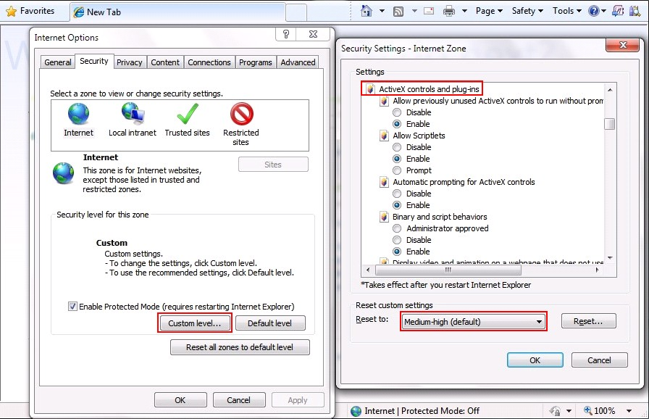
Before access to the camera over IE browser, user should adjust the security level.

Open the IE browser, and set the security level to Medium in Tools/InternetOptions/Security/Custom Level..., and enable or prompt Activex Control and Plug-in directly as well.

Figure 2.1.1 Adjust the Security Level

2.1.1 Live View
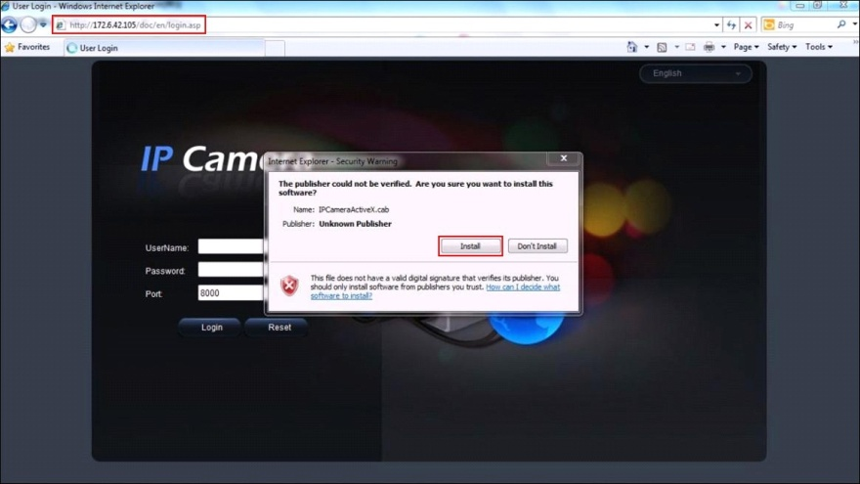
Step 1:Install Active-XControl
Type the IP address of the network camera and press Enter, then the ActiveX mention dialog will pop up.

Click Install to install the ActiveX control.

Figure 2.1.2 Install the ActiveX Control
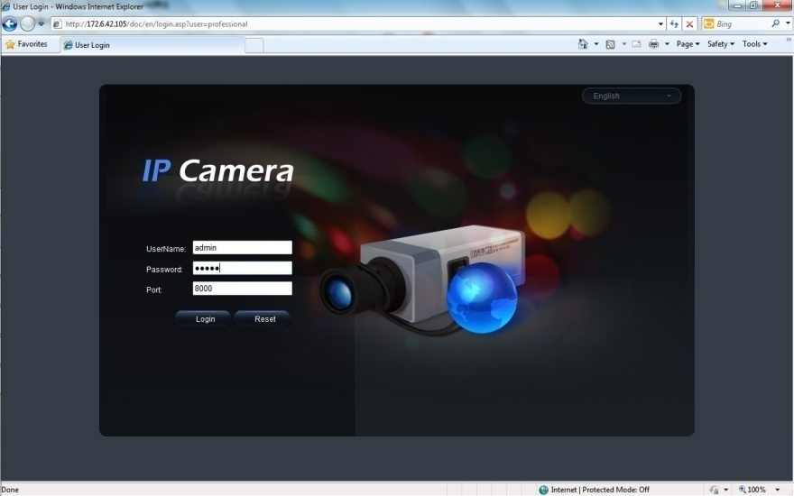
Step 2:
Input the Username (default: admin), Password (default: 12345) and Port (default: 8000) of the camera, and then click [Login].

Figure2.1.3 Login Interface
Step 3: After successful login, user is allowed to view the live video. Refer to Figure 2.1.4.

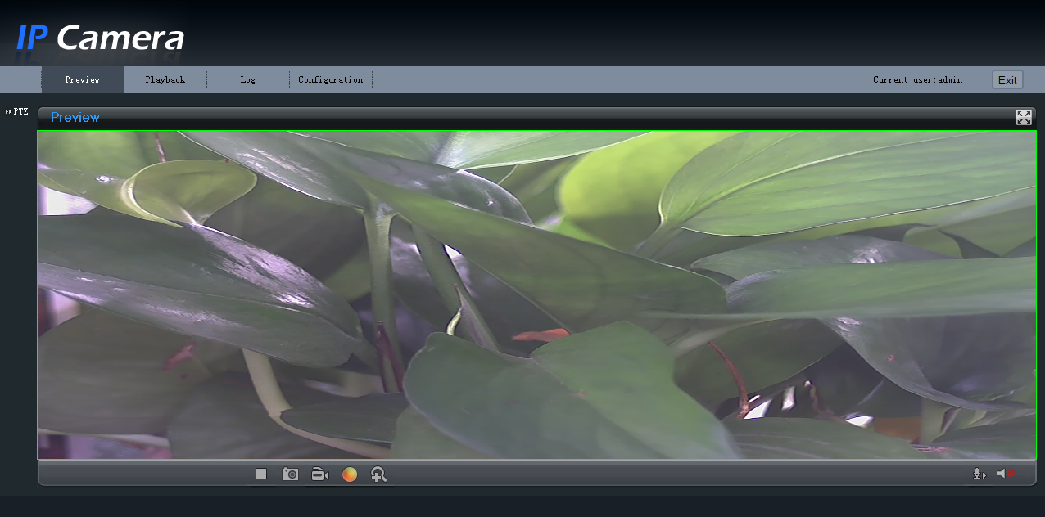

Figure2.1.4 Live View Page
Icons on Live View Page:
Icon | Description
 | Full-screen display mode
 | Exit full-screen display mode
 | Start Preview
 | Stop Preview
 | Capture Picture
 | Start/Stop Record
 | Digital Zoom
 | Video Parameters
Digital Zoom:
Click mouse in the desired position of live video image and scroll the mouse to realize zoom in and zoom out function.

Video Parameters:
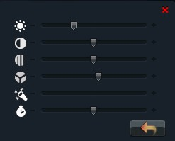
Icon | Description
 | Brightness: 0~100 configurable
 | Contrast: 0~100 configurable
 | Saturation: 0~100 configurable
 | Hue: 0~100 configurable
 | Gain: 0~100 configurable
 | Exposure time: 0~40000 configurable
 | Restore default
Note: This menu varies depending on different camera models.

Figure2.1.5 Video Parameters

2.1.2 Parameters Configuration
Click Configuration to enter the Parameters Configuration interface.

2.1.2.1 Local Configuration

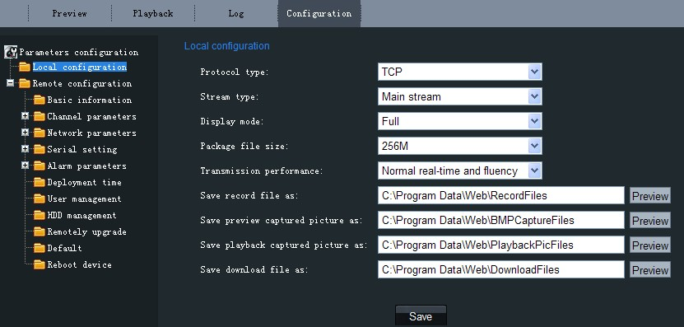

Figure2.1.6 Local Configuration

Local Configuration:
Parameters | Description
Protocol type | TCP and UDP selectable
Stream type | Main stream and Sub stream selectable
Display mode | Full screen, 4:3 mode, 16:9 mode or Adjustable to resolution
Package file size | 128M, 256M, 512M selectable
Transmission performance | Shortest delay mode, Good real-time, Normal real-time and fluency and Good fluency selectable
Save record file as | The default directory for saving record files is C:\Program Data\Web\RecordFiles, which can be modified by user
Save preview captured picture as | The default directory for saving captured files is C:\Program Data\Web\BMPCaptureFiles, which can be modified by user
Save playback captured picture as | The default directory for saving captured files is C:\Program Data\Web\PlaybackPicFiles, which can be modified by user
Save download file as | The default directory for saving captured files is C:\Program Data\Web\DownloadFiles, which can be modified by user

2.1.2.2 Remote Configuration
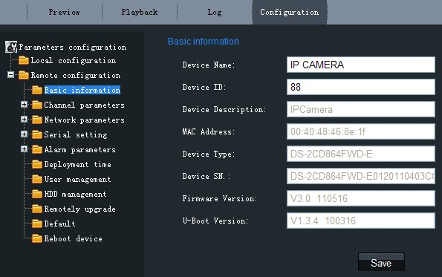
Basic Information:
In the Basic Information settings interface, user is allowed to set the Device Name and Device ID, as well as view the information of IP camera, including Device Description, Device Location, MAC address, Device Type, Device SN, Firmware Version, and U-boot Version.

Figure2.1.7 Basic Information

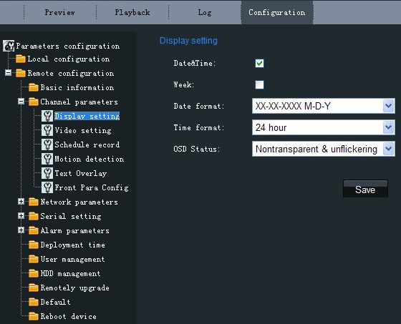
Channel Parameters→DisplaySetting:
According to different requirements, enable the display of Date&Time and Week by clicking the checkbox.
Different date formats can be selected.
There are two Time format: 24 hour and 12 hour.
The OSD Status can be set to transparent & flickering, transparent &unflickering, nontransparent & flickering, or nontransparent &unflickering.

Figure2.1.8 Display Settings

Channel Parameters→Video Settings:
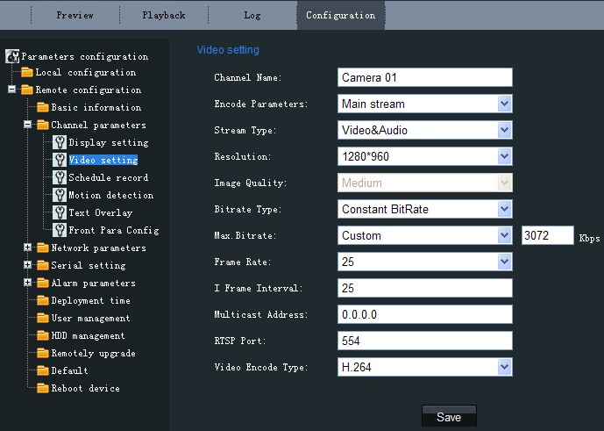

Figure2.1.9 Video Settings

Parameter | Description
Channel Name | Input the channel name for your need
Encode Parameters | Main stream or Sub stream optional
Stream Type | Video&Audio or Video optional
Resolution | Select the resolution for your need
Image Quality | Highest, Higher, Medium, Low, Lower or Lowest optional
Bitrate Type | Constant bitrate or Variable bitrate optional
Max. Bitrate | Select or customize a bitrate according to the resolution
Frame Rate | Select the frame rate for your need
Multicast Address | Set the multicast address, with the default multicast of 0.0.0.0
RTSP Port | Set the RTSP port, with the default RTSP port of 554
Video Encode Type | Select the video encode type for your need

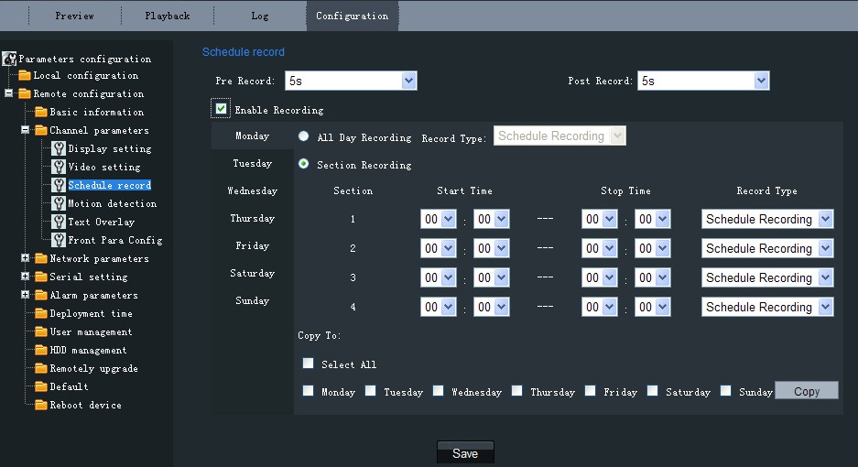
Channel Parameters→ Schedule Record:
Check the checkbox to enable recording schedule.

If video is required to record all day long, please enable All Day Recording . Select a Record Type: Schedule Recording, Motion Detection, Alarm Recording, Motion|Alarm, Motion&Alarm, Command.

If video is required to record in different time sections, select Section Recording and set the Start Time and End Time. There are up to 4 sections available.

Note: The time of each segment can’t be overlapped.

Figure 2.1.10 Schedule Record
Pre Record: “No PreRecord”, “5 s”, “10 s”, “15 s”, “20 s”, “25 s”, “30 s” optional.
Post Record: “5 s”, “10 s”, “30 s”, “1 min”, “2 min”, “5 min”, “10 min” optional.
Select the checkboxes below “Copy To:” to copy this day’s settings to whole week or some days in one week.

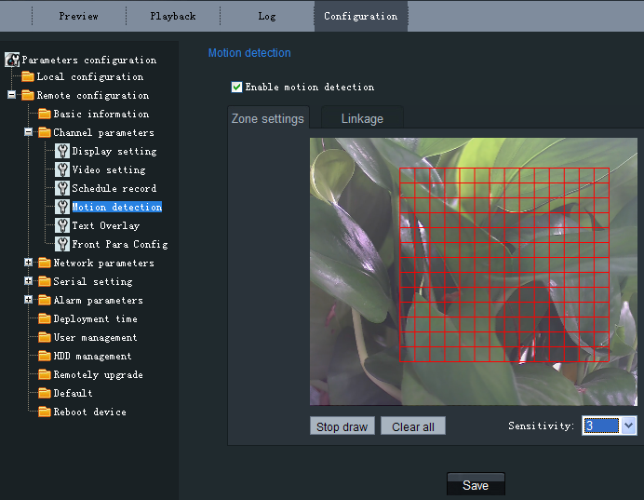

Figure2.1.11 Motion Detection Zone Settings
Channel Parameters→Motion Detection Setting:
Select the checkbox of Enable motion detection to enable this function.
Zone Settings:
Click Start draw button to draw motion detection zone by clicking and dragging the mouse in the live video image.
User is allowed to draw multiple motion detection zones in the same picture. When all zones have been set, click Stop draw to finish drawing.
Sensitivity:
The sensitivity level can be set to 0, 1, 2, 3, 4 and 5. When it is set to 0, the sensitivity is disabled.
Linkage:
The Linkage method can be selected to either Email link, Trigger recording or Trigger alarm output.
Click "Save" button to save the modified parameters.

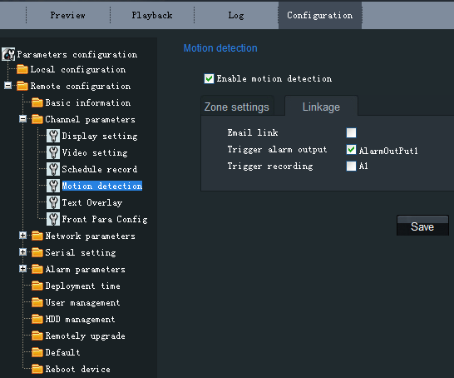

Figure2.1.12 Motion Detection Linkage Settings

Channel Parameters→Text Overlay Setting:
Input the characters in the Text Information box and define the OSD location in the image by setting the XPosition and YPosition, and then select the checkbox of OSD Text. After clicking Save to finish the settings, the defined title will be displayed on the image.
Note: The values of XPosition and YPositon are relative to the upper left corner origin of the image.

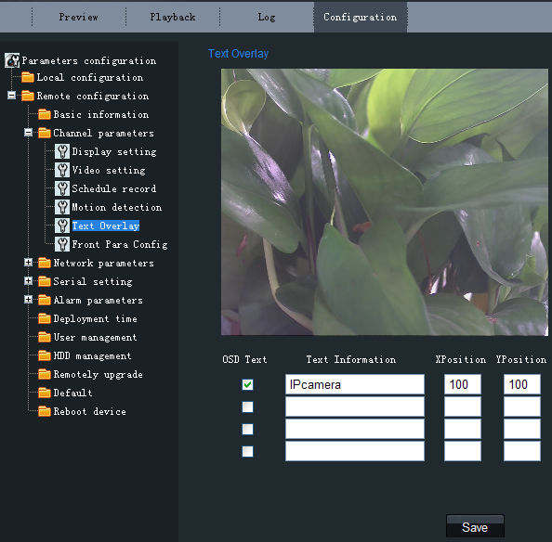

Figure2.1.13Text Overlay Settings

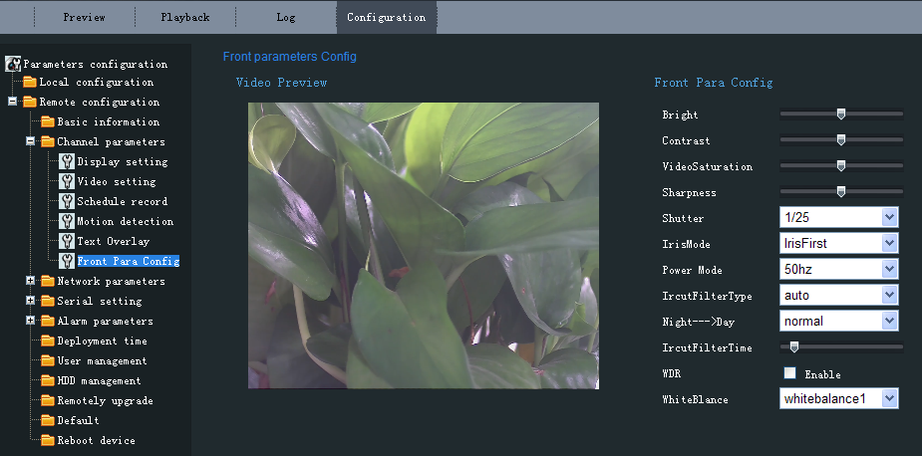
Channel Parameters→Front Para Config:
In this page, user can adjust the parameters like brightness, contrast, saturation, sharpness, etc.
Shutter:
User can set the shutter time according to the different camera models.
IrisMode:
There are two modes: IrisFirst and manual optional.
Power Mode:
There are two modes: 50Hz and 60Hz optional.

Figure2.1.14 Front Parameters Config

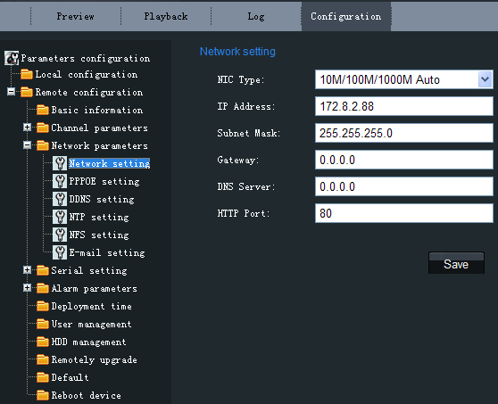
Network Parameters→Network Setting:
Set the NIC Type, IP Address, Subnet Mask, Gateway and DNS Server of the network camera.
Click "Save" button to save the modified parameters.
Note: Please reboot the network camera to validate the modified parameters.

Figure2.1.15 Network Settings

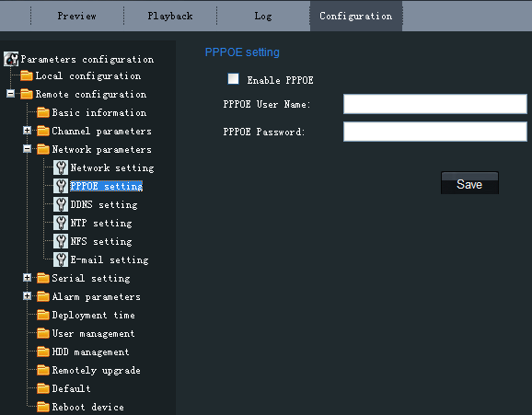
Network Parameters→PPPOE Setting:
Click the checkbox of Enable PPPOE to enable this function.
Input the PPPOE user name and password in the text box and then click Save to finish settings. After reboot, the camera will obtain a public IP address.
Click "Save" button to save the modified parameters.
Note: Please reboot the network camera to validate the modified parameters.

Figure2.1.16 PPPOE Settings

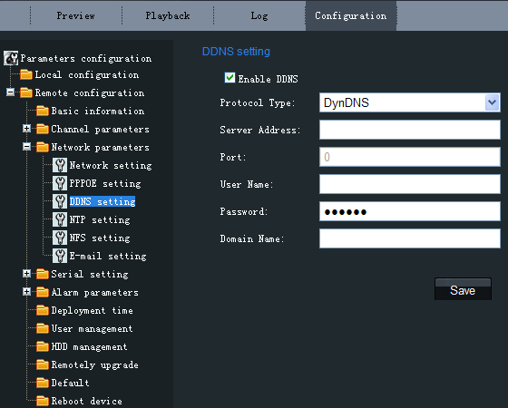
Network Parameters→DDNS Setting:
Click the checkbox of Enable DDNS to enable this function.
The protocol type can be set to DynDNS or IPServer.
Click "Save" button to save the modified parameters.
Note: Please reboot the network camera to validate the modified parameters.

Figure2.1.17DDNS Settings
If the protocol type is selected to DynDNS, please input the Server Address, e.g., members.dyndns. org.
The User Name and Password refer to the user name and password registered in the DynDNS website.
The Device Name refers to the domain name applied in the DynDNS website.
Click "Save" button to save the modified parameters.
Note: Please reboot the network camera to validate the modified parameters.

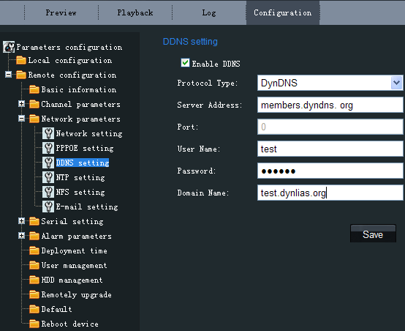

Figure2.1.18DynDNS Settings

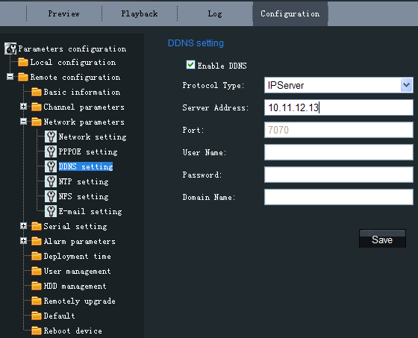
If the protocol type is selected to IPServer, please input the Server Address of the IPServer.
Click "Save" button to save the modified parameters.
Note: Please reboot the network camera to validate the modified parameters.

Figure2.1.19IPServer Settings

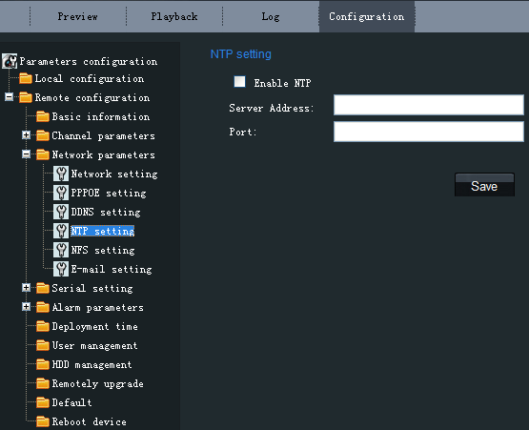
Network Parameters→NTP Setting:
Click the checkbox of Enable NTP to enable this function. Input the Server Address and Port of NTP.
If the public network is applied, please input the NTP Server Address with provision of time sync service, e.g., 210.72.145.44.
In the private network is applied, the NTP software can be used to establish NTP server to achieve time synchronization.
Click "Save" button to save the modified parameters.
Note: Please reboot the network camera to validate the modified parameters.

Figure 2.1.20 NTP Settings

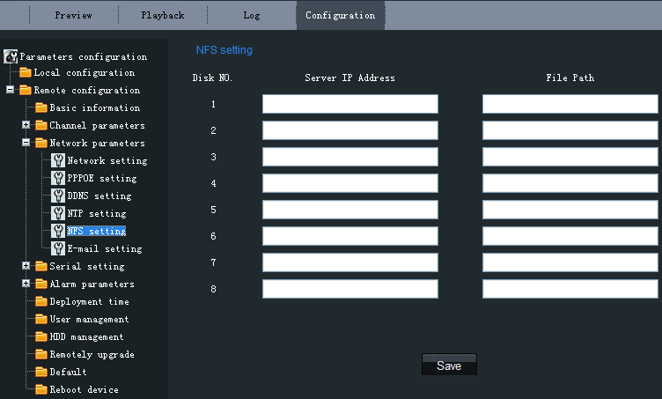
Network Parameters→NFS Setting:
The video files can be saved to network hard disk sever via the network after the NFS setting.
In the NFS setting page, input the IP address of network hard disk sever into Sever IP Address, input the directory into File Path for saving record files. Then click “Save” to save the parameters.
Note: Please make sure that your camera supports network storage before using this function.

Figure 2.1.21 NFS Settings

Network Parameters→E-mail Setting:
Through E-mail settings, the alarm message can be sent to the designated E-mail address when alarm event occurs.
Input the SMTP server, SMTP port, user name, password, E-mail sender and receiver.
Click "Save" button to save the modified parameters.
Note: Please reboot the network camera to validate the modified parameters.

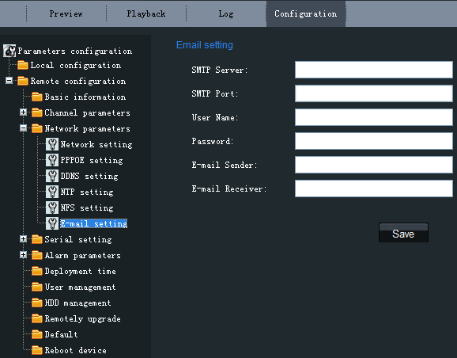

Figure2.1.22 E-mail Settings

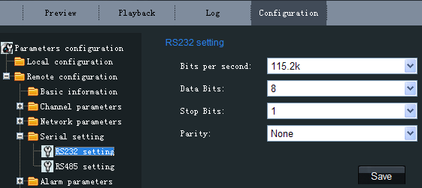
Serial Setting→RS232/RS485 Setting:
The RS232/RS485 interfaces parameters can be configured in this page.
Bits per second: There are eight options from 2400 to 115.2K.
Data Bits: There are four options: 5, 6, 7, 8.
Stop Bits: There are three options: 1, 1.5, 2.
Parity: There are three options: None, Odd, Even.
Then click “Save” to save the parameters.

Figure2.1.23 RS232 Setting
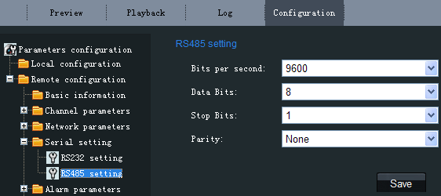

Figure2.1.24 RS485 Setting

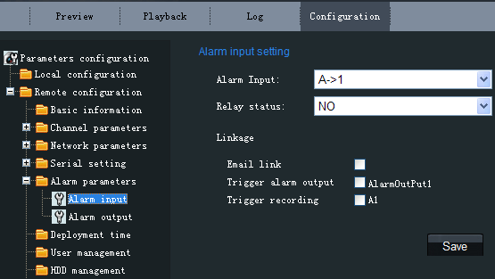
Alarm Parameters→Alarm Input Setting:
Set the type of Relay Status to NC or NO.
Note: Please reboot the network camera to validate the modified parameters.

The Linkage can be selected to E-mail link, Trigger alarm output or Trigger recording.
Click "Save" button to save the modified parameters.

Figure2.1.25 Alarm Input Settings

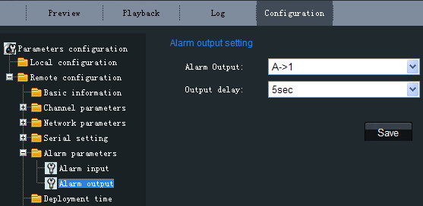
Alarm Parameters→Alarm Output Setting:
The Output Delay refers to the length of time that the relay remains in effect after alarm occurs. The output delay time can be set to 5sec, 10sec, 30sec, 1min, 2min, 5min, 10min or Manual (manually disable).
Click "Save" button to save the modified parameters.

Figure2.1.26 Alarm Output Delay Settings

Alarm Deployment Time:
The Deployment time can be set to several days a week or to all week, with only four period configurable for each day.
Note: The alarm deployment time setting is valid only when the camera has already been configured with the motion detection, alarm input and alarm output functions.
Click "Save" button to save the modified parameters.
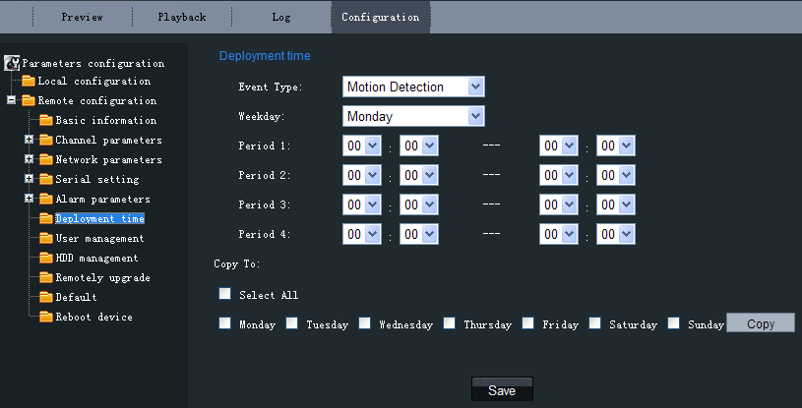
Figure2.1.27 Alarm Deployment Time Settings

User Management:
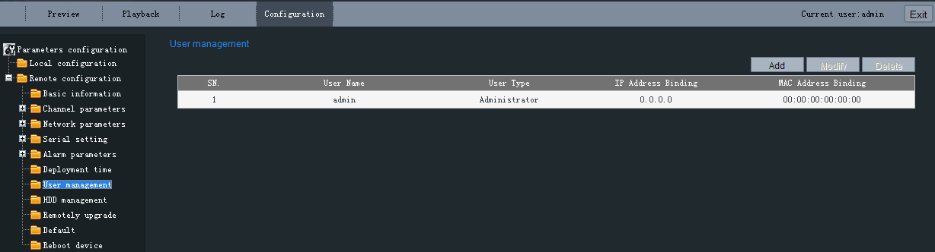

Figure 2.1.28 User Management
When the current login user is admin, it is allowed to create other users. Up to 15 users can be created. Refer to Figure 2.1.28.
Add User:
Click Add to enter the settings interface as shown in Figure 2.1.29.
Input the user name, password, IP address, MAC address, and then select user type. Finally, click OK to finish the user addition.
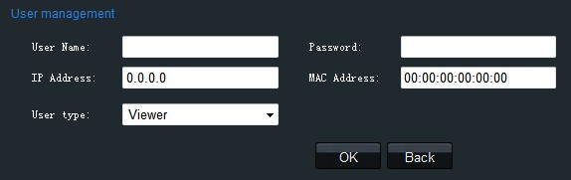

Figure 2.1.29 Add User

Modify User:
Click Modify to enter the settings interface as shown in Figure 2.1.30.
It is allowed to modify the user name, password, IP address, MAC address, and then select user type. Finally, click OK to finish the user modification.
Note: Only the password of the user admin can be modified.

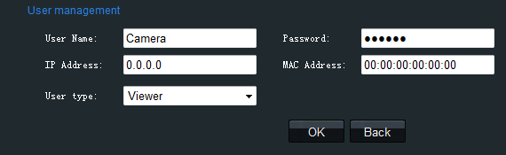

Figure 2.1.30 Modify User

HDD management
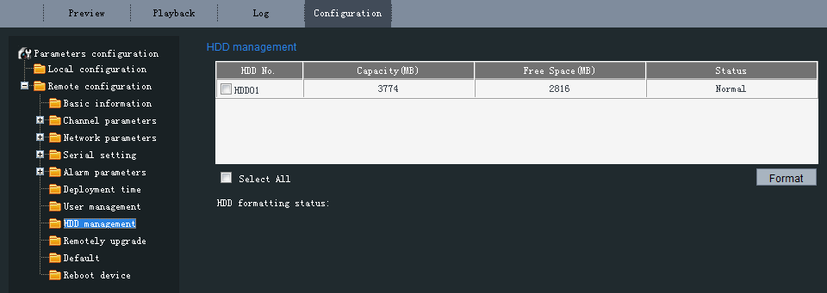

Figure 2.1.31 HDD management
In this page, user is allowed to view the hard disks’ No., capacity, remaining memory and working status, as well as format the hard disks.
Item | Description
HDD No. | Hard disk’s serial number.
Capacity(MB) | Hard disk’s total capacity.
Free Space(MB) | The remaining memory of the hard disks.
Status | The working status of the hard disks.
Format | Select the hard disk you want to format and press this button.
HDD formatting status | The formatting progress of the hard disk.

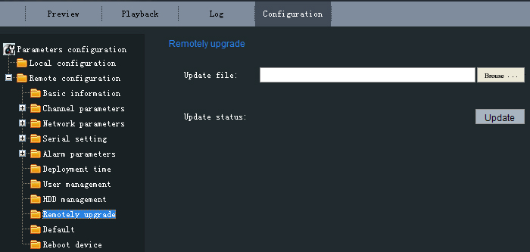
Remote Upgrade:
Click Browse to select the local update file and then click Updade to finish remote upgrade.

Figure 2.1.32 Remote Upgrade
Restore Default:
Select Full Mode or Basic Mode to restore the default settings.
Note:
The Full Mode refers to restore all parameters to the factory default settings.
The Basic Mode refers to restore the parameters to factory default settings except IP address, subnet mask, gateway and port.

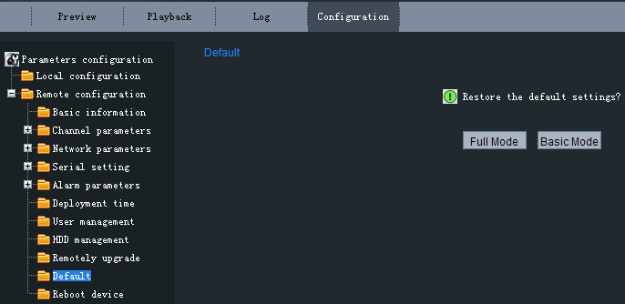

Figure 2.1.33 Restore Default

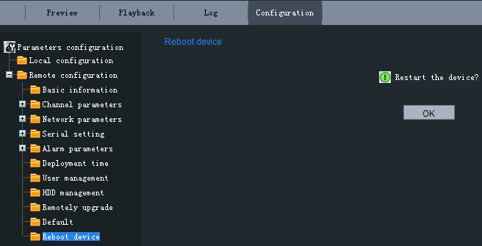

Figure 2.1.34 Reboot Device
Reboot Device:
Click OK to reboot the network camera.

2.1.2.3 Advanced Configuration
Note: This chapter is applicable to professional configuration.
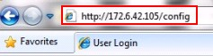
1:Input the IP address of the network camera and “config” (Such as http://172.6.42.105/config), and then click [Enter].

Figure 2.1.35
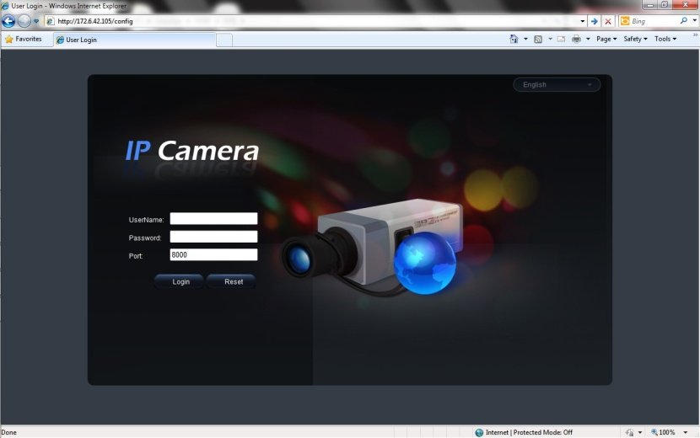
2:Input the Username (default: admin), Password (default: 12345) and Port (default: 8000) of the camera, and then click [Login].

Figure 2.1.36
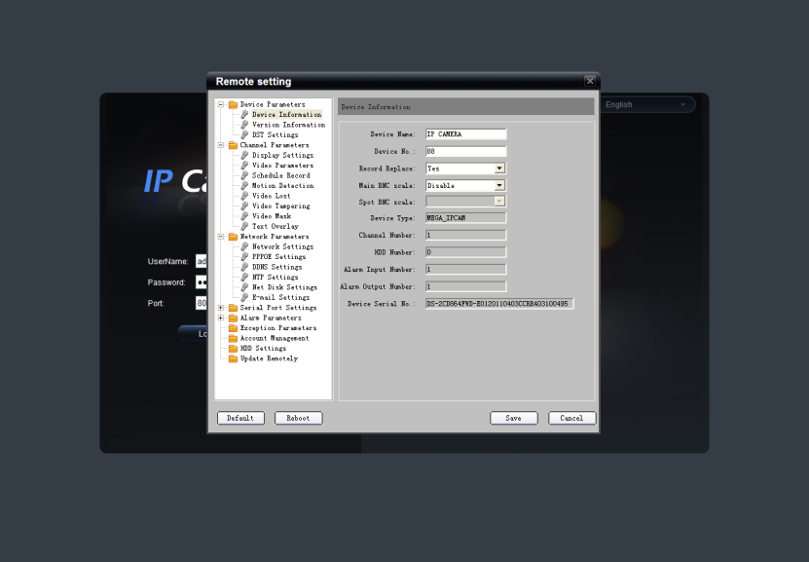
3:The “Remote config” dialog will pop up, which has more advanced settings.

Figure 2.1.37
Please refer to “Client Software-4000(v2.0)_ENG.pdf” for a more detailed parameters configuration. You can find the document in the PC Operating System after the installation of client software 4000 v. 2.0 by selecting “Start”-> “All Programs”-> “client software 4000 v. 2.0”.

2.1.3 Wireless Parameters Configuration
Note:This section is only for wireless network camera with mark '-W' in the model number.
Before configuring the wireless network camera, please set the wireless router first. For more details about wireless router configuration, please refer to the wireless router configuration instructions.
There are two network interface cards in the camera: wired network interface card and wireless network interface card.The factory default settings of wired network interface card are IP address: 192.0.0.64, port number: 8000, superuser: admin, superuser password: 12345, while the default IP address of wireless network interface card is 192.168.1.64. Before accessing to the wireless network camera through wireless network, use the wired Ethernet port of the wireless network camera to configure parameters of wireless network interface card. The configuration steps are the same way as section 1.3.
If users want to configure the wireless parameters through IE browser, enter the remote parameter settings interface first. Refer to section '2.1.2.3 Advanced Configuration' for more detailed settings. After entering the remote parameter settings interface, select "WiFi parameters"-> "WiFi Settings" to enter the WiFi settings interface, as shown in figure 2.1.38.
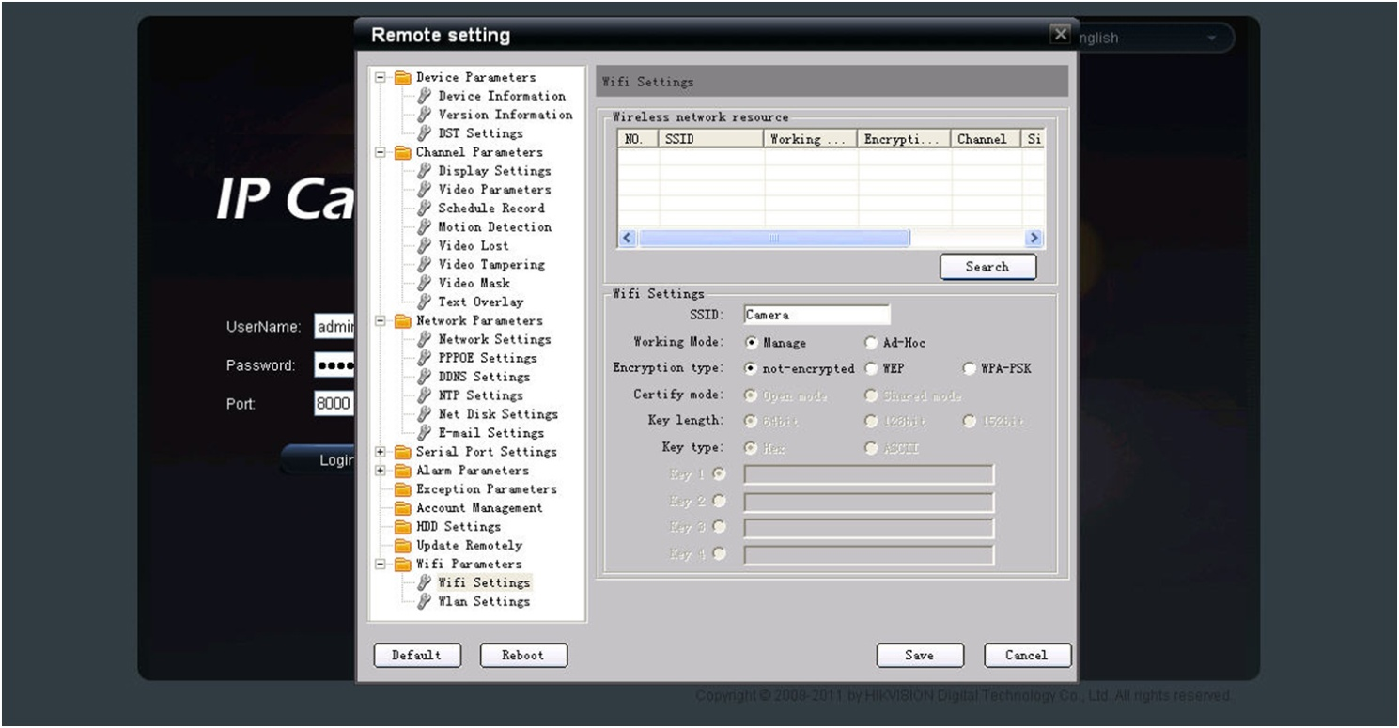

Figure 2.1.38 WiFi Settings Interface
In the WiFi settings interface, if user select Ad-Hoc mode as the operating mode, please set the PC's wireless IP address in the same network segment as the IP address of wireless network camera. Select "View Wireless Networks" in the computer's "Wireless Network Connection". Find the device which has the same name as the SSID number of the wireless camera. Then point-to-point communication through wireless network is established successfully. So, there is no need to use an Access Point (AP) between the PC and wireless network camera.
If users need to enable encryption, select the appropriate encryption type and set the corresponding encryption parameters.
In the remote parameter settings interface, select "WiFi parameters"-> "Wlan Settings" to enter the Wlan settings interface, as shown in Figure 2.1.39.
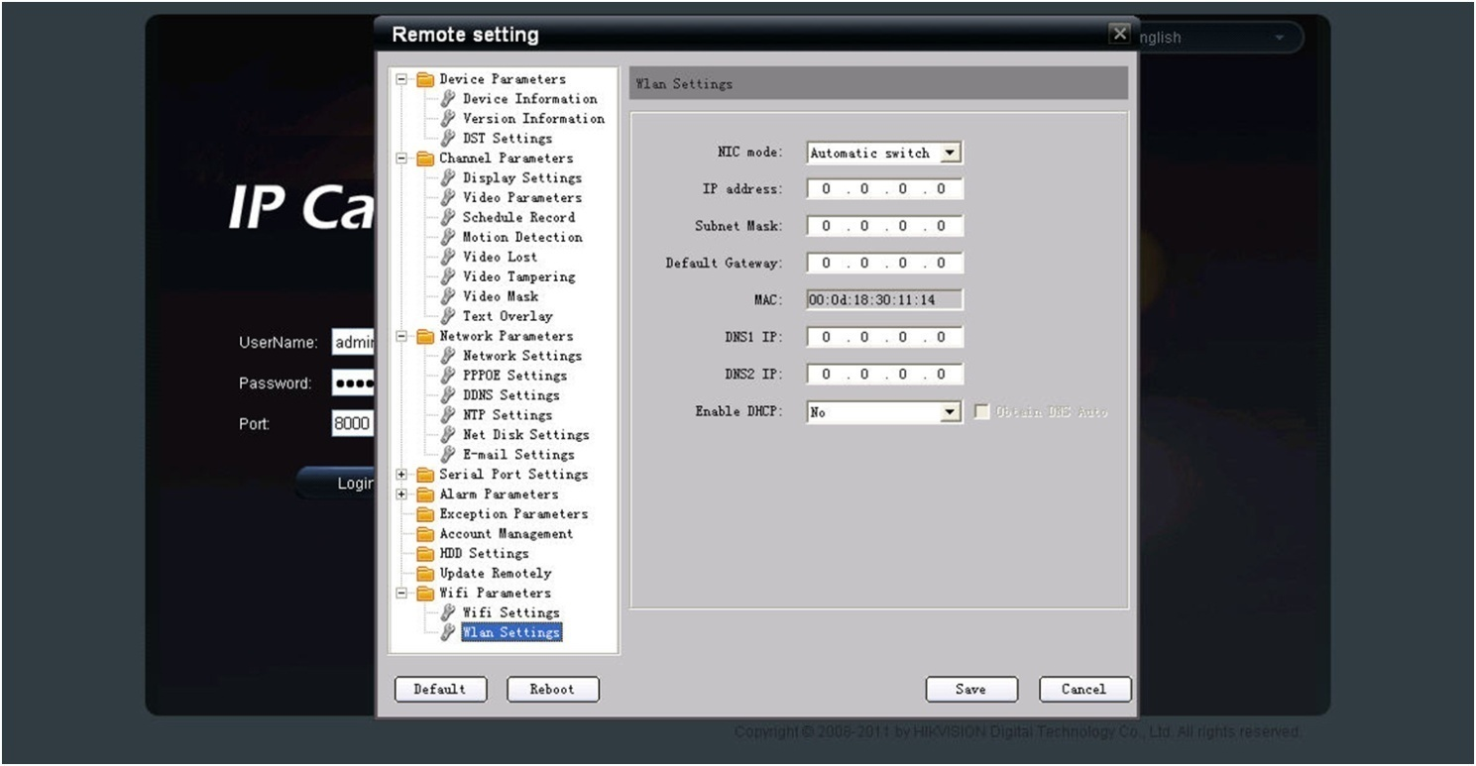

Figure 2.1.39Wlan Settings Interface
In the "Wlan settings" interface, user can set the wireless network camera's parameters like wireless IP address, subnet mask, gateway and DNS server address, etc. Unplug the network cable from wireless network camera. The wireless network camera now can be accessed through wireless network after the related network parameters have been set. The way that accesses to wireless network camera through wireless network is similar to cable network. Refer to section 2.1.

2.2 Access over Client Software
Please refer to “iVMS-4000(v2.0) introductor.pdf” for detailed client software installation. You can find the document in the PC Operating System after the installation of client software 4000 v. 2.0 by selecting “Start”-> “All Programs”-> “iVMS 4000( v. 2.0)” -> “iVMS 4000( v. 2.0)”.

2.2.1 Live View
Right click to add devices in the setup interface of client software. Please refer to “iVMS-4000(v2.0) introductor.pdf” for more detailed device added process. You can find the document in the PC Operating System after the installation of client software 4000 v. 2.0 by selecting “Start”-> “All Programs”-> “iVMS 4000( v. 2.0)” -> “iVMS 4000( v. 2.0)”.
Click Preview, and then double click the device name in the left tree to view the live video. Refer to Figure 2.2.1.

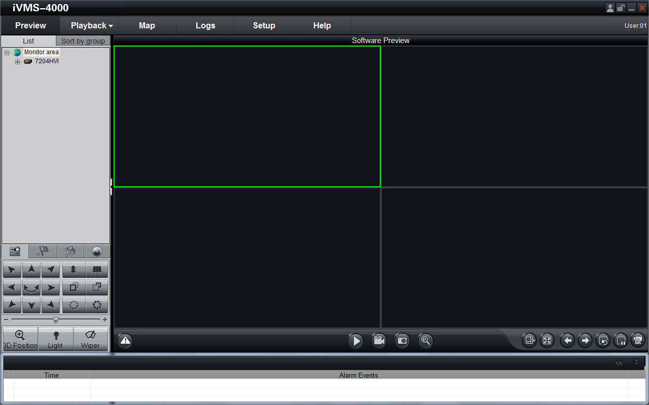

Figure 2.2.1 Preview
Please refer to “iVMS-4000(v2.0) introductor.pdf” for more detailed parameters configuration. You can find the document in the PC Operating System after the installation of client software 4000 v. 2.0 by selecting “Start”-> “All Programs”-> “iVMS 4000( v. 2.0)” -> “iVMS 4000( v. 2.0)”.

2.2.2 Camera Parameters Configuration

Note:
Different types of network cameras maybe have different configuration parameters in the interface of “Config Sensor Parameters”. This section takes a type of network camera for example to introduce configuration parameters in the interface of “Config Sensor Parameters”. If the information in the actual interface of “Config Sensor Parameters” is not different from the information shown in this section, then subject to the actual interface information.

For viewing better image, you can set the parameters of the camera, and operate as following:
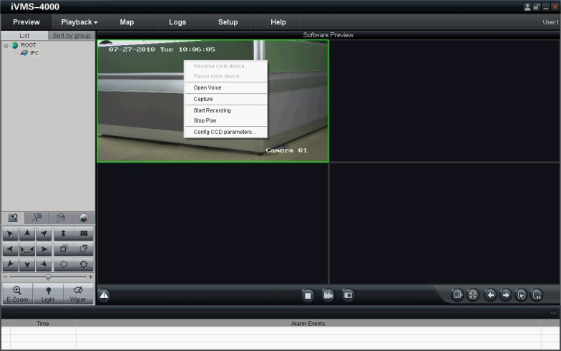
Step 1:
Right click in the preview window, and click [ConfigSensor Parameters…], then the [ConfigSensor Parameters…] box will pop up.

Figure 2.2.2 Sensor Parameters
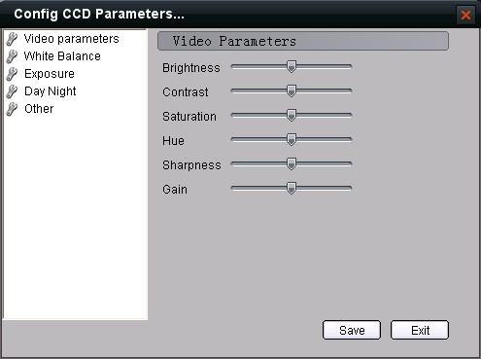
Step 2: Video Parameters Configuration
Adjust the value of “Brightness”, “Contrast”, “Saturation”, “Hue”, “Sharpness” and “Gain”for your need, which can be set from 1 to 100.

Figure 2.2.3 Video Parameters
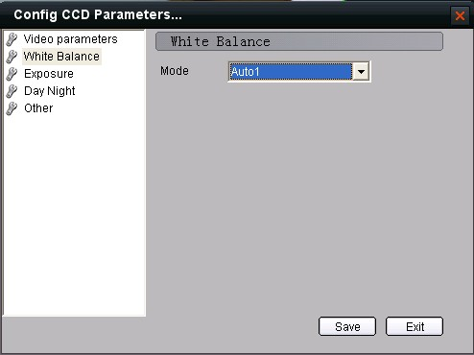
Step 3: White Balance Configuration
Select the mode to Auto1 or Off for yourneed.

Figure 2.2.4 White Balance
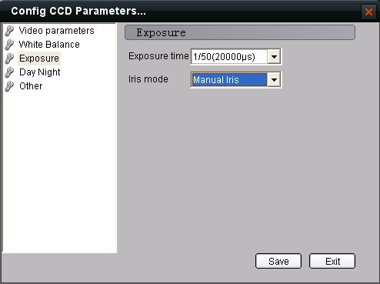
Step 4: Exposure Configuration
Select “Exposure time” and “Iris mode”for your need.

Figure 2.2.5 Exposure
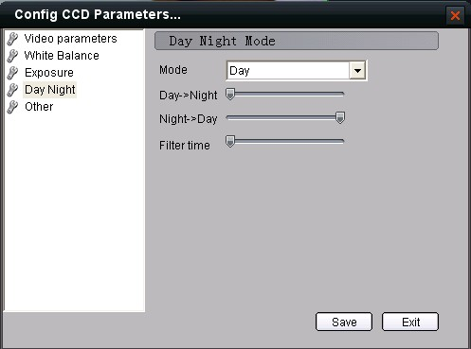
Step 5: Day/Night Mode Configuration
Select “Day”, “Night” or “Auto” modein
Mode and adjust the value of “Day->Night”,
“Night->Day”, and “Filter time” for yourneed.

Figure 2.2.6 Day/ Night Mode

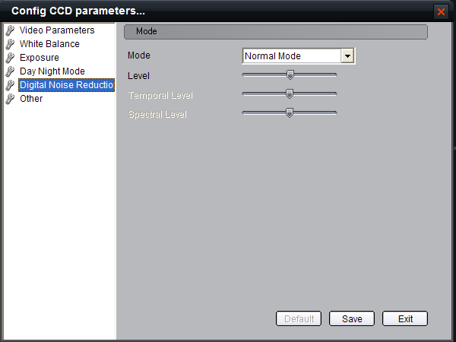
Step 6:DigitalNoise Reduction
Note: Not all of the models have this feature.
There are three modes selectable: Close, Normal Mode, Experts Mode.
The Level can be adjusted from 0 to 100 to enhance the DNR effect.

Figure 2.2.7 Digital Noise Reduction

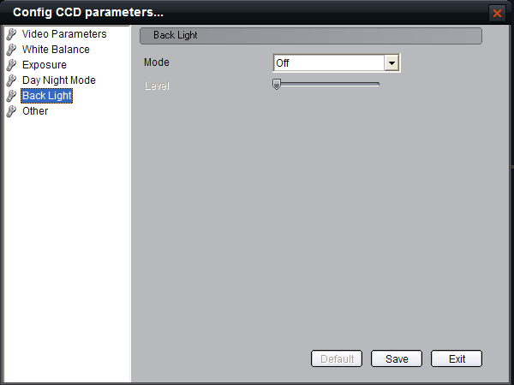
Step 7: BLC Configuration
Note: Not all of the models have this feature.
“Mode”can be set to “Up”, “Down”, “Left”, “Right”, “Center” and “Off”.
The “Level” can be adjusted from 0 to 15 to enhance the back light compensation level.

Figure 2.2.8BLC

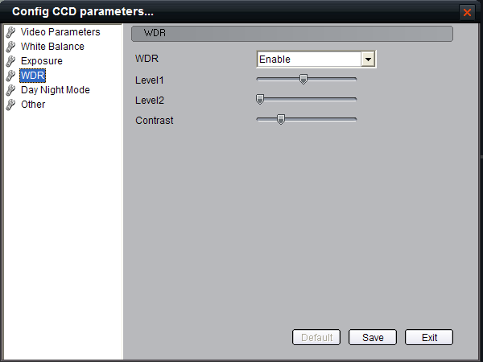
Step 8: WDR Configuration
Note: Not all of the models have this feature.
“WDR” can be set to “Enable” or “Disable”.

The “Level” 1 can be adjusted from 0 to 15 to enhance the background dynamic level.
The “Level” 2 can be adjusted from 0 to 15 to enhance the background dynamic level.

“Contrast” is from 0-100 selectable.

Figure 2.2.9WDR

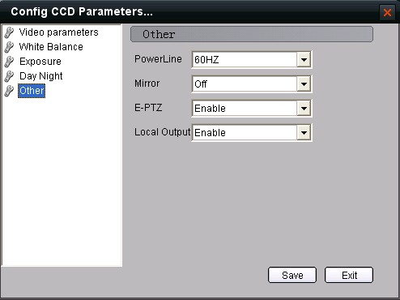
Step 9: Other Parameters Configuration
Select the value of “Power Line”, “Mirror”, “E-PTZ” and “Local Output”.

Figure 2.2.10 Other Parameters

2.2.3 Wireless Parameter Configuration
Note: This section is only for wireless network camera with mark '-W' in the model number.
Click “setup” in the client software to enter the devices management interface. Right click the device that needs to be configured, select “Remote Configuration” to enter the remote configuration interface.
The way to configure the parameters in the client software is the same as the way in IE browser. Please refer to section 2.1.3 for more detailed parameters configuration.
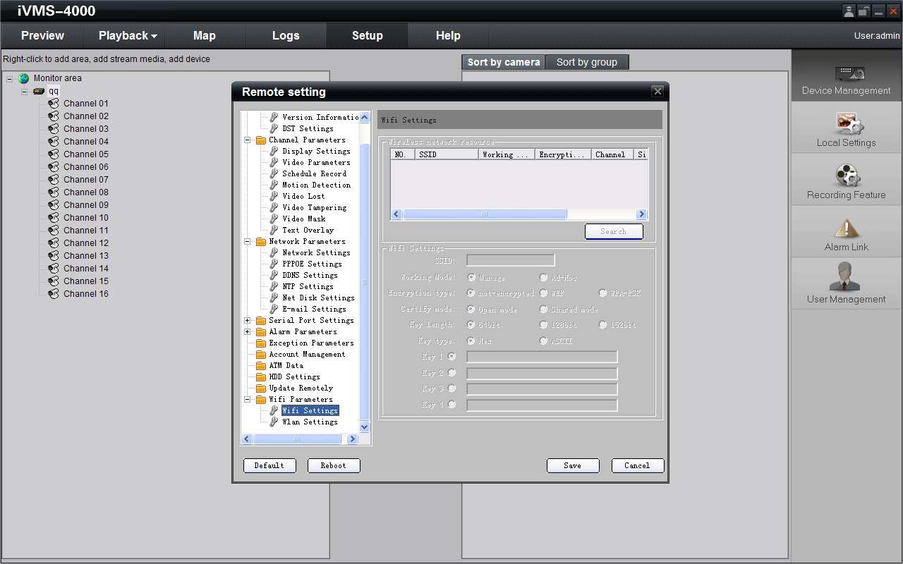

Figure 2.2.11 Client Software Wireless Configuration Interface

Chapter 3 Access over Internet

3.1 Access network camera with static IP
When there is a static IP from an ISP, open some ports (such as 80 and 8000 ports) in the router. Then a user can visit it through a web browser or client software via the internet. The steps for port forwarding are different for each model of router. Please call the router manufacturer for assistance with port forwarding or visit www.portforward.com.
Note: Refer to Appendix 2 for a detailed explanation about Port Map.
Users can directly connect the network camera to the internet without using a router.
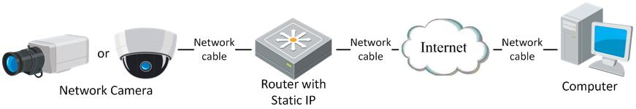

Figure 3.1.1 Access IPC through Router with Static IP
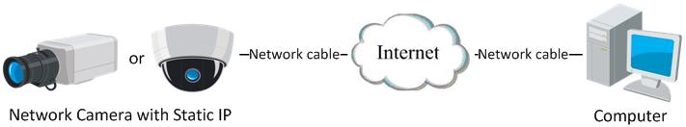

Figure3.1.2 Access IPC with Static IP directly
For the client software to view the camera, in the adding equipment column, select the normal model, and then fill in the IP info.
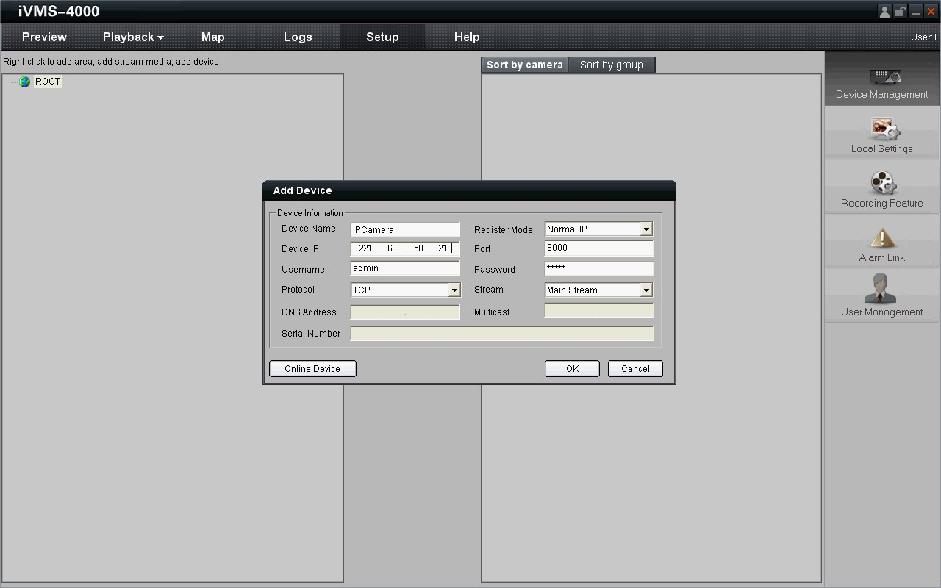

Figure 3.1.3 Selecting Normal IP

3.2 Access network camera with dynamic IP
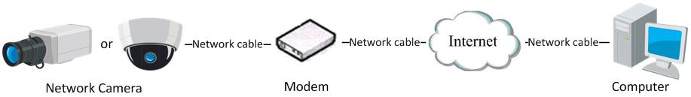

Figure 3.2.1 Access IPC through PPPoE Dial-up
This camera supports the PPPoE auto dial-up function. The camera will get a public IP address by ADSL dial-up after the camera is connected to a Modem; First, access to the network camera through local network, select “Configure”→”Right Click the Device”, “Remote Configuration”, and finally select “PPPoE Settings” under “Network Parameters” to fill in the PPPoE user name and password and confirm the password. Please restart the network camera after completion of configuration. Then the network camera can obtain a dynamic IP from an ISP operation business. However, the obtained IP address is dynamically assigned via PPPoE, so the IP address always changes accompanied with modem rebooting.
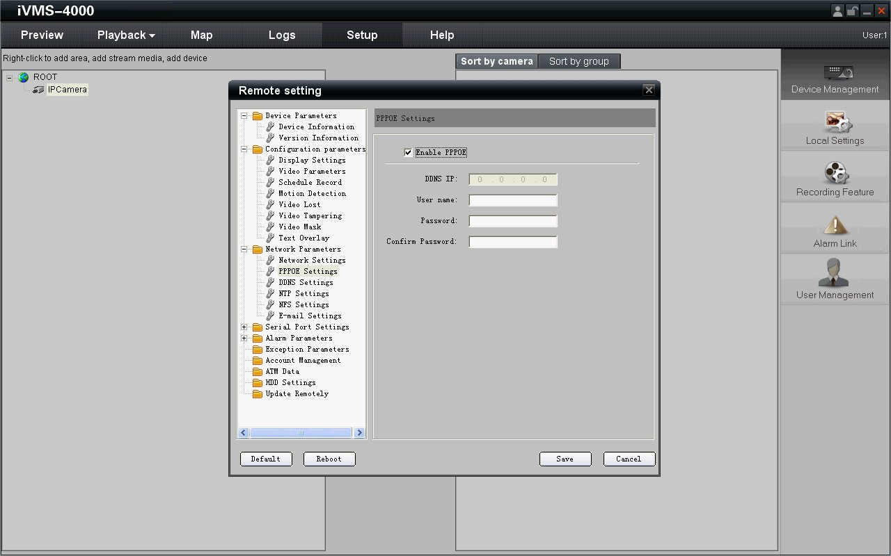

Figure 3.2.2PPPoE configuration Dialog box
It is inconvenient to view a network camera with a dynamic IP, therefore, users should register with a dynamic DNS provider. (Such as DynDns.com)
Domain name resolution contains normal domain name resolution and private domain name resolution. First, we will introduce normal domain name resolution.
- Normal Domain Name Resolution
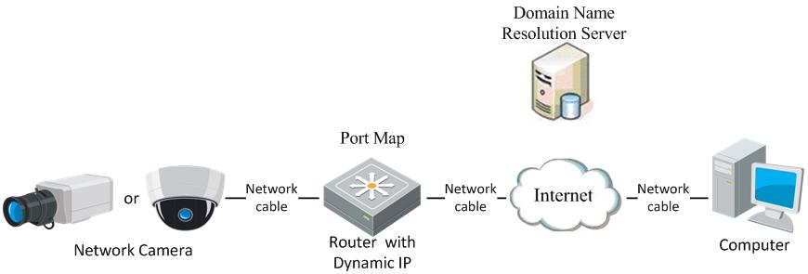

Figure 3.2.3 Normal Domain Name Resolution
Apply a domain name from a domain name provider, then view the camera via the applied domain name. If the camera connects to the internet via a router, users should port forward the router. Please refer to Appendix 2.
Input domain names in the client software or IE to view the network cameras. Take the client software configuration as an example.
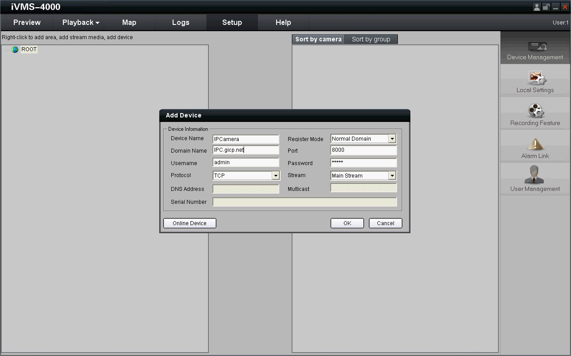

Figure 3.2.4 Selecting Normal Domain Mode
- Private Domain Name Resolution
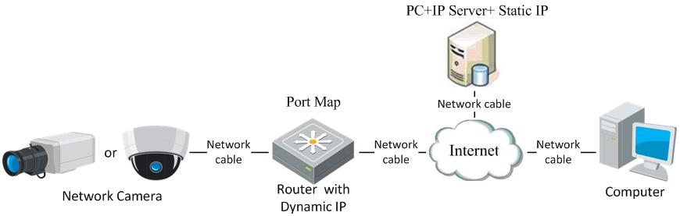

Figure 3.2.5 Private Domain Name Resolution
A PC with a static IP which is running the domain name resolution service is necessary.
When the network camera connects to the internet through PPPoE and obtains an IP address, it will send its name and IP address to the resolution server. When the client software connects to the network camera, it will connect to the resolution server and tell the resolution server the expected camera’s name. And the server will find the camera from all the registered cameras and send its IP address to the client software. Once the client software gets the IP address, it can connect the network camera.
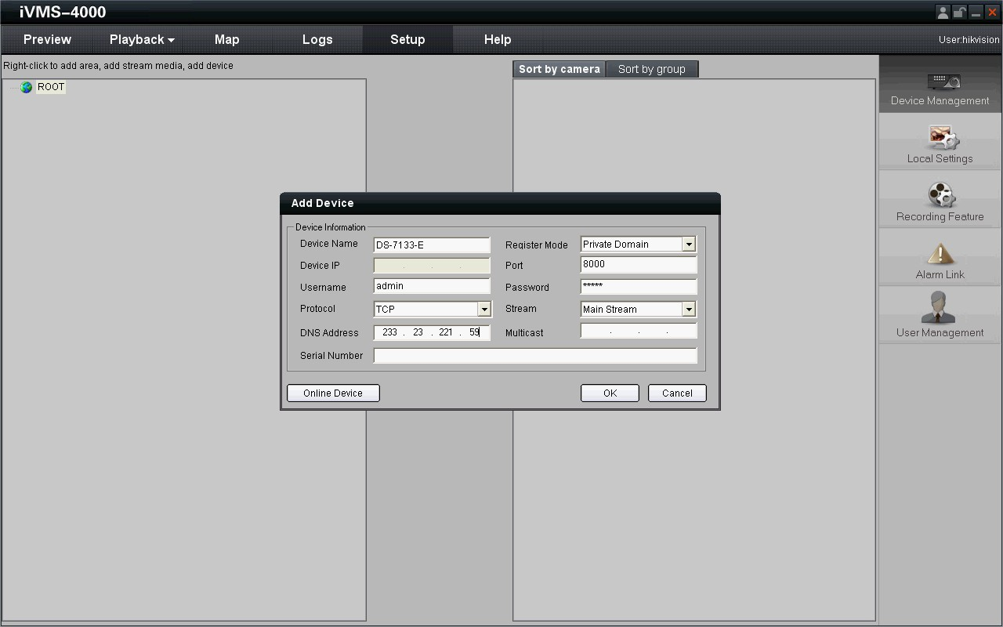

Figure 3.2.6 Selecting Private Domain Mode

Appendix 1 SADP Introduction
- Brief introduction
SADP (Search Active Devices Protocol) is a kind of software which can automatically search network speed dome in LAN. User can modify the IP address, subnet mask and port of the device without visiting IP address of the device. Additionally, password of the super user in this device can be recovered as default.
SADP software needs to support SADP, so we should install WinPcap at first, which is placed at the directory of SADP software.

- Search active devices online
After installing WinPcap, double click sadpdlg.exe. The software will start to search active devices in LAN, and device type, IP address, Port number, Device Serial No., subnet mask, MAC address, the number of channels, main control and encoding version and device initiating time are showed in the list, as following:
- Modify device information
Select the device that needs modification in the device list, then basic information of the device will be demonstrated in the information column on the right. Click “modify” button to activate IP address, subnet mask, device port editing and password validating box, as follows:
Select the device that needs modification in the device list, then basic information of the device will be demonstrated in the information column on the right. Click “modify” button to activate IP address, subnet mask, device port editing and password validating box, as following:
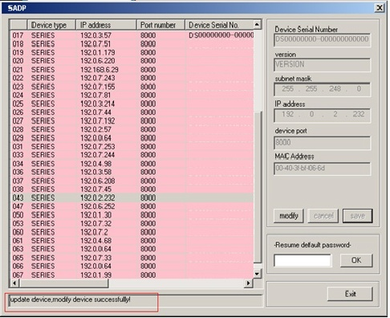
Input new IP address, subnet mask, and port number, and click “save” button. If a dialog pops up, showing “saved successfully”, that means you have modified the configuration information; if “saving failed” turns up, click the “cancel” button to quit it.

- Recover default password
You can reset the password of the super user as “12345” in the case of a lost password.
Input certain validation code into the ‘Resume default password’ box, and click ‘OK’ to finish the administrator’s password initiating.

Appendix 2 Port Map
Note: The following setting is about TP-LINK router (TL-R410), which is maybe distinct from other router’s setting.
- Firstly, select the router’s WAN connection Type. As the following Figure shows:
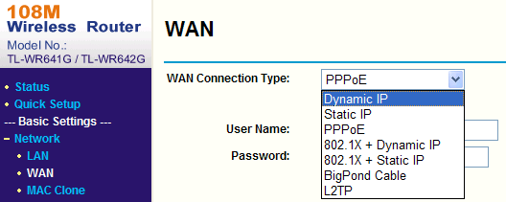
- Set the “network parameter” of the router as the below figure. The setting includes subnet mask and gateway.
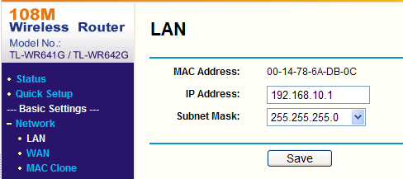
- Set the port map in the virtual severs of Forwarding. By default, camera uses port 80, 8000, 554 and 8200. You can change these ports value with IE or client software.
The following figure gives the illustration. One camera’s ports are 80, 8000, 554, 8200 and its IP address is 192.168.1.23. The other camera’s ports are 81, 8001, 555, 8201 and IP is 192.168.1.24. Afterwards, enable all or TCP protocols. Enable the port map after pressing the ‘Save’.
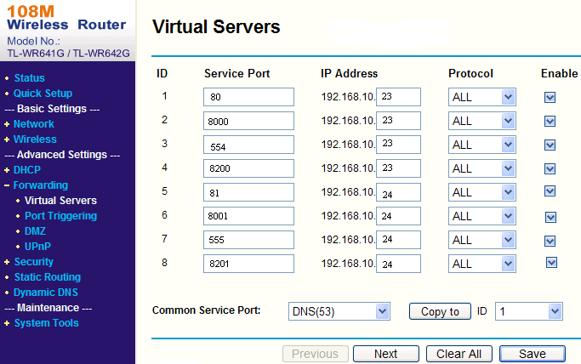
As the settings mentioned above, map the router’s port 80 and 8000 to the network camera at 192.168.1.23; and port 81 and 8001 to the network camera at 192.168.1.24. In this way, user can access the 192.168.1.23 through accessing the router’s port 80 and 8000.
Note: The port of the network camera cannot conflict with other ports. For example, some router’s web management port is 80. User can amend the router’s or the camera’s port to solve this problem.

Appendix 3 Pin Definition
(1)UTP between the network port of camera and HUB (Direct Cable)
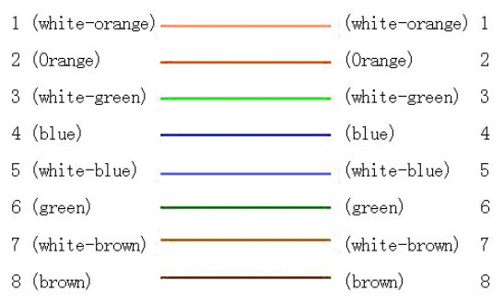
(2)UTP between the network port of camera and PC (Cross Cable):
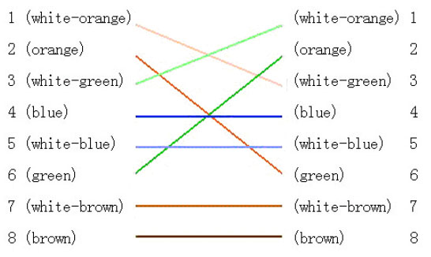

First Choice for Security Professionals

