IR Speed Dome
Installation Manual
V2.0.0

2010-04

Thank you for purchasing our product. If there is any question or request, please do not hesitate to contact dealer.
This manual is applicable to IR Speed Dome.
This manual may contain several technically incorrect places or printing errors, and the content is subject to change without notice. The updates will be added into the new version of this manual. We will readily improve or update the products or procedures described in the manual.

Safety Instruction
These instructions are intended to ensure that user can use the product correctly to avoid danger or property loss. The precaution measure is divided into “Warnings” and “Cautions”:
Warnings: Neglecting any of the warnings may cause serious injury or death.
Cautions: Neglecting any of the cautions may cause injury or equipment damage.
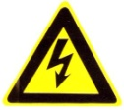 | 
Warnings Follow these safeguards to prevent serious injury or death. | Cautions Follow these precautions to prevent potential injury or material damage.
Warnings
1. In the use of the product, you must be strict compliance with the electrical safety regulations of the nation and region.
2. Please use the power adapter, which is provided by normal company. The standard of the power adapter is AC24V/3A.
3. Do not connect several devices to one power adapter as adapter overload may cause over-heat or fire hazard.
4. Please make sure that the plug is firmly connected on the power socket.
5. When the product is installed on wall or ceiling, the device shall be firmly fixed.
6. If smoke, odors or noise rise from the device, turn off the power at once and unplug the power cable, and then please contact the service center.
7. If the product does not work properly, please contact your dealer or the nearest service center. Never attempt to disassemble the camera yourself. (We shall not assume any responsibility for problems caused by unauthorized repair or maintenance.)
Warnings
1. Do not drop the dome or subject it to physical shock, and do not expose it to high electromagnetism radiation. Avoid the equipment installation on vibrations surface or places subject to shock (ignorance can cause equipment damage).
2. Do not place the dome in extremely hot, cold (the operating temperature shall be -30°C ~ +65°C), dusty or damp locations, or fire or electrical shock will occur otherwise.
3. The dome cover for indoor use shall be kept from rain and moisture.
4. Exposing the equipment to direct sun light, low ventilation or heat source such as heater or radiator is forbidden (ignorance can cause fire danger).
5. Do not aim the camera at the sun or extra bright places. A blooming or smear may occur otherwise (which is not a malfunction however), and affecting the endurance of CCD at the same time.
6. Please use the provided glove when open up the dome cover, avoid direct contact with the dome cover, because the acidic sweat of the fingers may erode the surface coating of the dome cover.
7. Please use a soft and dry cloth when clean inside and outside surfaces of the dome cover, not to use alkaline detergents.

Preparation for Installation
- Basic requirements
- All the electronic operation should be strict compliance with the local electrical safety regulations, fire prevention regulations and other related regulations at the installation place.
- Check whether all the accessories are there according to the packing list, make sure that the place and installation mode are conform to the demands, if not, please contact the supplier.
- Please use this product according to the working environment.
- Check installation space.
Make sure the place have enough space to install the speed domes and its accessories.
- Check the intensity of conformation at the installation scene.
Please make sure that the endure ability of ceilings or walls is 4 times as the weight of speed dome and its accessories.
- Preparation of cables
- Choose the video cable according to the transmission length. The video should meet the least demands as:
    - 75Ω resistance
    - 100% copper core conducting wire.
    - 95% weaving copper shield.
- RS485 communication cable, please refer to Appendix 2
- 24V AC power cable, please refer to Appendix 3

- Please keep all wrappers
Please keep all wrappers after unpack them for future use. In case of any failure occurred, please return the speed dome to the factory with the original wrapper.
Note: Transportation without the original wrapper may result in damage on the speed dome and cost additional charge.

Table of Contents
Table of Contents 4
Chapter 1 Installation 5
1.1 Check Parts List 5
1.2 Installation 5
1.2.1 IR Speed Dome Installation 5
1.3 Initial Settings 11
1.4 DIP Switch Settings 11
1.4.1 DIP Switch Location 11
1.4.2 Address Settings 12
1.4.3 Baud Rate Settings 15
1.4.4 Protocol Settings 15
1.4.5 Simplex/Half-duplex Settings 15
1.4.6 Terminating Resistor Settings 15
1.5 Alarm In/Out Connections 15
Chapter 2 Mounts Dimension 17
2.1 Long-arm Wall Mount 17
2.2 Short-arm Wall Mount 18
2.3 Corner Adapter 18
2.4 Pole Adapter 19
2.5 Pendant Adapter 19
Chapter 3 Wall Mounting Applications 20
3.1 Mounting Components 20
3.2 Wall Mounting Instructions 20
Chapter 4 Corner Mounting Applications 23
4.1 Mounting Components 23
4.2 Corner Mounting Instructions 24
Chapter 5 Pole Mounting Applications 26
5.1 Mounting Components 26
5.2 Pole Mounting Instructions 27
Chapter 6 Pendant Mounting Applications 30
6.1 Mounting Components 30
6.2 Pendant Mounting Instructions 31
Appendix 1 Lightning & Surge Protection 33
Appendix 2 RS485 Bus Connection 34
Appendix 3 24VAC Wire Gauge & Transmission Distance 37
Appendix 4 Table of Wire Gauge Standards 38

Chapter 1 Installation

Check Parts List
Prior to installation, unpack the dome unit and check whether it is in good condition and all parts and accessories are included by referring to the packing list.
Note: The power supply for the dome is 24VAC/3A.

Installation

IR Speed Dome Installation
Note: The following installation instructions are applicable to both IR Speed Dome and the IR Network Speed Dome models.
  - Install the dome mount. Please refer to the related sections from Chapter2 to Chapter7 for specific installation methods of different mounts.
  - Install the back box of the IR speed dome, and then feed out the cables through the mount and back box. Remove the protective sticker from the dome drive.
Note: During the outdoor application, please apply the thread seal tape around the connection between the back box and mount as well as insert with the damp-proof stopper to prevent water from entering the dome.
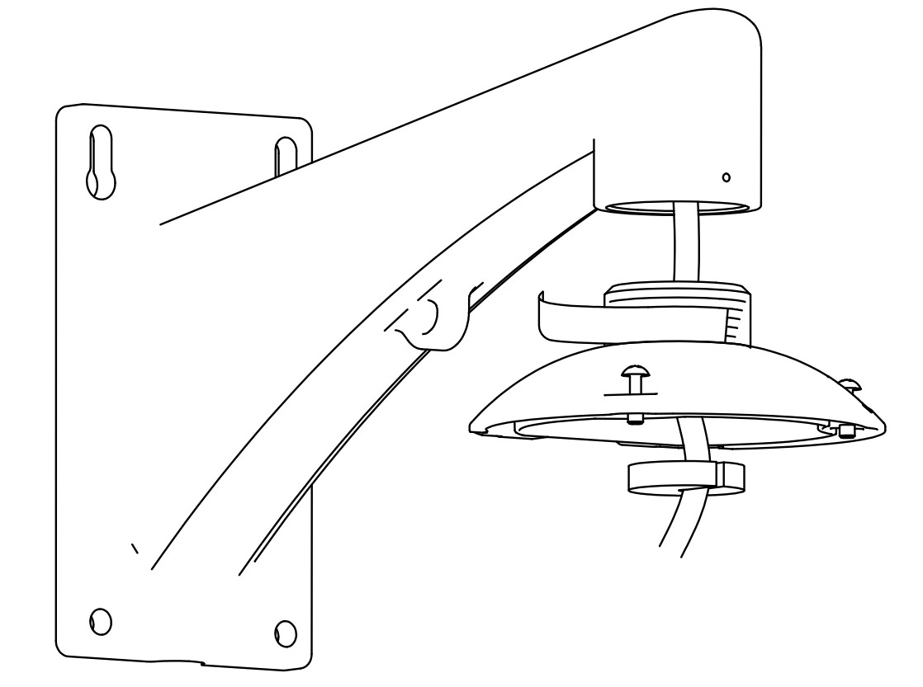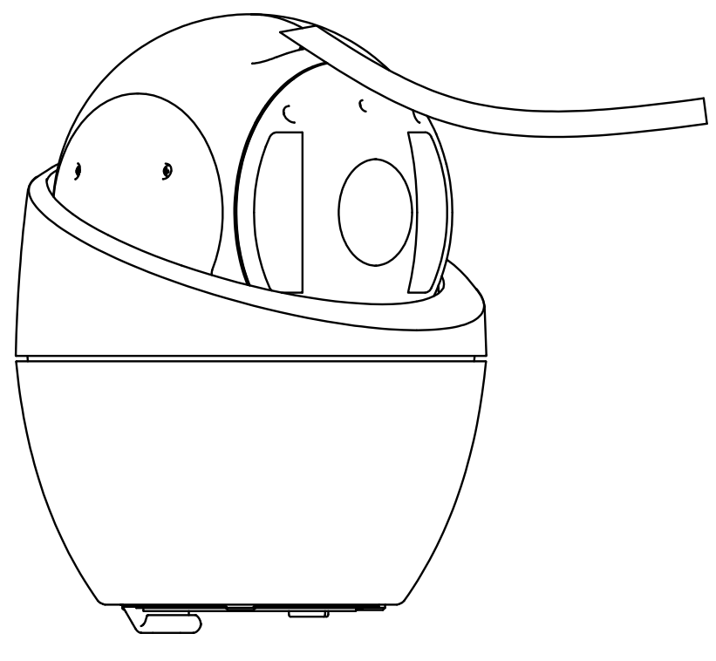
Protective sticker

Figure 1.2.1 Install the Back Box of Dome Figure 1.2.2 Remove the Protective Sticker

  - Configure the dome address, baud rate and other settings through DIP switch SW1 and SW2 located on the bottom board of the dome drive, as shown in Figure 1.2.3 (IR Speed Dome) and Figure 1.2.4 (IR Network Speed Dome). Please refer to Section 1.4 DIP Switch Settings for setting address, baud rate, communication protocol, etc.

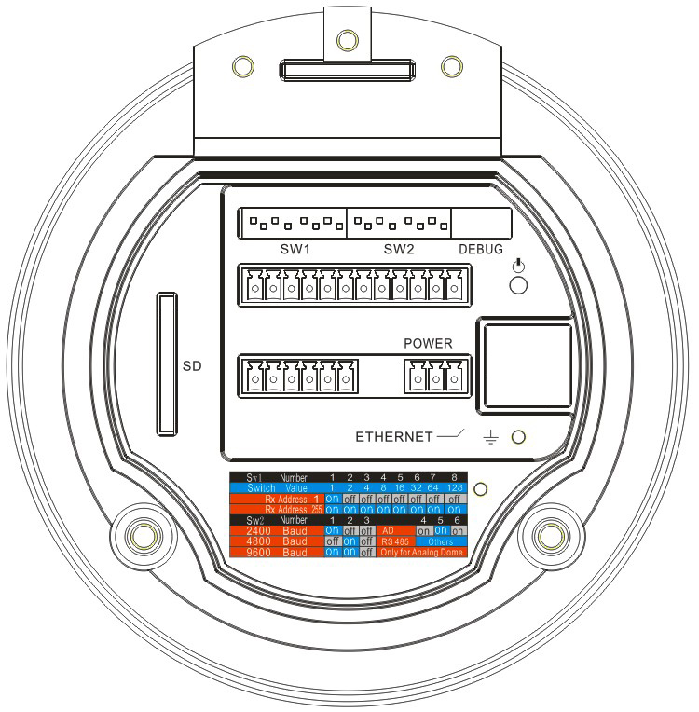
1. Address DIP Switch
2. Protocol DIP Switch
3. Address and Protocol Settings
1
2
3
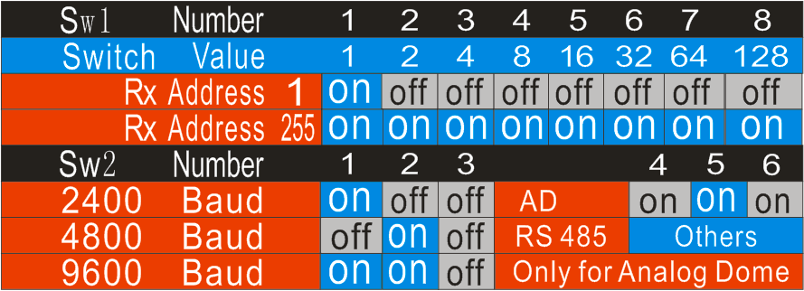
Figure 1.2.3 Bottom Board of IR Speed Dome Drive

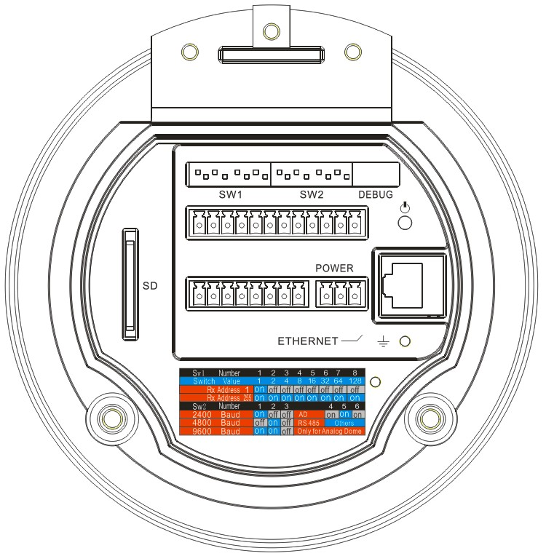
1. Address DIP Switch
2. Protocol DIP Switch
3. Address and Protocol Settings
4. RJ-45 Port
5. SD Card Slot
2
3
1
4
5
Figure 1.2.4 Bottom Board of IR Network Speed Dome Drive
  - Attach the O-ring and then the safety chain to the back box.
Note: The O-ring must be applied to prevent water from entering the dome.
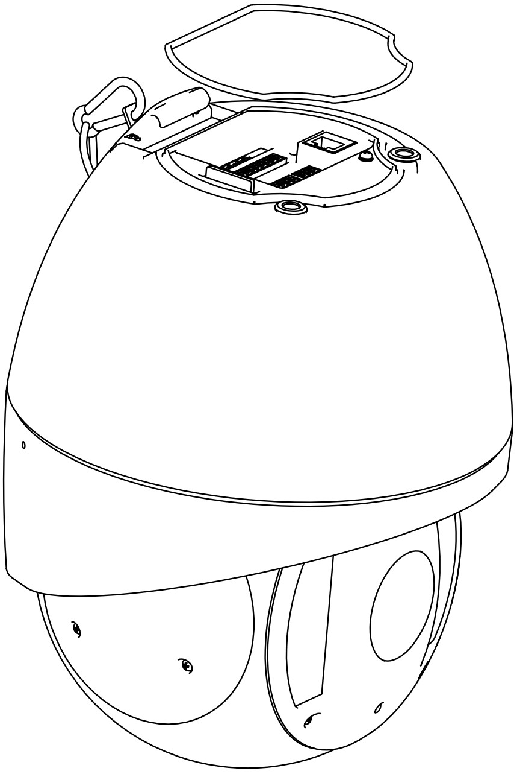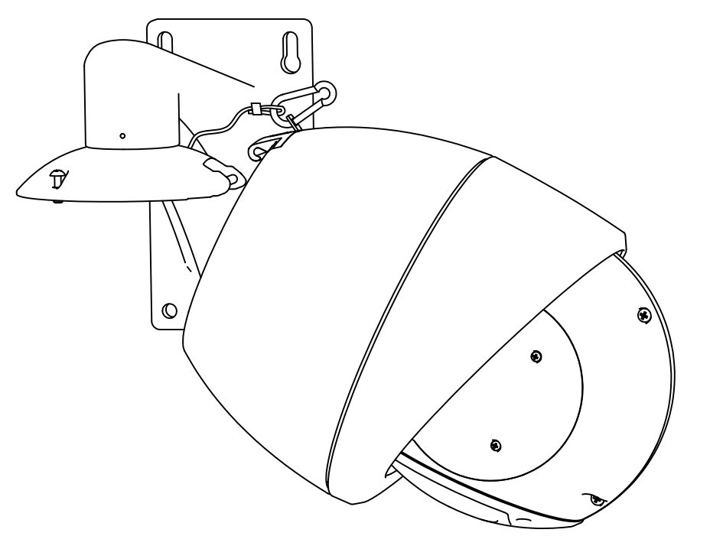
Figure 1.2.5 Attach the O-ring Figure 1.2.6 Attach the Safety Chain

5. Fasten the hook of IR speed dome to the back box and then plug the cables into their matching slots respectively.
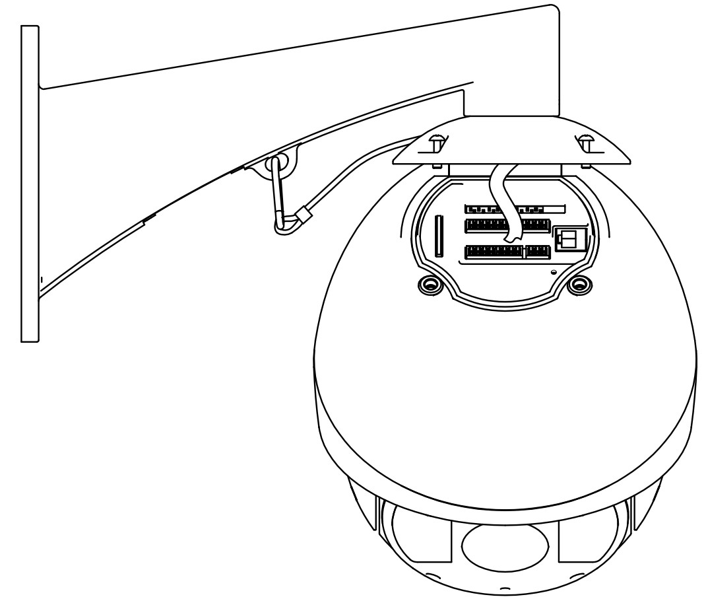
Figure 1.2.7 Fasten the Hook of IR Speed Dome to the Back Box

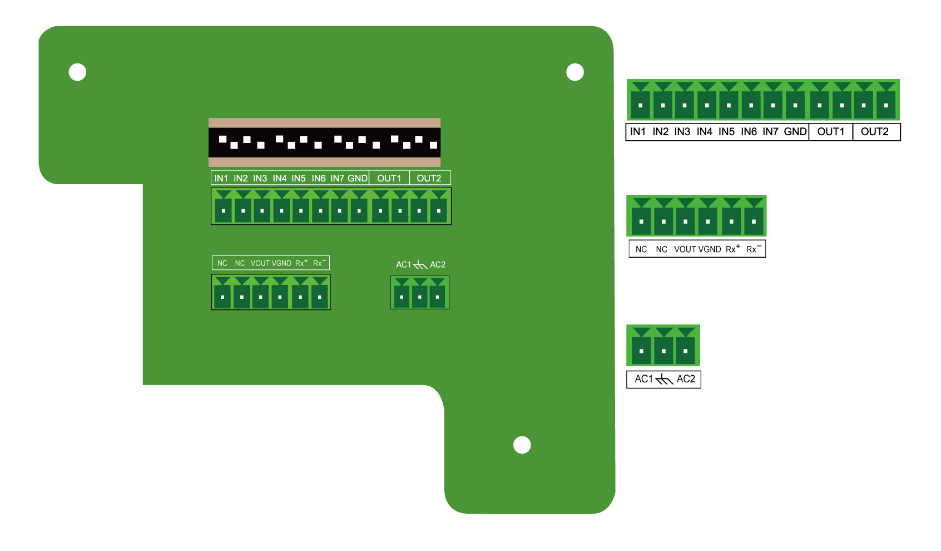
1: Alarm In/Out (7 inputs/2outputs)

2: Video Out and RS-485 COM
3: 24VAC Voltage Input and GND

3
2
1

Figure 1.2.8 Back Box Circuit Board (IR Speed Dome)
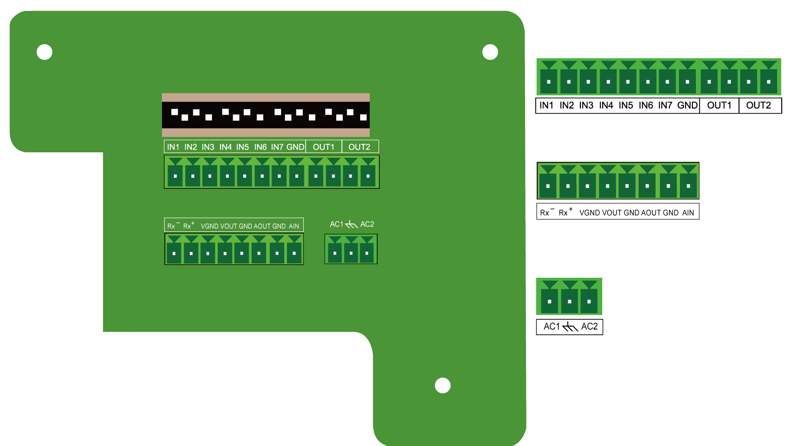
1: Alarm In/Out (7 inputs/2outputs)
2: Audio In/Out, Video Out and
RS-485 COM Terminals
3: 24VAC Voltage Input and GND

3
2
1

1
2
3
Figure 1.2.9 Back Box Circuit Board (IR Network Speed Dome)

  - Use the mounting screws to secure the dome.

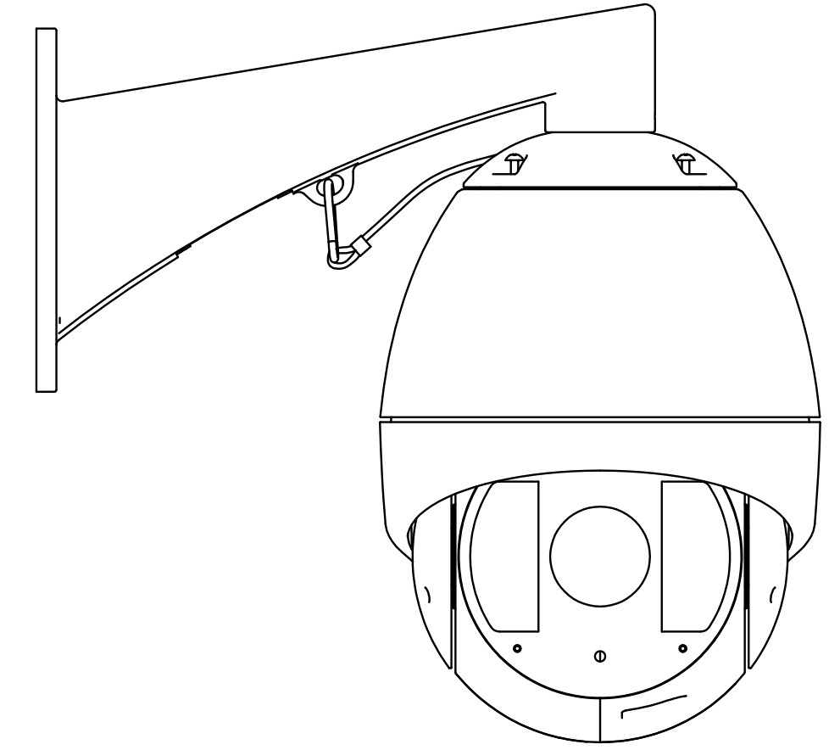
Figure 1.2.10 Use the Mounting Screws to Secure the Dome

Initial Settings
Address code: 0
Baud rate: 2400
120Ω terminator: OFF

DIP Switch Settings

DIP Switch Location
1
2
3
1. Address DIP Switch
2. Protocol DIP Switch
3. Address and Protocol Settings

Figure 1.4.1 Bottom Board of Dome Drive
The dome provides two DIP switches SW1 and SW2 for setting the dome address, baud rate, protocol, etc. As shown in Figure 1.4.1, ON=1, OFF=0. In SW1 and SW2, 1 is the lowest position and 8 is the highest position.
Note: As the IR speed dome is capable of being self-adaptive to PELCO-D, PELCO-P, PRIVATE-Code, VICON and KALATEL-32 protocols, and the IR network speed dome is self-adaptive to Pelco-P, Pelco-D and PRIVATE-Code protocols as well, no DIP switch settings for control protocol are required.

Address Settings
The DIP Switch SW1 is used for setting the dome address:
Dome Address | SW1 Settings | 1 | 2 | 3 | 4 | 5 | 6 | 7 | 8
0 |  | OFF | OFF | OFF | OFF | OFF | OFF | OFF | OFF
1 |  | ON | OFF | OFF | OFF | OFF | OFF | OFF | OFF
255 |  | ON | ON | ON | ON | ON | ON | ON | ON

Settings for address 0~71 are listed as below:
SW1 Position | DIP Switch SW1 Settings
Address | 1 | 2 | 3 | 4 | 5 | 6 | 7 | 8
0 | OFF | OFF | OFF | OFF | OFF | OFF | OFF | OFF
1 | ON | OFF | OFF | OFF | OFF | OFF | OFF | OFF
2 | OFF | ON | OFF | OFF | OFF | OFF | OFF | OFF
3 | ON | ON | OFF | OFF | OFF | OFF | OFF | OFF
4 | OFF | OFF | ON | OFF | OFF | OFF | OFF | OFF
5 | ON | OFF | ON | OFF | OFF | OFF | OFF | OFF
6 | OFF | ON | ON | OFF | OFF | OFF | OFF | OFF
7 | ON | ON | ON | OFF | OFF | OFF | OFF | OFF
8 | OFF | OFF | OFF | ON | OFF | OFF | OFF | OFF
9 | ON | OFF | OFF | ON | OFF | OFF | OFF | OFF
10 | OFF | ON | OFF | ON | OFF | OFF | OFF | OFF
11 | ON | ON | OFF | ON | OFF | OFF | OFF | OFF
12 | OFF | OFF | ON | ON | OFF | OFF | OFF | OFF
13 | ON | OFF | ON | ON | OFF | OFF | OFF | OFF
14 | OFF | ON | ON | ON | OFF | OFF | OFF | OFF
15 | ON | ON | ON | ON | OFF | OFF | OFF | OFF
16 | OFF | OFF | OFF | OFF | ON | OFF | OFF | OFF
17 | ON | OFF | OFF | OFF | ON | OFF | OFF | OFF
18 | OFF | ON | OFF | OFF | ON | OFF | OFF | OFF
19 | ON | ON | OFF | OFF | ON | OFF | OFF | OFF
20 | OFF | OFF | ON | OFF | ON | OFF | OFF | OFF
21 | ON | OFF | ON | OFF | ON | OFF | OFF | OFF
22 | OFF | ON | ON | OFF | ON | OFF | OFF | OFF
23 | ON | ON | ON | OFF | ON | OFF | OFF | OFF
24 | OFF | OFF | OFF | ON | ON | OFF | OFF | OFF
25 | ON | OFF | OFF | ON | ON | OFF | OFF | OFF
26 | OFF | ON | OFF | ON | ON | OFF | OFF | OFF
27 | ON | ON | OFF | ON | ON | OFF | OFF | OFF
28 | OFF | OFF | ON | ON | ON | OFF | OFF | OFF
29 | ON | OFF | ON | ON | ON | OFF | OFF | OFF
30 | OFF | ON | ON | ON | ON | OFF | OFF | OFF
31 | ON | ON | ON | ON | ON | OFF | OFF | OFF
32 | OFF | OFF | OFF | OFF | OFF | ON | OFF | OFF
33 | ON | OFF | OFF | OFF | OFF | ON | OFF | OFF
34 | OFF | ON | OFF | OFF | OFF | ON | OFF | OFF
35 | ON | ON | OFF | OFF | OFF | ON | OFF | OFF
36 | OFF | OFF | ON | OFF | OFF | ON | OFF | OFF
37 | ON | OFF | ON | OFF | OFF | ON | OFF | OFF
38 | OFF | ON | ON | OFF | OFF | ON | OFF | OFF
39 | ON | ON | ON | OFF | OFF | ON | OFF | OFF
40 | OFF | OFF | OFF | ON | OFF | ON | OFF | OFF
41 | ON | OFF | OFF | ON | OFF | ON | OFF | OFF
42 | OFF | ON | OFF | ON | OFF | ON | OFF | OFF
43 | ON | ON | OFF | ON | OFF | ON | OFF | OFF
44 | OFF | OFF | ON | ON | OFF | ON | OFF | OFF
45 | ON | OFF | ON | ON | OFF | ON | OFF | OFF
46 | OFF | ON | ON | ON | OFF | ON | OFF | OFF
47 | ON | ON | ON | ON | OFF | ON | OFF | OFF
48 | OFF | OFF | OFF | OFF | ON | ON | OFF | OFF
49 | ON | OFF | OFF | OFF | ON | ON | OFF | OFF
50 | OFF | ON | OFF | OFF | ON | ON | OFF | OFF
51 | ON | ON | OFF | OFF | ON | ON | OFF | OFF
52 | OFF | OFF | ON | OFF | ON | ON | OFF | OFF
53 | ON | OFF | ON | OFF | ON | ON | OFF | OFF
54 | OFF | ON | ON | OFF | ON | ON | OFF | OFF
55 | ON | ON | ON | OFF | ON | ON | OFF | OFF
56 | OFF | OFF | OFF | ON | ON | ON | OFF | OFF
57 | ON | OFF | OFF | ON | ON | ON | OFF | OFF
58 | OFF | ON | OFF | ON | ON | ON | OFF | OFF
59 | ON | ON | OFF | ON | ON | ON | OFF | OFF
60 | OFF | OFF | ON | ON | ON | ON | OFF | OFF
61 | ON | OFF | ON | ON | ON | ON | OFF | OFF
62 | OFF | ON | ON | ON | ON | ON | OFF | OFF
63 | ON | ON | ON | ON | ON | ON | OFF | OFF
64 | OFF | OFF | OFF | OFF | OFF | OFF | ON | OFF
65 | ON | OFF | OFF | OFF | OFF | OFF | ON | OFF
66 | OFF | ON | OFF | OFF | OFF | OFF | ON | OFF
67 | ON | ON | OFF | OFF | OFF | OFF | ON | OFF
68 | OFF | OFF | ON | OFF | OFF | OFF | ON | OFF
69 | ON | OFF | ON | OFF | OFF | OFF | ON | OFF
70 | OFF | ON | ON | OFF | OFF | OFF | ON | OFF
71 | ON | ON | ON | OFF | OFF | OFF | ON | OFF

Baud Rate Settings
The positions 1-3 of DIP Switch SW2 are used for setting the baud rate of dome. The settings 100~101 respectively corresponds to the baud rate of 2400bps, 4800bps and 9600bps. For baud rate out of the above range, the default setting is 2400bps. Refer to the following table:

DIP Switch SW2-Baud Rate Settings
Baud Rate | Positions1-3 Settings | 1 | 2 | 3
2400 |  | ON | OFF | OFF
4800 |  | OFF | ON | OFF
9600 |  | ON | ON | OFF

Protocol Settings
The positions 4-6 of DIP Switch SW2 are used for setting the communication protocols of dome. Refer to the following table (network speed dome model does not support Manchester code protocol):
DIP Switch SW2-Protocol Settings
Protocol | Positions 4-6 Settings | 4 | 5 | 6
Bosch Manchester |  | OFF | ON | ON
AD Manchester |  | ON | ON | ON
Self-adaptive | Others

Simplex/Half-duplex Settings
The position 7 of DIP Switch SW2 is used for setting the communication method of dome to simplex or half-duplex.
DIP Switch SW2-Simplex/Half-duplex Settings
Description | Position 7 Setting | 7
Simplex |  | OFF
Half-duplex |  | ON

Terminating Resistor Settings
The position 8 of DIP Switch SW2 is used for setting the 120Ω terminating resistor of dome.
DIP Switch SW2-Terminating Resistor Settings
Description | Position 8 Setting | 8
Not Terminated |  | OFF
Terminated |  | ON

Alarm In/Out Connections
The IR Speed Dome and IR Network Speed Dome can be connected with 7 alarm inputs (0~12VDC) and 2 alarm outputs. Refer to the following diagram:

The alarm provides the relay output (no voltage), and the external power supply is required when it connects to the alarm device. For DC power supply (left diagram), the input voltage must be within the range of 12VDC, 30mA. For AC power supply, the external relay must be used (right diagram) so as to prevent damages to the unit and avoid risk of electric shock.

Chapter 2 Mounts Dimension

2.1 Long-arm Wall Mount
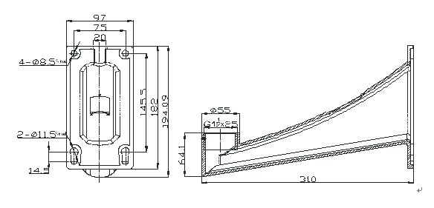

2.2 Short-arm Wall Mount
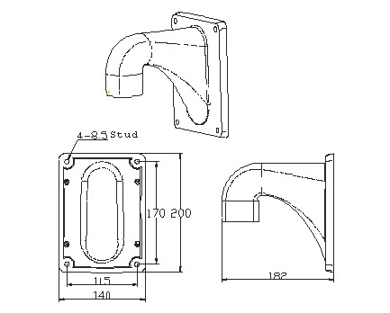

2.3 Corner Adapter
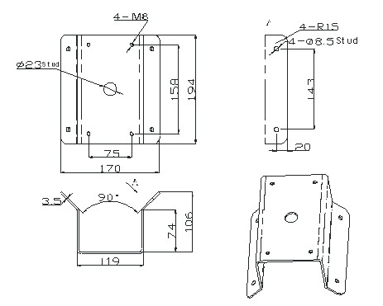

2.4 Pole Adapter
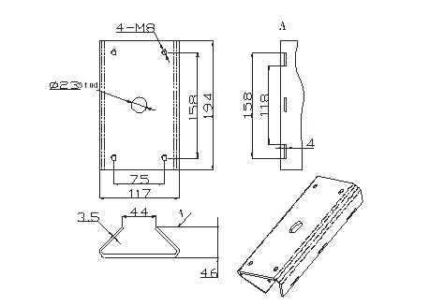

2.5 Pendant Adapter
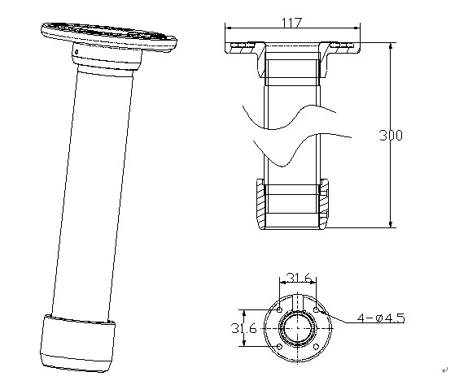

Chapter 3 Wall Mounting Applications

3.1 Mounting Components
- Wall Mount
Applicable to indoor/outdoor pendant domes.
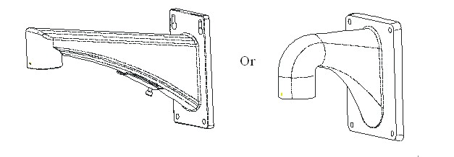
- Mounting Accessories
Nuts and Flat Washers

3.2 Wall Mounting Instructions
The wall mounting is applicable to the indoor/outdoor solid wall construction which should comply with the following mounting requirements:
  - The wall must be thick enough to install the expansion screws.
  - The wall must be capable of supporting up to 8 times the total load of the dome and its accessories.
Step1: Drill mounting holes in the wall and install the expansion screws
Drill four holes in the wall according to the mounting locations, and then insert M6 expansion screws (not supplied) into the mounting holes.

Step2: Secure the wall mount to the wall
Fasten the expansion screws through the wall mount and gasket by using four hex nuts with flat washers to secure the wall mount to the wall.
Step3: Install dome to the mount
Feed cables through the opening on top of the back box, screw the back box into the threads in the mount, and then use M3 screws to secure the dome. Refer to Section 1.2 for installation instructions.
Note: Follow the same instructions described above for the Short-arm Wall Mount installation. For outdoor applications, please adopt the water-proof measures. The Short-arm Wall Mount is not recommended for outdoor applications.

Chapter 4 Corner Mounting Applications

4.1 Mounting Components
  - Wall Mount
Applicable to the indoor/outdoor pendant domes with the use of corner adapter, wall adapter or pole adapter.
  - Corner Adapter
For use with the wall mount in the corner mounting applications.
- Mounting Accessories
Hex Screws (M8×30), Nuts, Spring Washers and Flat Washers

4.2 Corner Mounting Instructions
The corner mounting is applicable to the indoor/outdoor 90° solid corner construction which should comply with the following mounting requirements:
  - The wall must be thick enough to install the expansion screws.
  - The wall must be capable of supporting up to 8 times the total load of the dome and its accessories.

Step1: Install the corner adapter
Drill four holes in the corner according to the mounting locations, and then insert M6 expansion screws (not supplied) into the holes. Pull the power cord, video cable and control line through the opening of the corner adapter. Secure the corner adapter to the corner by using nuts and washers to tighten the four expansion screws.
Note: Make sure the cables have enough length. For outdoor applications, please apply the sealant around the cable opening to prevent water.
Step2: Secure the wall mount to the corner
Apply four hex screws with the spring washers to the corner adapter through the wall mount and gasket.
Note: When tightening the screw, it is better to compress the spring washer firstly and then rotate half a round so as to maintain required waterproof effect without damaging the threads.

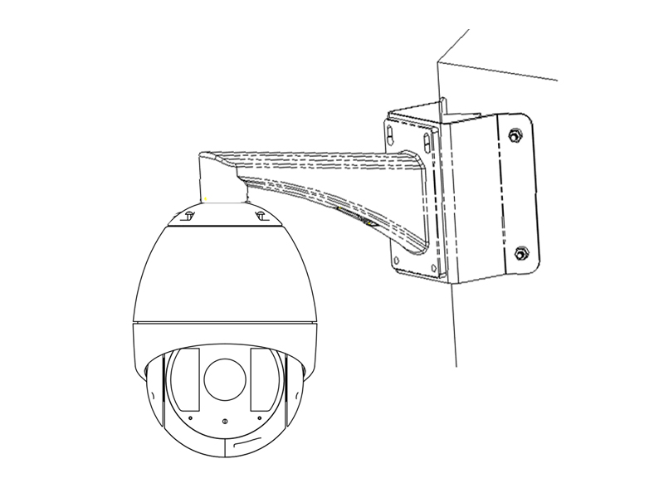
Step3: Install dome to the mount
Feed the cables through the opening on top of the back box, and attach the dome to the mount. Finally, use M3 screws to secure the two units. Refer to Section 1.2 for installation instructions.
Note: Follow the same instructions described above for the Short-arm Corner Mount installation. For outdoor applications, please adopt the water-proof measures. The Short-arm Wall Mount is not recommended for outdoor applications.

Chapter 5 Pole Mounting Applications

5.1 Mounting Components
  - Wall Mount
Applicable to indoor/outdoor pendant domes with the use of corner adapter, wall adapter or pole adapter.

  - Pole Adapter
For use with the wall mount in the pole mounting applications.

  - Stainless Steel Straps
For use with the pole adapter, with the following dimensions selectable:
φ59-82mm, φ84-108mm, φ103-127mm, φ130-152mm, φ155-178mm, φ180-203mm, φ194-216mm;
Customized dimensions can also be provided according to user’s demand.
  - Mounting Accessories
Hex Screws (M8×30) and Spring Washers

Pole Mounting Instructions
The pole mounting is applicable to the indoor/outdoor solid pole construction which should comply with the following mounting requirements:
  - The diameter of pole must be constituent with the mounting dimensions of the stainless steel straps.
  - The pole construction must be capable of supporting up to 8 times the total load of the dome and its accessories.

Step1: Assemble the pole mount adapter
Use a screwdriver to loosen the three stainless steel straps and then insert them through the rectangle holes on the pole adapter.
Step2: Install pole adapter
Feed the control line, video cable and power cable through the central opening and secure the three stainless steel straps to the pole, and finally use the screwdriver to fasten the screws at the steel straps.
Note: For outdoor applications, please adopt the water-proof measures.

Step3: Install wall mount assembly
Screw four hex screws with the spring washers to the pole adapter through the wall mount and gasket.
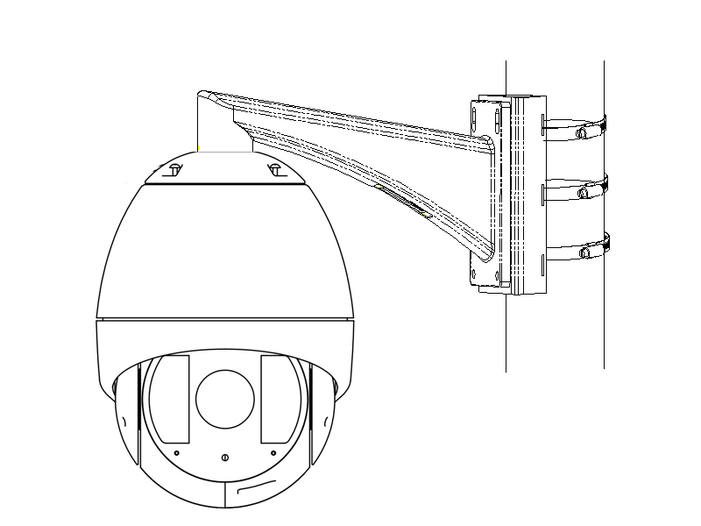
Step4: Install dome to the mount
Feed the cables through the opening on top of the back box, and attach the dome to the mount, and finally use M3 screws to secure the dome. Refer to Section 1.2 for installation instructions.
Note: Follow the same instructions described above for the Short-arm Corner Mount installation. For outdoor applications, please adopt the water-proof measures. The Short-arm Wall Mount is not recommended for outdoor applications.

Chapter 6 Pendant Mounting Applications

6.1 Mounting Components
  - Mounting Base
Applicable to pendant domes with the use of the pendant pole and pole adapter.
  - Pendant Pole
- Pendant Adapter

Pendant Mounting Instructions
The pendant mounting is applicable to the indoor/outdoor solid ceiling construction which should comply with the following mounting requirements:
  - The ceiling must be thick enough to mount the expansion screws.
  - The ceiling must be capable of supporting up to 8 times the total load of the dome and its accessories.

Step1: Install the mounting base
Drill four φ6 holes in the ceiling according to the fastener holes locations of the mounting base, and then insert M6 expansion screws (not supplied) into the holes. Pull the power cord, video cable and control line through the opening at the mounting base. Secure the mounting base to the corner by using nuts and washers to tighten the four expansion screws.
Note: Make sure the cables have enough length. For outdoor applications, please apply water-proof measures between the ceiling surface and mounting base and around the cables opening. The pendant mounting application is not recommended for outdoor environment where directly suffers rain.

Step2: Install the pendant pole
Swivel the pendant adapter into the matching pendant pole and then use the retainer screws to secure the two parts. Pull out the cables through the pendant pole and screw the pendant pole into the mounting base and use the set screws to secure the two parts as well.
Note: For outdoor applications, please apply the water-proof thread compound to the threads.

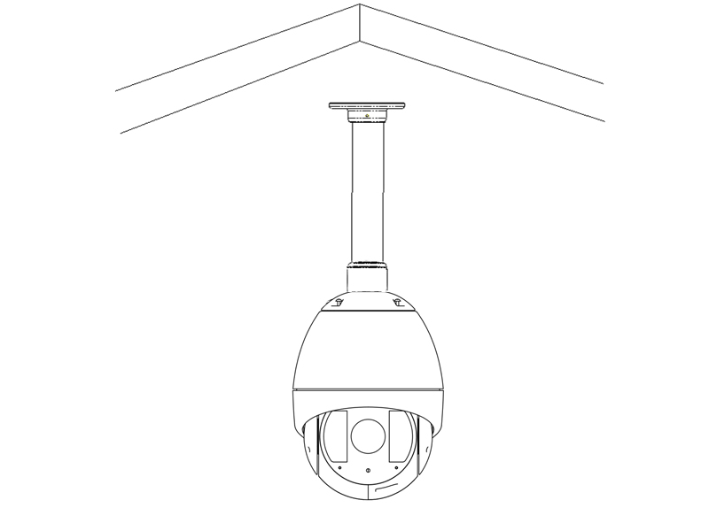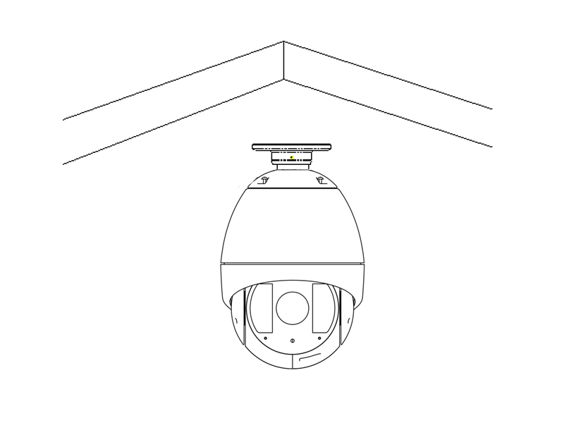
Step3: Install dome to the mount
Feed the cables through the opening on top of the back box, and attach the dome to the pendant pole, and finally use M3 screws to secure the dome. Refer to Section 1.2 for installation instructions.
Note: In case of insufficient ceiling height, directly attach the dome to the mounting base without use of pendant pole, as shown in the figure right above.

Appendix 1 Lightning & Surge Protection
This product adopts TVS plate lightning protection technology to avoid damage caused by pulse signal that is below 3000W, like instantaneous lighting, surging, etc. According to the actual situation outdoors, necessary protection measures must be taken to secure the electrical safety.
1. The distance between signal transmission line and High-voltage equipment or high-voltage cable is at least 50m.
2. Outdoor wiring should better be along the eaves as much as possible.
3. In the open field, wiring should be buried underground in sealed steel pipe, and the steel-pipe should be one-point grounding. Overhead routing method is forbidden.
4. In strong thunderstorm area or high induction voltage areas (such as high-voltage transformer substation), high power lightning protection apparatus and lightning conductor are necessary to be appended.
5. The design for installation and wiring with lightning protection and grounding in mind should be combined with the lightning protection consideration of the building, and conform to the related national standards and industry standards.
6. The system should be equipotentially grounded, and the grounding equipment must satisfy double-request of system anti-jamming and electric safety, and it must not appear short circuit and open circuit with the zero conductor of strong grid. When the system is grounding individual, the resistance should be no more than 4Ω, the section al area of the grounding cable should be no less than 25mm². For grounding instructions, please refer to the Installation Manual of Speed Dome.

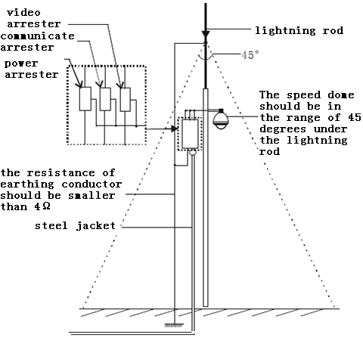

Appendix 2 RS485 Bus Connection
1. General Property of RS485 Bus
According to RS485 industry bus standard, RS485 is a half-duplex communication bus which has 120Ω characteristic impendence, the maximum load ability is 32 payloads (including controller device and controlled device).
2. RS485 Bus Transmission Distance
When using 0.56mm (24AWG) twisted-pair line, according to different baud rate, the max transmission distance theory table is shown as below:

Baud Rate | Max Distance
2400BPS | 1800m
4800BPS | 1200m
9600BPS | 800m

The transmission distance will be decreased if we use the thinner cable, or use this product under the strong electromagnetic interference situation, or there are lots of devices are added to the bus; on the contrary, the transmission distance will be increased.
3. Connection Method and Terminal Resistance
- RS485 industry bus standard require daisy-chain connection method between any devices, both sides have to connect a 120Ω terminal resistance (show as Diagram 1), the simplified connection method is shown as diagram 2, but the distance of “D” should not be too long.

Diagram 1
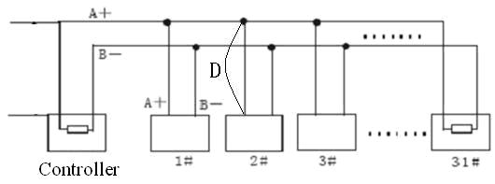
Diagram 2
2) Connection of 120Ω terminal resistor
The 120Ω terminal resistor can be connected through the DIP switch on the communications board, as high speed dome shown in Figure3. For a new dome, the 120Ω matching resistor is defaulted as unconnected, switch on the eighth bit of SW2, it will be connected. Conversely, switch off the eighth bit of SW2, it will be unconnected.
1. Address DIP Switch
2. Protocol DIP Switch
3. Address and Protocol Settings

3
2
1

Figure 3
4. Problems in the Practical Application
Normally, users adopt star-shape connection method in construction, under this situation, the terminal resistors must be connected between two farthest devices (as Figure 4, 1# and 15#), but this connection method is not satisfy the requirement of the RS485 industry standard so that it will lead to some problems such as signal reflection, anti-jamming ability decline when the devices are faraway. At this time, the dome will be uncontrollable, or self-running, etc.
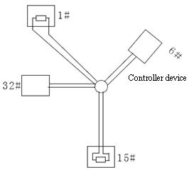
Figure 4
For such case, the best way is adding a RS485 distributor. This product can effectively change the star-shape connection to which satisfies the requirement of RS485 industry standard, in order to avoid those problems and improve the communication reliability. Show as figure 5.
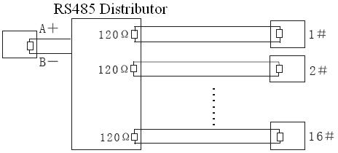
Figure 5
- FAQ of RS485 Bus
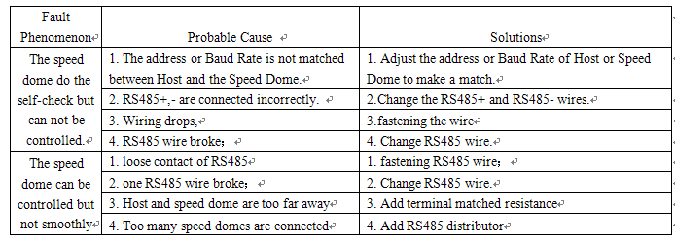

Appendix 3 24VAC Wire Gauge & Transmission Distance
The following table has described the recommended max. distance adopted for the certain wire gauge when the 24VAC voltage loss rate is less than 10%. For the AC driven device, the maximum voltage loss rate allowable is 10%. For example, for a device with the rating power of 80VA which is installed at a distance of 35 feet (10m) away from the transformer, then the minimum wire gauge required is 0.8000mm.

Appendix 4 Table of Wire Gauge Standards

