Verify Contents
Verify that the package contents are correct by checking the items against the packing list.
Note: Please contact your dealer for damaged or missing items.

DVR Pre-Installation
The DS-7600-S Series Embedded NVR is highly advanced surveillance equipment that should be installed with care. Please take into consideration the following precautionary steps before installation of the DVR.
1. Keep all liquids away from the DVR.
2. Install the DVR in a well-ventilated and dust-free area.
3. Ensure environmental conditions meet factory specifications.
4. Install a manufacturer recommended HDD.

DVR Installation
During the installation of the DVR:
1. Use brackets for rack mounting.
2. Ensure there is ample room for audio and video cables.
3. When installing cables, ensure that the bend radius of the cables are no less than five times than it’s’ diameter.
4. Connect both the alarm and RS-485 cable.
5. Allow at least 2cm (~0.75in) of space between racks mounted devices.
6. Ensure the DVR is grounded.
7. Environmental temperature should be within the range of -10ºC ~ 55ºC, 14ºF ~ 131ºF.
8. Environmental humidity should be within the range of 10% ~ 90%.

Hard Disk Installation
Before installing a hard disk drive (HDD), please make sure the power is disconnected from the DVR. A factory recommended HDD should be used for this installation.
Tools Required: Phillips screwdriver.

To install a HDD on your DVR:
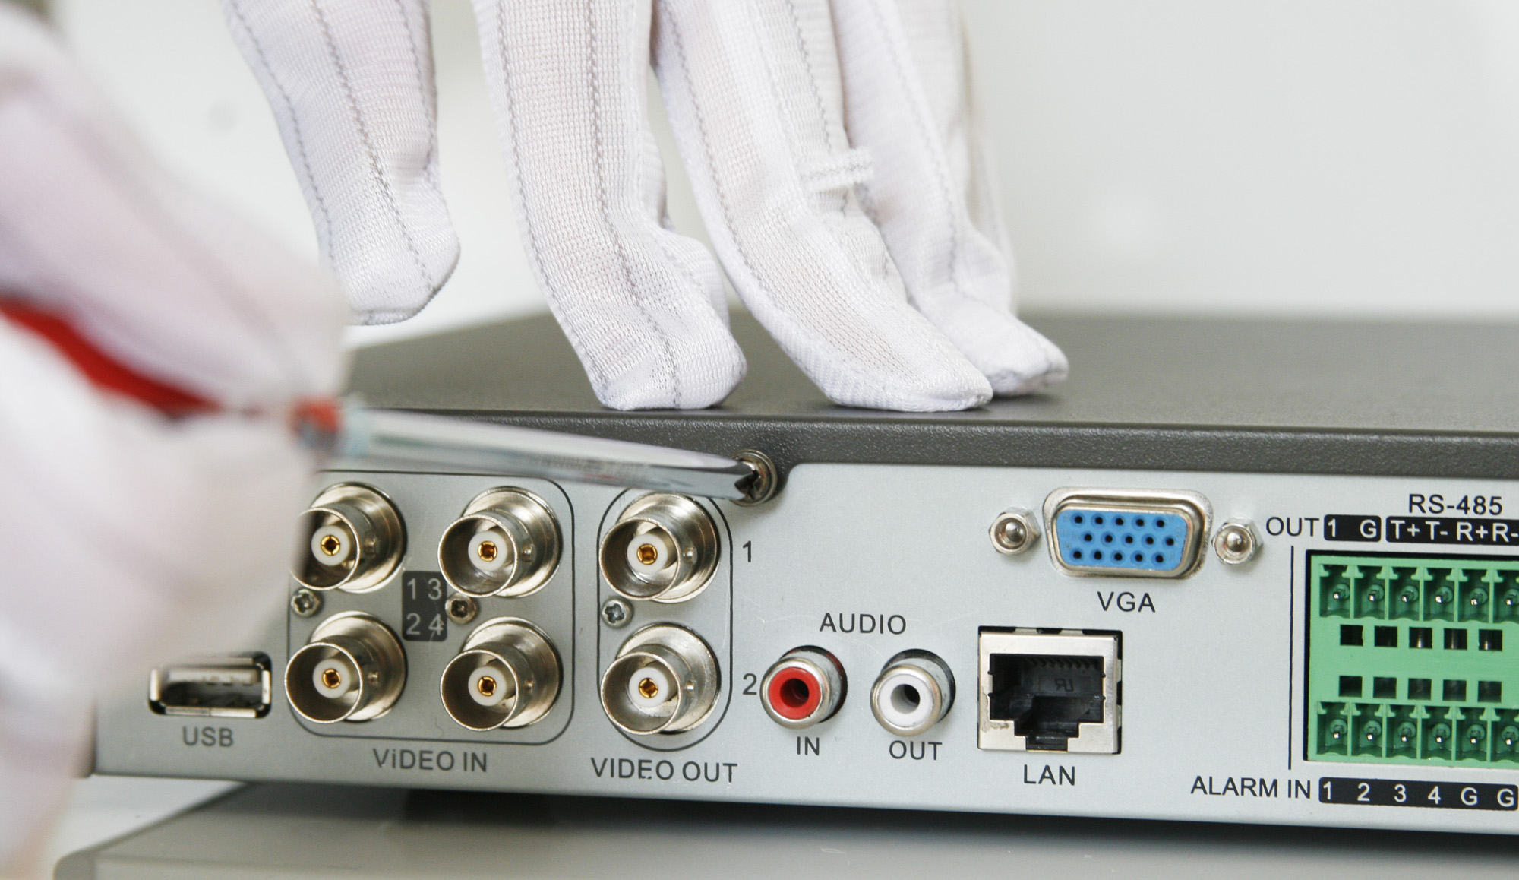
1. Remove the lid of the DVR by unfastening the screws on the back and side.
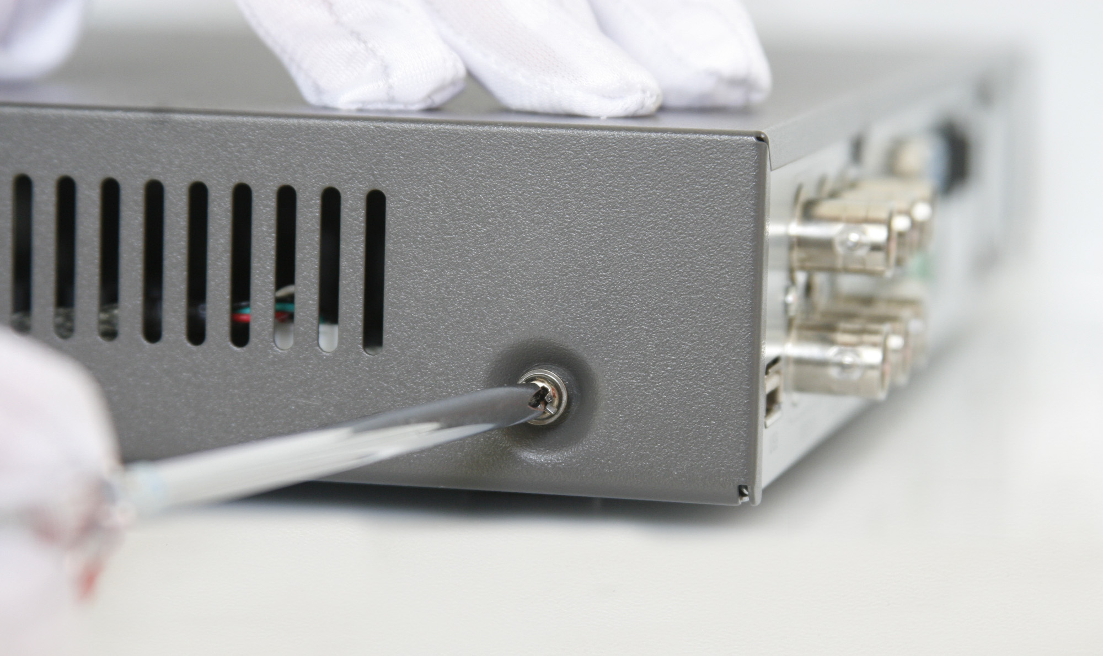

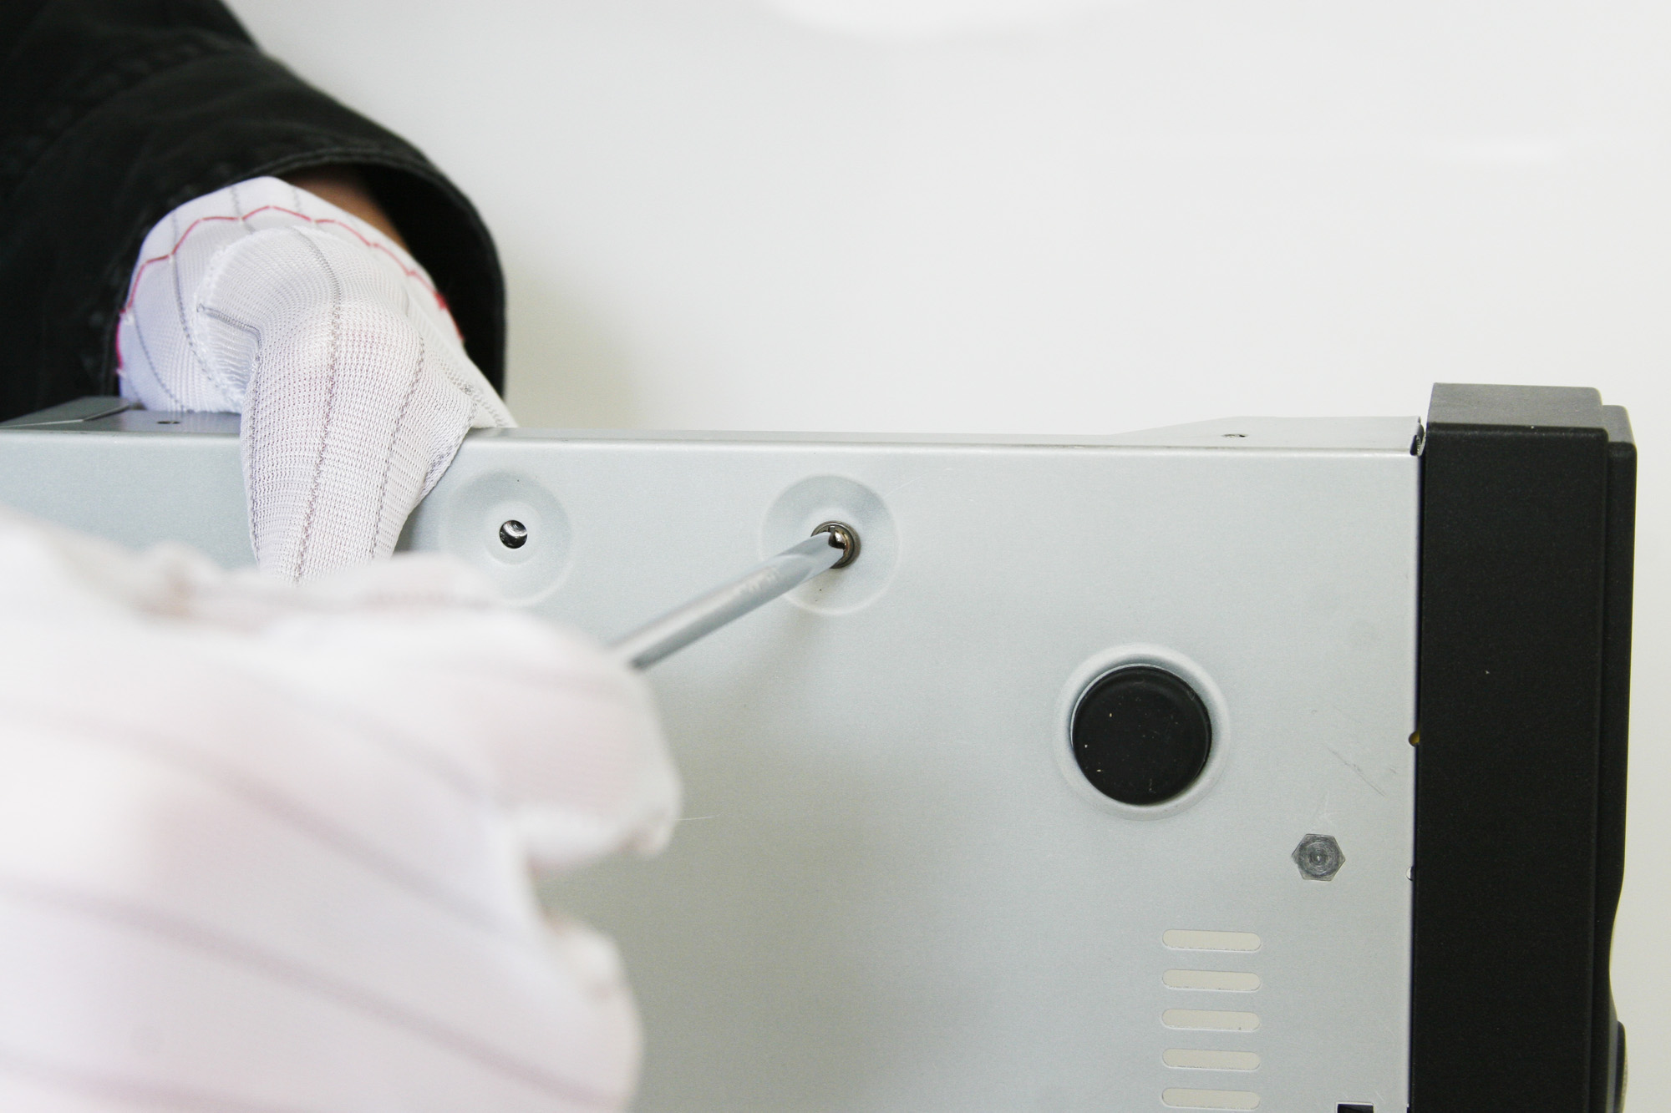
2. Install the HDD in the HDD rack using the provided screws. Fasten the screws on the button to fix the HDD.
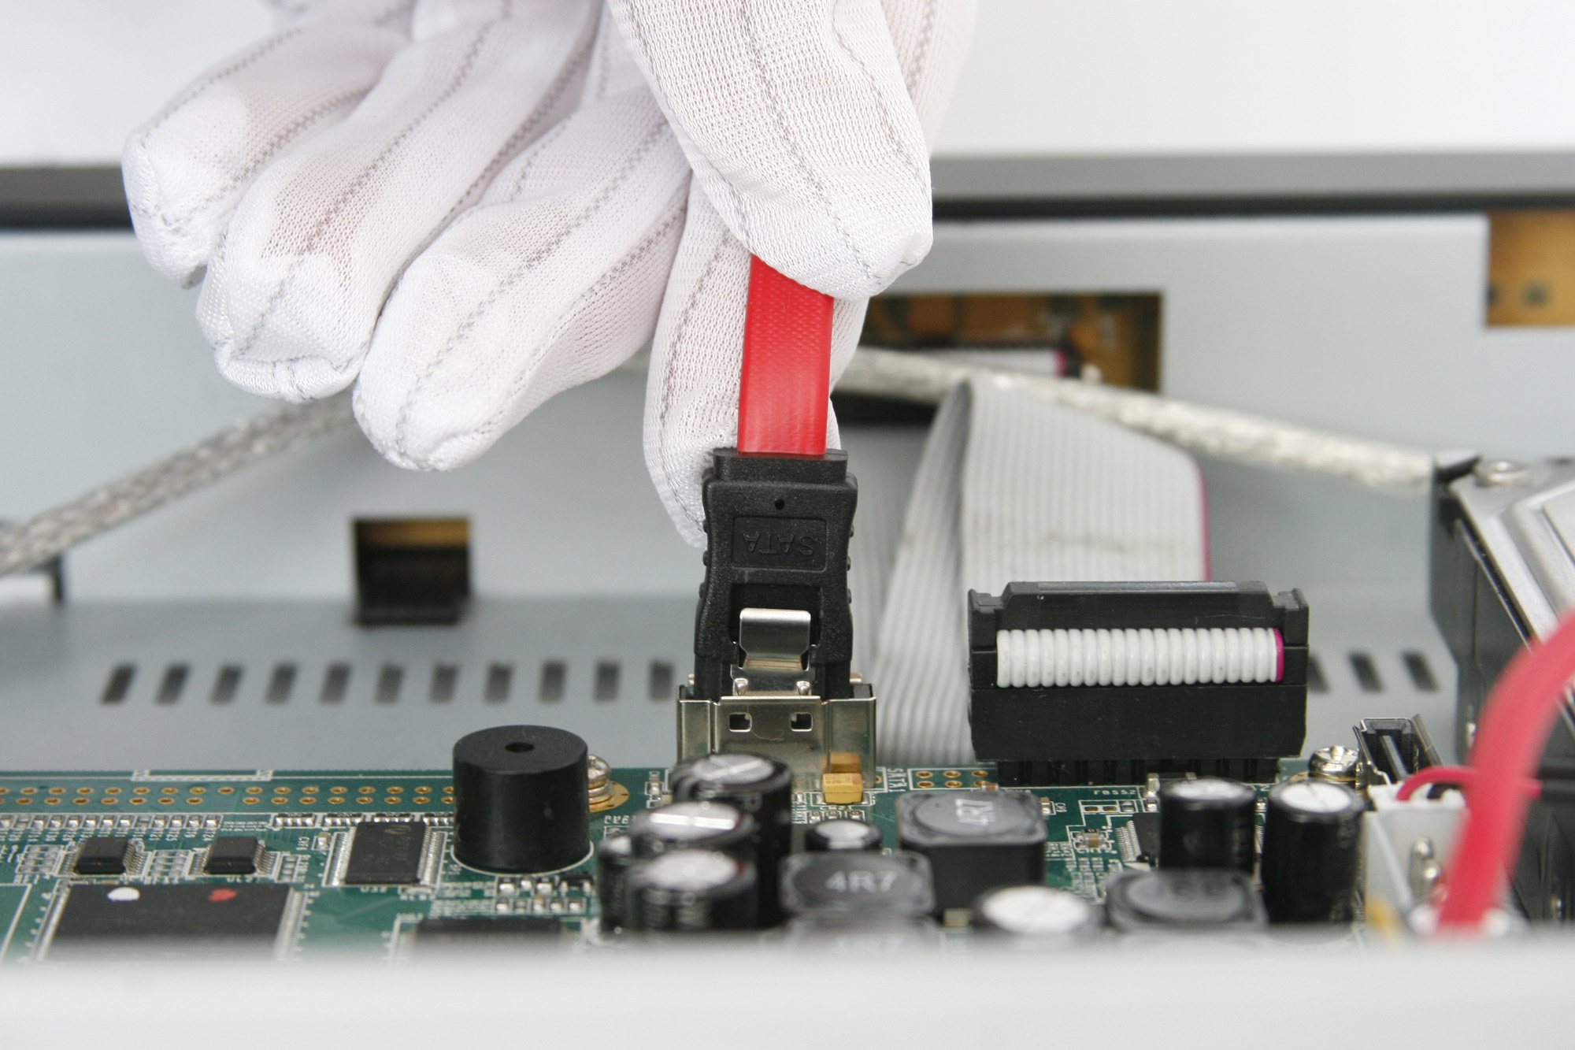
3. Connect the HDD to the motherboard of the DVR with the included data cable.
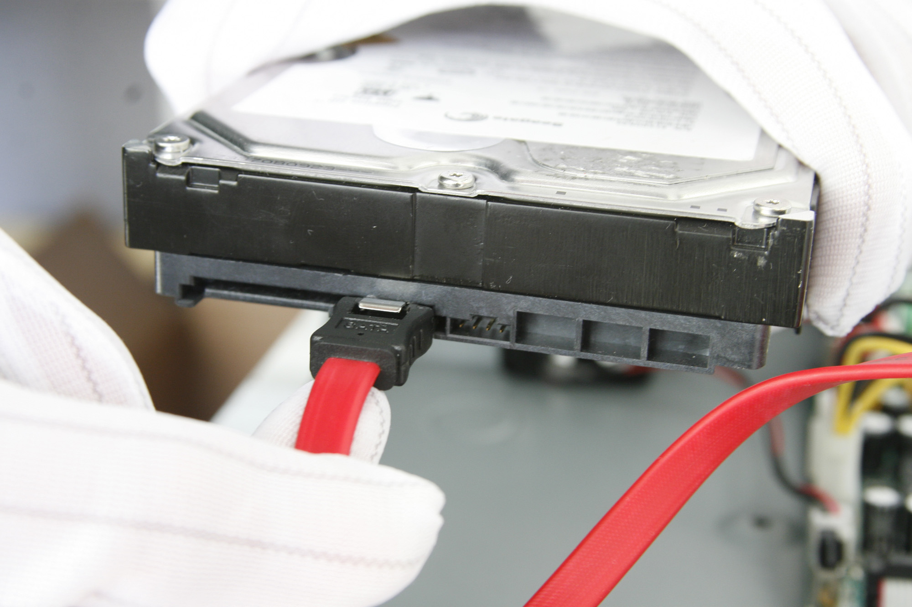

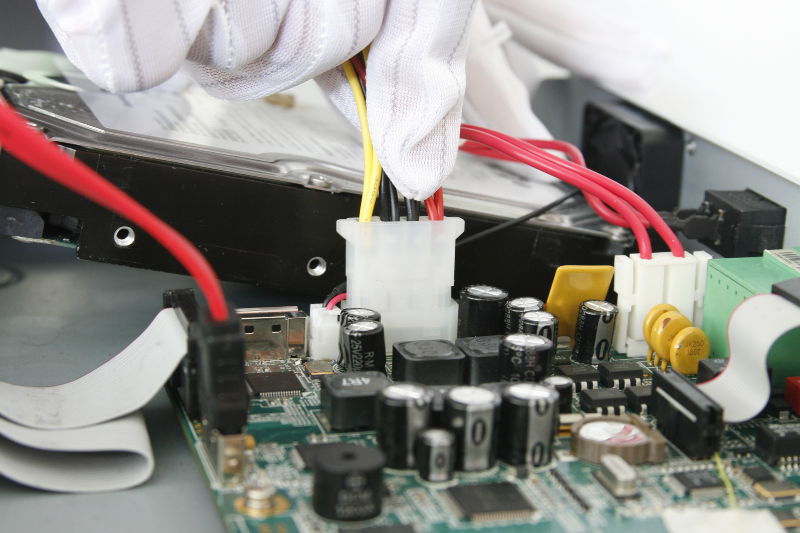
4. Connect the power cable to the HDD.

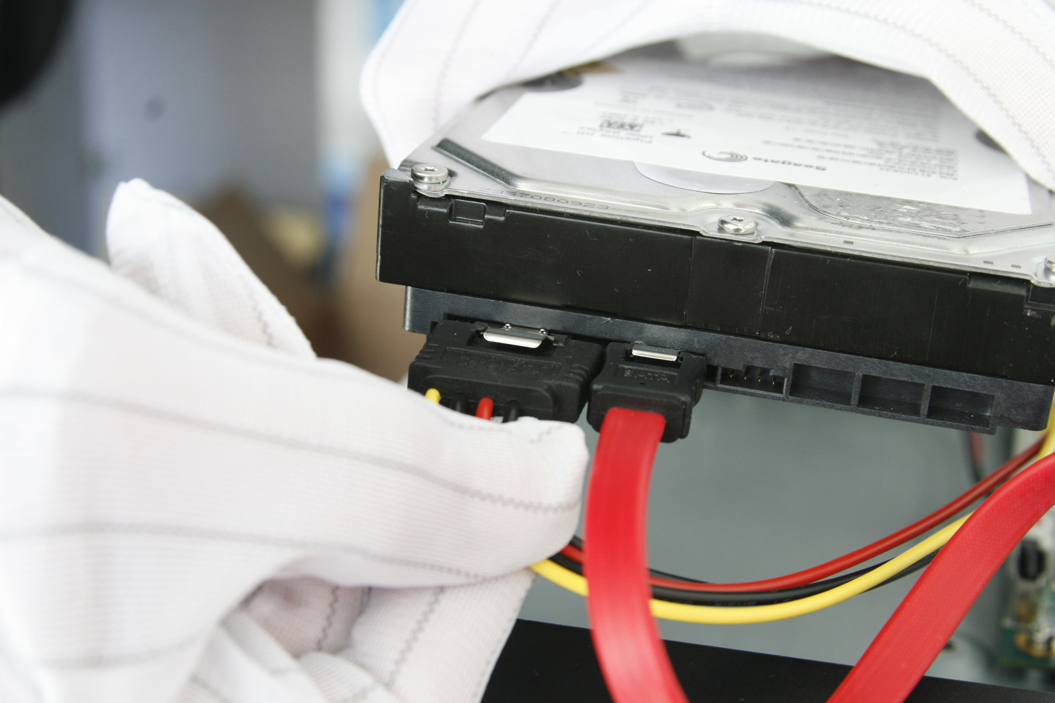

5. Re-install the lid of the DVR and fasten screws.

Rear Panel Diagram

DS-7604NI-S:

No. | Item | Description
1 | USB Interface | Connector for USB devices.
2 | VIDEO OUT | BNC connector for video output.
3 | AUDIO IN | RCA connectors for analog audio input.
4 | AUDIO OUT | RCA connector for audio output.
5 | LAN Interface | Connector for LAN (Local Area Network).
6 | VGA | VGA connector for video output
7 | RS-485 Interface | Connector for RS-485 devices. T+, T- pin connects to PTZ.
 | ALARM IN | Connector for alarm input (up to 4 channels).
 | ALARM OUT | Connector for alarm output (1 channel).
8 | Power Switch | Switch for turn on/off the device.
9 | POWER | 12VDC
10 | GND | Ground(needs to be connected when DVR startup)

DS-7604HI-S:

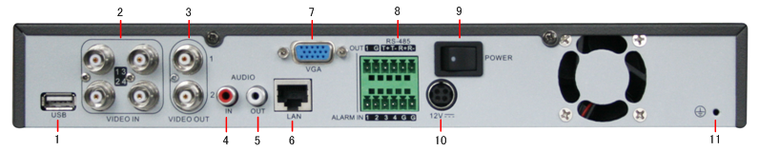

No. | Item | Description
1 | USB Interface | Connector for USB devices.
2 | VIDEO IN | BNC connectors for analog video input.
3 | VIDEO OUT | BNC connector for video output. If VGA is connected, the interface will be disabled (The screen will become black.). If BNC is connected, the VGA interface will be diabled. 1 is main video out, 2 is spot video out.
4 | AUDIO IN | RCA connectors for analog audio input.
5 | AUDIO OUT | RCA connector for audio output.
6 | LAN Interface | Connector for LAN (Local Area Network).
7 | VGA | DB15 connector for VGA output. Display local video output and menu.
8 | RS-485 Interface | Connector for RS-485 devices. T+, T- pin connects to PTZ.
 | ALARM IN | Connector for alarm input (up to 4 channels).
 | ALARM OUT | Connector for alarm output (1 channel).
9 | Power Switch | Switch for turn on/off the device.
10 | POWER | 12VDC
11 | GND | Ground(needs to be connected when DVR startup)

DS-7608NI-S:
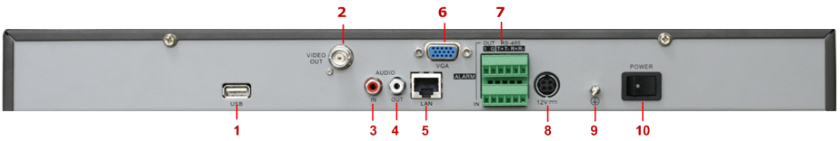

No. | Item | Description
1 | USB Interface | Connector for USB devices
2 | VIDEO OUT | BNC connector for video output
3 | AUDIO IN | RCA connectors for analog audio input
4 | AUDIO OUT | RCA connector for audio output
5 | LAN | Connector for LAN (Local Area Network).
6 | VGA | DB15 connector for VGA output. Display local video output and menu
7 | RS-485 Interface | Connector for RS-485 devices. T+, T- pin connects to PTZ
7 | ALARM IN | Connector for alarm input (up to 4 channels)
7 | ALARM OUT | Connector for alarm output (1 channel)
8 | 12V | 12VDC power supply
9 | GND | Ground(needs to be connected when DVR startup)
10 | POWER | Switch for turn on/off the device

Peripheral Connections

Connecting to Alarm Input / Output Device

The alarm input/output interface of the DVR is shown below:
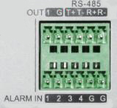
The alarm input is an open/close relay. If the input is not an open/closed relay, follow the connection diagram below:

To connect to an AC/DC load, use the following diagram:

For DC load, JP4 can be used within the limit of 12V/1A safely. If the interface is connected to an AC load, JP4 should be left open. Use an external relay for safety (as shown in the figure above).

There are 4 jumpers (JP4, JP5, JP6, and JP7) on the motherboard, each corresponding with one alarm output. By default, jumpers are connected. To connect an AC load, jumpers should be removed.

Note: An external relay is needed to prevent electric shock when connecting to an AC load.

Alarm Connection
To connect alarm devices to the DVR:
1. Disconnect pluggable block from the ALAM IN /ALARM OUT terminal block.
2. Unfasten stop screws from the pluggable block, insert signal cables into slots and fasten stop screws. Ensure signal cables are in tight.
3. Connect pluggable block back into terminal block.

RS-485 Connection
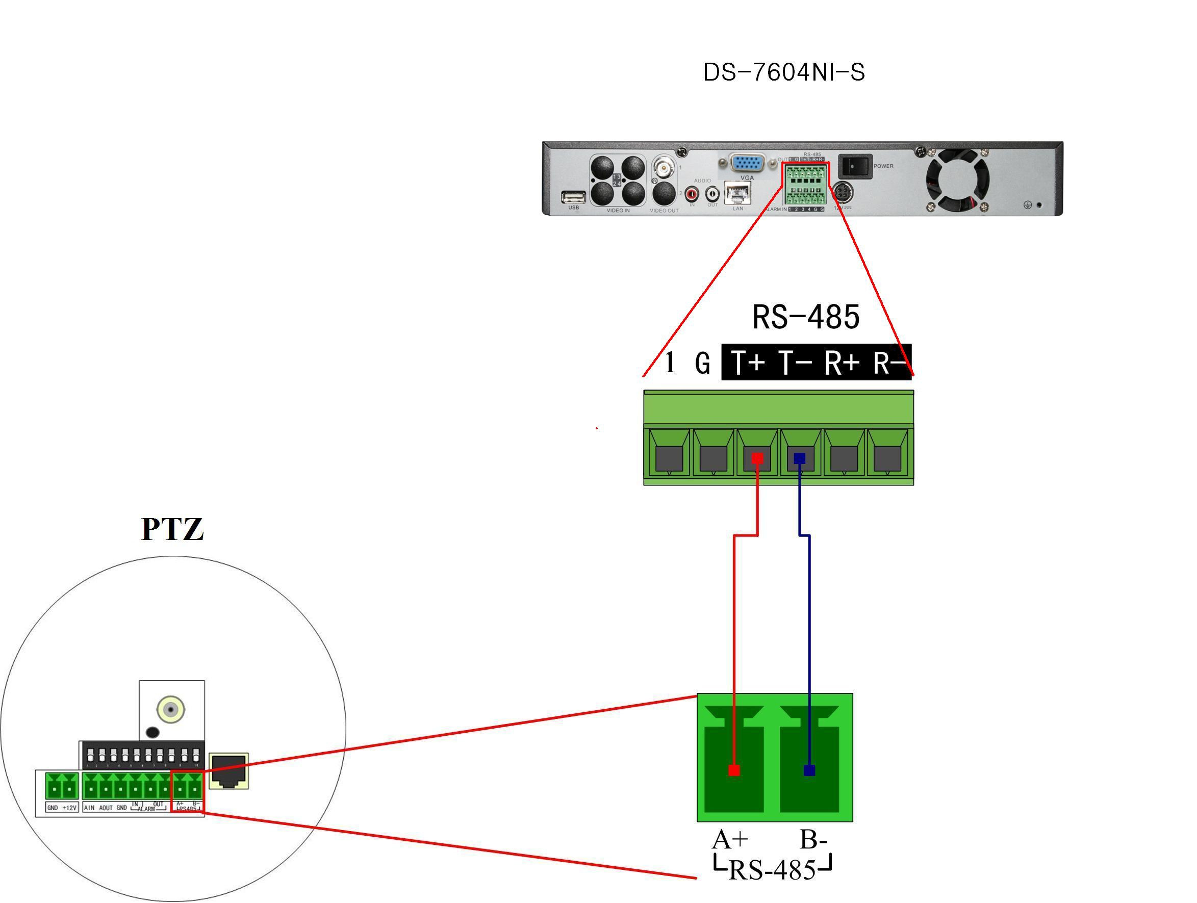

To connect RS-485 devices to the DVR:
1. Disconnect pluggable block from the RS-485 terminal block.
2. Unfasten stop screws from the pluggable block, insert signal cables into slots and fasten stop screws. Ensure signal cables are in tight.
3. Connect pluggable block back into terminal block.
HDD Storage Calculation Chart

The following chart shows an estimation of storage space used based on recording at one channel for an hour at a fixed bit rate.

Bit Rate | Storage Used
96K | 42M
128K | 56M
160K | 70M
192K | 83M
224K | 98M
256K | 112M
320K | 140M
384K | 168M
448K | 196M
512K | 225M
640K | 281M
768K | 337M
896K | 393M
1024K | 450M
1280K | 562M
1536K | 675M
1792K | 787M
2048K | 900M

Note: Please note that supplied values for storage space used is just for reference. Storage space used is estimated by formulas and may have some deviation from actual value.

