NETWORK CAMERA
User Manual
V2.0.0

2009-8

Thank you for purchasing our product. If there are any questions, or requests, please do not hesitate to contact the dealer.
This manual applies to DS-2CD802/812/892PF(NF)(-E)(-W), DS-2CD832F(-E), DS-2CD802/812/892P(N)-IR1(IR3)(IR5), DS-2CD702/712/792PF(NF)(-E), DS-2CD732F(-E) series Network Camera
This manual may contain several technical incorrect places or printing errors, and the content is subject to change without notice. The updates will be added to the new version of this manual. We will readily improve or update the products or procedures described in the manual.
DISCLAIMER STATEMENT
“Underwriters Laboratories Inc. (“UL”) has not tested the performance or reliability of the security or signaling aspects of this product. UL has only tested for fire, shock or casualty hazards as outlined in UL’s Standard(s) for Safety, UL60950-1. UL Certification does not cover the performance or reliability of the security or signaling aspects of this product. UL MAKES NO REPRESENTATIONS, WARRANTIES OR CERTIFICATIONS WHATSOEVER REGARDING THE PERFORMANCE OR RELIABILITY OF ANY SECURITY OR SIGNALING RELATED FUNCTIONS OF THIS PRODUCT.”
Safety Instruction
These instructions are intended to ensure that the user can use the product correctly to avoid danger or property loss.
The precaution measure is divided into ‘Warnings’ and ‘Cautions’:
Warnings: Serious injury or death may be caused if any of these warnings are neglected.
Cautions: Injury or equipment damage may be caused if any of these cautions are neglected.
 | 
Warnings Follow these safeguards to prevent serious injury or death. | Cautions Follow these precautions to prevent potential injury or material damage.
Warnings
1. In the use of the product, you must strictly comply with the electrical safety regulations of the nation and region.
2. Source with AC 24V or DC 12V according to the IEC60950－1 standard. Please refer to technical specifications for more details.
3. Do not connect several devices to one power adapter as an adapter overload may cause over-heating and can be a fire hazard.
4. Please make sure that the plug is firmly inserted into the power socket.
5. When the product is installed on a wall or ceiling, the device should be firmly fixed.
6. If smoke, odor, or noise rise from the device, turn off the power at once and unplug the power cable, then contact the service center.
7. If the product does not work properly, please contact your dealer or the nearest service center. Never attempt to disassemble the camera yourself. (We shall not assume any responsibility for problems caused by unauthorized repair or maintenance.)
Notice:
- Make sure the power supply voltage is correct before using the camera.
- Do not drop the camera or subject it to physical shock.
- Do not touch CCD (Charge Coupled Device) modules with fingers. If cleaning is necessary, use a clean cloth with a bit of ethanol and wipe it gently. If the camera will not be used for an extended period of time, put on the lens cap to protect the CCD from dirt.
- Do not aim the camera at the sun or extra bright places. A blooming or smear may occur otherwise (which is not a malfunction however), and affecting the endurance of CCD at the same time.
- The CCD may be burned out by a laser beam, so when any laser equipment is being used, make sure that the surface of the CCD will not be exposed to the laser beam.
- Do not place the camera in extremely hot or cold temperatures (the operating temperature should be between -10°C ~ +60°C), dusty or damp locations, and do not expose it to high electromagnetic radiation.
- To avoid heat accumulation, good ventilation is required for a proper operating environment.
- Keep the camera away from liquids.
- While shipping, the camera should be packed in its original packing, or packing of the same texture.
- Regular part replacement: a few parts (e.g. electrolytic capacitor) of the equipment should be replaced regularly according to their average life time. The average time varies because of differences between operating environment and usage history, so regular checking is recommended for all users. Please contact with your dealer for more details.
Index
Chapter 1 Introduction 1
1.1 Network camera Functions and Features 1
1.2 Applications 2
Chapter 2 Installation 4
2.1 Panels Description 4
2.1.1 Side Elevation of the Camera 4
2.1.2 Rear Panel Description 6
2.2 Product Installation 9
2.2.1 Box camera Installation 9
2.2.2 Dome camera Installation 11
2.2.3 Topological graph of network camera 12
2.3 Client Software Installation 14
2.3.1 Live View 16
2.4 Special Client Software Installation for Wireless camera 20
Chapter 3 Parameter Configuration 25
3.1 Network Camera access model overview 25
3.1.1 Wireless Network (Only “-w” series support) 25
3.1.2 Wired network 26
3.2 Visit Network Camera in LAN 26
3.3 Configuration via Web browser 27
3.4 Configuration via Client Software 31
3.5 Wireless Network Camera Access 38
3.6 Visit Network Camera in Internet 41
3.6.1 Visit network camera with static IP 41
3.6.2 Visit network camera with dynamic IP 42
Appendix 1 SADP Introduction 46
Appendix 2 Port Map 49
Appendix 3 Pin Definition 51
Appendix 4 Product Specification 52
DS-2CD802/812/892/PF(NF)(-E)(-W) 52
Specification 52
Dimension 53
DS-2CD832F(-E) 54
Specification 54
Dimension 55
DS-2CD802/812/892P(N)-IR1(IR3)(IR5) 56
Specification 56
Dimension 57
DS-2CD702/712/792PF (NF)(-E) 58
Specification 58
Dimension 59
DS-2CD732F(-E) 60
Specification 60
Dimension 61

Chapter 1 Introduction
Network camera is a kind of embedded digital surveillance product that combines the features of both traditional analog camera and net DVS (Digital Video Server). Due to the embedded Linux operation system and the latest Davinci hardware platform of TI, the system operates with high scheduling efficiency. Furthermore, the firmware is burned in the flash, which makes the product small, reliable and highly stable.

1.1 Network camera Functions and Features
Functions:
- Network Function :support the TCP/IP protocols(TCP/IP,HTTP,DHCP,DNS,RTSP RTCP,PPPoE, Furthermore,FTP,SMTP,NTP,SNMP addible),and IE browsing.
- Heartbeat Function: The server can acquire real time operating performance of the network camera through the heartbeat function.
- Alarm Function: The product includes 1 channel of alarm signal input and 1 channel of alarm on/off output, and supports motion detection, video missing, mask alarm and external alarm input.(Get details in Specification)
- Voice Talking：Support bidirectional voice talking and monomial voice broadcasting.
- User Management: Support multilevel right management. The administrator can create up to 15 separate users with different right levels, which highly improves the system security.
Compression Functions:
- Support 1 channel video signal and 25fps in Pal (704 × 576) ,30fps in NTSC (704 × 480) real time H.264 video Encoding standard compression, which supports both variable bit rate and variable frame rate; besides, you can self-define both the video quality and its compressed bit rate.
- Support resolution of 4CIF (PAL:704 × 576, NTSC:704 × 480), DCIF (PAL:528 × 384, NTSC:528 × 320), 2CIF (PAL:704 × 288, NTSC:704 × 240), CIF (PAL:352 × 288, NTSC:352 × 240),QCIF (PAL:176 × 144, NTSC:176 × 120).
Remote Control:
- The product offers a 10M/100M self-adaptive Ethernet interface.
- Support TCP / IP, HTTP, DNS, RTP / RTCP, PPPoE protocols.
- Set the parameters, browse real time videos or check the camera performance through software or IE, and get external alarming and store the compressed bit rate through network.
- Support remote upgrades and maintenance.
- RS-485 supports monomial transparent channel function so that clients on remote PC can control the serial devices.
- Support NAS storage.

1.2 Applications
This camera is ideal for remote control network applications. E.g.:
- Network surveillance for ATM, bank counters, supermarkets and factories.
- Remote surveillance for nursing homes, kindergartens and schools.
- AI janitors.
- AI building/district management systems.
- Self-service systems of power plants.
- Outdoor monitoring systems for bridges, tunnels and crossroad traffic.
- Pipelining and warehouse monitoring.
- 24-hour monitoring for road traffic.
- Remote monitoring of forest and water resources.
- Surveillance for airdrome, railway station, bus stop etc.

Chapter 2 Installation
Notes：
- Please check if all the items on the package list have been included with your camera.
- Read the following contents carefully before the installation.
- Make sure that all the related equipment is power-off during the installation.
- Check the power supply to prevent any damage caused by mismatching problems.
- If the product does not operate properly, please contact your dealer or the nearest service center. Never attempt to disassemble the camera yourself. Users are responsible for any problem caused by modification or repairing without authorization.

2.1 Panels Description

2.1.1 Side Elevation of the Camera
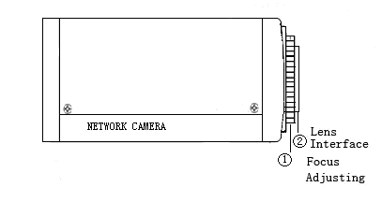
Fig 2.1.1 Side Elevation of DS-2CD832F(-E) network camera
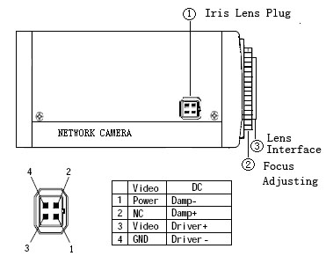
Fig 2.1.2 Side Elevation of DS-2CD802, DS-2CD812, DS-2CD892 series camera
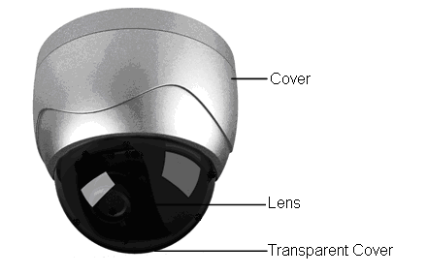
Fig 2.1.3 Side Elevation of DS-2CD702,DS-2CD712,DS-2CD732,DS-2CD792 series camera

2.1.2 Rear Panel Description
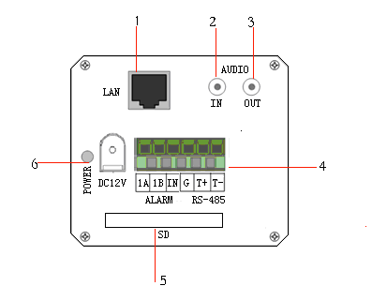
Fig. 2.1.4 Rear Panel of DS-2CD832F(-E)
1. Standard Ethernet (UTP) RJ45 (10M/100M self-adaptive).
2. 1 channel voice talk input,3.5mm audio interface, 2.0～2.4Vp-p, 1kΩ.
3. 1 channel voice talk output, 3.5mm audio interface, electric line level, 600Ω.
4. 1 channel alarm output (1A 1B). 1 channel alarm input signal (IN,G). RS-485 bus interface (T＋ T-).
5. SD card slot (Support SDHC ).
6. Power supply interface of 12VDC, ±10%.
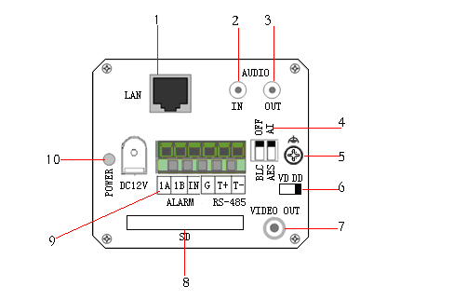
Fig. 2.1.5 Rear Panel of DS-2CD802, DS-2CD812 , DS-2CD892 series
1. Standard Ethernet (UTP) RJ45 (10M/100M self-adaptive).
2. 1 channel voice talk input,3.5mm audio interface, 2.0～2.4Vp-p, 1kΩ.
3. 1 channel voice talk output, 3.5mm audio interface, electric line level, 600Ω.
4. BLC, AI, AES dial switch.
5. GND.
6. VD( Video Drive), DD(Direct current Drive).
7. Video Output port.
8. SD card slot.
9. alarm output (1A 1B); RS-485 bus interface（T＋ T-）; Alarm input signal (IN,G).
10. Power supply interface of 12VDC, ±10%.
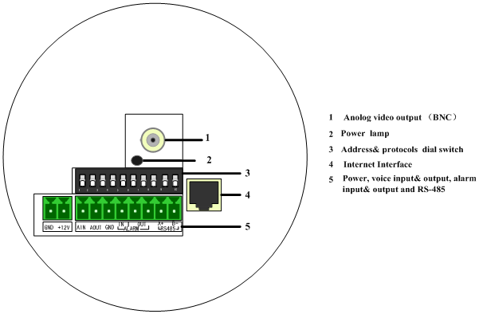
Fig. 2.1.7 Rear Panel of DS-2CD702, DS-2CD712, DS-2CD732, DS-2CD792 series
Address& protocols dial switch, define for dial switch: 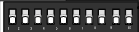, from 1 to 5 dial switch function as follows:
Switch Function | ON | OFF
1 | SHARP | SOFT
2 | AES | AI
3 | BLC | OFF
4 | FL | ON
5 | NAGC | SAGC
Notices: There are invalid dial switches for DS-2CD702, DS-2CD712, DS-2CD792, DS-2CD732 series from 6 to 10;
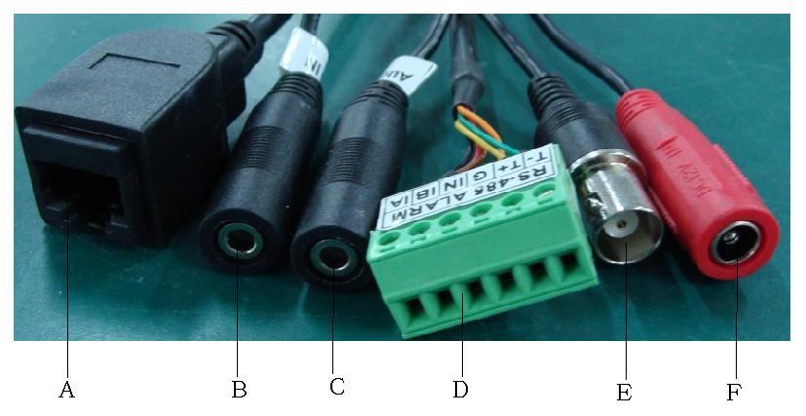
Fig 2.1.8 Rear Panel of DS-2CD802/812/892P-IR1/3/5 series camera
1. A means UTP interface;
2. B means voice input interface;
3. C means voice output interface;
4. D means, T+,T- means RS-485 interface; G, IN means alarm input interface; 1A,1B means alarm output interface;
5. E means BNC video output interface;
6. F means power supply input interface;

2.2 Product Installation

2.2.1 Box camera Installation
Box camera can be fixed in both metope and ceiling. Customers can choose whichever way according to their specific needs. Please follow the steps below:(Take fixing in ceiling as an example, fixing in metope follows the same rule).Choose the fixing method and fix the camera bracket accordingly. If it is metope, then you need to fix the expand bolt (note: the mounting hole of the expand bolt should align with the bracket) before fixing the bracket. If the wall surface is wooden, the first step can be ignored and you can use the self-tapping screw to directly fix the bracket. Please note that the metope on which the camera is fixed should be able to bear at least three times the weight of the bracket and the camera.
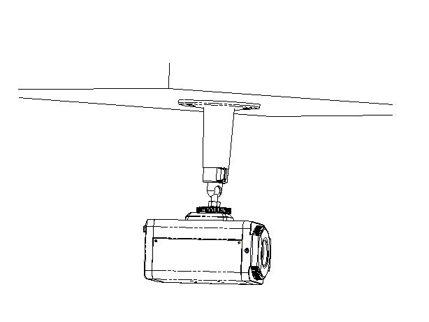
Fig 2.2.1 Fix Ceiling Bracket Fig 2.2.2 Fix Camera
Fig 2.2.3 Fix Lens

2.2.2 Dome camera Installation
Dome camera can be installed include hold equipment, ceiling mounted, cylinders and other styles. Client can be installed in accordance with their own ways to achieve the installation.Please according the following specific steps to install (take ceiling mounted as example), when the wall is wood, use the self-tapping screws to fix the ceiling plate to the wall surface.
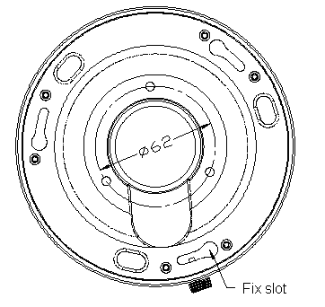
Fig 2.2.4 Fix card Fig 2.2.5 Fix in Ceiling
Take the three columns of Dome camera insert in the three fix slot of the ceiling plate. Pay attention to the direction of insertion. Let the ceiling plate “I” logo and the Dome camera “I” logo in the same direction. Meanwhile, make the Dome camera along the counterclockwise Rotate 15 degrees until the switch to the fixed date. At the same time, the “I” signs on the Dome camera and the locking screw on the ceiling plate is alignment. Then screw down the locking screw on the Ceiling plate. 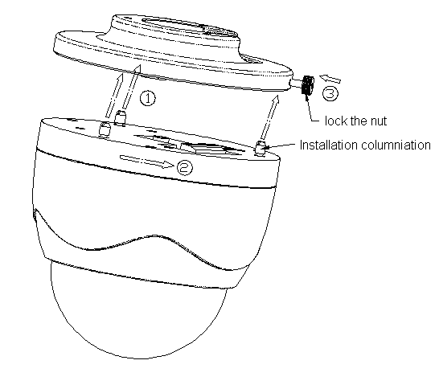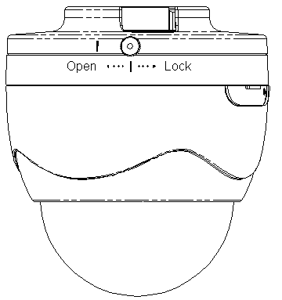
Fig 2.2.6 Dome camera fixing Fig 2.2.7 Dome camera fixed

2.2.3 Topological graph of network camera
Take DS-2CD802/812/892PF-E series for example:
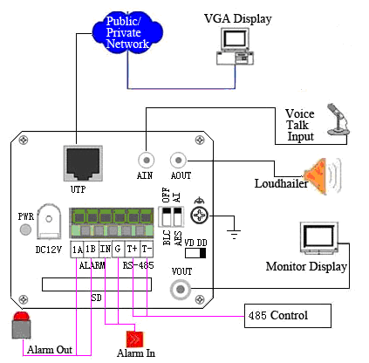
Fig 2.2.8 Topological Graph of Network Camera

Physical Interface | Connection
UTP Network Interface | Connect to network devices, such as switch , HUB, etc. Please refer to Appendix B for pin Definition.
Audio Input（AIN） | Connect to audio input devices such as active tone (2.0～2.4Vp-p, 1kΩ)
Audio Output（AOUT） | Connect to sounders like loudhailer 600Ω.
Power Supply（DC12V） | Please refer to the appendix for specified types. Please use a matched regulator.
Alarm Output（1A 1B） | 1 channel alarm out. Please refer to Section 2.3.2 for connecting instructions. (external series-wound power shall be under 12V DC / 30mA)
Alarm Input（IN G） | 1 channel alarm in.
RS-485 Interface（T+ T-） | Connect to RS-485 devices like PTZ.
SD card slot | Insert an SD card for local storage.
Video Output（VOUT） | Standard BNC, connect to monitor.
Notice:
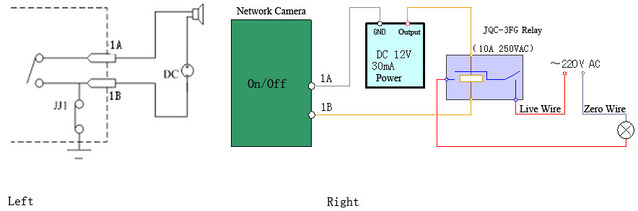
Fig 2.2.9Alarm output
The alarm output is an on/off output that requires external power supply on connection. The external power supply shall be 12V DC/30mA, or use AC with external relays. Equipment damage or electric shock may cause if without relays.

2.3 Client Software Installation
Note:
It is recommended to use the computer adopting INTEL P3, P4, C4, Core4 CPU, and the Intel chipset motherboard of well-known brands (Asus, Gigabyte, MSI, ECS, and INTEL etc.) to ensure the stability of the system. After testing, the following models of the current graphics cards support the installation of the client software: ATIRadeonX1650, X1600, X1550, X1300, X800, X600, X550, HD2400, HD2600, NVIDIA GeForce 8600GT, 8500GT, 8400GS, 7600, 7300LE, 6600LE, 6200LE, and INTEL915/945G. And the graphics driver must support hardware scaling function.
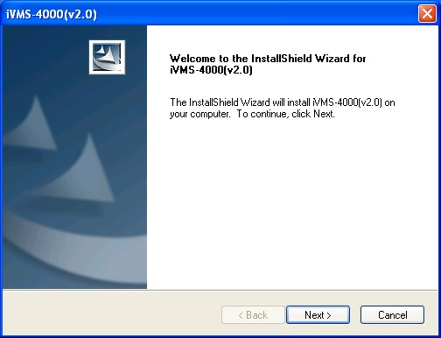
Step 1:
Double click ‘Client Software Setup.exe’ in the Windows Operating System. The ‘Preparing Setup’ dialog box will automatically pop up as shown Fig.2.3.1.

Fig. 2.3.1 Client Software Installation
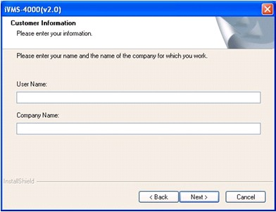
Step 2:
Input the User Name and Company Name, and then click Next.

Fig.2.3.2 Customer Information
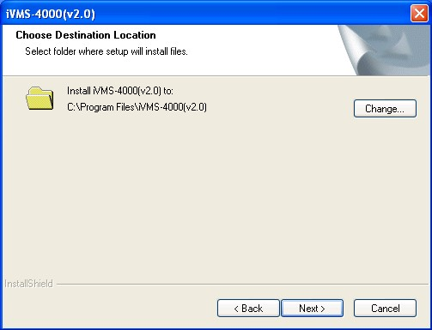
Step 3:
Select the destination folder and click Next to enter the next step.

Fig. 2.3.3 Ready to Install the Program
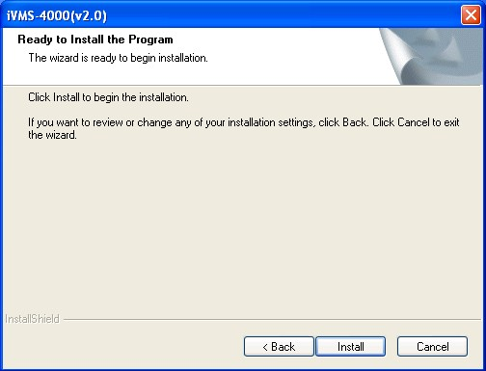
Step 4:
Click Install to start installation till finishing the installation.

Fig. 2.3.4 Installation
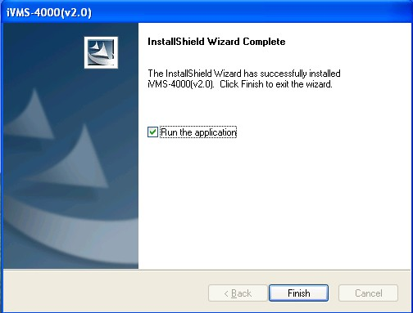
Step 5:
Click Finish to close the dialog box.

Fig. 2.3.5 Done
After the client software has been installed, you can find the remote client software through Start-> Programs from your PC.

2.3.1 Live View
After the installation of client software-iVMS-4000(v2.0), there is a short-cut icon named “iVMS - 4000(v2.0)” on computer’s desktop. Please double click “iVMS-4000(v2.0)” to run the software.
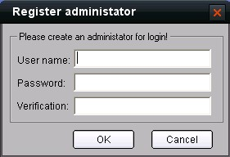
Step 1:
Used for the first time:
User needs to register an administrator if the software is used for the first time.

Input User name, Password, Verification, and click OK, then user can log in as the administrator.
Fig. 2.3.6 Register Administrator

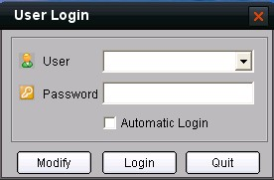
User login:
Input User, Password and click Login to enter the GUI window of the software.
Fig. 2.3.7 User Login
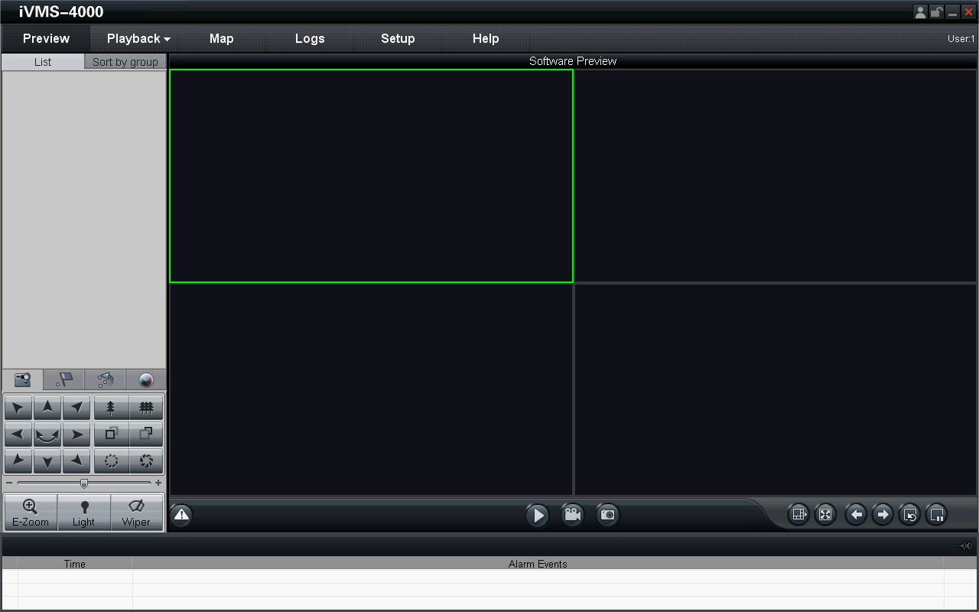
Fig. 2.3.8 GUI window of the software
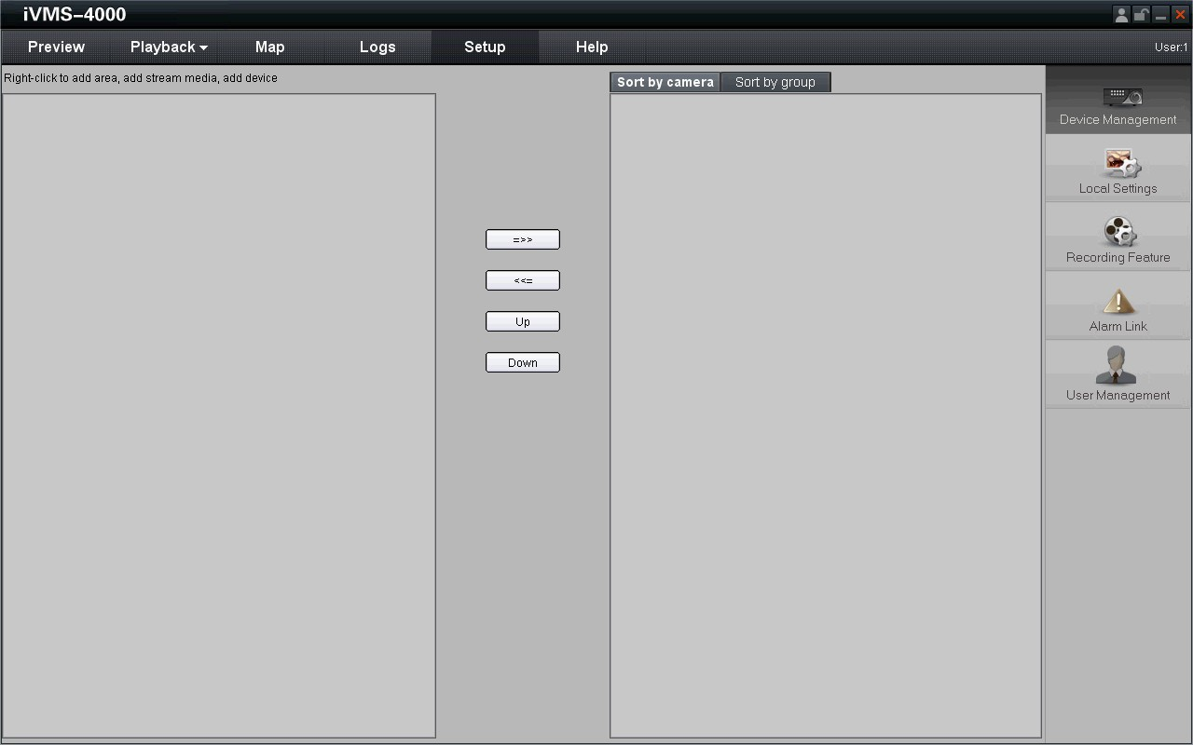
Step 2:
Click Setup to enter the configure mode, and then click Device Management.
Fig. 2.3.9 Device Management
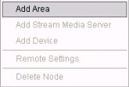
Step 3:
Right click the left area, and then click Add Area.

Input Area Name for your need, and then click OK to add area.
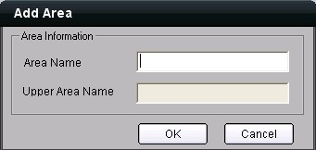
Step 4:
Right click the area that you add, and then click Add Device to add network camera.
Fig. 2.3.10 Add Area

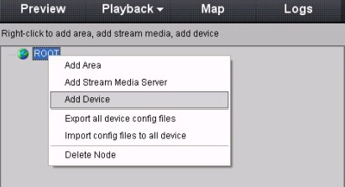
Input “Device Name” for your need. Select “Normal IP” from Register Mode.
Input network camera’s IP in Device IP, e.g. 192.0.0.64, Port: 8000, User Name: admin, Password: 12345.
Select “TCP”, “UTP”, “MCAST” or “RTP” in [Protocol] for your need.
Select “Main Stream” or “Sub Stream” in Protocol for your need.
Finally, click OK to finish settings.
Fig. 2.3.11 Add Area
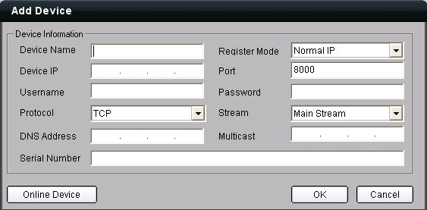
Fig. 2.3.12 Add Device

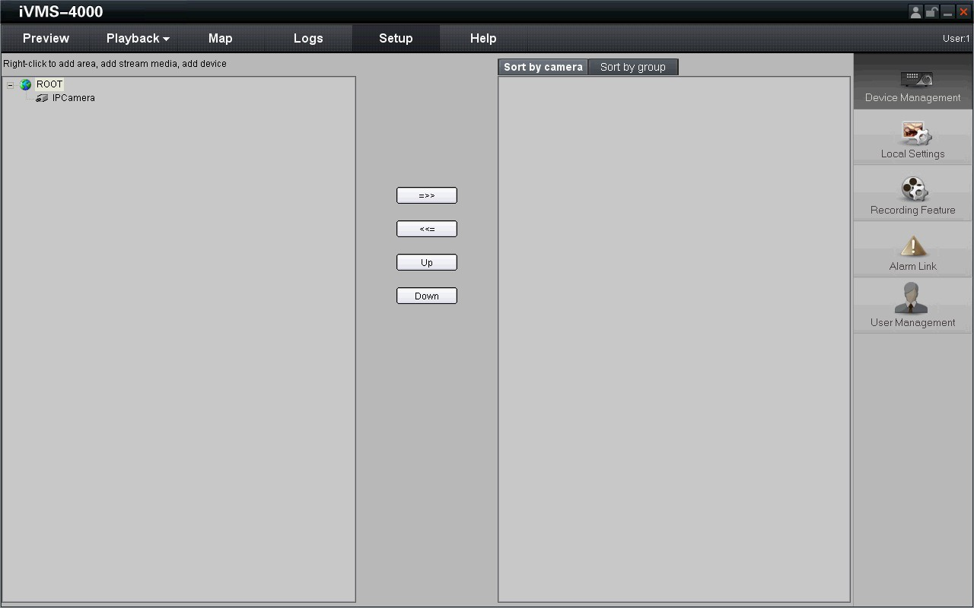
Fig. 2.3.13 Camera Adding Completed
Step 5: Click the Preview, and then double click the device name in the left tree to view the live video.
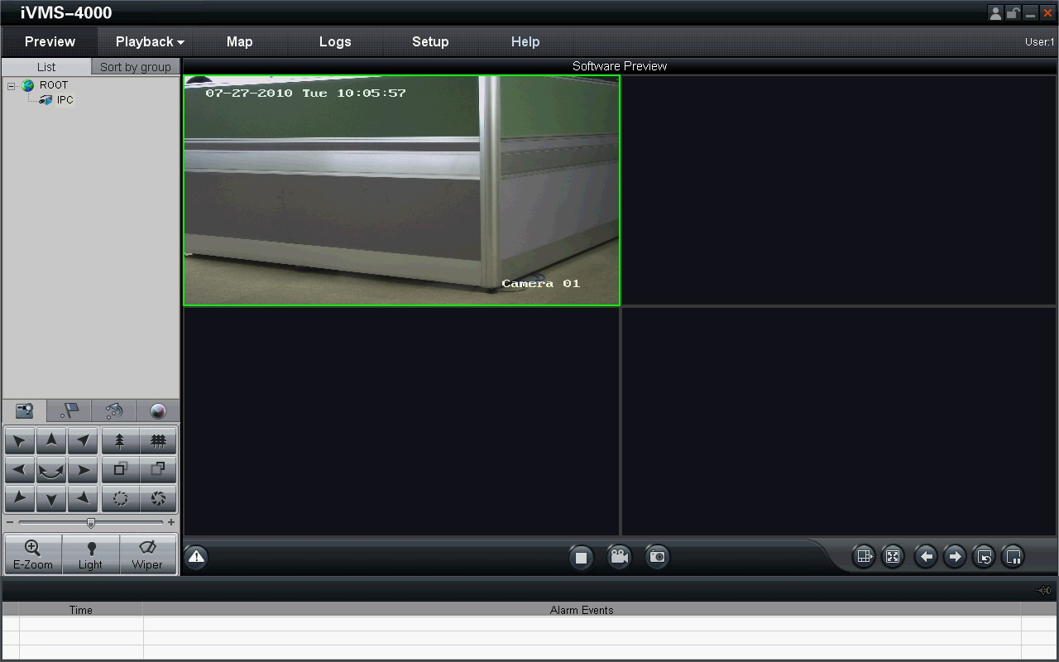
Fig. 2.3.14 Preview

2.4 Special Client Software Installation for Wireless camera
Step1: Double click “Client software (v4.01)” under Windows Operating System. The “Preparing Setup” dialog box will pop up as Fig.2.4.1 and go to Fig2.4.2 automatically.
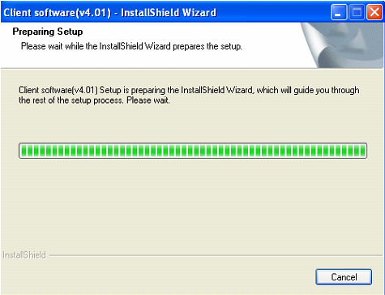
Fig.2.4.1 Client Software Installation
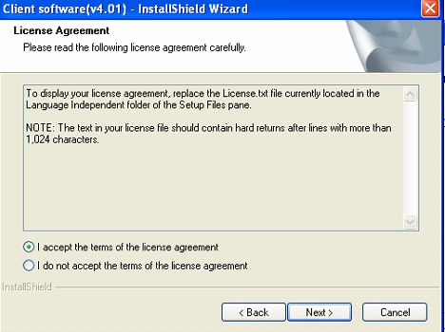
Fig.2.4.2 License Agreement
Step2: Enable the option “I accept the terms of the license agreement” and click the “Next” button to go to the next step as Fig.2.4.3.
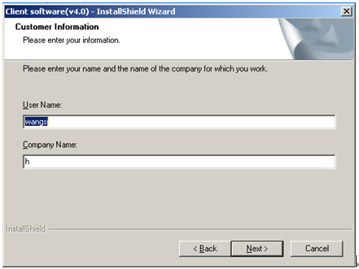
Fig.2.4.3 Customer Information

Step3: Input “User Name”, “Company Name” and click “Next” to go to the next step.
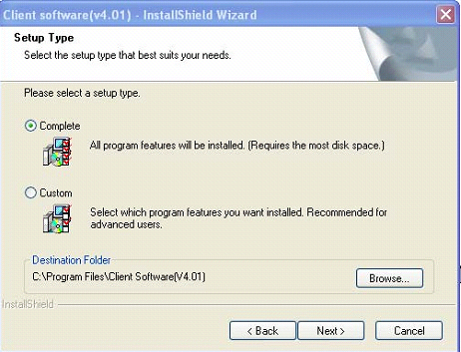
Fig.2.4.4 Destination Folder

Step4: Select the destination folder and click “Next” to go to the next step.
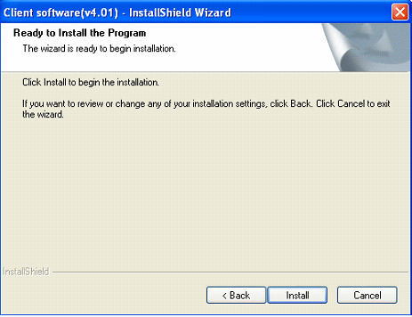
Fig2.4.5 Ready to Install the Program

Step5: Click “Install” to start installation shown as Fig2.4.6.
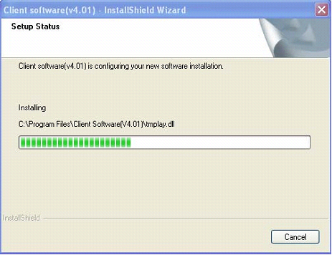
Fig2.4.6 Install Process
Step6: After finishing the installation, the installation completed dialog box will popup as Fig.2.4.7.
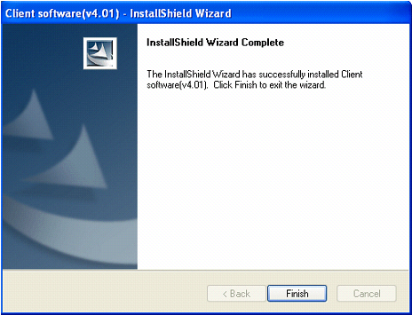
Fig2.4.7 Installation Complete
Click the “Finish” button to close the dialog box.
After the client software being installed, you can find the remote client software through “Start” -> “Program” on your PC

Chapter 3 Parameter Configuration
There are several network parameters of the camera which need to be set after the hardware installation. Those parameters including IP address, subnet mask and port number, etc. can be set through various kinds of methods, 2 of which are introduced as below.
- Set the camera parameters via IE.
- Set the camera parameters through the client software.
Please make sure that the PC and network camera are connected and can ping successfully before the parameter setting.

3.1 Network Camera access model overview

3.1.1 Wireless Network (Only “-w” series support)
Type 1: Point to Point Cennect Model
In this model, the camera is connected to the PC on wireless network directly.
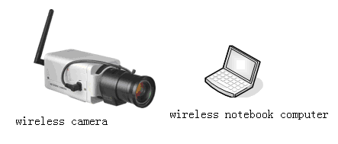
Fig 3.1.1 Point to Point connection

Type 2: Integrated connection
In this model, the camera is connected to the wireless access point.
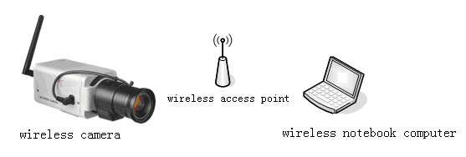
Fig 3.1.2 Connection through wireless access point

3.1.2 Wired network
There are two ways of connecting between IPC and PC as below:
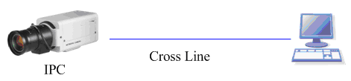
Fig. 3.1.3 Cross Line Connection
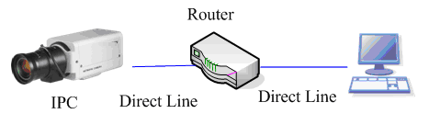
Fig. 3.1.4 Direct Line Connection

3.2 Visit Network Camera in LAN
Before visiting network camera, user should detect its IP address. SADP is a tool software which can automatically detect hikvision’s network device in the LAN and give the device’s information like IP address, mask, port number, device serial number, software version and so on.
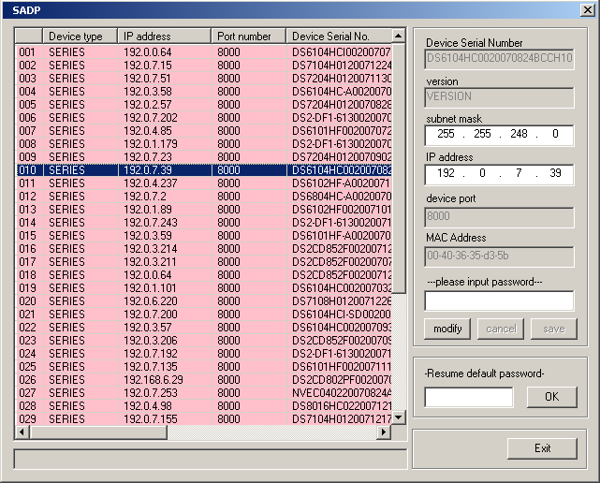
Fig. 3.2.1
Select the device, and set its IP address and mask at the same network segment with the PC.
The detailed introduction of SADP, please refer to Appendix 1.

3.3 Configuration via Web browser
Before visit the camera via web browser, user should adjust security level. Open the web browser, and enter the menu “Tool/ internet option/Security/Custom level”, then set the security level to Security Level –Low, or enable ActiveX Control and the Plug-in directly. Figure 3.3.1 gives you a visual illustration. After you can see the camera video, recover the security level for security.
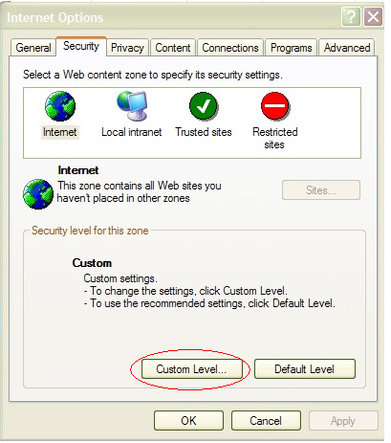
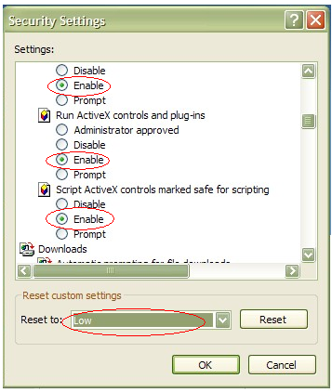
Fig. 3.3.1 Set the Security Level
The default IP of the camera is 192.0.0.64 with 8000 as the default port, admin as the administrator, and 12345 as the password. The administrator can create up to 15 separate operators with different right levels.
To login the camera through IE, input the IP address in the address column, and the “Login” dialog box will pop-up as Fig. 3.3.2. Input your user name and password, and then click “Login” to enter the “preview” page. Double click the “Camera 01” channel or “Preview” button to preview the video as Figure 3.3.3. Right click the “Camera 01” channel, and the “Main Stream”, “Sub Stream” and “Open sound” options will popup. Select the Open sound option if you connect a pickup to the camera.
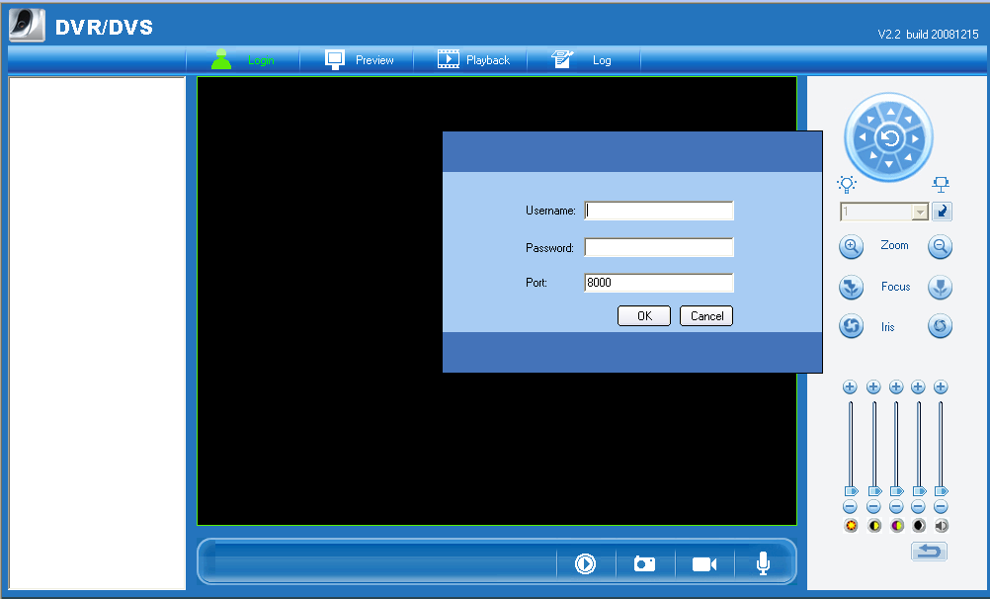
Fig. 3.3.2 Login Interface
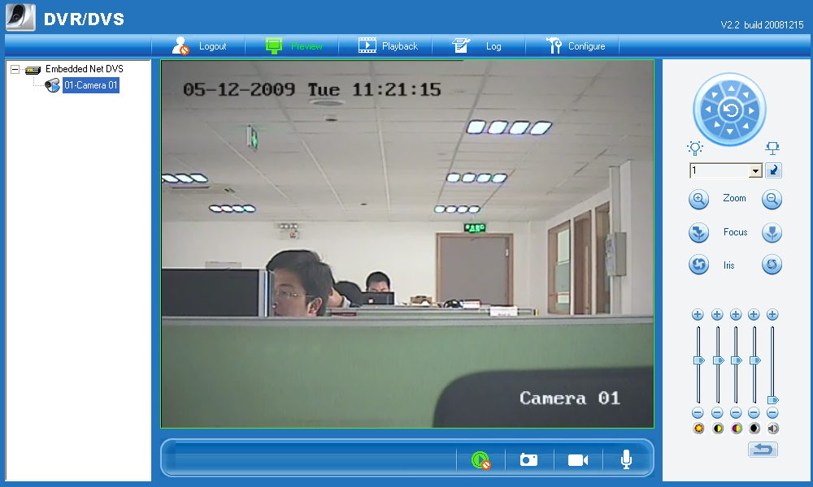
Fig 3.3.3 Preview Interface
The “Playback” and “Log” functions can be used only in the condition of existing SD card. To set the camera parameters through IE browser, click “Config” and wait for the “Remote Parameters Config” dialog box to pop up, and then set the parameters like IP address, etc. for your demand.
Enter the menu by invoking the 95th preset. Select the function you want by clicking the direction key. Click the IRIS+ button you can enter the submenu. The menu operation is like the remote control.
Note: If plug the SD card into the camera, user should enter the “config” and select “other function” to format the SD card.
For more specific information of “Remote Parameters Config”, please refer to “Instructions of Client Software (version 4.01)” from Section 2.5.3 of remote-distance parameter settings. Instructions can be found in the client software4.01 in the path of “Start” → “Program”→ “client software 4.01” after installation.
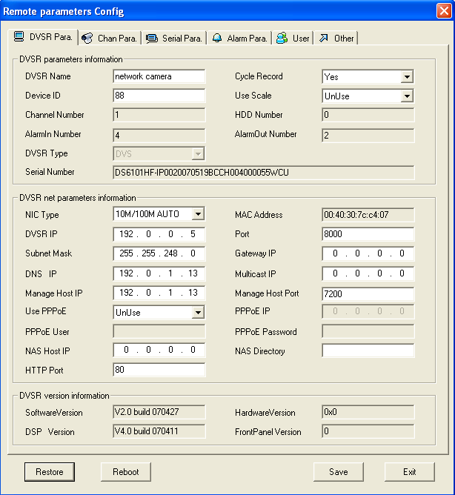
Fig. 3.3.4 Remote Parameters Configuration

3.4 Configuration via Client Software
After the installation of client software-4000(v2.0), there is a short-cut icon named “Client Software-4000(v2.0)” on computer’s desktop. Please double click client software icon, a message box of “Register Administrator” as Fig. 3-4-1 will appear the first time running. Password should be more than 6 digits for registration.
Note: Please keep the user name and password in mind .You will not be able to get access the software without the proper login information.
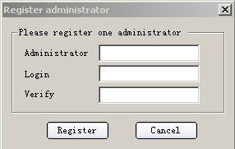
Fig.3.4.1 Register Administrator
Enter the registered user name and password as Fig. 3.4.2. Click “Login” to enter the “Preview” menu as Fig. 3.4.3.
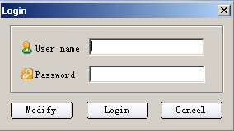
Fig. 3.4.2 User Login

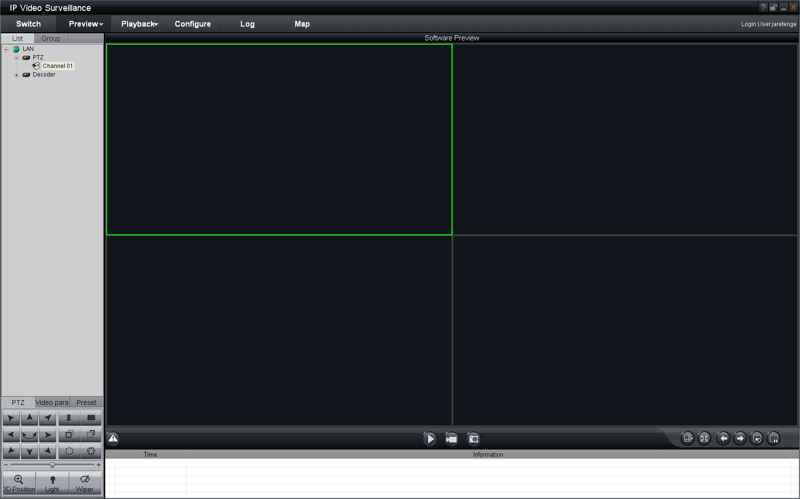
Fig. 3.4.3 Preview Menu
Click the “Configure” button in Fig. 3.4.4, and then right click the blank white space. Click the “Add Area” button, and the “Add Area” message will pop up.
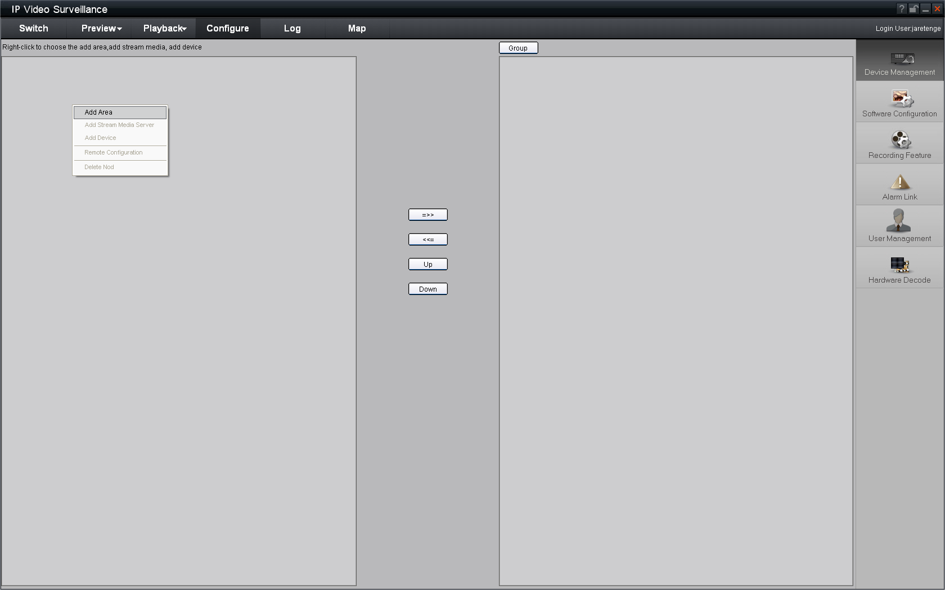
Fig. 3.4.4 Add Area
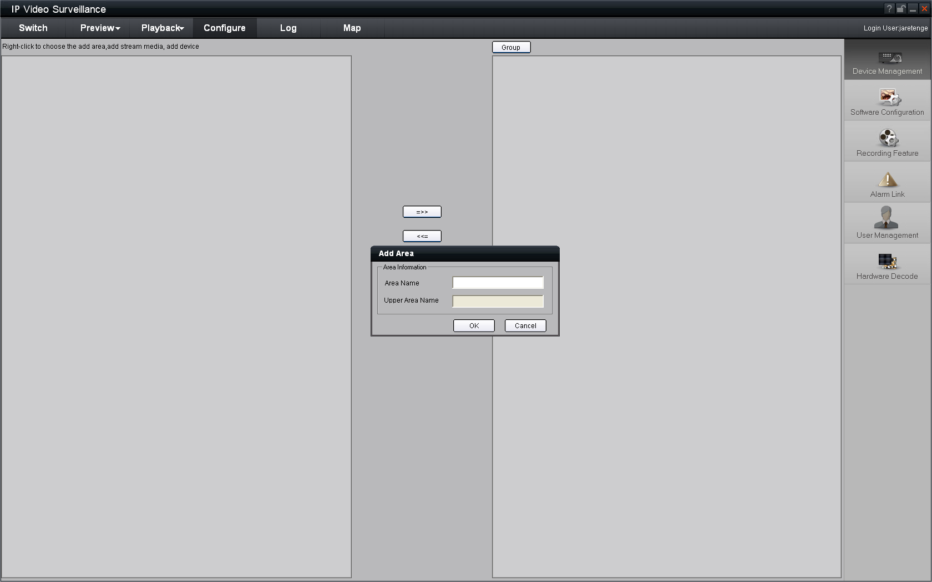

Fig. 3.4.5 Add Area Properties
Input the area name (you can create whatever name you like) and click “OK” as Fig. 3.4.6. Then right click the area you have just created as Fig. 3.4.7.

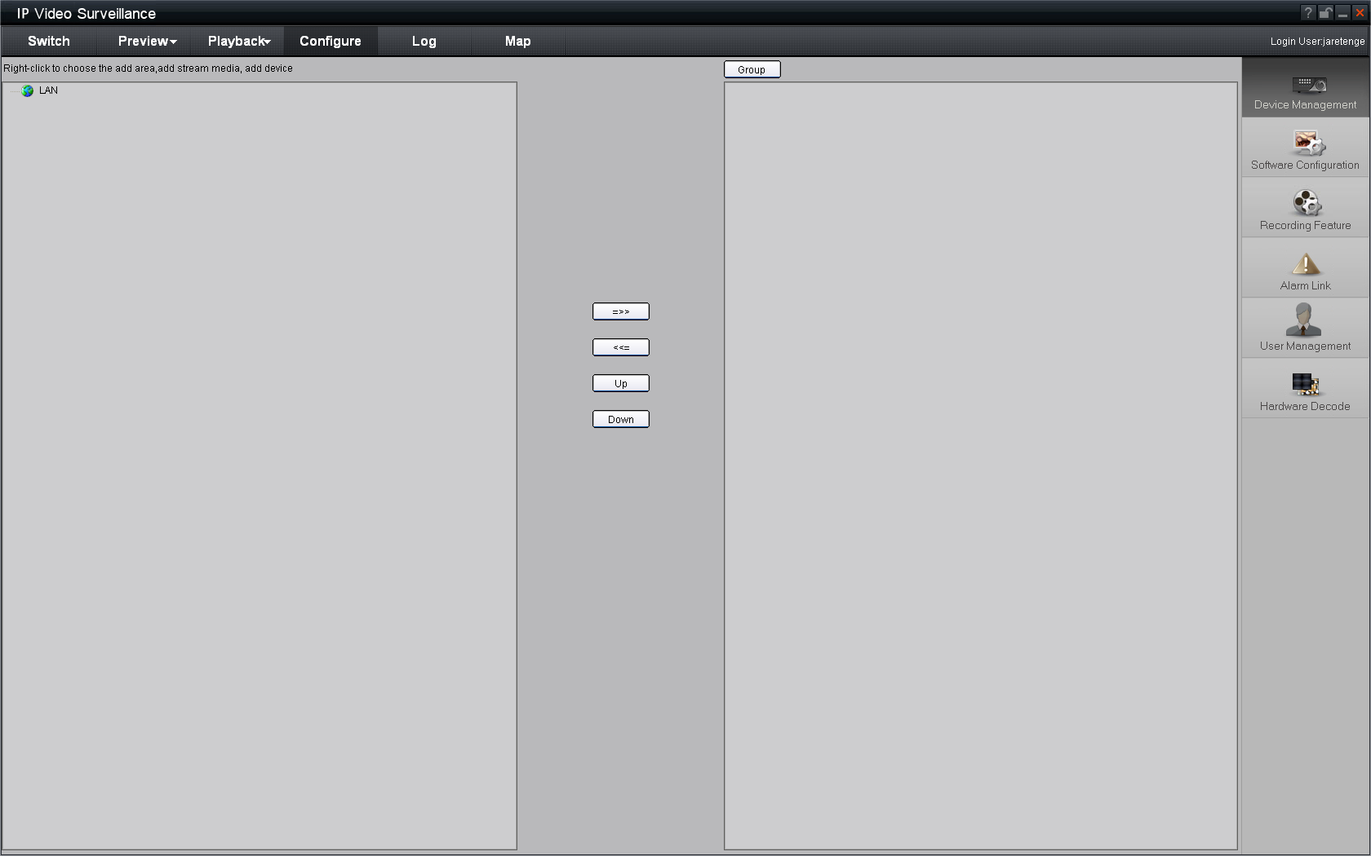

Fig. 3.4.6 Area Name Adding Completed
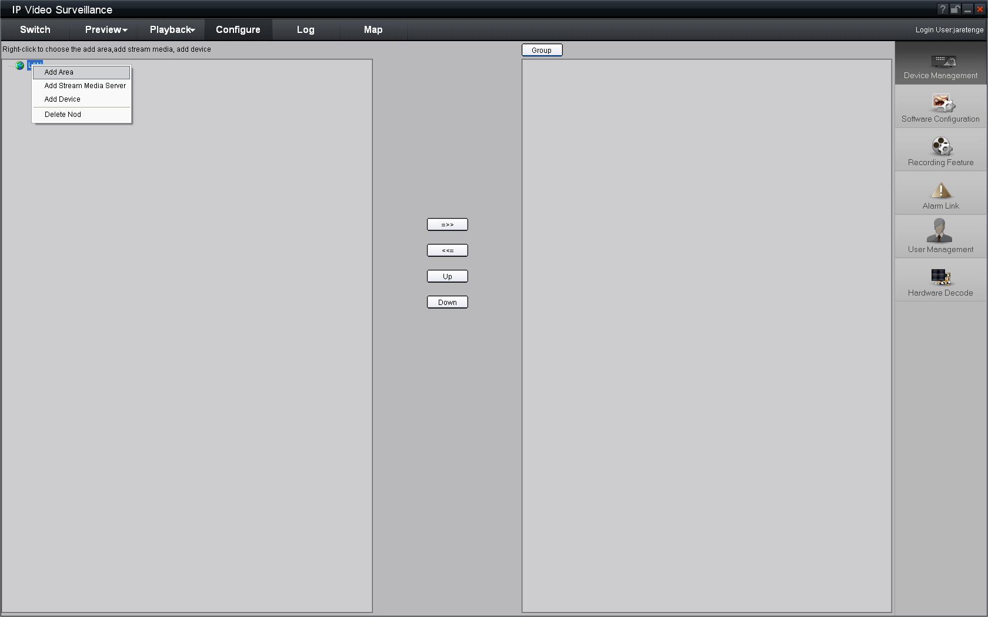

Fig. 3.4.7 Right Click the Area Name
Click “Add Device”, and the “Add Device” dialog box will pop up as Fig. 3.4.8. Input your “Device Name”. Select “Normal” from “Register” option. Input your camera IP in “Device IP”, e.g. 192.0.0.64; “User Name”: admin, “Password”: 12345, and 8000 for the default “Port”, and then modify “Channel” to 1. Click the “OK” button as Fig. 3.4.8.
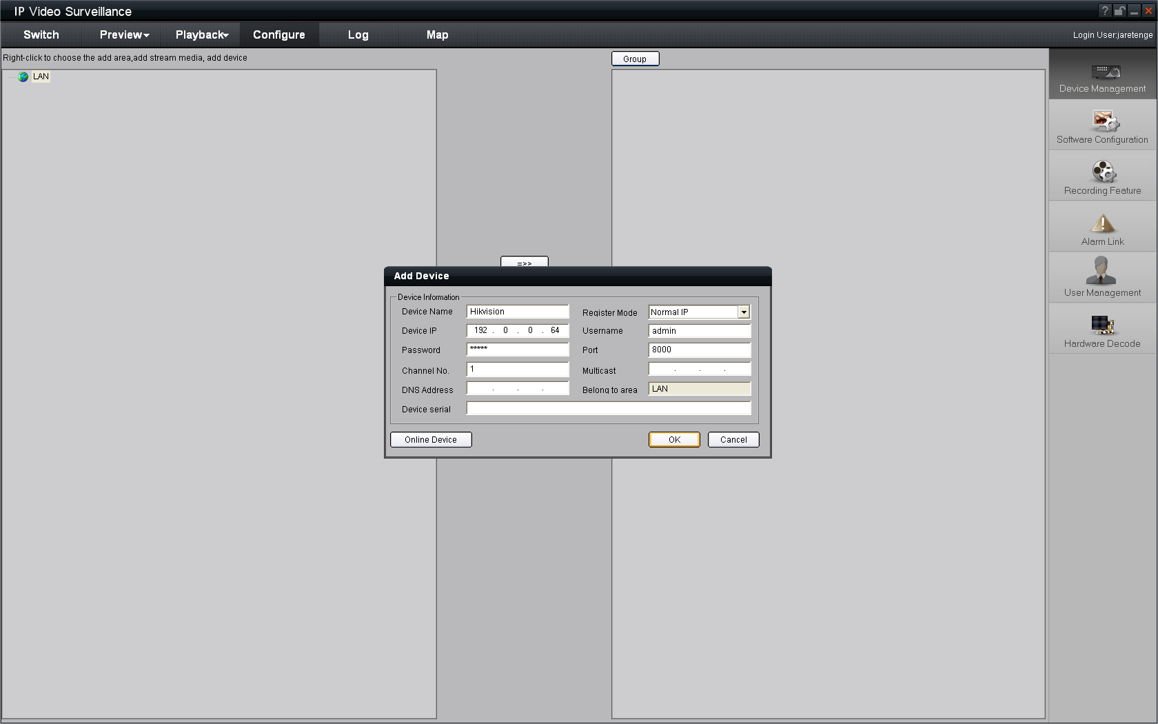

Fig. 3.4.8 Add Device
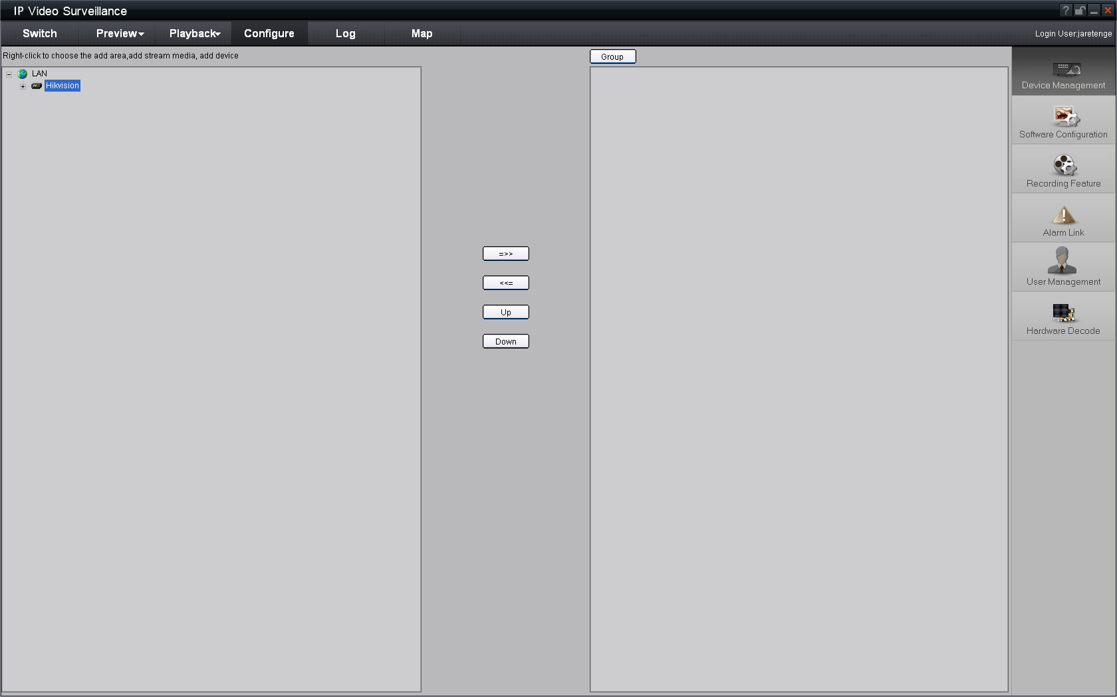
Fig.3.4.9 Camera Adding Completed
Click the “Preview” button to enter the “Preview” menu as Fig. 3-4-10. Double click the channel name in the left tree to preview the camera feed.
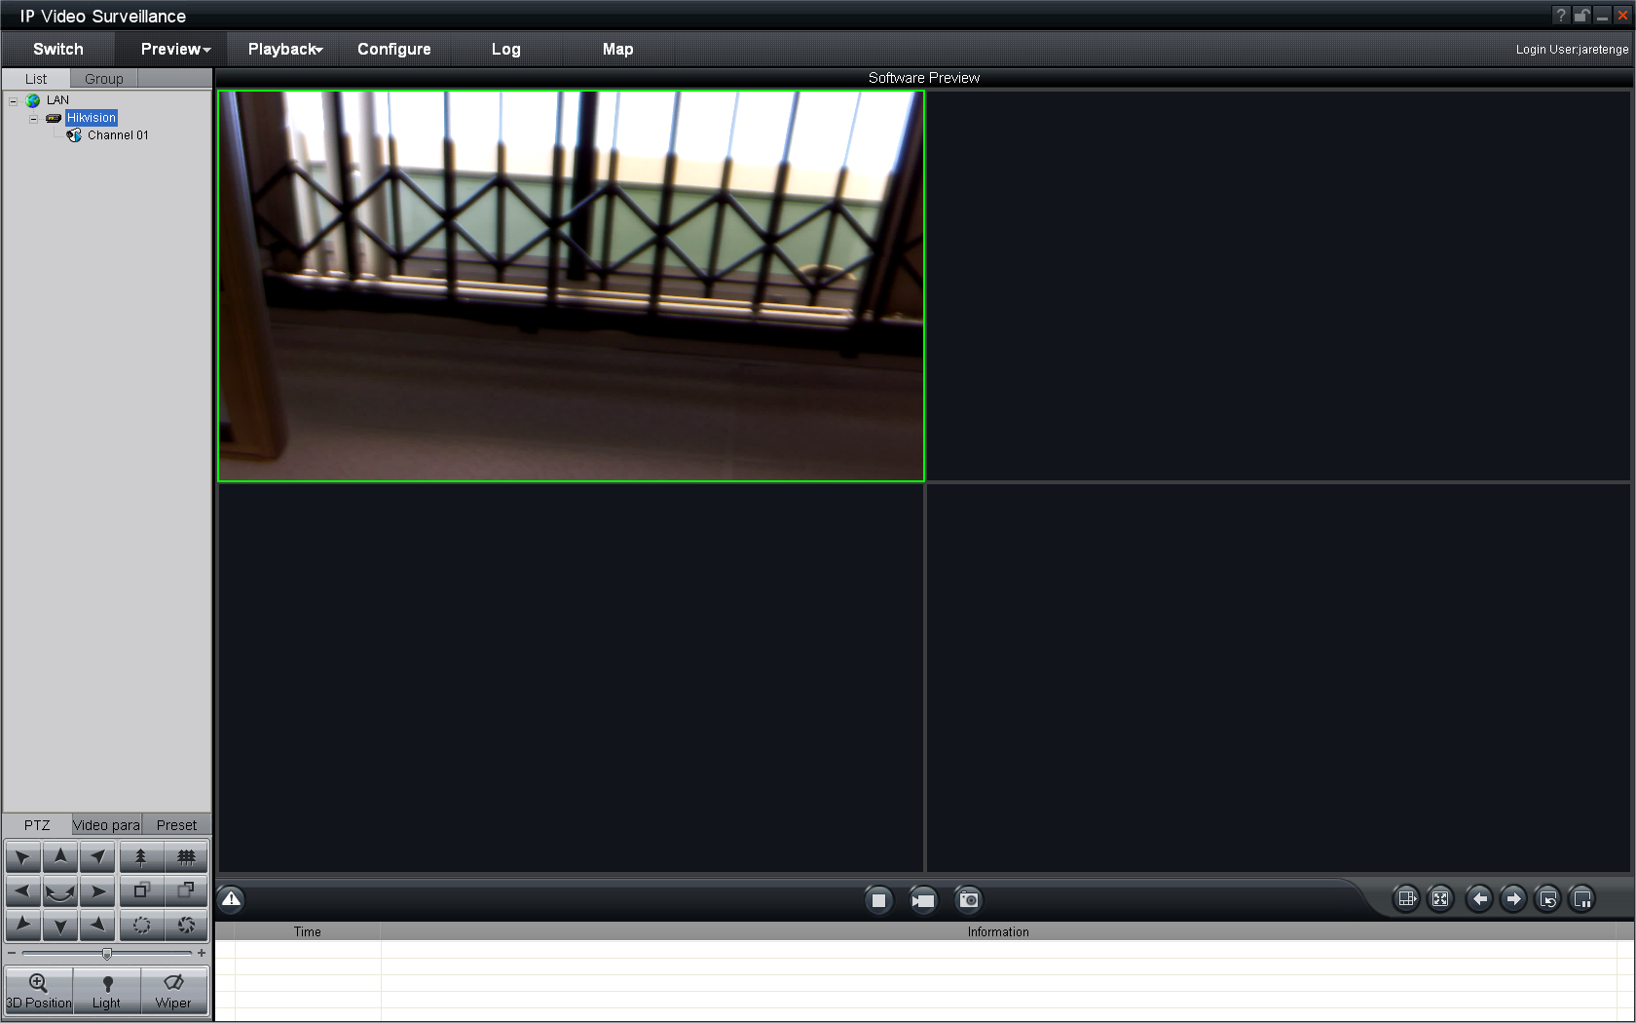
Double click the channel
Fig.3.4.10 Preview Menu
Please refer to “Client Software-4000(v2.0)_ENG.pdf” for a more detailed parameters configuration. You can find the document in the PC Operating System after the installation of client software 4000 v. 2.0 by selecting “Start”-> “All Programs”-> “client software 4000 v. 2.0”.
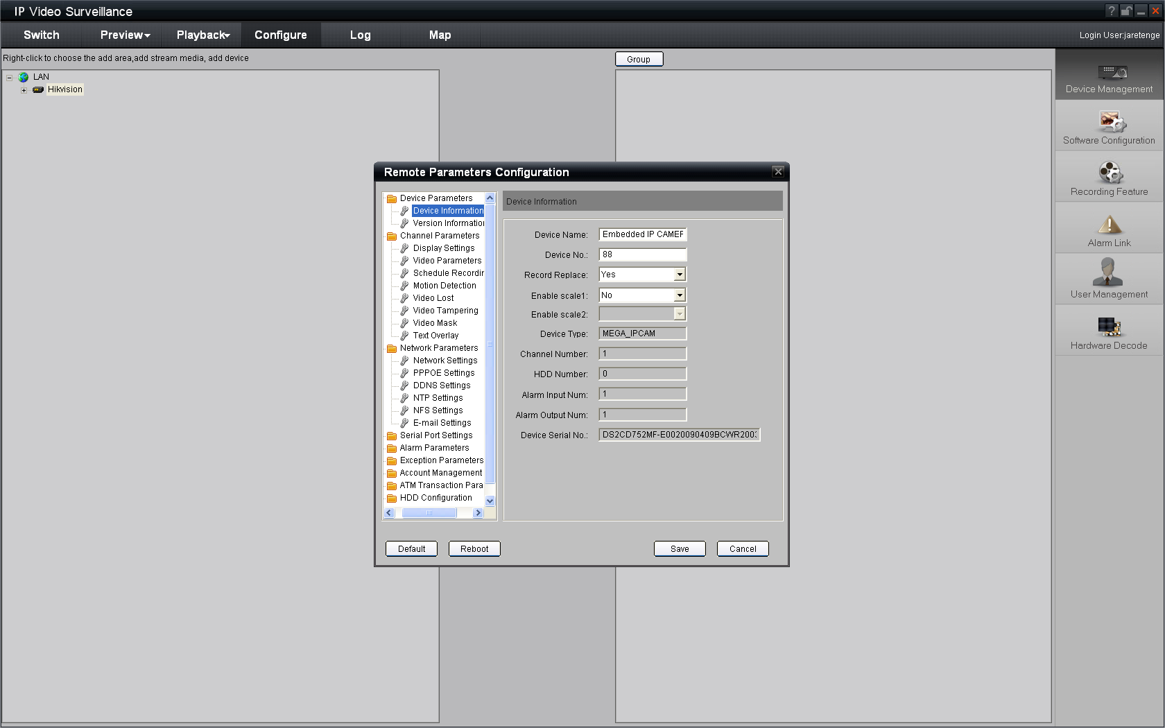
Fig.3.4.11 Remote Configuration

3.5 Wireless Network Camera Access
[Notice] The following message only introduces the –W series wireless IP camera. Take the IE Browser Access for example.
Before configure parameters of the wireless IP camera, you should set the wireless router. The following example is TP-LINK. Firstly configure the ‘network parameter’ of the ‘LAN setting’ and ‘WAN setting’ in the wireless router’s management page. Enter the ‘Wireless Parameter’, and set the ‘SSID NO.’, ‘Frequency band’ and ‘Mode’. User can input any letter and number in the ‘SSID NO.’ . ‘Frequency Band’ is selected according to the on-the-spot environment, and usually we recommend 6 frequency band; Select the ’54 Mbps(802.11g)’. Select the ‘Enable Wireless Function’ and ‘Allow SSID Broadcast’.
User can select ‘Enable Security Function’ according to the on-the-spot environment. You can select the ‘Security Type’, ‘Security Option’, ‘Key Mode Option’ and ‘Key Content’. Please refer to the introduction of the wireless router to get the detailed configuration. As shown:
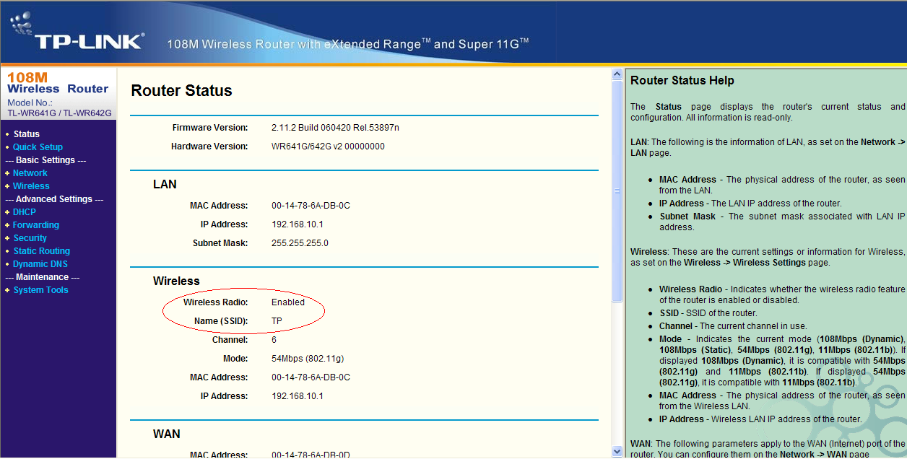
Fig.3.5.1 Router wireless parameter configuration
There are two network cards in the wireless IP camera: cable network card and wireless network card. The default IP of the cable network card is 192.0.0.64 with 8000 as the default port, admin as the administrator, and 12345 as the password. The wireless network card’s default IP is 192.168.1.64.
User should configure the parameters of the wireless network card through the cable network interface. The way of visiting is the same as the chapter 3.2. Enter the menu as ‘Fig. 3.3.2 preview page’ shows, then click the ‘Config’ option, enter the interface as following:
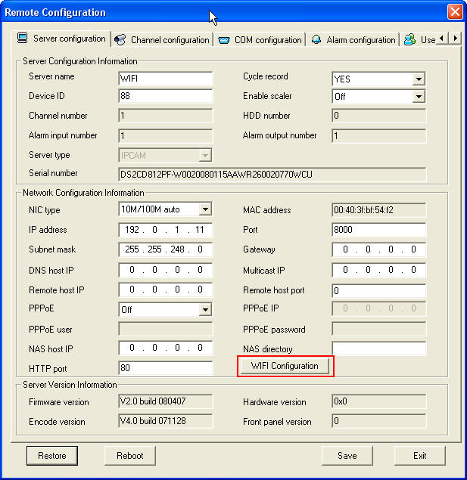
Fig.3.5.2 Remote Configure parameter
In channel configuration, you can click WIFI configuration button to set WIFI parameter of wireless camera. SSID should be same as the wireless router. If your wireless router has a security code, please enable network key and type into the code.
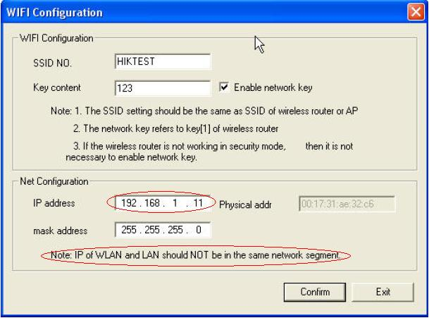
Fig.3.5.3 WIFI Configuration

3.6 Visit Network Camera in Internet

3.6.1 Visit network camera with static IP
When there is a static IP from an ISP, open some ports (such as 80 and 8000 ports) in the router. Then a user can visit it through a web browser or client software via the internet. The steps for port forwarding are different for each model of router. Please call the router manufacturer for assistance with port forwarding or visit www.portforward.com.
Note: Refer to Appendix 2 to for a detailed explanation about Port Map.
Users can directly connect the network camera to the internet without using a router.
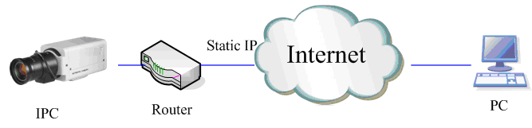
Fig.3.6.1 Static IP through Router access IPC
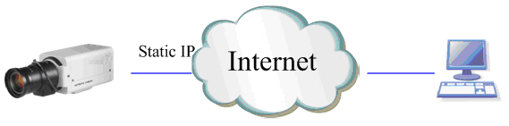
Fig.3.6.2 Static IP access IPC directly
For the client software to view the camera, in the adding equipment column, select the normal model, and fill in the IP info.
Fig.3.6.3 Selecting Normal Mode

3.6.2 Visit network camera with dynamic IP
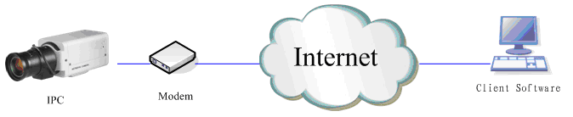
Fig.3.6.4 Visit camera through PPPoE dail-up
This camera supports the PPPoE auto dial-up function, connecting the camera to a Modem for dial-up access to an ADSL network to get a public IP address; First, through local network access to the network camera, select “Configure”→”Right Click the Device”, Select “Remote Configuration”, Select “PPPoE Settings” under “Network Paramters” fill in the PPPoE user name and password and confirm the password. Please restart the network camera after completion of configuration. Then the network camera can obtain a dynamic IP from an ISP operation business. However, the obtained IP address is dynamically assigned via PPPoE, so the IP address always changes accompanied with modem rebooting.
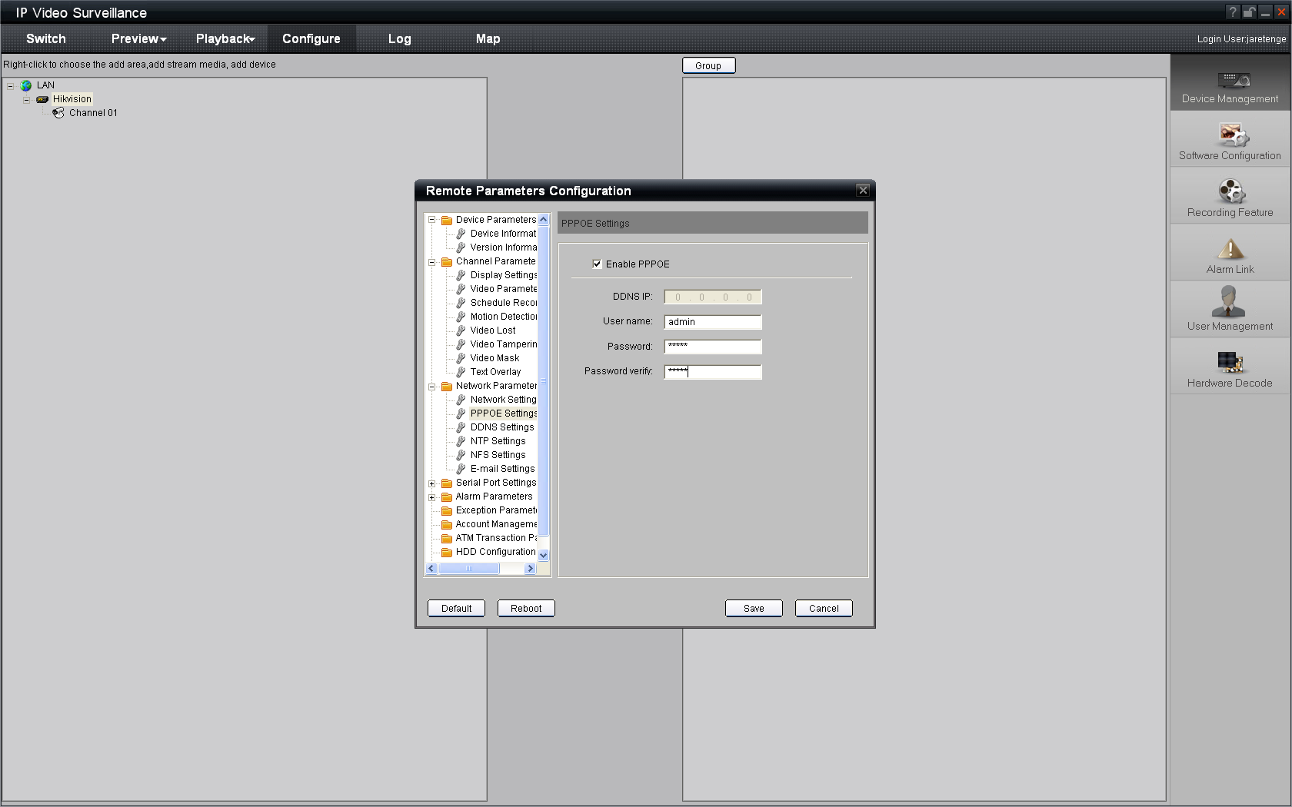

Fig.3.6.5 PPPoE configuration dialog box
It is inconvenient to view a network camera with a dynamic IP, therefore, users should register with a dynamic DNS service provider. (Such as DynDns.com)
Domain name resolution contains normal domain name resolution and private domain name resolution. First, we will introduce normal domain name resolution.
- Normal Domain Name Resolution
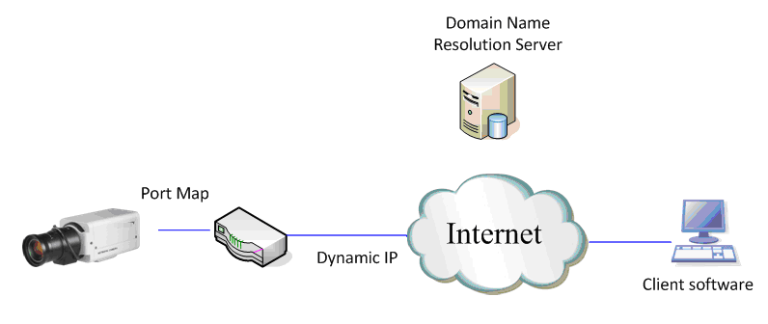
Fig.3.6.6 Normal Domain Name Resolution
Apply a domain name from a domain name provider, then view the camera via the applied domain name. If the camera connects to the internet via a router, users should port forward the router. Please refer to Appendix 2.
Input domain names in the client software or IE to view the network cameras. Take the client software configuration as an example.
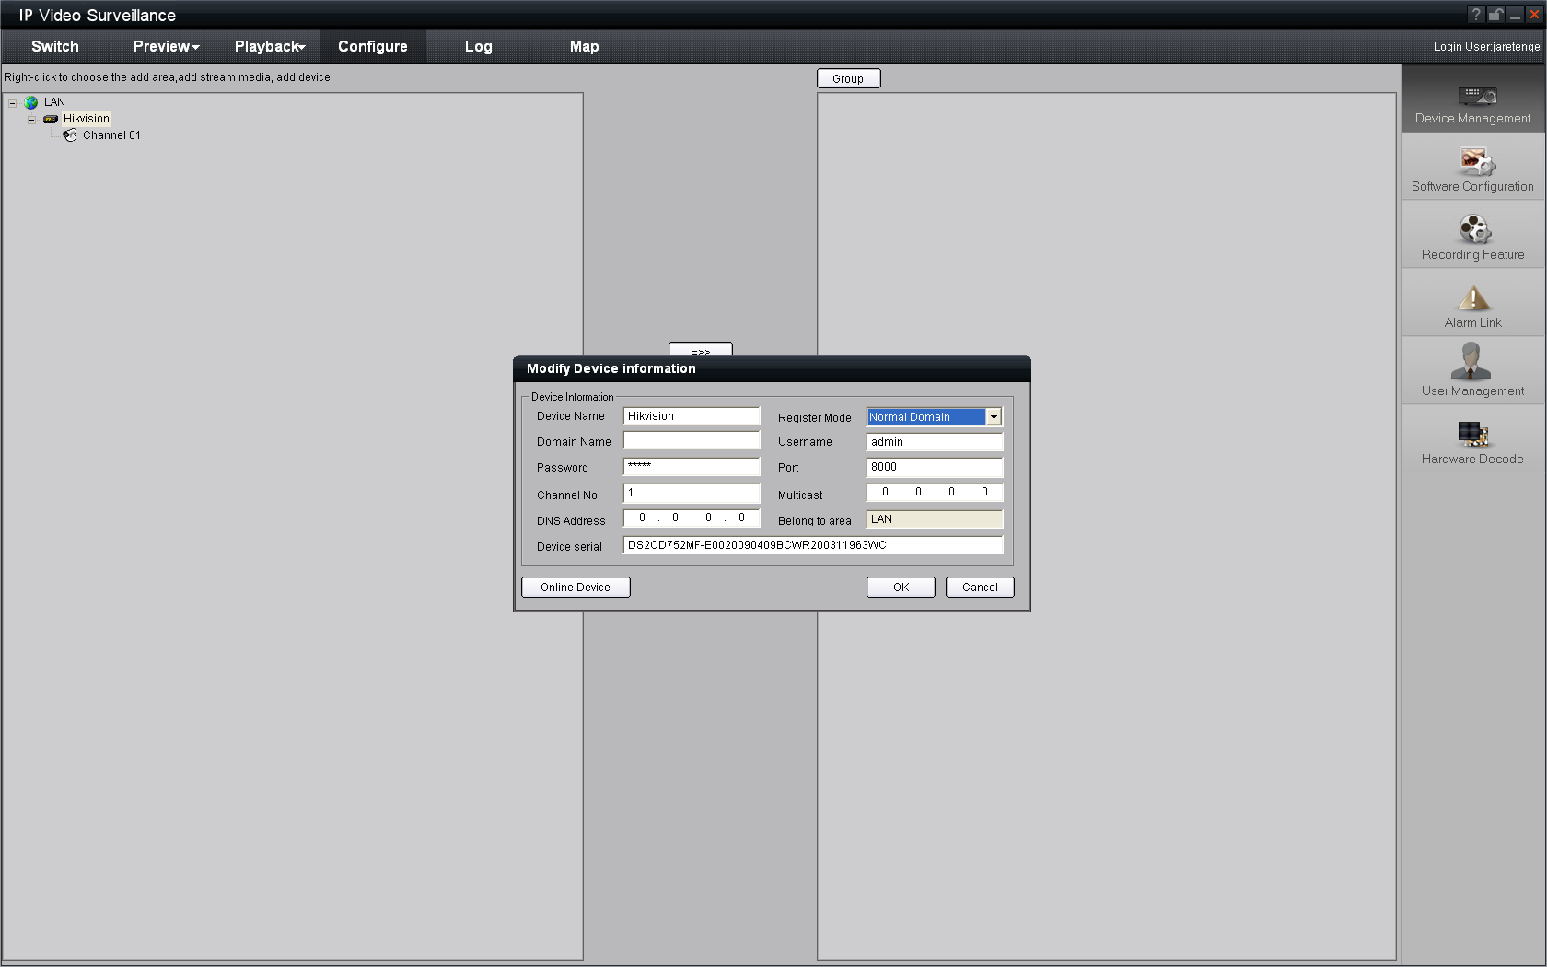
Fig.3.6.7 Selecting Normal Domain Mode
- Private Domain Name Resolution
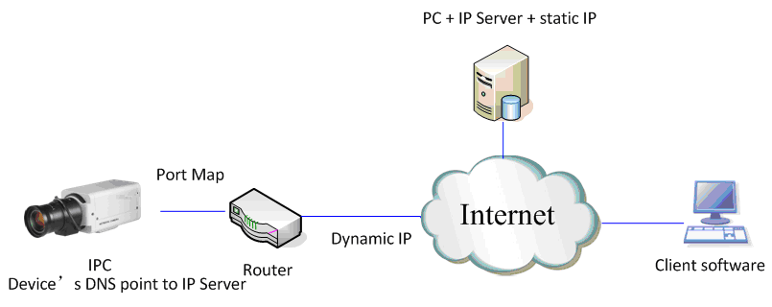
Fig.3.6.8 Private Domain Name Resolution
A PC with a static IP which is running the domain name resolution service is necessary.
When the network camera connects to the internet through PPPoE and obtains an IP address, it will send its name and IP address to the resolution server. When the client software connects to the network camera, it will connect to the resolution server and tell the resolution server the expected camera’s name. And the server will find the camera from all the registered cameras and send its IP address to the client software. Once the client software gets the IP address, it can connect the network camera.
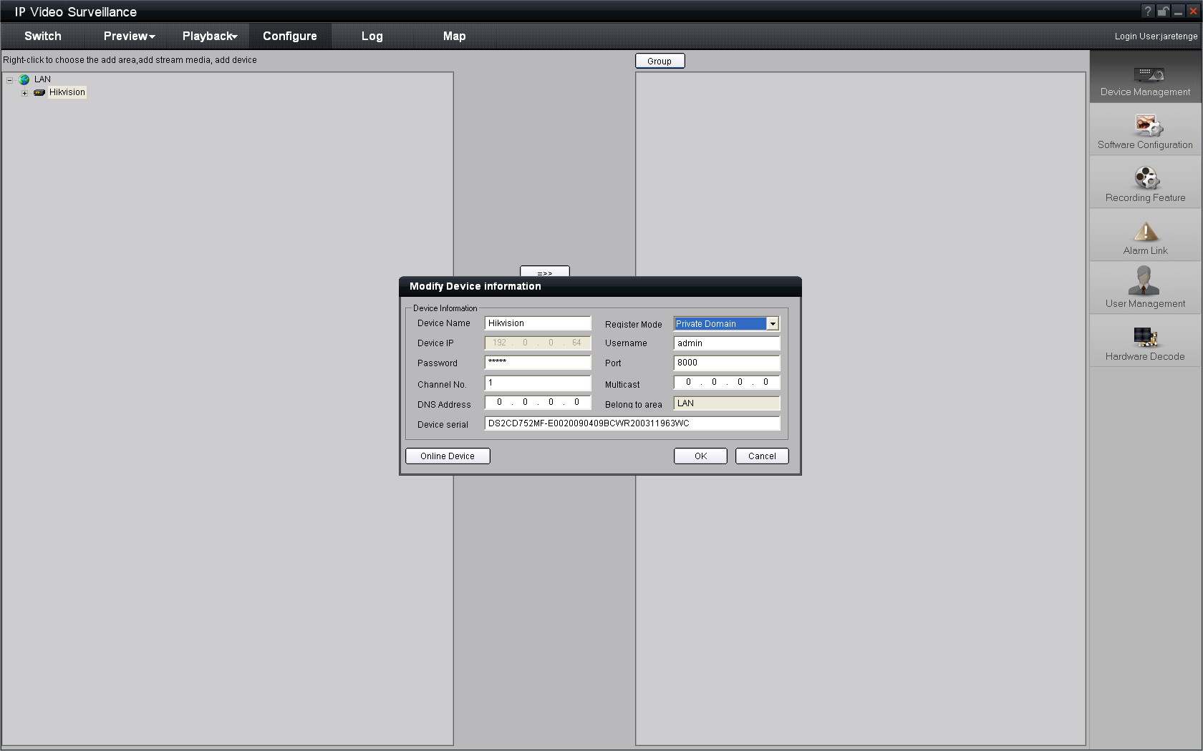
Fig.3.6.9 Selecting Private Domain Mode

Appendix 1 SADP Introduction
- Brief introduction
SADP (Search Active Devices Protocol), can automatically search IP cameras in LAN. User can modify the IP address, subnet mask and port of the device without visiting IP address of the device. Additionally, password of the super user in this device can be recovered as default.
SADP software needs to support sadp, so we should install WinPcap at first, which is placed in the directory of SADP software.
- Searching active devices online
After installing WinPcap, double click sadpdlg.exe. The software will start to search active devices in LAN, and device type, IP address, Port number, Device Serial No., subnet mask, MAC address, the number of channels, main control and encoding version and device initiating time are showed in the list, as follows:
- Modifying the information of active devices
Select the device that needs modification in the device list, then basic information of the device will be demonstrated in the information column on the right. Click ‘modify’ button to activate IP address, subnet mask, device port editing and password validating box, as follows:
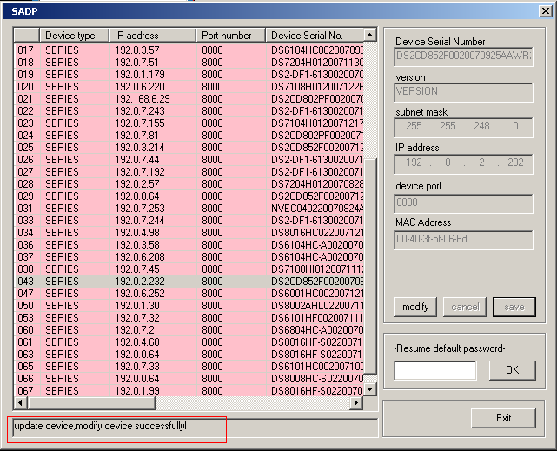
Input the new IP address, subnet mask, and port number, and click ‘save’ button. If a dialog pops up, showing ‘saved successfully’, that means you have modified the configuration information; if ‘saving failed’ dialog pops up, click the ‘cancel’ button to quit it.
- Recovering default password
You can reset the password of the super user as ‘12345’ in the case of a lost password.
Input certain validation code into the ‘Resume default password’ box, and click ‘OK’ to finish the administrator’s password initiating.
Note: Password reset code can be obtained by the technicians from Hikvision after you provide the device Serial NO.

Appendix 2 Port Map
Note: The following setting is about TP-LINK router (TL-R410), which is maybe distinct from other router’s setting.
- Firstly, select the router’s WAN connection Type. As the following Fig. shows:
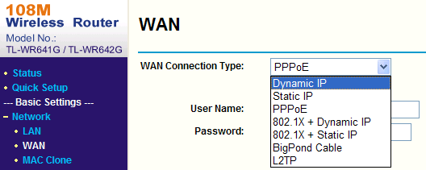
- Set the “network parameter” of the router as the below figure. The setting includes subnet mask and gateway.
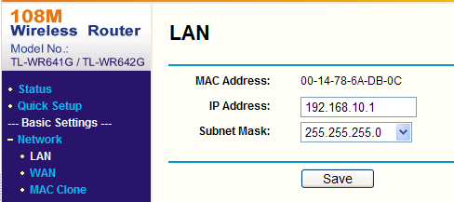
- Set the port map in the virtual severs of Forwarding. By default, camera uses port 80, 8000, 554 and 8200. You can change these ports value with IE or client software.
The following figure gives the illustration. One camera’s ports are 80, 8000, 554, 8200 and its IP address is 192.168.1.23. The other camera’s ports are 81, 8001, 555, 8201 and IP is 192.168.1.24. Afterwards, enable all or TCP protocols. Enable the port map after pressing the ‘Save’.
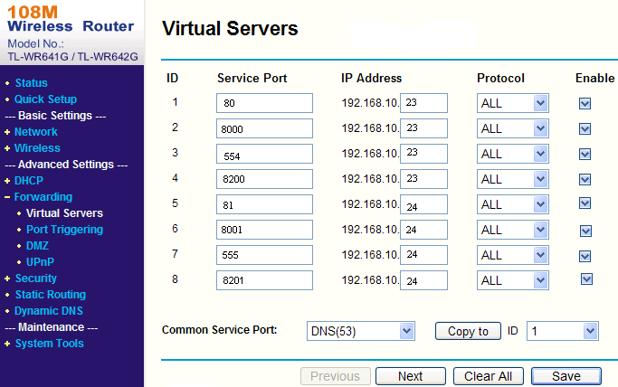
As the above mentioned setting, we map the router’s port 80, 8000, 554, 8200 to the network camera 192.168.1.23; and port 81, 8001, 555, 8201 to the network camera 192.168.1.24. In this way, user can visit the 192.168.1.23 through visiting the router’s port 80, 8000, 554 and 8200.
Note: The port of the network camera cannot conflict with other ports. For example, some router’s web management port is 80. User can amend the router’s or the camera’s port to solve this problem.

Appendix 3 Pin Definition
(1)UTP between the network port of camera and HUB (Direct Cable)
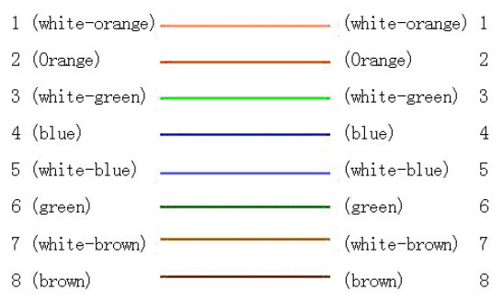
(2)UTP between the network port of camera and PC (Cross Cable):
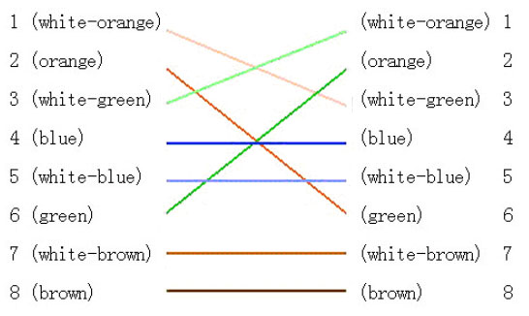

Appendix 4 Product Specification

DS-2CD802/812/892/PF(NF)(-E)(-W)

Specification
Parameter Model | DS-2CD802PF (NF) (-E) (-W) | DS-2CD812PF (NF) (-E) (-W) | DS-2CD892PF (NF) (-E) (-W)
Camera
Image Sensor | 1/3 inch SONY Super HAD CCD
Effective Pixels | PAL: 500 (H) × 582 (V)  NTSC: 510 (H) × 492 (V) | PAL: 752 (H) × 582 (V)  NTSC: 768 (H) × 494 (V) | PAL: 752 (H) × 582 (V)  NTSC: 768 (H) × 494 (V)
Lens Mount | C / CS mount
Signal System | PAL / NTSC
Electronic shutter | 1/50 (1/60)s ~ 1/100,000s
Min. Illumination | 0.1Lux @ F1.2
Day & Night | Electronic
Auto Iris Lens | DC / Video
Lens | Option
S/N Ratio | More than 48dB
Video Output | 420 TVL, 1Vpp Composite Output (75Ω / BNC) | 480TVL, 1Vpp Composite Output (75Ω / BNC) | 540TVL, 1Vpp Composite Output (75Ω / BNC)
Compression Standard
Video Compression | H.264 or MPEG-4
Video Output | 32 K ~ 2M, adjustable (8Mbps maximum)
Audio Compression | OggVorbis
Image
Image Resolution | PAL: 704 × 576, 528 × 384, 704 × 288, 352 × 288, 176 × 144  NTSC: 704 × 480, 528 × 320, 704 × 240, 352 × 240, 176 × 120
Frame Rate | 25 fps (704 × 576), 30fps (704 × 480)
Function
Motion Detect | Support
Dual Stream | Support
SD Card Local Recording | Support
Heartbeat | Support
Password Protect | Support
Protocols | TCP / IP, HTTP, DHCP, DNS, RTP / RTCP, PPPoE (FTP, SMTP, NTP, SNMP addible) ;  (-W) series support IEEE802.11g Wireless, 2.4GHz Frequency.
Interface
Audio Input | 1 channel 3.5mm audio interface (2.0 ~ 2.4Vp-p, 1kΩ)
Audio Output | 1 channel 3.5mm audio interface (line level, 600Ω)
Communication | 1 RJ45 10M/100M self-adaptive Ethernet port and one RS-485 interface
Alarm Input | 1 channel signal input
Alarm Output | 1 channel relay output
Others
Working Temperature | -10℃ ~ 60℃
Power Supply | 12VDC, ±10%, (-E) series support PoE (Power over Ethernet)
Power Consumption | 4W MAX
Dimensions (mm) | 63 × 59 × 114 (2.5” × 2.34” × 4.5”)
Weight | 650g (1.21lbs)

Dimension
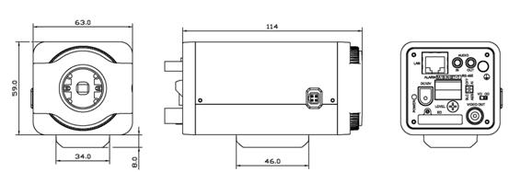

DS-2CD832F(-E)

Specification
Parameter Model | DS-2CD832F (-E) (-W)
Camera
Image Sensor | 1/4 inch CMOS
Effective Pixels | 640 (H) × 480 (V)
Lens Mount | C / CS mount
Lens | Option
Auto Iris Lens | ---
Min. Illumination | 0.4Lux @ F1.2
Day & Night | Electronic
Compression Standard
Video Compression | H.264 or MPEG-4
Video Output | 32 K ~ 2M, adjustable (8Mbps maximum)
Audio Compression | OggVorbis
Image
Image Resolution | 704 x 576, 640 x 480, 528 x 384, 704 x 288, 352 x 288, 176 x 144
Frame Rate | 25fps (704 x 576), 30fps (704 x 480)
Functions
Motion Detect | Support
Dual Stream | Support
Heartbeat | Support
SD Card Local Recording | Support
Password Protect | Support
Protocols | TCP / IP, HTTP, DHCP, DNS, RTP / RTCP, PPPoE (FTP, SMTP, NTP, SNMP addible);
Interface
Audio Input | 1 channel 3.5mm audio interface (2.0～2.4Vp-p, 1kΩ)
Audio Output | 1 channel 3.5mm audio interface (Line level, 600Ω)
Communication | 1 RJ45 10M / 100M self-adapted Ethernet port and, 1 RS-485 interface
Alarm Input | 1 channel signal input ( 0～12VDC )
Alarm Output | 1 channel signal relay output
Others
Working Temperature | -10℃ ~ 60℃
Power Supply | 12VDC, ±10%, (-E) series support PoE (Power over Ethernet)
Power Consumption | 3W MAX
Dimensions (mm) | 63 × 59 × 116 (2.5” × 2.34” × 4.51”)
Weight | 650g (1.21lbs)

Dimension
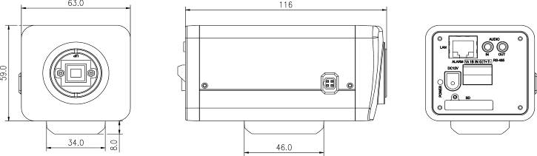

DS-2CD802/812/892P(N)-IR1(IR3)(IR5)

Specification
Model  Parameter | DS-2CD802P (N)-IR1 (IR3)(IR5) | DS-2CD812P (N)-IR1 (IR3)(IR5) | DS-2CD892 P(N)-IR1 (IR3)(IR5)
Camera
Image Sensor | 1/3 inch SONY Super HAD CCD
Effective Pixels | PAL:500(H) × 582 (V)  NTSC:510 (H) × 492 (V) | PAL:752 (H) × 582 (V)  NTSC:768 (H) × 494 (V) | PAL:752 (H) × 582 (V)  NTSC:768 (H) × 494 (V)
Lens Mount | M12×0.5
Signal System | PAL / NTSC
Electronic Shutter | 1/50 (1/60)S ~ 1/50~1/100,000S
Min. Illumination | 0.1Lux @ F1.2 (0 Lux With IR)
Lens | “-IR1” series: 6mm (2.8mm, 3.6mm option)  “-IR3” series: 12mm (3.6mm, 6mm, 8mm,16mm option)  “-IR5” series: 16mm (3.6mm, 6mm, 8mm,12mm option)
S/N Ratio | More than 48dB
Video Output | 420 TVL,1Vpp Composite Output (75Ω/BNC) | 480TVL, 1Vpp Composite Output (75Ω/BNC) | 540TVL,1Vpp Composite Output (75Ω/BNC)
Compression Standard
Video Compression | H.264 or MPEG-4
Video Output | 32 K ~ 2M, adjustable (8Mbps maximum)
Audio Compression | OggVorbis
Image
Image Resolution | PAL: 704 × 576, 528 × 384, 704 × 288, 352 × 288, 176 × 144  NTSC: 704 × 480, 528 × 320, 704 × 240, 352 × 240, 176 × 120
Frame Rate | 25 fps (704 × 576), 30fps (704 × 480)
Function
Motion Detect | Support
Dual Stream | Support
Heartbeat | Support
Password Protect | Support
Protocols | TCP / IP,HTTP,DHCP,DNS,RTP / RTCP, PPPoE (FTP,SMTP,NTP,SNMP addible)
Infrared Distance | “-IR1” series: approx 10 to 20 meters;  “-IR3” series: approx 30 to 40 meters  “-IR5” series: approx 50 to 60 meters
Interface
Audio Input | 1 channel (2.0 ~ 2.4Vp-p, 1kΩ)
Audio Output | 1 channel (Line level, 600Ω)
Communication | 1 RJ45 10M / 100M self-adapted Ethernet port and one RS-485 interface
Alarm Input | 1 channel signal input
Alarm Output | 1 channel relay output
Others
Working Temperature | -10℃ ~ 60℃
Water and Dust Resistance | IP66
Power Supply | 12VDC, ±10%
Power Consumption | “-IR1” series: 5.5W MAX  “-IR3” series: 7W MAX  “-IR5” series: 9W MAX
Dimensions(mm) | 86.5 × 83 × 228 (3.43” × 3.29” × 9.04”)
Weight | 1400g (3.04lbs)

Dimension
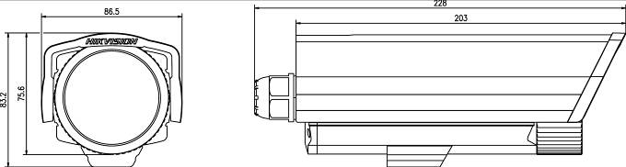

DS-2CD702/712/792PF (NF)(-E)

Specification
Parameter Model | DS-2CD702PF (NF) -E | DS-2CD712P F(NF) -E |  | DS-2CD792PF (NF) -E
Camera
Image Sensor | 1/3 inch SONY Super HAD CCD
Effective Pixels | PAL:500 (H) × 582 (V)  NTSC:510 (H) × 492 (V) | PAL:752 (H) × 582 (V)  NTSC:768 (H) × 494 (V) |  | PAL:752 (H) × 582 (V)  NTSC:768 (H) × 494 (V)
Lens | 3.5 ~ 9mm @ F1.2 / Φ14 / Fixed Iris lens
Signal System | PAL / NTSC
Electronic Shutter | 1/50 (1/60)s to 1/100,000s
Min. Illumination | 0.1Lux @ F1.2
Day & Night | Electronic
S/N Ratio | More than 48dB
Video Output | 420 TVL, 1Vp-p Composite Outpu t (75Ω/BNC) |  | 480 TVL, 1Vp-p Composite Output (75Ω/BNC) |  | 540TVL, 1Vp-p Composite Output (75Ω/BNC)
Compression Standard
Video Compression | H.264 or MPEG-4
Video Output | 32 K ~ 2M, adjustable (8Mbps,maximum)
Audio Compression | OggVorbis
Image
Image Resolution | PAL: 704 × 576, 528 × 384, 704 × 288, 352 × 288, 176 × 144  NTSC: 704 × 480, 528 × 320, 704 × 240, 352 × 240, 176 × 120
Frame Rate | 25fp s(704 × 576), 30fps (704 × 480)
Functions
Motion Detect | Support
Dual Stream | Support
SD Card Local Recording | Support
Heartbeat | Support
Password Protect | Support
Protocols | TCP / IP, HTTP, DHCP, DNS, RTP / RTCP, PPPoE (FTP,SMTP,NTP,SNMP addible)
Adjustment Range | 355° Pan  90° Tilt
Interface
Audio Input | 1channel (2.0 ~ 2.4Vp-p, 1kΩ)
Audio Output | 1 channel (Line level, 600Ω)
Communication | 1 RJ45 10M / 100M self-adapted Ethernet port and 1 RS-485 interface
Alarm Input | 1 channel signal input
Alarm Output | 1 channel relay output
Others
Working Temperature | -10℃ ~ 60℃
Power Supply | 12VDC, ±10%, (-E) series support PoE (Power over Ethernet)
Power Consumption | 4W MAX
Dimensions (mm) | φ145 × 132.8 (φ5.75” × 5.26”)
Weight | 900g (1.98lbs)

Dimension
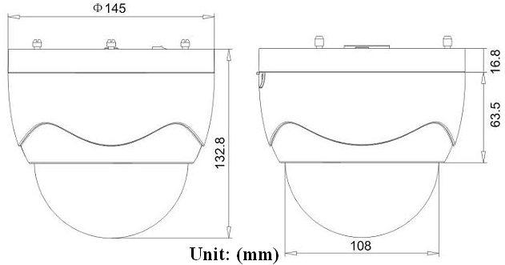

DS-2CD732F(-E)

Specification
Parameter Model | DS-2CD732F-E
Camera
Image Sensor | 1/4 inch CMOS
Effective Pixels | 640 (H) × 480 (V)
Lens | 3.5-8mm @ F1.6 / M12 / manual Iris lens
Min. Illumination | 0.4Lux @ F1.2
Video Output | 1.0Vp-p Composite Output (75Ω/BNC)
Day&Night | Electronic
Compression Standard
Video Compression | H.264 or MPEG-4
Video Output | 32 K ~ 2M, adjustable (8Mbps maximum)
Audio Compression | OggVorbis
Image
Image Resolution | 704 × 576, 640 × 480, 528 × 384, 704 × 288, 352 × 288, 176 × 144
Frame Rate | 25fps (704 × 576)
Functions
Motion Detect | Support
Dual Stream | Support
SD Card Local Recording | Support
Heartbeat | Support
Password Protect | Support
Protocols | TCP / IP, HTTP, DHCP, DNS, RTP / RTCP, PPPoE (FTP, SMTP, NTP, SNMP addible).
Interface
Audio Input | 1 channel (2.0 ~ 2.4Vp-p,1kΩ)
Audio Output | 1 channel (Line level, 600Ω)
Communication | 1 RJ45 10M / 100M self-adaptive Ethernet port and 1 RS-485 interface
Alarm Input | 1 channel signal input
Alarm Output | 1 channel signal relay output
Others
Working Temperature | -10℃ ~ 60℃
Power Supply | 12VDC, ±10%, (-E) series support PoE (Power over Ethernet)
Power Consumption | 3W MAX
Dimensions (mm) | φ145 × 132.8 (φ5.75” × 5.26”)
Weight | 900g (1.98lbs)

Dimension

First Choice for Security Professionals

