

iVMS-4200 Client Software
Quick Start Guide

Notices

The information in this documentation is subject to change without notice and does not represent any commitment on behalf of HIKVISION. HIKVISION disclaims any liability whatsoever for incorrect data that may appear in this documentation. The product(s) described in this documentation are furnished subject to a license and may only be used in accordance with the terms and conditions of such license.

Copyright © 2006-2011 by HIKVISION. All rights reserved.

This documentation is issued in strict confidence and is to be used only for the purposes for which it is supplied. It may not be reproduced in whole or in part, in any form, or by any means or be used for any other purpose without prior written consent of HIKVISION and then only on the condition that this notice is included in any such reproduction. No information as to the contents or subject matter of this documentation, or any part thereof, or arising directly or indirectly therefrom, shall be given orally or in writing or shall be communicated in any manner whatsoever to any third party being an individual, firm, or company or any employee thereof without the prior written consent of HIKVISION. Use of this product is subject to acceptance of the HIKVISION agreement required to use this product. HIKVISION reserves the right to make changes to its products as circumstances may warrant, without notice.

This documentation is provided “as-is,” without warranty of any kind.

Please send any comments regarding the documentation to:
overseasbusiness@hikvision.com

Find out more about HIKVISION at www.hikvision.com

1. Overview

This Guide provides basic instructions on how to operate the software, live view, record images and play back the recorded video. For detailed instructions on programming and using the software, please refer to the iVMS-4200 User Manual.

2. Install the Software

Insert the DX4200 resource disc into the remote computer CD/DVD drive, and wait a while for the window to open.
Follow the installation prompts to install the software.
Step1: Double click the program file to enter the following InstallShield Wizard as shown below:
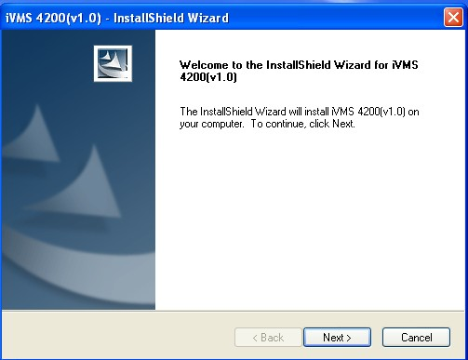
Figure 3.1 Welcome to InstallShield Wizard

Step2: Click “Next” to start the InstallShield Wizard. Select the language (English) for installation, and then click “Next” to continue.
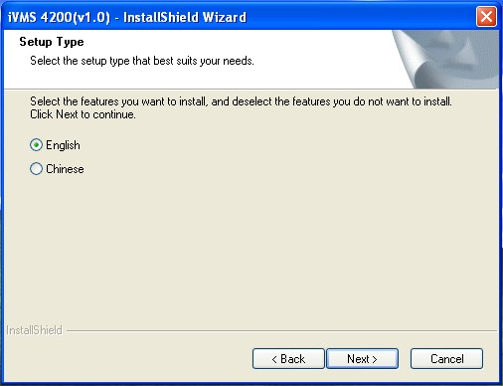
Figure 3.2 Select Language

Step3: Install vcredist_x86 patch/Card Driver/WinpCap
Select the driver you want to install.
vcredist_x86 patch:for X86 operating system
Card Driver: for compression card
WinpCap: for open source software, SADP driver
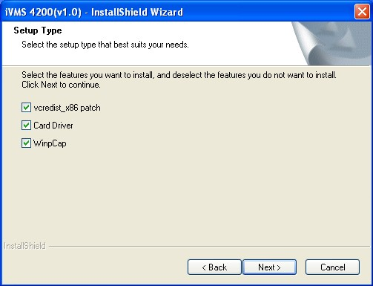
Figure 3.3 Select Driver
Install vcredist_x86 patch
Start to install the vcredist_x86 patch and then click ”Next” to continue.
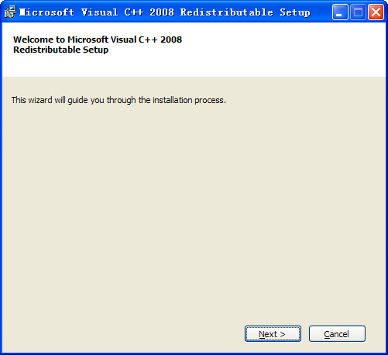
Figure 3.4 Install vcredist_x86 patch-Start Installation

In the License Terms dialog box, click “I have read and accept the license terms”, and then click “Install” to install the vcredist_x86 patch.
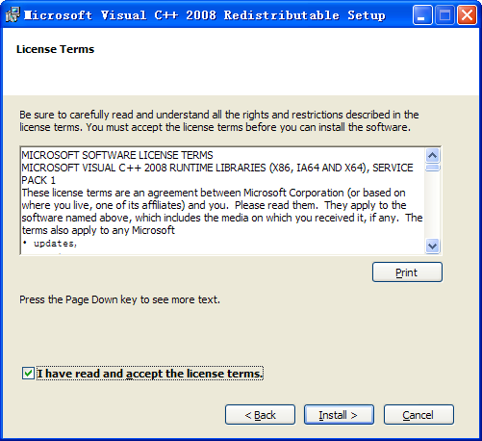
Figure 3.5 Install vcredist_x86 patch-Accept License Terms

After the Setup Complete interface appears, click Finish to complete the installation of vcredist_x86 patch.
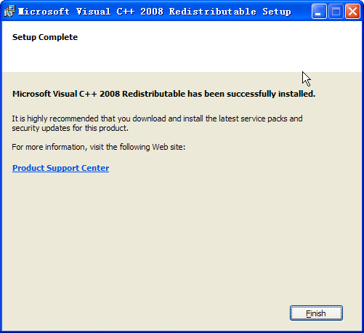
Figure 3.6 Install vcredist_x86 patch-Complete Installation

Install Card Driver
If there is compression card installed on your computer, you can click the “Install or Update Driver” option to install the card driver.

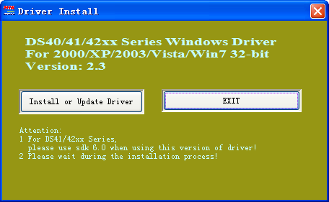
Figure 3.7 Install Card Driver

Install WinPcap
Follow the installation prompt to complete the installation of WinPcap. If it has been installed on your computer, you can cancel this step.

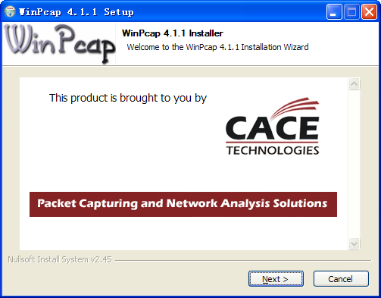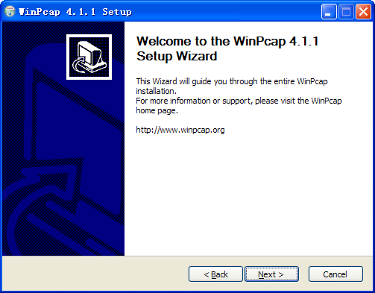
Figure 3.8 Install WinPcap

Note: The SADP is used for automatically searching the online device in the local network. If the WinPcap is not installed, the SADP software cannot be used.

After the driver has been installed, continue the following steps.

Step5: Select the programs you want to install on your computer, including the User Client, PC NVR Server and Stream Media Server. User can also click Browse to change the directory to save the program files.
Click “Next” to continue.
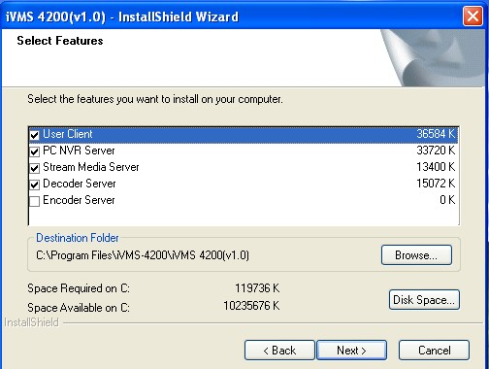
Figure 3.9 Select Installation Programs
Step6: In the License Terms interface, click “I accept the terms of the license agreement”, and then click “Next” to continue the installation.
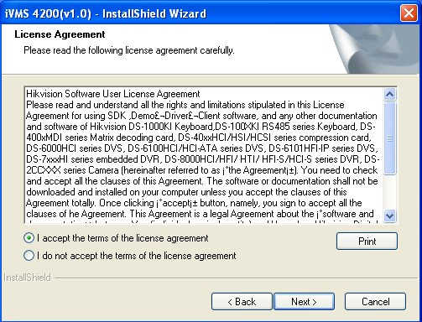
Figure 3.10 Select Installation Programs

Step7: Click “Install” to start installation of the selected programs.
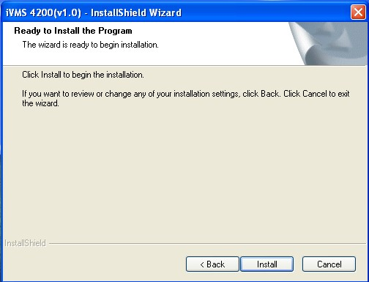
Figure 3.11 Install the Selected Programs

Step8: After the installing progress is completed, enter the Setup Type interface to select the desktop shortcut icons for the installed programs. Click “Next” to continue the installation.
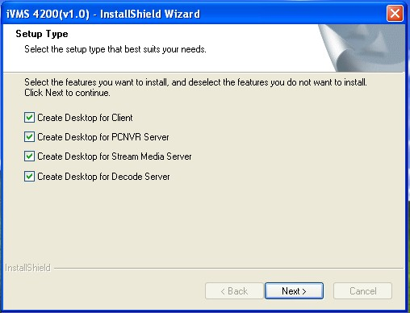
Figure 3.12 Create Desktop Shortcut Icons

Step9: Click “Finish” to complete the installation.
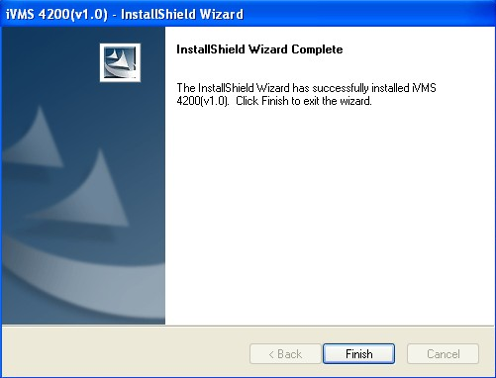
Figure 3.13 Finish the Completion

3. Uninstall the Software
Click Start→All Programs→4200 client and select “Uninstall iVMS-4200” option to enter the following interface:
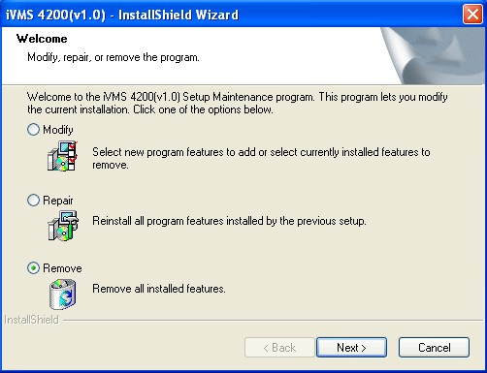
Figure 3.1 Uninstall the Programs

Select “Remove” to remove all installed features and then click “Next” to uninstall iVMS-4200 according to the prompts.

4. User Registration
For the first time to use the iVMS-4200 software, user needs to register a super user for login.

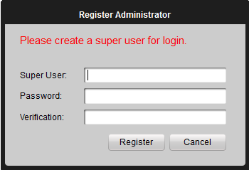
Figure 4.1 User Login

Input the super user name, password and verification in the dialog box and click Register. Then, user can log in as the super user.
Note: Enter, Space, and TAB buttons are invalid for the user name and password. The password cannot be null, and it should not be less than six characters and does not support the copy and paste operation.

5. Quick Start

User Login
Double click the shortcut 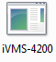 on desktop to run the client software. When user opens the iVMS-4200 software after registration, the login dialog box will pop up, shown as below:
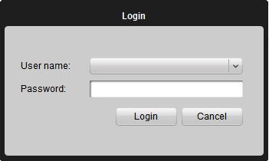
Figure 5.1 User Login
Input user name and password, and then click Login to start using the iVMS-4200 software.

Control Panel
For the intelligent video management system, Hikvision iVMS-4200 provides an effective and convenient GUI for user to operate the client software. The main control panel of the iVMS-4200 is shown as below:
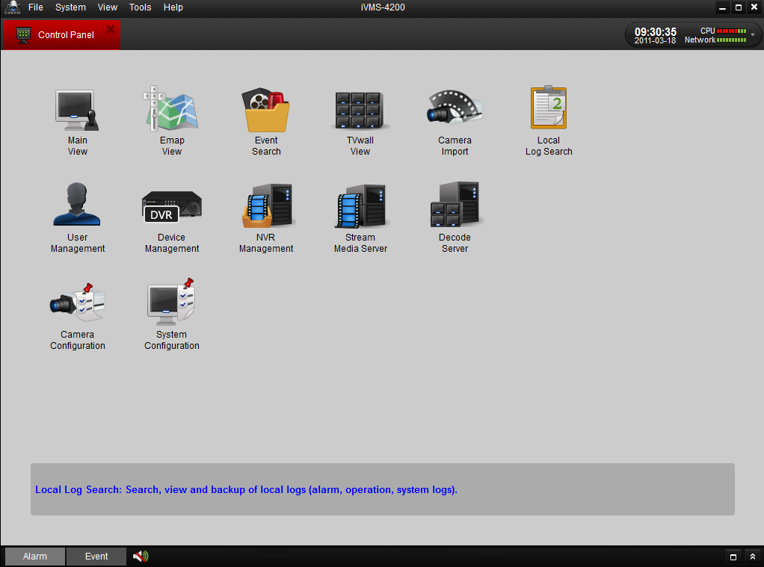
Figure 5.2 Control Panel

Import Camera
After registration and login, the following message box pops up:
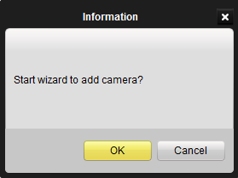

Figure 3.15 Import Camera Wizard

Click OK to start the wizard and add the device, or click Cancel to exit the wizard.
Step1: According to the hint, click Import Camera icon to enter the Camera Import control interface.
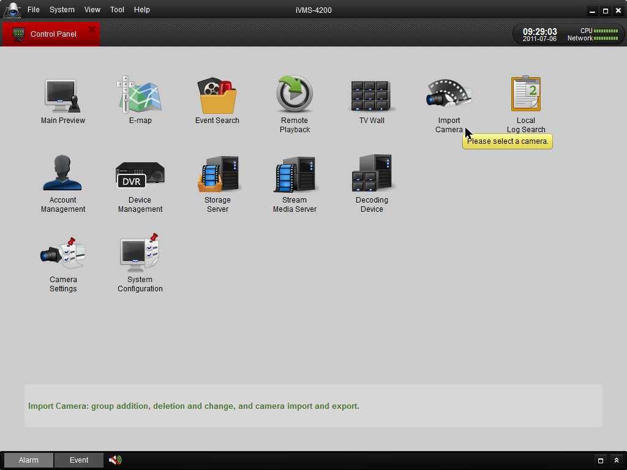
Figure 3.16 Enter Camera Import Interface

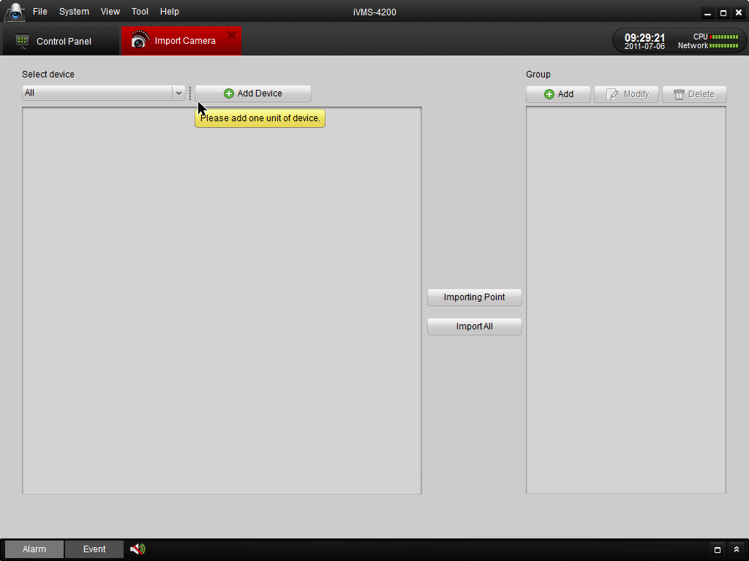
Figure 3.17 Device Management Interface
Step2: Add DVR
Click Add Device and then input the device information and then click Add to enter the device information in the dialog box of Add DVR interface.
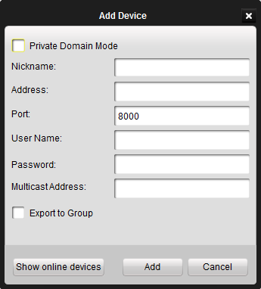
Figure 3.18 Add DVR

Step 3: After adding the device according to the above steps, you will see the toolbar after the device name.
click to enter the Device Parameters configuration interface (Figure 3.19).

Click to edit the connected device settings.
Click to delete the added group.
Click to refresh the page.
Click to import all the monitoring point to the group named by the name of the device.

Step 4: Add Group
After adding DVR, please click the Add on Group dialog box. Edit the name of group and then click OK to save your settings.. The added group will be displayed in the list.
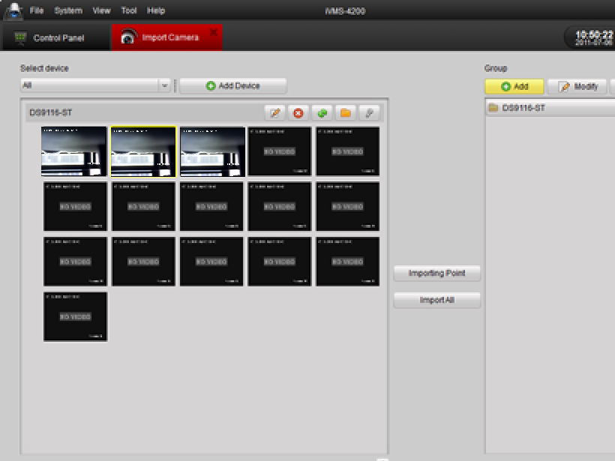
Figure 3.19 Add Group

Step 5: Import Channel to Group
In the left area on the Camera Import interface, click to select the channels and then click Import button to import the selected channels to the Group on the right.
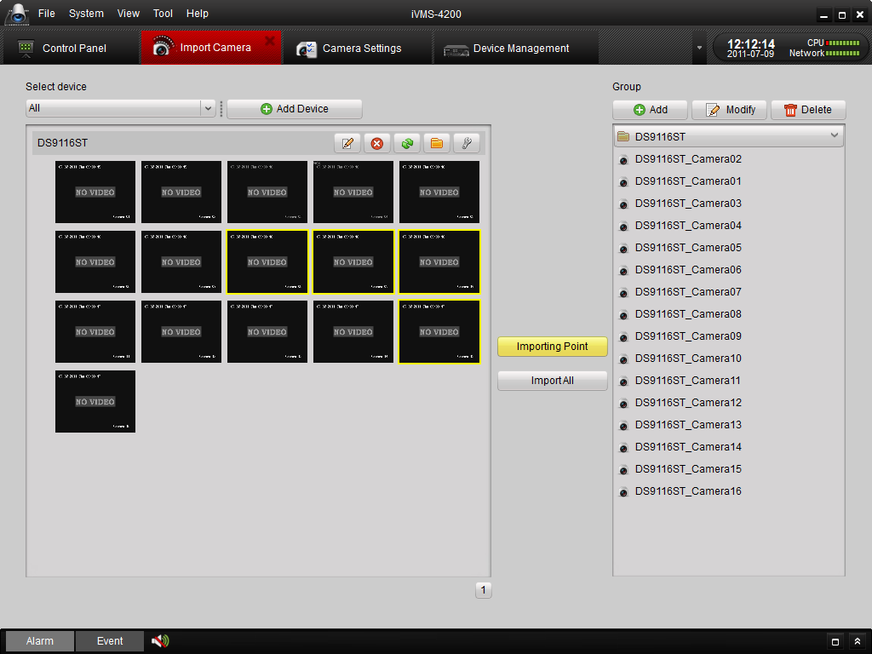

Figure 3.20 Import Channel

Note:
- You can hold the Ctrl key on PC to select multiple channels or click Import All button to select all channels for import.
- The devices to be added must be online currently.
- Each channel can be added to one group only once, while the same channel can be added to different groups.
- Up to 50 channels can be added to each group, with a maximum of 256 channels for all the groups totally.

Step 6: After importing the selected channels to the group, you can return to the control panel and then enter the Main View interface to get a live view of the added channels.

Start Live View
To view the live video, drag the camera from the list to the right display window, or double click the camera node to view the live video (Figure 5.12).
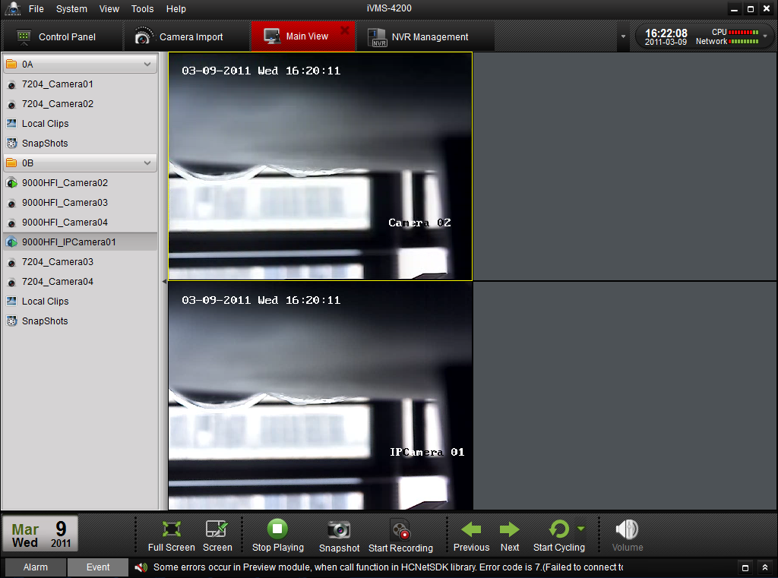
Figure 5.12 Start Live View
Toolbar in each display window:
Button | Description
 | Take a snapshot of the camera
 | Start manual record, click again to stop
 | Start voice talk, click again to stop
 | PTZ control, 8 direction icons will be displayed on the video.
 | Check the input camera status
 | Go back to the camera configuration interface
 | Stop live view
 | Remote playback about 7 minutes record of current camera
 | Audio button, click to open and close

Playback

Playback of Local Stored Files
Play back the video files created in local recording mode.
- Go to Main View panel and click the All Files icon to enter the Local Record Files interface. Select a camera and specify the start time and the stop time, and then click Search button to search the video clips. The matched video found will be listed in the display panel below. Refer to Figure 7.1:
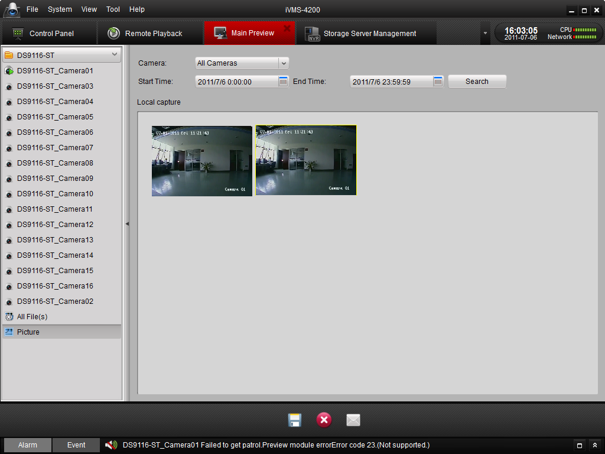
Figure 7.1 Search Local Record Files

- User can click  button to save the selected video clip. User can also click 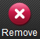 to delete the clip from the panel, or click the  button to send the selected video clip by Email (size of video clip must be less than 5M).

- Select a video clip and double click it, and then a player will pop up (refer to Figure 7.2).
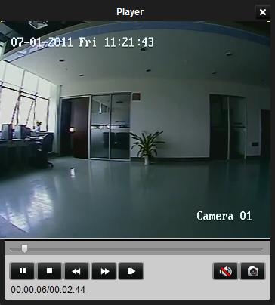
Figure 7.2 Playback Player

You can click icon to view the video, click and icons to fast or slow play the video. Click to pause the playing. You can also capture in the playing video.

Instant Playback
- Go to Main View panel, double-click a channel to enable the tool bar shown as below, and click button to start instant playback.
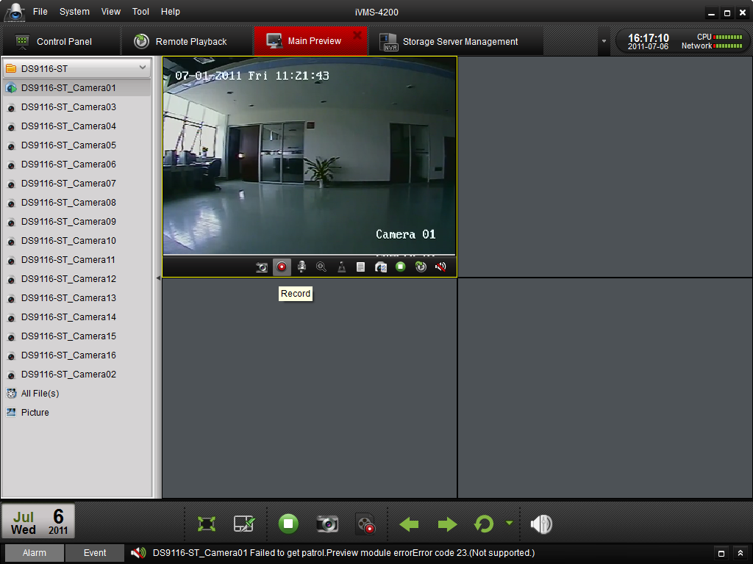
Figure 7.3 Switch Live Preview/Playback Mode
- In instant playback interface, please click button to start playback the first video files of current day; click and buttons to fast or slow play the video. Click to pause.
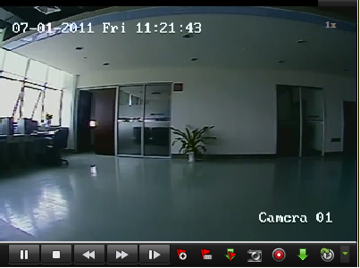
7.4 Playback Player

- The table below is a list of other buttons in this interface for video management.

Button | Description
 | Picture capture
 | Start/Stop video cutting
 | Download the video file with flow control
 | Switch preview/playback mode
 | Open/close audio
 | Add default tag
 | Add customized tag
 | Tag download

- You may also use the timeline at the bottom of the Main View panel to adjust the playback progress. Also and buttons are used to expand and narrow down the time bar so user can choose a more accurate playback time.
Figure 7.5 Time Bar

Event Playback
Playback the record files of event type.
- Go to Event Search interface and select an event type: motion or alarm input.
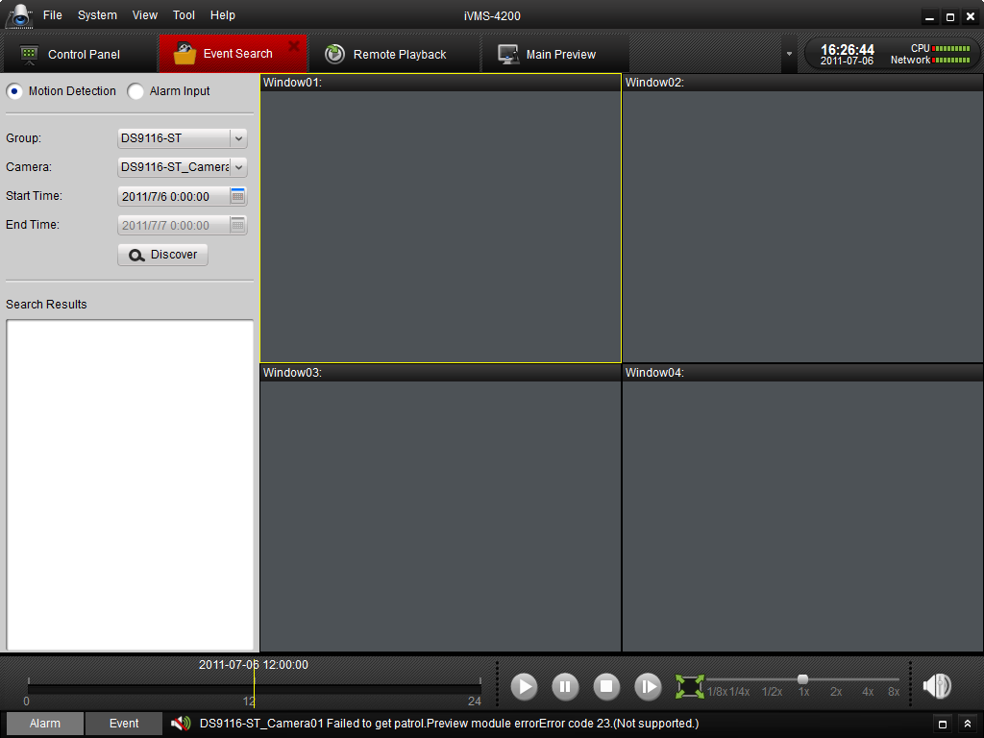
Figure 7.6 Event Search

- Select a camera in the group and specify a start time, then click Search button.
- Select a window, and double-click a video file from the search results list to play.

- During playing back the video, you may right click the mouse in the image to get a drop-down menu as shown in Figure 7.7. Please refer to the table below for more details on this menu. You may also change playback speed by clicking on the 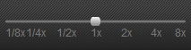 bar.

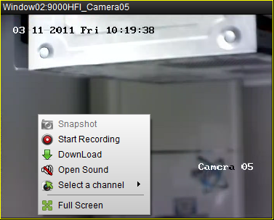
Figure 7.7 Event Playback

Button | Description
 | Picture capture
 | Start/Stop the video cutting
 | Download the video file
 | Audio button, click to open and close audio
 | Select a recording-triggered channel for playback
 | Full screen

Note:
- Event playback function is only available for NVR/DVR which support event recording.
- Make sure to import all the channels that you wish to play back in Import Camera panel.
- It is also required to enable continuous recording on all the alarm/motion-triggered channels before event playback.

Remote Playback
The remote client can search the record files on the Storage Server and the DVR, and it can also do the dynamic analysis for the record files.
Click 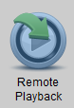 on the control panel to enter the Remote Playback Interface.
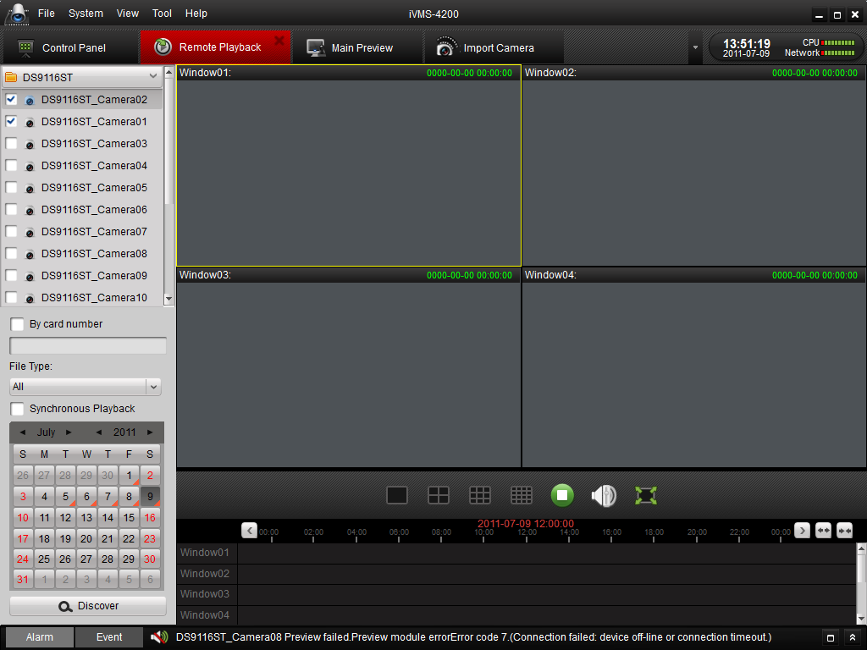
Figure 7.8 Remote Playback
Keyboard Description:
Icon | Name | Description
 | Screen Split | 1、4、9、16 screen-mode
 | Stop | Stop all the playback
 | Volume | Adjust volume
 | Full-screen | Full-screen Preview

Search the record files:
- By date and camera:
Check the checkbox on the camera list, and then on the calendar below, select the day you want to search. Then click Search.

Note: If there are record files for that camera in that day. In the calendar, the icon for that day is displayed as . Otherwise it is displayed as .
The timeline indicates the time duration for the record file.
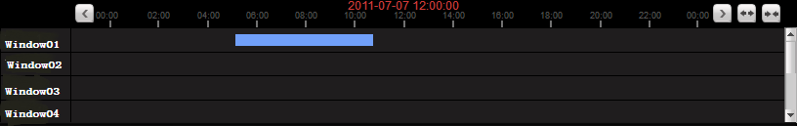
Figure 7.9 Playback Timeline
- By card number:
This function is only applied to the ATM DVR, you can search the record files by the DVR card number.
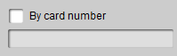
Figure 7.10 Search by Card Number
Note: You still need to choose the date and camera to search the files.
- By File Type:
You can select the file type to restrict the searching condition and search for only the record files for certain types.
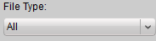
Figure 7.11 Search by File Type
Playback Management:
After finding the record files, you can see the files displayed on the screen playing automatically.
- Move the mouse to the screen of which camera you’d like to manage. A toolbar is showed at the bottom.
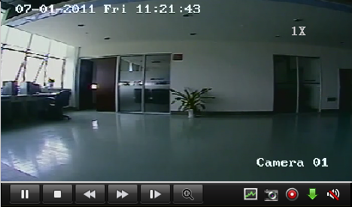
Figure 7.12 Playback Toolbar
Toolbar description:
Icon | Description
 | Pause the video
 | Stop playing
 | Playback by single frame
 | Dynamic Analysis
 | Clip
 | Audio on/off
 | Play
 | Speed Control
 | Digital Zoom
 | Capture in the playback mode.
 | Download
Note: Click , the video move forward to next frame.
You can enable audio on only one channel at one time.

Dynamic Analysis Management:
Click on the toolbar, the dynamic analysis toolbar is showed up.
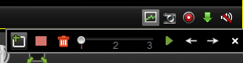
Figure 7.13 Dynamic Analysis
Note: The dynamic analysis function is applied to 9000 or 9100 series or upper version DVR.
Toolbar Description:
Icons | Description |  | Icons | Description
 | Draw Area |  |  | All Area
 | Delete Area |  |  | Sensitivity of Event
 | Start Searching |  |  | Last Event
 | Next Event |  |  | Close

If there are eligible record files for dynamic analysis, there are red areas on the time line.
Figure 7.14 Dynamic Analysis Time Line

Download Record Files:
Click to download the files you selected.
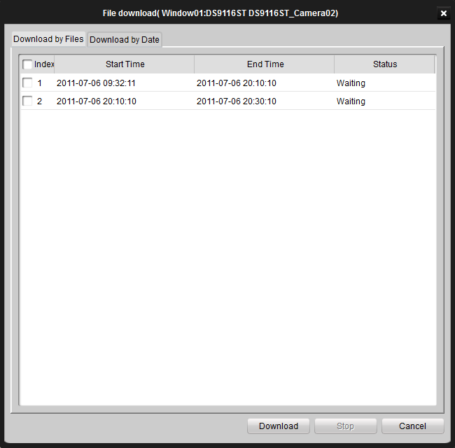
Note: The saving path for the downloaded files can be set in the System Configuration interface. See chapter 13.2.

6. Exit System
Click File on the top menu and select Exit, or click on the top right corner of the main interface, and then a confirmation dialog pops up. Click OK to exit iVMS-4200 client software

