Verify Contents
Verify that the package contents are correct by checking the items against the packing list.
Note: Please contact your dealer for damaged or missing items.
DVR Pre-Installation
TheDS-7200/DS-7300/DS-8100-S(E) Series DVRs are highly advanced surveillance equipment that should be installed with care. Please take into consideration the following precautionary steps before installation of the DVR.
1. Keep all liquids away from the DVR.
2. Install the DVR in a well-ventilated and dust-free area.
3. Ensure environmental conditions meet factory specifications.
4. Install a manufacturer recommended HDD.
DVR Installation
During the installation of the DVR:
1. Use brackets for rack mounting.
2. Ensure there is ample room for audio and video cables.
3. When installing cables, ensure that the bend radius of the cables are no less than five times than its diameter.
4. Connect both the alarm and RS-485 cable.
5. Allow at least 2cm (~0.75in) of space between racks mounted devices.
6. Ensure the DVR is grounded.
7. Environmental temperature should be within the range of -10ºC ~ 55ºC, 14ºF ~ 131ºF.
8. Environmental humidity should be within the range of 10% ~ 90%.
Hard Disk Installation
Before installing a hard disk drive (HDD), please make sure the power is disconnected from the DVR. A manufacturer recommended HDD should be used for this installation.
Tools Required: Phillips screwdriver.

To install hard disk for 7300/8100–SE series DVR:

- Fasten a hard disk handle to one side of the hard disk with screws.
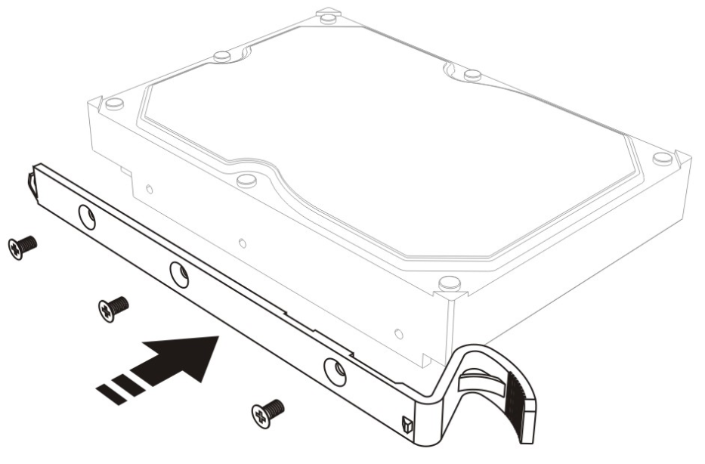
- Fasten another hard disk handle to the other side of the hard disk with screws.
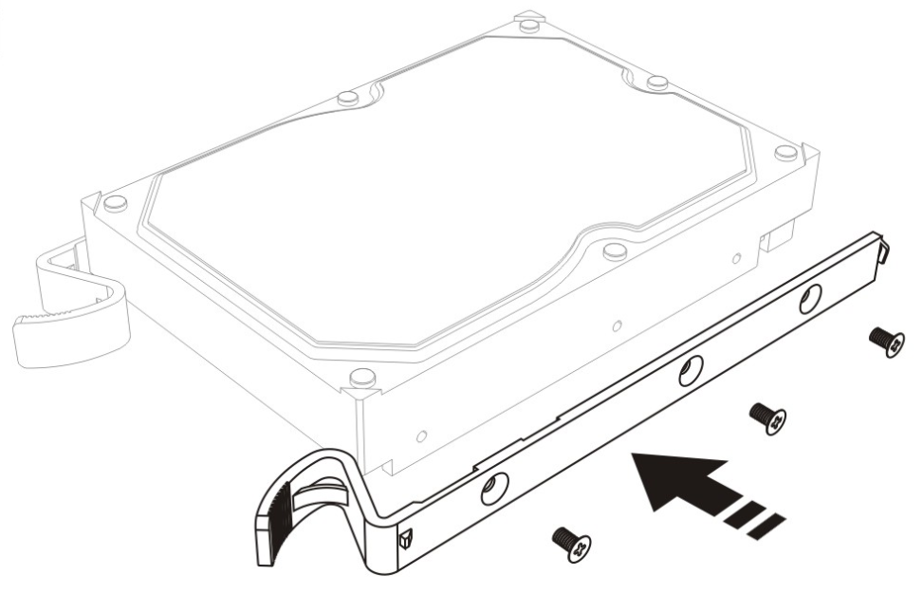
- Insert the key and turn clockwise to open panel lock, and then pull out the key.
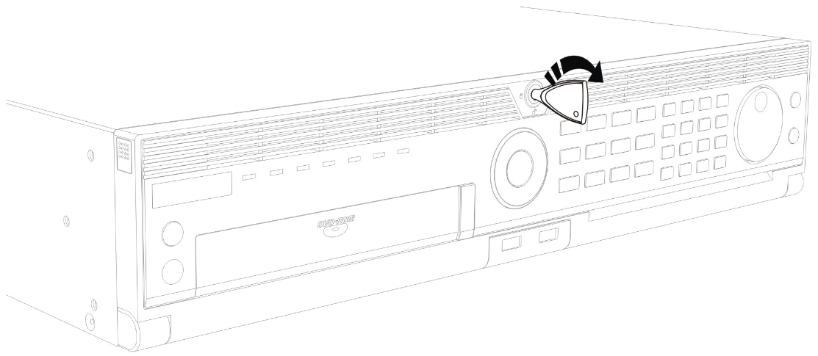
- Press the buttons on the panel of two sides, after panel and chassis unhooks, and then turn down the panel.
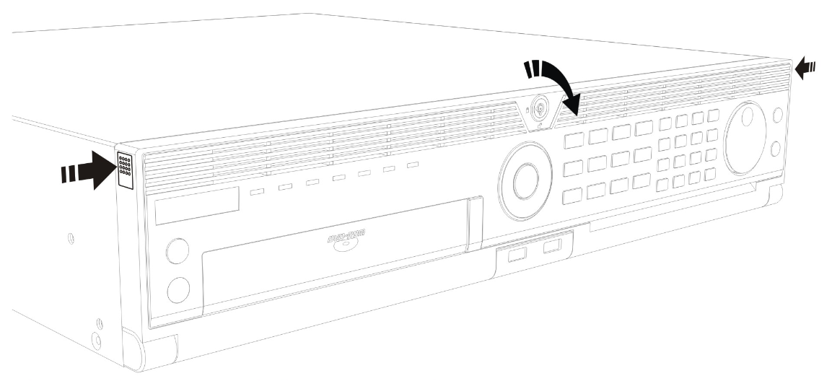
- Keep front side of the hard disk up and insert it along the slide way, push the hard disk to the bottom and make sure it is in the right place to finish installation.
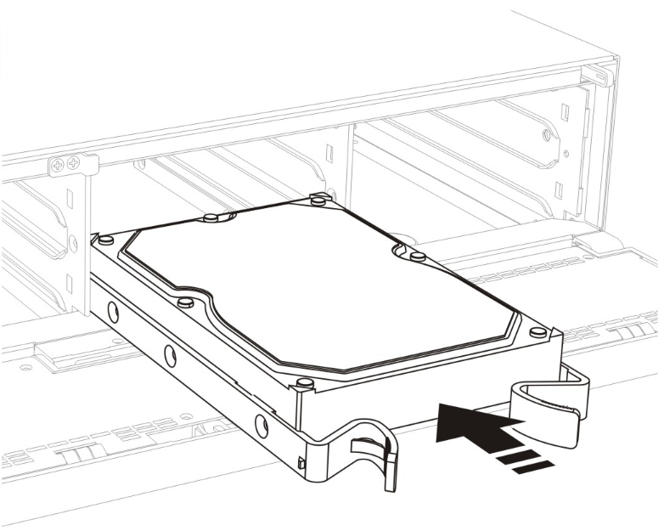
- Press the hard disk handles of both sides to pull out the hard disk.
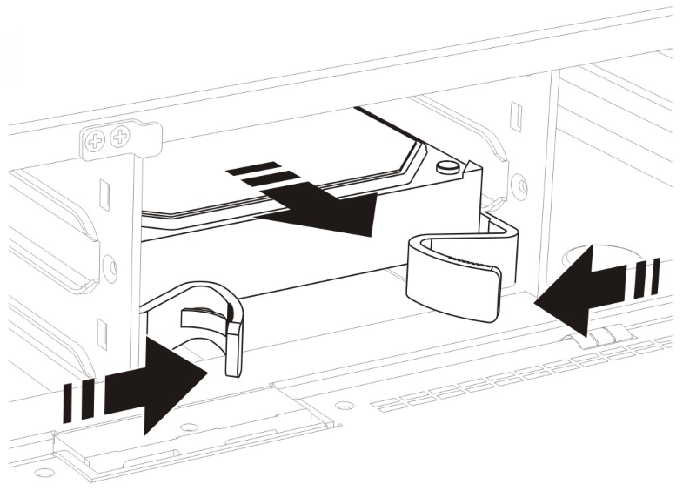
Note: Please handle with care to avoid the hard disk damage caused by fall-off or collision.

To install hard disk for 7200/7300/8100–S series DVR:

- Remove the lid of the DVR by unfastening the screws on the back.
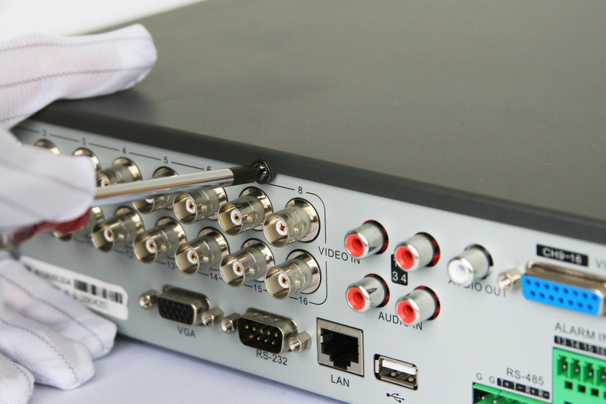

- Install the HDD on the chassis
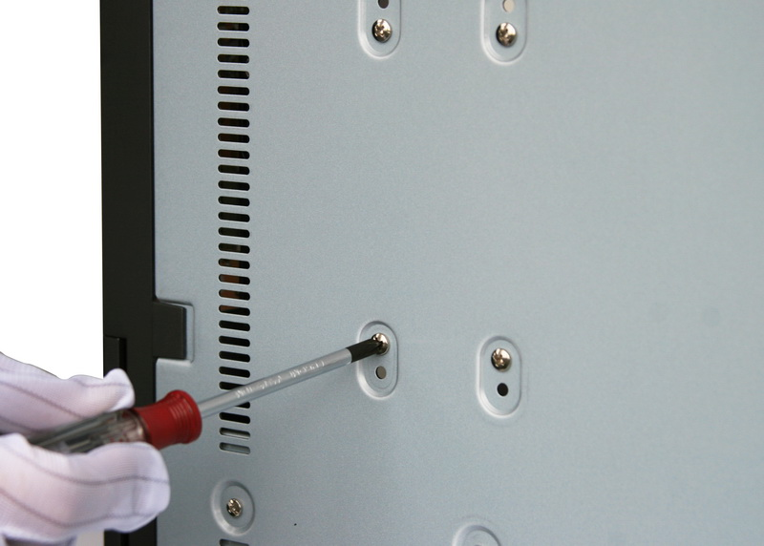

- Connect the HDD to the motherboard of the DVR with the included data cable.
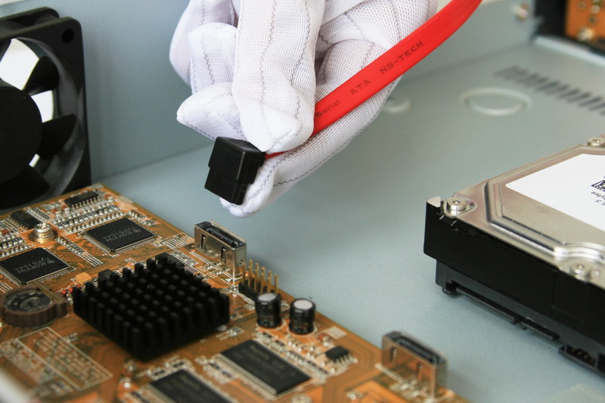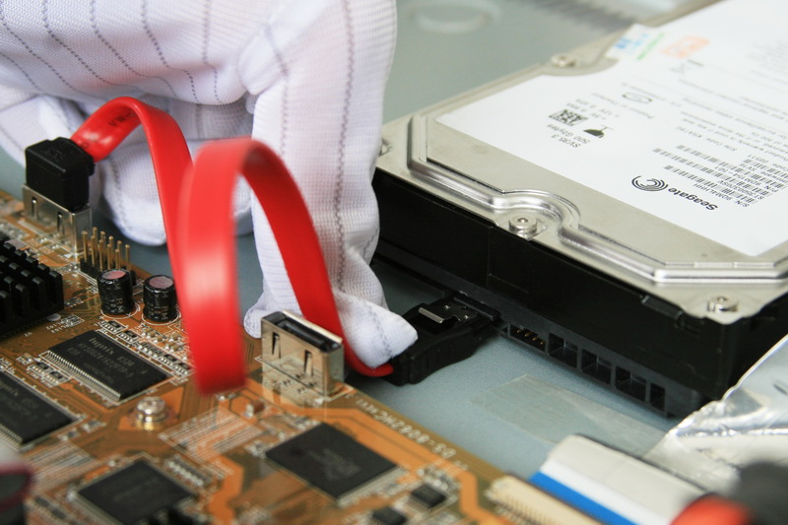

- Connect the power cable to the HDD.
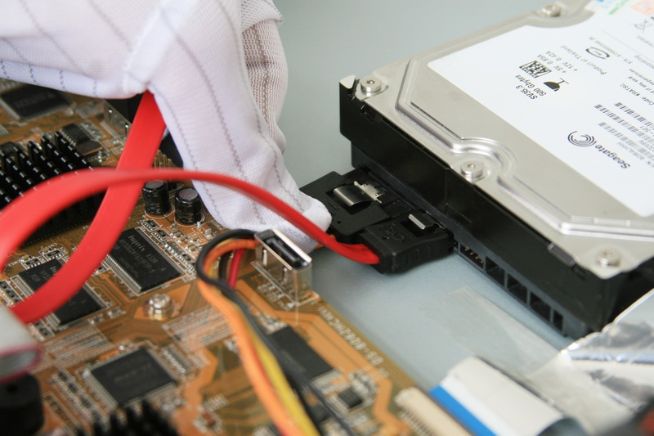

5. Re-install the lid of the DVR and fasten screws.

Rear Panel Diagram
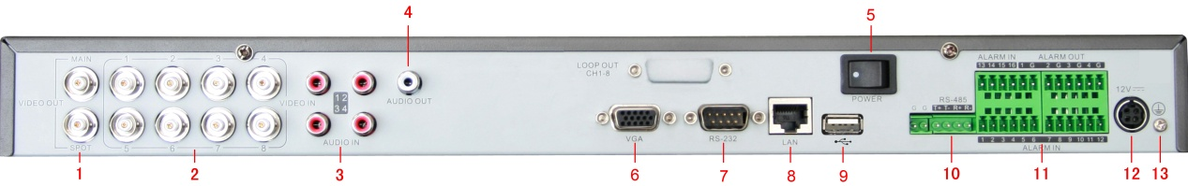
Figure 1: DS-7208HVI-S
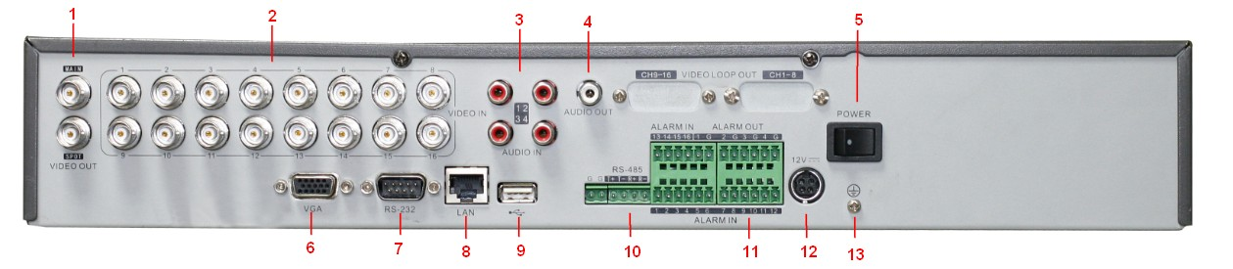
Figure 2: DS-7216HVI-S

No. | Item | Description
1 | VIDEO OUT | BNC connector for video output. If VGA is connected, the interface will not function. If VGA is not connected, the interface is used as the main video output with local video display and menu operations.
1 | VIDEO SPOT OUT | BNC connector for monitor. Single window view.
2 | VIDEO IN | BNC connectors for analog video input.
3 | AUDIO IN | RCA connectors for analog audio input.
4 | AUDIO OUT | RCA connector for audio output. This connector is synchronized with VIDEO OUT.
5 | Power | Power on/off DVR
6 | VGA | VGA output. Display local video output and menu.
7 | RS232 | DB9 connector for RS232
8 | LAN Interface | Connector for LAN (Local Area Network).
9 | USB Interface | Connector for USB devices.
10 | RS-485 Interface | Connector for RS-485 devices. T+, T- pin connects to PTZ.
11 | ALARM IN | Connector for alarm input (up to 16 channels).
11 | ALARM OUT | Connector for alarm output (4 channels).
12 | POWER | DC 12V
13 | GROUND | Ground(needs to be connected when DVR startup)

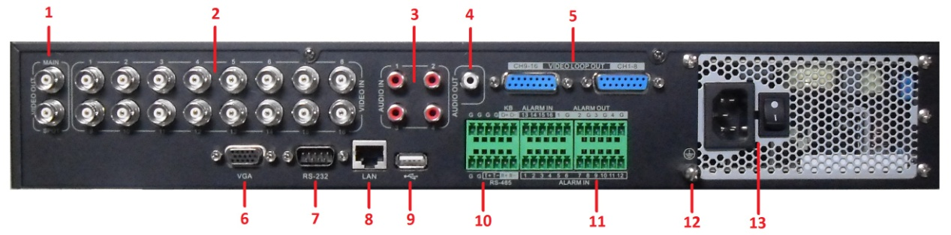
Figure 3: DS-7300HI-S(E)

No. | Item | Description
1 | VIDEO OUT | BNC connector for video output. The interface is set not to function.
1 | VIDEO SPOT OUT | BNC connector for monitor. Single window view.
2 | VIDEO IN | BNC connectors for analog video input.
3 | AUDIO IN | RCA connectors for analog audio input.
4 | AUDIO OUT | RCA connector for audio output.
5 | Video LOOP OUT | 16-ch DB15 connector for video loop out
6 | VGA | VGA output. Display local video output and menu.
7 | RS232 | DB9 connector for RS232
8 | LAN Interface | Connector for LAN (Local Area Network).
9 | USB Interface | Connector for USB devices.
10 | RS-485 Interface | Connector for RS-485 devices. T+, T- pin connects to PTZ.  Connector for KB devices. D+, D- pin connects to special keyboard.
11 | ALARM IN | Connector for alarm input.
11 | ALARM OUT | Connector for alarm output.
12 | GROUND | Ground(needs to be connected when DVR startup)
13 | POWER | AC 100~240V

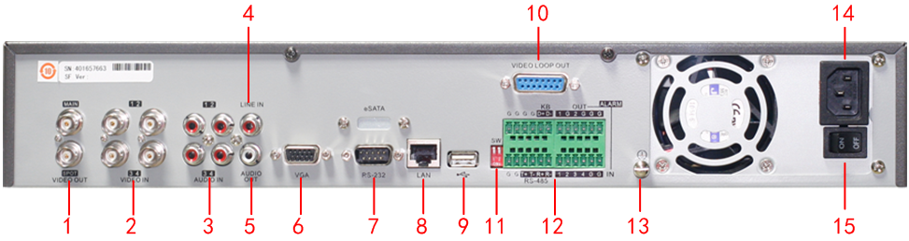
Figure 4: DS-7304HFI-S

No. | Item | Description
1 | MAIN VIDEO OUT | BNC connector for main video output. If VGA is connected, the MAIN VIDEO OUT will not function. If VGA is not connected, it is used as the main video output with local video display and menu operations.
1 | SPOT VIDEO OUT | BNC connector for spot monitor. Single window-division view.
2 | VIDEO IN | BNC connectors for analog video input.
3 | AUDIO IN | RCA connectors for analog audio input.
4 | LINE IN | RCA connector for audio input.
5 | AUDIO OUT | RCA connector for audio output. This connector is synchronized with VIDEO OUT.
6 | VGA | VGA output. Display local video output and menu.
7 | RS-232 | DB9 connector for RS-232 devices.
8 | LAN Interface | Connector for LAN (Local Area Network)
9 | USB Interface | Connector for USB devices.
10 | VIDEO LOOP OUT | Connector for video loop output.
11 | Termination Switch | Connection of 120-ohm terminator for RS-485 bus. ON=connected; OFF=disconnected.
12 | RS-485 Interface | Connectors for RS-485 devices. T+, T- pin connects to PTZ.
12 | KB Control Interface | D+, D- pin are connected to Ta, Tb pin of controller. For cascading devices, the first DVR’s D+, D- pin should be connected with the D+, D- pin of the next DVR.
12 | ALARM IN | Connector for alarm input.
12 | ALARM OUT | Connector for alarm output.
13 | GND | Grounding (needs to be connected when DVR starts up).
14 | 100~240VAC | 100~240VAC power supply.
15 | POWER | Switch for turn on/off the device.

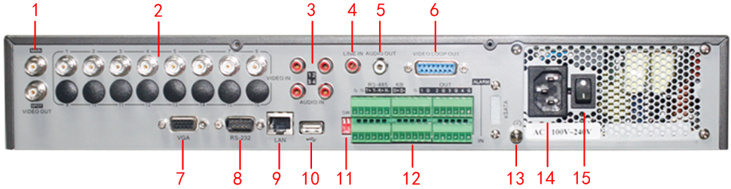
Figure 5: DS-7308/16HFI-S
No. | Item | Description
1 | MAIN VIDEO OUT | BNC connector for main video output. If VGA is connected, the MAIN VIDEO OUT will not function. If VGA is not connected, it is used as the main video output with local video display and menu operations.
1 | SPOT VIDEO OUT | BNC connector for spot monitor. Single window-division view.
2 | VIDEO IN | BNC connectors for analog video input.
3 | AUDIO IN | RCA connectors for analog audio input.
4 | LINE IN | RCA connector for audio input.
5 | AUDIO OUT | RCA connector for audio output. This connector is synchronized with VIDEO OUT.
6 | VIDEO LOOP OUT | Connector for video loop output.
7 | VGA | VGA output. Display local video output and menu.
8 | RS-232 | DB9 connector for RS-232 devices.
9 | LAN Interface | Connector for LAN (Local Area Network)
10 | USB Interface | Connector for USB devices.
11 | Termination Switch | Connection of 120-ohm terminator for RS-485 bus. ON=connected; OFF=disconnected.
12 | RS-485 Interface | Connectors for RS-485 devices. T+, T- pin connects to PTZ.
12 | KB Control Interface | D+, D- pin are connected to Ta, Tb pin of controller. For cascading devices, the first DVR’s D+, D- pin should be connected with the D+, D- pin of the next DVR.
12 | ALARM IN | Connector for alarm input.
12 | ALARM OUT | Connector for alarm output.
13 | GND | Grounding (needs to be connected when DVR starts up).
14 | 100~240VAC | 100~240VAC power supply.
15 | POWER | Switch for turn on/off the device.

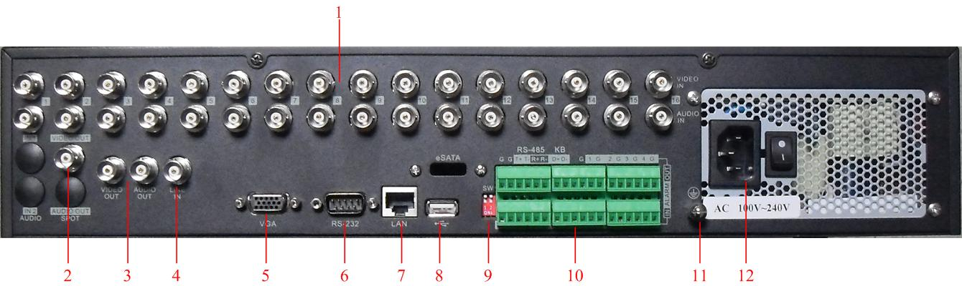
Figure 6: DS-8100-S(E)

No. | Item | Description
1 | VIDEO IN | BNC connectors for analog video input.
1 | AUDIO IN | BNC connectors for analog audio input.
2 | VIDEO SPOT OUT | BNC connector for monitor. Single window view.
3 | VIDEO OUT | BNC connector for video output. If VGA is connected, the interface will not function. If VGA is not connected, the interface is used as the main video output with local video display and menu operations
3 | AUDIO OUT | BNC connector for audio output. This connector is synchronized with VGA
4 | LINE IN | BNC connector for audio input.
5 | VGA | VGA output. Display local video output and menu.
6 | RS232 | DB9 connector for RS232.
7 | LAN Interface | Connector for LAN (Local Area Network)
8 | USB Interface | Connector for USB devices.
9 | Matching Resistor Switch(SW) | Terminal matching resistor switch for 485 bus, and its upwards (default) means cut off the resistor, its downwards means connecting a 120 ohm resistor.
10 | RS-485 Interface | Connector for RS-485 devices. T+, T- pin connects to PTZ.
10 | Controller port | D+, D- pin connects to Ta, Tb pin of controller. For cascading devices, the first DVR’s D+, D- pin should be connected with the D+, D- pin of the next DVR.
10 | ALARM IN | Connector for alarm input.
10 | ALARM OUT | Connector for alarm output.
11 | GROUND | Ground(needs to be connected when DVR startup)
12 | POWER | AC 100~240V

Peripheral Connections
Connecting to Alarm Input / Output Device

The alarm input/output interface of the DVR is shown below:
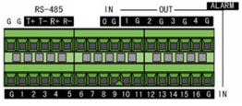

The alarm input is an open/close relay. If the input is not an open/closed relay, follow the connection diagram below:

To connect to an AC/DC load, use the following diagram:

For DC load, JP4 can be used within the limit of 12V/1A safely. If the interface is connected to an AC load, JP4 should be left open. Use an external relay for safety (as shown in the figure above).

There are 4 jumpers (JP4, JP5, JP6, and JP7) on the motherboard, each corresponding with one alarm output. By default, jumpers are connected. To connect an AC load, jumpers should be removed.

Note: An external relay is needed to prevent electric shock when connecting to an AC load.

Alarm Connection
To connect alarm devices to the DVR:
1. Disconnect pluggable block from the ALAM IN /ALARM OUT terminal block.
2. Unfasten stop screws from the pluggable block, insert signal cables into slots and fasten stop screws. Ensure signal cables are in tight.
3. Connect pluggable block back into terminal block.

RS-485 Connection
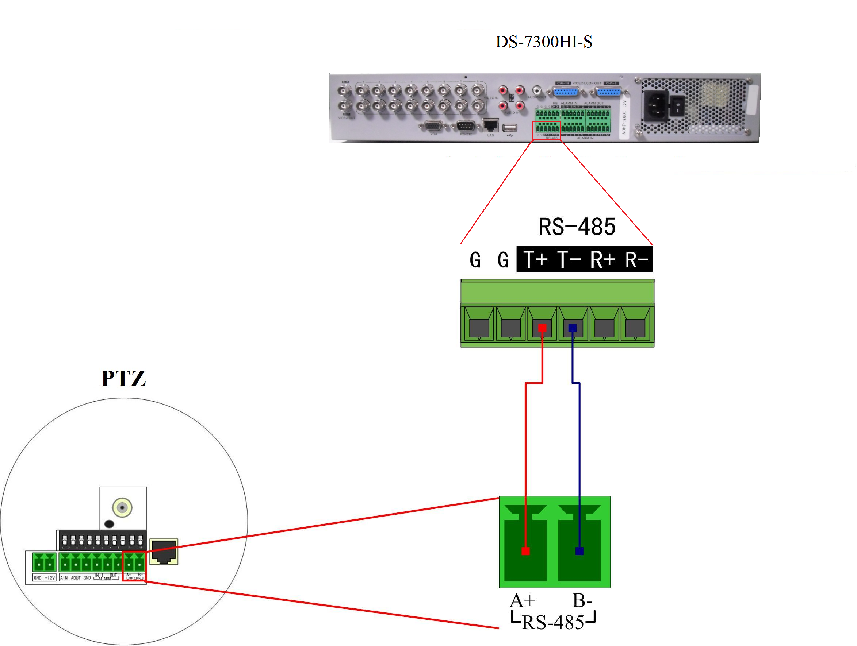

To connect RS-485 devices to the DVR:
1. Disconnect pluggable block from the RS-485 terminal block.
2. Unfasten stop screws from the pluggable block, insert signal cables into slots and fasten stop screws. Ensure signal cables are in tight.
3. Connect pluggable block back into terminal block
Note: The RS-485 PTZ control should be connected with the T+ and T- pin on the RS-485 terminal block.

Controller Connection
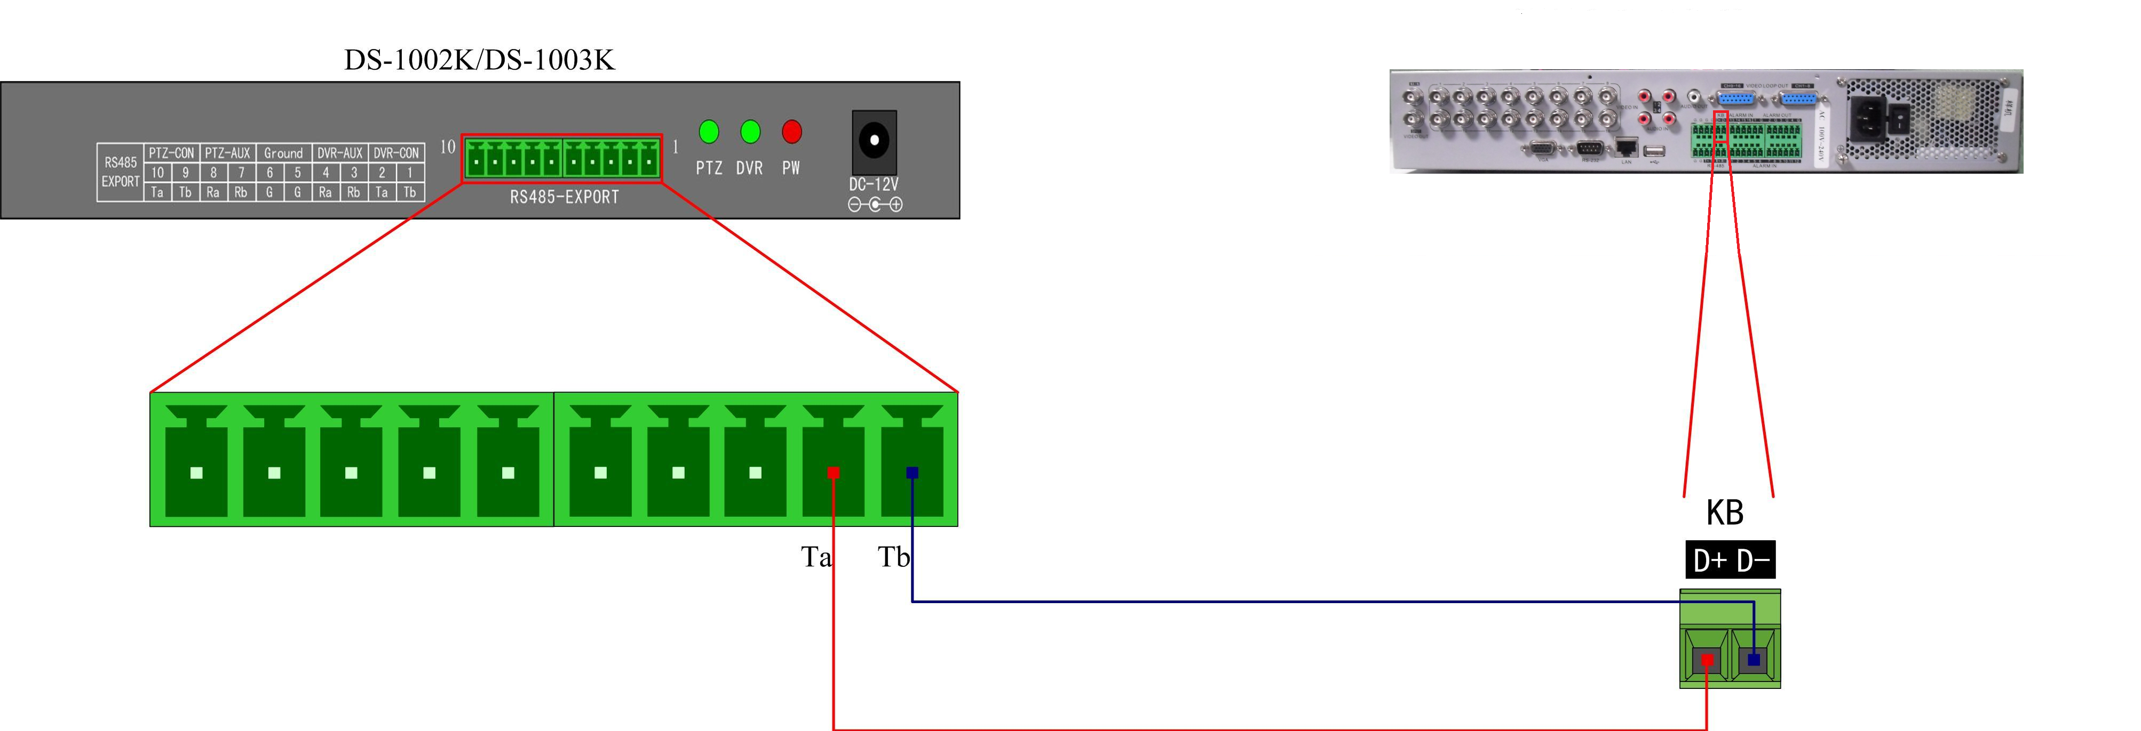
To connect a controller to the DVR:
1. Disconnect pluggable block from the KB terminal block.
2. Unfasten stop screws from the KB D+, D- pluggable block, insert signal cables into slots and fasten stop screws. Ensure signal cables are in tight.
3. Connect Ta on controller to D+ on terminal block and Tb on controller to D- on terminal block. Fasten stop screws.
4. Connect pluggable block back into terminal block.
Note: Make sure both the controller and DVR are grounded.

HDD Storage Calculation Chart

The following chart shows an estimation of storage space used based on recording at one channel for an hour at a fixed bit rate.

Bit Rate | Storage Used
96K | 42M
128K | 56M
160K | 70M
192K | 83M
224K | 98M
256K | 112M
320K | 140M
384K | 168M
448K | 196M
512K | 225M
640K | 281M
768K | 337M
896K | 393M
1024K | 450M
1280K | 562M
1536K | 675M
1792K | 787M
2048K | 900M

Note: Please note that supplied values for storage space used is just for reference. Storage space used is estimated by formulas and may have some deviation from actual value.

