Menu Structure
The menu structure of the DS-7200/DS-7300/DS-8100 Series DVR is as followed:
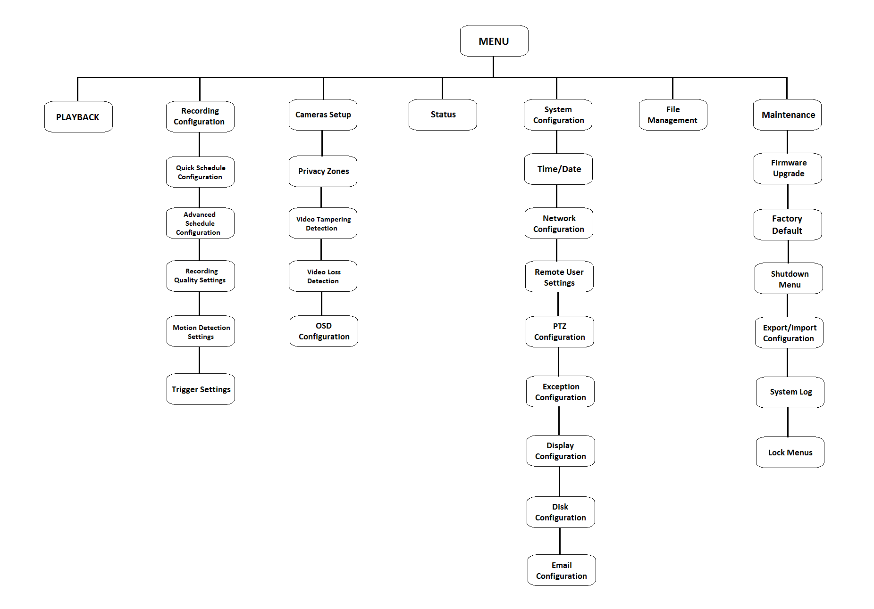

Startup and Shutdown
Proper startup and shutdown procedures are crucial to expanding the life of your DVR.
To startup your DVR:
1. Plug power adapter into DVR and electrical outlet. It is HIGHLY recommended to use a surge protector. The Power indicator LED on the front panel will turn red.
2. Connect a VGA monitor and mouse into the DVR.
3. Switch the POWER button on the back rear panel. The Power indicator LED will turn blue. The unit will begin to start.
There are two proper ways to shutdown the DVR. To shutdown the DVR:
• OPTION 1: Standard Shutdown
1. Enter the Shutdown menu by going to Menu > Maintenance > Shutdown.
2. Select the Shutdown button.
3. Click the Yes button.
4. Turn off switch on rear panel
• OPTION 2: Manual Shutdown
1. Press and hold the POWER button for 3 seconds.
2. Enter the administrator’s username and password in the dialog box for authentication.
3. Click the Yes button.
4. Turn off switch on rear panel
Note: Do not press the POWER button again when the system is shutting down.

Formatting a Disk
A newly installed hard disk drive (HDD) must be formatted first before it can be used with your DVR.

Note: Formatting the disk will erase all data on it.

To format a new disk:

1. Enter the Disk Management menu by going to Main Menu > System Configuration> Disk Management.

2. Select a disk to format. A disk that has not been formatted will show Error Detected as its status. If the disk is one that is newly installed, the status of the drive will show up as Non-Active and the Reformat button will change to the Add button.

3. Click the Add button.

4. A confirmation message will appear on the screen. Click the Yes button to continue formatting process.

5. A format progress bar will be shown on the menu. After the disk has been formatted, the status of the disk will change to Active.

6. Click the Done button to exit out of Disk Management.

Setting Date & Time
It is extremely important to setup the system date and time to accurately timestamp recordings and events.
To setup date and time:

1. Enter the Time/Date menu by going to Main Menu> System Configuration > Time/Date.

2. Enter the correct date and time.

3. Click the Save button to save the setting.

Recording
To setup quick recording schedule:
1. Enter the Quick Schedule Configuration menu by going to Main Menu > Recording Configuration> Quick Schedule Configuration.
2. Select the camera to configure from the camera drop down menu. If all the cameras are to be configured with the same settings, select All Cameras from the list.
3. Check the Enable checkbox to enable the recording schedule. If the checkbox is unchecked, the recording schedule will be disabled.
4. Check the 24/7 checkbox if you would like to record continuously or on event for 24 hours a day, 7 days a week. If you wish to schedule different time frames for Monday through Sunday, leave the 24/7 checkbox unchecked and skip to step 6.
5. Select Recording Type for 24/7 recording and move on to step 8. Recording type includes Continuous for continuous recording or On Event for recording when an event is triggered (i.e. from detected motion).
6. Select the start and stop time for each day of the week. The start and stop time are listed using a 24 hr cycle (i.e. 18:00 is equivalent to 6:00pm).
7. Select Recording Type for each day of the week. Recording type includes Continuous for continuous recording or On Event for recording when an event is triggered (i.e. from detected motion) for the selected time period.
8. Check the Enable Audio checkbox if you would like to enable audio recording along with the video. Audio can only be recorded if an amplified audio source is connected to the DVR.
9. Select the Save button to save the schedule settings and select Exit to return to the previous menu. Selecting the Exit button without clicking Save will quit out of the menu without saving settings.

Note: On Event recordings are recordings that are triggered from motion detection and/or from an external alarm. See Configuring Alarms and Exceptions in the user manual.

Playback

Playback from Search
1. Enter the Playback menu by going to Main Menu > Playback.
2. Set the search parameters by selecting cameras to search and date to search on.
3. The search results will be shown on the timeline with blue bars designating recorded files.
4. Select file and click the Play button to begin playback.
5. Click button to enter full screen mode.
Note: In full screen mode, you can select multiple channel playback.

Playback from System Log
1. Enter the System Logs menu by going to Main Menu > Maintenance > System Logs.
2. Select date from the Calendar to search for system logs in.
3. Select Search Type.
4. Click the Search button.
5. A list of results with your search criteria will be displayed. If applicable, select the video log to playback and click Play.
6. The recording will begin to play in the Playback interface.

Backup
Recorded files can be backed up to various devices, such as USB flash drives, USB HDDs or a DVD writer.
To export recorded files:
1. Enter the File Management menu by going to Main Menu > System Configuration > File Management
2. Select desired parameters to search for files to backup.
3. Select the files to backup. You may also click the Play button to verify that these files are indeed the ones you would like to backup. The total size of the files will also be shown on this menu.
4. Click the Files Backup button to access the Files Backup Menu.
5. Select device to backup to from drop-down list (USB Flash Drive, USB HDD, DVD Writer). If backup device is not recognized:
• Click the Refresh button.
• Reconnect device.
• Check for compatibility from vendor.
6. The total available free space will be shown. If the free space is not sufficient, delete files from the storage device or insert a device with more available free space.
7. Click the Backup button to begin backup process. After the backup has completed, click the OK button.
Note: Video Player software will automatically be copied on to the device that the recorded files were exported on.

Using the Front Panel Controls

DS-7208HVI-S

The controls on the front panel include:

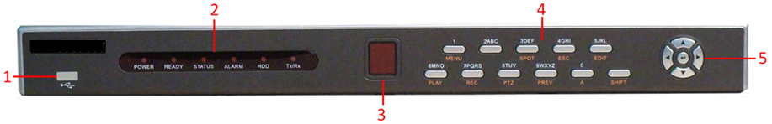
- USB Interface: Universal Serial Bus (USB) ports for additional devices such as USB mouse and USB Hard Disk Drive (HDD).
- Status Indicators: Status indicators for different features of the DVR.
- Power: Power indicator turns red when the DVR is switched on.
- Ready: Ready indicator turns green when DVR is functioning properly.
- Status: Status indicator turns green when DVR is controlled by an IR remote.
- Alarm: Alarm indicator turns red when a sensor alarm is detected.
- HDD: HDD indicator blinks red when data is being read from or written to HDD.
- Tx/Rx: NETWORK indictor blinks green when network connection is functioning properly.
- IR Receiver: Receiver for IR remote.
- Control Buttons:
• 1/MENU Button: The 1/MENU button works as numeric [1]. Pressing this button will return the user to the Main menu (after successful login). The 1/MENU button will also bring up Sensitivity Interface settings.
• 2ABC/F1: The 2ABC/F1 button works as numeric [2] and letter [ABC]. When it is used in a list field will select all items on the list.
• 3DEF/F2: The 3DEF/F2 button works as numeric [3] and letter [DEF]. It is also used to cycle through tab pages.
• 4GHI/ESC: The 4GHI/ESC button works as numeric [4] and letter [GHI], it is also used to escape to the previous menu
• 5JKL/EDIT: The 5JKL/EDIT button works as numeric [5] and letter [JKL]. The 5JKL/EDIT button is used to edit text fields. When editing text fields, it will also function as a Backspace button to delete the character in front of the cursor. On checkbox fields, pressing the 5JKL/EDIT button will tick the checkbox. In Playback mode, it can be used to generate video clips for backup.
• 6MNO/PLAY: The 6MNO/PLAY button works as numeric [6] and letter [MNO]. It is used to enter the Playback menu. It is also used to turn audio on/off in the Playback menu.
• 7PQRS/REC: The 7PQRS/REC button works as numeric [7] and letter [PQRS]. It is also used to enter the Manual Record interface.
• 8TUV/PTZ: The 8TUV/PTZ button works as numeric [8] and letter [TUV]. It is also used to enter the PTZ Control mode.
• 9WXYZ/PREVIEW: The 9WXYZ/PREVIEW button works as numeric [9] and letter [WXYZ]. It is also used to switch between single screen and multi-screen mode.
• 0/A: The 0/A button works as numeric [0]. It is also used to switch between input methods (upper and lowercase alphabet, symbols and numeric input). It can also be used to clear entire masked areas, such as in the Motion Detection and Privacy Mask menus.
• SHIFT: The SHIFT button is used for switch button action between numeric button and control button.
- DIRECTION/ENTER Buttons:
• DIRECTION Buttons: The DIRECTION buttons are used to navigate between different fields and items in menus. In Playback mode, the Up and Down button is used to speed up and slow down recorded video. The Left and Right button will jump 30s backward and forward in a video. In Preview mode, these buttons can be used to cycle through channels.
• ENTER Button: The ENTER button is used to confirm selection in any of the menu modes. It can also be used to tick checkbox fields. In Playback mode, it can be used to play or pause the video. In Single Play mode, pressing the ENTER button will advance the video by a single frame.

DS-7216HVI-S

The controls on the front panel include:

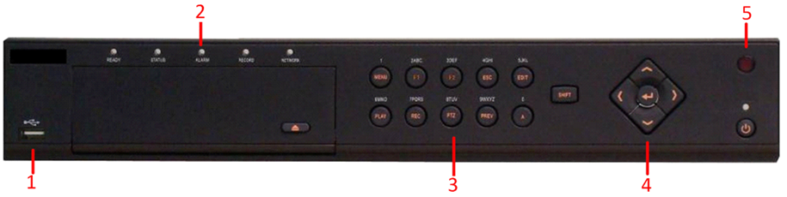
- USB Interface: Universal Serial Bus (USB) ports for additional devices such as USB mouse and USB Hard Disk Drive (HDD).
- Status Indicators: Status indicators for different features of the DVR.
• Ready: Ready indicator turns green when DVR is functioning properly.
• Status: Status indicator turns green when DVR is controlled by an IR remote.
• Alarm: Alarm indicator turns red when a sensor alarm is detected.
• Record: Record indicator blinks red when data is being read from or written to HDD.
• NETWORK: Network indictor blinks green when network connection is functioning properly.
- Control Buttons:
• 1/MENU Button: The 1/MENU button works as numeric [1]. Pressing this button will return the user to the Main menu (after successful login). The 1/MENU button will also bring up Sensitivity Interface settings.
• 2ABC/F1: The 2ABC/F1 button works as numeric [2] and letter [ABC]. When it is used in a list field will select all items on the list.
• 3DEF/F2: The 3DEF/F2 button works as numeric [3] and letter [DEF]. It is also used to cycle through tab pages.
• 4GHI/ESC: The 4GHI/ESC button works as numeric [4] and letter [GHI], it is also used to escape to the previous menu
• 5JKL/EDIT: The 5JKL/EDIT button works as numeric [5] and letter [JKL]. The 5JKL/EDIT button is used to edit text fields. When editing text fields, it will also function as a Backspace button to delete the character in front of the cursor. On checkbox fields, pressing the 5JKL/EDIT button will tick the checkbox. In Playback mode, it can be used to generate video clips for backup.
• 6MNO/PLAY: The 6MNO/PLAY button works as numeric [6] and letter [MNO]. It is used to enter the Playback menu. It is also used to turn audio on/off in the Playback menu.
• 7PQRS/REC: The 7PQRS/REC button works as numeric [7] and letter [PQRS]. It is also used to enter the Manual Record interface.
• 8TUV/PTZ: The 8TUV/PTZ button works as numeric [8] and letter [TUV]. It is also used to enter the PTZ Control mode.
• 9WXYZ/PREVIEW: The 9WXYZ/PREVIEW button works as numeric [9] and letter [WXYZ]. It is also used to switch between single screen and multi-screen mode.
• 0/A: The 0/A button works as numeric [0]. It is also used to switch between input methods (upper and lowercase alphabet, symbols and numeric input). It can also be used to clear entire masked areas, such as in the Motion Detection and Privacy Mask menus.
• SHIFT: The SHIFT button is used for switch button action between numeric button and control button.
- DIRECTION/ENTER Buttons:
• DIRECTION Buttons: The DIRECTION buttons are used to navigate between different fields and items in menus. In Playback mode, the Up and Down button is used to speed up and slow down recorded video. The Left and Right button will jump 30s backward and forward in a video. In Preview mode, these buttons can be used to cycle through channels.
• ENTER Button: The ENTER button is used to confirm selection in any of the menu modes. It can also be used to tick checkbox fields. In Playback mode, it can be used to play or pause the video. In Single Play mode, pressing the ENTER button will advance the video by a single frame.
- IR Receiver: Receiver for IR remote.
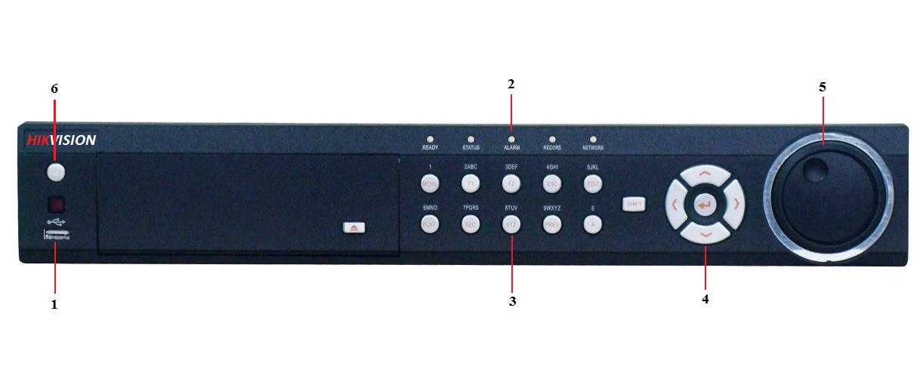
DS-7300HI-S Series DVR

The controls on the front panel include:

- USB Ports: Universal Serial Bus (USB) ports for additional devices such as USB mouse and USB Hard Disk Drive (HDD).
- Status Indicators: Status indicators for different features of the DVR.
• Alarm: Alarm indicator turns red when a sensor alarm is detected.
• Ready: Ready indicator turns green when DVR is functioning properly.
• Status: Status indicator turns green when DVR is controlled by an IR remote.
• HDD: HDD indicator blinks red when data is being read from or written to HDD.
• Tx/Rx: Tx/Rx indictor blinks blue when network connection is functioning properly.
- Control Buttons:
• MENU/WIPER Button: Pressing the MENU/WIPER button will return the user to the Main menu (after successful login). In PTZ Control mode, the MENU/WIPER button will start wiper (if applicable). In Playback mode, it also can be used to enable/disable side bar menu.
• F1/LIGHT: In PTZ Control mode, it will turn on/off PTZ light. In PTZ Control mode, the F1/LIGHT button is used to zoom the PTZ camera in when in the PTZ Control menu.
• F2/AUX: It is used to cycle through tab pages. In PTZ Control mode, the F2/AUX button is used to zoom the PTZ camera out when in the PTZ Control menu.
• ESC: The ESC button is used to escape to the previous menu and to arm/disarm the DVR in Preview mode.
• EDIT/IRIS+: The EDIT/IRIS+ button is used to edit text fields. When editing text fields, it will also function as a Backspace button to delete the character in front of the cursor. On checkbox fields, pressing the EDIT/IRIS+ button will tick the checkbox. In PTZ Control mode, the EDIT/IRIS+ button opens up the iris of the camera.
• PLAY/AUTO: The PLAY/AUTO button is used to enter the Playback menu. It is also used to turn audio on/off in the Playback menu and auto scan in the PTZ Control menu.
• REC/SHOT: The REC/SHOT button is used to enter the Quick Schedule Configuration interface. If used when controlling a PTZ, pressing the REC/SHOT button and then a Numeric button will call a PTZ preset.
• PTZ/IRIS-: The PTZ/IRIS- button is used to enter the PTZ Control mode. When in the PTZ Control mode, it is used to close the iris of the PTZ. In Playback mode, it also can be used to enable/disable audio.
• PREV/FOCUS-: The PREV/FOCUS- button is used to switch between single screen and multi-screen mode. In PTZ Control mode, it is used to adjust the focus in conjunction with the A/FOCUS+ button.
• A/FOCUS+: The A/FOCUS+ button is used to adjust focus in the PTZ Control menu. It is also used to switch between input methods (upper and lowercase alphabet, symbols and numeric input).
• SHIFT: The SHIFT button is used for switch button action between numeric button and control button.
- DIRECTION/ENTER Buttons:
• DIRECTION Buttons: The DIRECTION buttons are used to navigate between different fields and items in menus. In Playback mode, the Up and Down button is used to speed up and slow down recorded video. In Preview mode, these buttons can be used to cycle through channels.
• ENTER Button: The ENTER button is used to confirm selection in any of the menu modes. It can also be used to tick checkbox fields. In Playback mode, it can be used to play or pause the video.
- JOG SHUTTLE Control: The JOG SHUTTLE control can be used to move the active selection in a menu. In the Playback mode,the inner ring can be used to speed up/slow down the video. In Preview mode, it can be used to cycle through different channels.
- POWER Button: The POWER button is used for power on or power off the DVR.
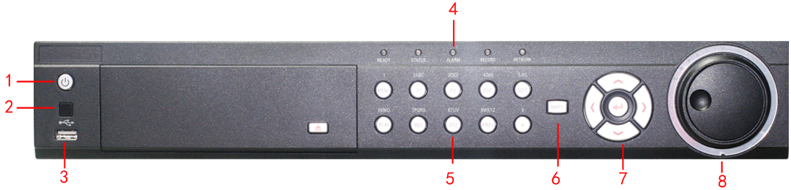
DS-7300HFI-S Series DVR

The controls on the front panel include:

- Power Button: Powers DVR on/off.
- IR Receiver: Receiver for IR remote.
- USB Interface: Universal Serial Bus (USB) ports for additional devices such as USB mouse and USB Hard Disk Drive (HDD).
- Status Indicators: Status indicators for different features of the DVR.
- Ready: The indicator lights in blue when DVR is functioning properly.
- Status: The indicator lights in blue when DVR is controlled by an IR remote. Indicator turns red when controlled by a keyboard and purple when IR remote and keyboard is used at the same time.
- Alarm: Alarm indicator turns red when a sensor alarm is detected.
- Record: Indicating the working status of the device. The indicator will light in green when the DVR is under recording.
- Network: The indictor will flicker in green when network connection is functioning normally.
- Alphanumeric Buttons: Alphanumeric buttons used in various menus of the DVR.
- Switching to the corresponding channel in Preview or PTZ Control mode.
- Inputting numbers and characters in Edit mode.
- Switching between different channels in Playback mode.
- Compound Buttons:
- 1 MENU: (1) Enter numeral “1”; (2) Access the main menu interface.
- 2ABC/F1: (1) Enter numeral “2”; (2) Enter letters “ABC”; (3) The F1 button when used in a list field will select all items on the list. In PTZ Control mode, it will turn on/off PTZ light.
- 3DEF/F2: (1) Enter numeral “3”; (2) Enter letters “DEF”; (3) The F2 button is used to cycle through tab pages. It will also bring up the Channel & OSD Position settings.
- 4GHI/ESC: (1) Enter numeral “4”; (2) Enter letters “GHI”; (3) Exit and back to the previous menu.
- 5JKL/EDIT: (1) Enter numeral “5”; (2) Enter letters “JKL”; (3) Delete characters before cursor; (4) Select the checkbox and ON/OFF switch; (5) Start/stop record clipping in playback.
- 6MNO/PLAY: (1) Enter numeral “6”; (2) Enter letters “MNO”; (3) Playback, for direct access to playback interface.
- 7PQRS/REC: (1) Enter numeral “7”; (2) Enter letters “PQRS”; (3) Manual record, for direct access to manual record interface; manually enable/disable record.
- 8TUV/PTZ: (1) Enter numeral “8”; (2) Enter letters “TUV”; (3) Access PTZ control interface.
- 9WXYZ/PREV: (1) Enter numeral “9”; (2) Enter letters “WXYZ”; (3) Multi-camera display in preview.
- 0/A: (1) Enter numeral “0”; (2) switch between input methods (upper and lowercase alphabet, symbols and numeric input).
- Control Buttons:
- Directional buttons: In menu mode, the direction buttons are used to navigate between different fields and items and select setting parameters. In playback mode, the Up and Down buttons are used to speed up and slow down record play, and the Left and Right buttons are used to select the recording 30s forwards or backwards. In preview mode, these buttons can be used to cycle through channels.
- Enter: The Enter button is used to confirm selection in menu mode; or used to select checkbox fields and ON/OFF switch. In playback mode, it can be used to play or pause the video. In single-frame play mode, pressing the Enter button will advance the video by a single frame. And in auto sequence preview mode, the buttons can be used to pause / resume auto sequence.
- JOG SHUTTLE Control:
The JOG SHUTTLE control can be used to move the active selection in a menu. The inner ring will move the selection up and down; the inner ring will move it left and right. In the Playback mode, the inner ring is used to jump 30 seconds forward/backward in a video. The inner ring can be used to speed up/slow down the video. In Preview mode, it can be used to cycle through different channels

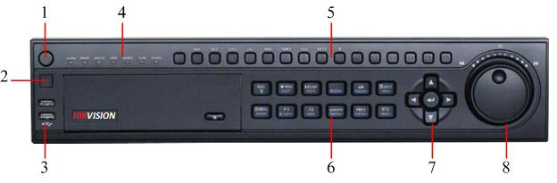
DS-8100HI-S Series DVR

The controls on the front panel include:

- Power Button: Powers DVR on/off.
- IR Receiver: Receiver for IR remote.
- USB Ports: Universal Serial Bus (USB) ports for additional devices such as USB mouse and USB Hard Disk Drive (HDD).
- Status Indicators: Status indicators for different features of the DVR.
• Alarm: Alarm indicator turns red when a sensor alarm is detected.
• Ready: Ready indicator turns blue when DVR is functioning properly.
• Status: Status indicator turns blue when DVR is controlled by an IR remote. Indicator turns red when controlled by a keyboard and purple when IR remote and keyboard is used at the same time.
• HDD: HDD indicator blinks red when data is being read from or written to HDD.
• Modem: Reserved
• TX/RX: TX/RX indictor blinks blue when network connection is functioning properly.
• Guard: Guard indicator turns blue when the device is armed, off when the device is unarmed. The arm/disarm state can be initiated by pressing and holding on the ESC button for more than 3 seconds in Preview mode.
- Alphanumeric Buttons: Alphanumeric buttons used in various menus of the DVR. Some uses include:
• Switching to the corresponding channel in Preview or PTZ Control mode.
• Inputting numbers and characters in Edit mode.
• Switching between different channels in Playback mode.
- Control Buttons:
• ESC Button: The ESC button is used to escape to the previous menu and to arm/disarm the DVR in Preview mode.
• REC/SHOT Button: The REC/SHOT button is used to enter the Manual Record interface. If used when controlling a PTZ, pressing the REC/SHOT button and then a Numeric button will call a PTZ preset.
• PLAY/AUTO Button: The PLAY/AUTO button is used to enter the Playback menu. It is also used to turn audio on/off in the Playback menu and auto scan in the PTZ Control menu.
• ZOOM+ Button: The ZOOM+ button is used to zoom the PTZ camera in when in the PTZ Control menu.
• A/FOCUS+ Button: The A/FOCUS+ button is used to adjust focus in the PTZ Control menu. It is also used to switch between input methods (upper and lowercase alphabet, symbols and numeric input). It can also be used to clear entire masked areas, such as in the Motion Detection and Privacy Mask menus.
• EDIT/IRIS+ Button: The EDIT/IRIS+ button is used to edit text fields. When editing text fields, it will also function as a Backspace button to delete the character in front of the cursor. On checkbox fields, pressing the EDIT/IRIS+ button will tick the checkbox. In PTZ Control mode, the EDIT/IRIS+ button opens up the iris of the camera. In Playback mode, it can be used to generate video clips for backup.
• MENU/WIPER Button: Pressing the MENU/WIPER button will return the user to the Main menu (after successful login). Pressing and holding the button for 5 seconds will turn off audible key beep. The MENU/WIPER button will also bring up Sensitivity Interface settings. In PTZ Control mode, the MENU/WIPER button will start wiper (if applicable).
• F1/LIGHT Button: The F1/LIGHT button when used in a list field will select all items on the list. In PTZ Control mode, it will turn on/off PTZ light.
• F2/AUX Button: The F2/AUX button is used to cycle through tab pages. It will also bring up the Channel & OSD Position settings.
• MAIN/SPOT/ZOOM- Button: The MAIN/SPOT/ZOOM- button is used to switch to the control of spot output. In PTZ Control mode, it can be used to zoom the camera out.
• PREV/FOCUS- Button: The PREV/FOCUS- button is used to switch between single screen and multi-screen mode. In PTZ Control mode, it is used to adjust the focus in conjunction with the A/FOCUS+ button. It can also be used to select entire masked areas, such as in Motion Detection and Privacy Mask menus.
• PTZ/IRIS- Button: The PTZ/IRIS- button is used to enter the PTZ Control mode. When in the PTZ Control mode, it is used to close the iris of the PTZ camera.
- DIRECTION/ENTER Buttons:
• DIRECTION Buttons: The DIRECTION buttons are used to navigate between different fields and items in menus. In Playback mode, the Up and Down button is used to speed up and slow down recorded video. The Left and Right button will select the next and previous day of recordings. In Preview mode, these buttons can be used to cycle through channels.
• ENTER Button: The ENTER button is used to confirm selection in any of the menu modes. It can also be used to tick checkbox fields. In Playback mode, it can be used to play or pause the video. In Single Play mode, pressing the ENTER button will advance the video by a single frame.
- JOG SHUTTLE Control: The JOG SHUTTLE control can be used to move the active selection in a menu. The inner ring will move the selection up and down; the inner ring will move it left and right. In the Playback mode, the inner ring is used to jump 30 seconds forward/backward in a video. The inner ring can be used to speed up/slow down the video. In Preview mode, it can be used to cycle through different channels.
Note: It is important to note that you must click the EDIT button on either the remote or front panel on a text field before you’re able to edit its content. After you’re done entering text, you must hit the ENTER button to be able to move on to the next field.
Note: The front panel controlling of the other series are similar, for details please refer to the user manual.

